Copyright © Lyuben Piperov June 2004
A Strange Code about AD 2006 Discovered in the Torah
Lyuben Piperov
Preliminary Notes
Hebrew is written from right to left. In this study, the most common “Absolute Method” of assigning numbers to each of the 22 Hebrew letters has been used. In this method, the five finals are assigned the same numbers as their corresponding letters of the alphabet. The mapping of the Absolute Method is given in the end of the document. The finals, however, have been used accordingly throughout in the text.
Introduction
Recently I read the second Michael Drosnin’s book on the Bible code: The Bible Code 2: The Countdown [1]. I read his first book some years ago. At that time I was impressed by his codes about the years 2000 and 2006. But these years are found as numbers expressed NOT as two thousand and two thousand and six, respectively, but, according to the Jewish calendar, as 5760 and 5766. In accordance with the rules, a certain year is written as a number from 1 to 999, preceded by a letter indicating the millennium. This letter indicates the number of whole millennia that have already passed since the foundation of the world and corresponds to the serial number of the letter in the alphabet. So, the years between 5000 and 5999 begin with the fifth letter in the Hebrew alphabet, he (ה). This is similar to the expression of a number by the positional Arabic system used everywhere. But this is valid for the first digit only. The number within the thousand is expressed almost exactly as in the Roman system: a row of letters always arrayed according to the descending order of their respective numeric equivalents. So, like the Roman numbers, their length varies according to the number of letters required to add up to a certain value. For instance, AD 2000 (התשס = 5760) is a four-digit number, while AD 2006 (התשסו = 5766) is a five-digit one.
Thus, due to the mixed expression of the numbers, practically any year could be found encoded even in a comparatively short text – say, a separate book of the Bible. This is especially valid for the millennia, centuries, decades or years that are expressed by relatively frequently appearing letters such as the fifth letter, he. Even with an added prefix indicating “in” (that is, beit, ב), the expression “in AD 2006”, בהתשסו, occurs 197 times in the whole Torah and 9 times in its longest book: Genesis. “In AD 2000” (בהתשס) occurs much more often: about 2500 and 85 times, respectively. In such cases the significance of a code is emphasized by the skip-value: the occurrence at a lower skip is considered as an indication of a higher significance. The significance of the code about 2006 illustrated in both Drosnin’s books arises out of the fact that the occurrence is at the lowest skip in the Torah: -11.
The belief that all the events even in the tiniest details are hidden in the Torah has its origin as far back as the time of Moses. This has been the reason for the enormously strict rules that were to be observed through the ages in copying the Torah: even one deleted, added or mistaken letter can destroy the information. In the pre-computer era, due to the limited possibilities for checking the vast number of permutations of the letters in the Torah, rare attempts for cracking a code hidden as an equidistant letter sequence (ELS), or skip, has been made by learned Jewish rabbis only. These have also been restricted to well known, fabulous events exclusively concerning famous Jews.
In the recent years, however, the computers provided the means for breaking codes concerning any event including Gentile nations, persons, places and dates. The names of the individuals and places can, basically, be spelt in various ways in Hebrew. Dates, on the other hand, except for some very rare occasions, have always been expressed in accordance with the Jewish rules.
An Ancient Code Plays a Significant Role in This Study
This study appeared as a strange combination of results obtained while trying to find out the significance of an eccentric feature I knew from Dr. Jeffrey Satinover’s The Truth behind the Bible Code [2]. There, writing about the feast of Purim, he refers to an odd tradition, kept for the book of Esther, of writing the names of the ten Haman’s sons hung by the Jews after the foiled plot for destruction of the God’s chosen nation designed by their father. Three of the letters are written in smaller characters. The numeric value of the sum is 707. For centuries it has been believed that this is a code for a year of a certain millennium. It has been thought to be the sixth millennium because the only letter among the ten names written in a larger character is vav (ו) – the sixth letter of the Hebrew alphabet. So, the year should be 5707 or from September AD 1946 to the autumn of 1947. It was within this year of the Jewish calendar, in October 1946, when the ten Nazi top officers were hanged after being convicted to capital penalties for the crimes during the Holocaust. The story is brilliantly described in the abovementioned book as an example of perfect recurrences of historical events as if they are positioned along a helix of time.
I read this story several years ago. At that time, I had just have got a copy of the Hebrew Bible that friends of mine brought for me from Britain and, intrigued by the story, decided to check for other places that contain this feature. Browsing through the pages, I noticed many more examples of this peculiar tradition. Once it has been proved to be a code in Esther, the other places should also be codes, I thought. Rarely, a word contained both kinds of modified characters. One of the places that impressed me very much, is an Aramaic word used only once in the whole Bible. The word is שפרפרא (pronounced probably ShFaRPaRA) and denotes “very early in the morning”. (The smaller character is also coloured in red, while the larger one is blue.) It is found in the book of Daniel 6:19, when king Darius “arose very early in the morning, and went in haste unto the den of lions”. There are two letters that are written in these strange ways, the same situation as with the name of the tenth Haman’s son, Vaizatha (ויזתא). The latter word encodes timing. But the former one explicitly indicates time. What then it should encode?
I believed it should encode something important about our time. So I began trying with different years expressed according to the Hebrew rules. Several matrices have been prepared but all results appeared to be unsatisfying. Nothing foreboding a dawn has been spotted. I was disappointed.
Then, suddenly, an idea came up to my mind. What if we change the rules? Why shouldn’t we try directly with 2000 instead of 5760 and neighboring numbers? But on one hand, the new rule shouldn’t violate the Hebrew rule and, on the other hand, it should contain the ancient tradition. If we add up tav (ת) after tav, we will follow strictly the Roman method but wouldn’t distinguish the millennia, which wouldn’t be in harmony with the spirit of Scripture. I didn’t like this idea on esthetical grounds too.
So I decided to follow basically the ancient principle, but combined with the Hebrew tradition of distinguishing millennia by using all numbers denoting whole hundreds: tav (ת), shin (ש), reish (ר) and qof (ק). After all, they just add up to 1000: 400 + 300 + 200 + 100. Even more, the letters encoding the number 707 in the names of three of the 10 Haman’s sons also appear in descending order. Arraying the corresponding letters in descending order leads to the 4-letter sequence תשרק. Then I decided to repeat it thus making 2000: תשרקתשרק. This is already an 8-letter long row, so I expected that it may not occur in the Torah. At this stage, the trial was like playing a game.
I was surprised to see that it occurs exactly once: at skip 14965. I use the free Torah4u2.zip by Arikh Anpin, Israel, US, so I couldn’t see how the row looks like in the matrix. I was trying to prepare a matrix with some other items already there, so I sent the latter item to the slide, although it was at some distance from the core. I felt that a single occurrence of any 8-letter item in the Torah is significant in itself. Therefore I adjusted the skip to that of the new item, reduced the font size and looked at the window. Within a second I noticed that the letter immediately below the second qof (ק) is vav (ו). This should already mean 2006! At once I forgot everything else and focused all my attention on the newcomer.
I wrote all these introductory words because subconscious played a significant role in the study. Intuition continued to play its role in the course of the research that followed too. However, the real investigation started here.
First Findings
With my scarce knowledge of Hebrew, I began a search for three-letter words just around the stem. First of all, I looked for salvation (ישע). This word occurs very often but I distinguished five words creating an impression of descending from above, winding around the trunk of a tree and ending with the roots: the symmetrical ישע in the bottom line at skip 4. All these words are shown as blue ovals in Figure 1.
Probably because I finished M. Drosnin’s book just a week or two ago and my eyes were trained, the next 3-letter word I detected was Bush (בוש) (green ovals, skip 14964). It intersects both vav, which is the 6 in 2006, and shin in one of the words salvation. Then I looked at the letter above the first tav. It was aleph (א). If the year is read in reversed order, it will be 2001. So there appeared to be three years encoded together: 2000, 2001 and 2006. The first one was the year of election, the next one – the year of taking the office in the White House and the 9/11 Al Qaeda’s attack on NYC and the Pentagon.
This was the turning point in my research. Then I realized that there probably IS a code indeed. I widened the area of observation and spotted the longer diagonal sentence-like “expression”: salvation and the measure (or, measuring) (of) the waters (ישעוהתכנהמימ), rhombs, at the same skip as Bush. It appears encoded only once in the Torah. The 3-letter word תכן (pronounced probably TaKhaN) is referred to in the Wilson’s Old Testament Word Studies [3] both as noun and verb. Measuring of waters with the use of תכן is referred to in Job 28:25, where Job says about God: To make a weight for the wind. Yea, he meteth (תכן) the waters (מים) by measure. Weighing of human actions is referred to in I Samuel 2:3, where Hannah thanks God for her firstborn child, Samuel: And by him actions are weighed. Finally, it is found in Proverbs 16:2, where The Lord weigheth the spirits.
Water and spirit are linked since the beginning (Gen. 1:2) and these three examples illustrate the idea of judgement. Sheep on the right and goats on the left (Matt. 25:33) at once has been recalled. I checked for a word meaning division or, as a verb, to divide. It was there: בקע (pronounced BeKAh), intersecting the second qof at skip -1 (ovals coloured in three different colours due to intersections). This is what is written in [3] under “cleave”:
בקע to break, tear, rip up, cleave or split asunder with a noise; to break through or into; applied to the cleaving of wood; to the cleaving of the ground; to breaking forth of light; to the cleaving or opening of an enclosure, in order to make a passage of it, particularly to open a passage for waters. (Emphasis is mine.)
This word is used for the description of the beginning of the Flood in Gen. 7:11: …were all the fountains of the great deep broken up…”, the division of waters during the exodus in Ex. 14:16: …lift thou up thy rod, and stretch out thine hand over the sea, and divide it, in 14:21: …and the waters were divided and in Numbers 16:31 when …the ground clave asunder that was under them [Korah, Dathan and Abiram].
Judgement couldn’t help me remembering the last night of the Babylonian king Belshazzar and his kingdom (book of Daniel, chapter 5) and the writing on the wall in particular (5:25ff). I read again the passage, especially 25:27: tekel; thou art weighed in the balances, and art found wanting. Then I easily found tekel (תקל, purple squares, skip -14965) close to the trunk.
Anticipated Items in the Matrix
Up to that time, I was trying to identify words by staring at the matrix. It was then when I started to assign words for searching. The first word I looked for was end. But it was not because I am obsessed with apocalyptic expectations. As I wrote before, there are some places in the Hebrew Bible, where a letter in a word is written in a character of different size. One of the instances is end in Ecclesiastes 12:13: This is the end of the matter; all had been heard: fear God, and keep his commandments; for this is the whole duty of man. End or conclusion is סוף (SOF). In the verse cited above, the first letter, samekh (ס), is written with a larger character. I easily memorized this fact because the whole word is the first part of the Hebrew spelling of Sofia (סופיה), the capital of Bulgaria – the city where I was born and live - and every now and then pondered on its meaning. Remarkably, it is also the Aramaic word for end.
I noticed the pe (פ) adjacent to the trunk. Vav is found often, so I began searching for samekh. I couldn’t find any nearby. Intrigued, I widened the area of searching step by step. Finally, I managed to find one and checked for the whole 3-letter word. It fitted perfectly! (Dark squares at skip 14954 on Figure 1.) I was so amazed that I wondered if I have missed a ס located closer to the stem. The skip seemed too large to me and I was trying to find a shorter one. Just for satisfying my curiosity, I printed the matrix with the stem and marked the letters samekh and pe. The result is shown on Figure 2. There are four samekh-s (red and blue ovals or green rhombs) altogether in the matrix and 14 pe-s (red and blue ovals and rhombs). The blue line indicates the actual occurrence of סוף. The red lines show the closer possibilities that are not materialized because the central letter is not vav. But even if they were materialized, the skips would be about two, respectively five times, larger. There are few more possibilities at the periphery that are not shown in the matrix (in order a 3-letter code to occur, both the number of the rows and the number of the columns that we count from end letter to end letter should be even). As a result, it appeared that the best theoretical possibility has been realized in this case. This fact made me try a close examination of this phenomenon.
What is remarkable even at first glance is that there is a פ at the closest possible distance form the stem, while the ס-s are relatively remote. I checked the distances of all the letters in the alphabet by kind from the 9-letter stem using the Pythagoras’ theorem. It appeared that the farthest letter from the stem is ס, the closest to the stem ס being those in the red oval. It is about 15% farther than the next farthest letter – the gimmel (ג) on place 272488. This is not extraordinary because samekh, together with gimmel, tet (ט), and zayin (ז) is among the less frequently used letters. However, even so, the probability for a random hit in an area of such a characteristic is less than 20% (we have to take into account some other letters too). On the other hand, the distribution of the more frequent pe-s is not less peculiar. They are situated almost exclusively along the periphery of the matrix, designating a member of their group to stand almost exactly in the middle for carrying out a specific task.
I was curious what the next letter after פ is (isn’t it yod (י) and then he (ה) to make Sofia?). It was ה (dark rhombus). I checked in the dictionary about the newly formed 4-letter word. It was there: סופה (SOuFA), meaning storm, tempest, or whirlwind. This is what is written in [3] under “whirlwind”:
סופה f. a whirlwind, which cometh suddenly, with great violence, sweeping all away before it; it implies also great swiftness, Isa. 5:28; and waste, Hos. 8:7
Is this a warning? I tried to find more significant 3-letter words in the stem and managed to spot the verb to blast a trumpet, תקע (TaKA), ochre ovals, at skip 44895. It is used often when the shofars, the ram horns, are blown.
I needed a pause to rationalize the results obtained so far. But first of all I needed some rest. I prepared a coffee and gazed blankly at the matrix while sipping it. I noticed the Irish (אירי) descending diagonally to the right starting with the aleph just above the tav in the stem (not shown in the figures). I looked at the calendar hung on the wall. It was June 16 2004, Bloomsday. The Irish presidency of the European Union is due to end in two weeks. Well, enough with jokes, I’d better be serious.
Finding the Key to the Code
During the pause I allowed myself I became aware of the fact that we still haven’t got evidence that the code relates to time. But we have got evidence that there IS a code, so the key should be there, before my eyes. The Lord always provides for what we need. The crucial thing we should do at this stage is to define the task. Few years ago, I wrote a paper on the seventy weeks prophecy in the book of Daniel [4]. This is one of my favourite books because it contains some prophecies that are unique for the Old Testament but are repeated almost literally in the New Testament, especially in the book of Revelation. One of these is the “for a time, and times, and a half time”. It was then when I realized that I have already used unconsciously this principle in defining the rules for the millennium. Indeed, if we define reish, ר, as a time of 200 years, shin ש and tav ת, with their numerical equivalents of 300 and 400, respectively, will define a different period of time each, i.e. they will be times. Finally, qof ק, which is 100, appears as a half-period of 200, or a half of a time. The same is valid if tav ת, 400 is the time. Then shin ש and qof ק will be the times of 300 and 100 years respectively, while reish ר will be the half of a time = 200 years.
I opened the Bible and read Dan. 12:7 in Bulgarian and English. There was a reference to 7:25, so I checked both places in the Hebrew Bible. But the terms used in each place were very different! I was astonished for a while but then I realized that chapter 7 is written in Aramaic. Adding the passage in Greek in Rev. 12:14 we have got a sheer Rosetta stone in the Bible!
I checked the Old Testament words first. The Hebrew word for “time” used in Dan. 12:7 is מועד (MOED), In [3], MOED is rendered as “appointed time”, “feast”, “set feast” and meanings that have nothing to do with our modern concept of time such as “congregation”. In fact, the 149 appearances of the latter word in the whole Hebrew Bible outnumber all the occasions implying time. The Aramaic word, עדן (EDaN), is translated in [3] as “time” but used exclusively to denote a “prophetic year”.
Then I checked the Greek text too. But instead of the more familiar term χρονος (chronos), meaning time indefinitely as well as period, season or space of time and where such well known words as chronometry and chronology derive from, another word has been used for time: καιρος (kairos).
This is what is written about καιρος in the Liddell and Scott’s Greek-English Lexicon [5]:
ΚΑΙΡΟΣ, ο, due measure, right proportion, fitness… II. of Time, the right season, the right time for action, the critical moment, Lat. opportunitas: generally, convenience, advantage, profit… III. of Place, the right point, right spot: also a vital part of the body. (Emphasis is mine.)
So the first meaning was not “time”?! I was intrigued and checked in other dictionaries because I felt the importance of understanding the correct meaning. The Hebrew Bible was translated into Greek – the Septuagint – in the third century BC by 70 learned men who were on familiar terms with both languages and could discern the peculiarities of each specific case. Later, in the New Testament, the Greek words were used in accordance with the terminology established in the Septuagint. This is how W. E. Vine describes the contrasts between time (chronos) and season (kairos) under “season” [6]:
KAIROS (καιρος), primarily, due measure, fitness, proportion, is used in the N.T. to signify a season, a time, a period possessed of certain characteristics, frequently rendered “time” or “times”…
The characteristics of a period are exemplified in the use of the term with regard, e.g., to harvest, reaping, punishment…
CHRONOS (χρονος)…
Broadly speaking, chronos expresses the duration of a period; kairos stresses it as marked by certain features…
Chronos marks quantity, kairos, quality… (Emphasis is mine.)
I did not hesitate to start with מועד. If the other languages have some significance, it is definitely not associated with a key for a code-matrix of the Torah, but probably with (an) auxiliary role(s) which I couldn’t comprehend at that stage.
MOED appears 168 times in the plain text of the Torah. (Significantly, 168 is the number of the hours in a week.) If the word is distributed randomly, it could be expected to appear at the average once in a matrix more than twice larger in area than that shown on Figure 1. So when I found it 9 places to the right from the vertical (turquoise ovals) I knew I am on the right way. As we saw, מועד is used in the Torah mainly to denote congregation, although at its first occurrence in the plain text of the Torah, in Gen. 1:14, it is in its plural form and stands for seasons. Also, not in all 168 instances it is a separate word – sometimes it combines parts of usually two words. It is as a congregation – a whole word – that it has been used in the plain text in our case. The lamed (ל) before it, however, is the end-letter of the previous word. Then I read again the whole expression in Hebrew in Dan. 12:7. There, lamed is a part of the single word for time in Hebrew!
The second word is MOEDYM (the plural form) but the third one – that for half חצי (ChaTsI) I have already noticed in the plain text but at reversed skip: –1 (squares). I checked it again and saw that it is actually part of the name of Isaac (יצחק). There are also few more 3-letter strings בקע (division, divide – see above) at skip -1 (squares), that are part of the name of Jacob (יעקב). I checked the rate of appearance of חצי and בקע at skip ±1 in the plain text and estimated that the probability of finding them in such numbers in the matrix is below 1/10.
In two occasions these two words go together. I checked the expression in the plain text. It is (light grey ovals in Fig. 1)
…to Abraham, to Isaac and to Jacob (וליעקב ליצחק לאברהם).
(The words commented above are coloured in red.) This expression appears 11 times in the whole text of the Torah. In 10 of these occasions it is part of the Lord’s words of promising the land to Israel. Both occasions are among these 10. The expectation for finding even a single letter of one of them by chance in such a small matrix is about 1/30. Chances to find two expressions of this length entirely enclosed in the matrix is already less than 1/1000.
I have finished recently a study on codes about the Holocaust [7], so I am trained to spot Israel (ישראל) in Hebrew texts. I have already noticed it above the stem (cherry rhombus on Fig. 1) and I was aware that it is not present anywhere else in the matrix and even in the larger matrix of Figure 2. It was rather against the odds because in the case of Fig. 2, there were normally to be expected two appearances in the plain text. But what amazed me in this case was the absolutely symmetrical positioning of ישראל in relation of the vertical of the stem. However, I continued with the searching of the key and decided to consider the question of symmetry later.
At that time, I still haven’t got the details of the key but I have already outlined the idea of it. It should validate the expression of the numbers 2000, respectively 2006 and possibly 2001. Therefore, it had to be something about time encoded in the matrix. Starting with MOED, I tried to find another MOED encoded with a skip ≠ 1, preferably intersecting the word in the plain text. It was there – at skip -29918. There is no space for the plural form, מועדים (MOADYM), to be held in this matrix. I pressed further and within minutes I found and a half (וחצי) at skip -14962 intersecting the encoded מועד in its second letter, vav. Thus, the encoded word intersects both its neighbouring words in a prophecy given to Daniel centuries after the Torah was given to Moses. All these are in turquoise ovals in Figure 1. So we have got the key and what a key indeed! Notice that this key has been ANTICIPATED. The code contains all the expression for a time, times and a half in Daniel 12:7 save two letters (in red):
וחצי מועדים למועד
Although this suffices to justify our approach, I felt somehow unsatisfied with the deficient red letters. At this stage, I have already ceased to assess probabilities for all these codes appearing by the blind chance – the overall probability, which is the result of the multiplication of all single probabilities, has already dwindled to extremely small value. I was absolutely certain that the Lord has encoded all these and He didn’t put these two letters in the key because He has something else in mind.
Reflections on Symmetry, Geometry and Physics
I returned to the matrix and little by little began to grasp the special role the symmetry in its pure mathematical sense plays in the code. I found two more occurrences of salvation (ישע) at skip 17 positioned absolutely symmetrically around the stem, then one more – at skip -14 (blue ovals), then another one at skip 24. It is not shown on Fig. 1 because I would have to change the scale to hold it. It is shown on Figure 4. In Figures 2-4, the stem is placed in the very centre. In fact, there are three shins (ש) in the stem column and the first ayin (ע) on the row to the left of them has its symmetrical counterpart - yod (י) on the right side – to form the word salvation.
I contemplated on the skip values. Why 17 and not, say, 18 or 19? I counted the letters in …to Abraham, to Isaac and to Jacob. They are 17. And what about the skip 24? The ayin in the left is exactly under the dalet (ד) in the encoded MOED, as if marking the end of the matrix (see Fig. 4). Also, it is the next ayin to the left of the shin in the stem and it also forms salvation.
Let us return to the skip 17. The number of the letters between any two neighbouring letters of the encoded word is 16. The number 16 was regarded as a number of perfection by the ancient Romans. On the other hand, 5760, which corresponds to the encoded year 2000, is exactly 16 times 360. And we know that 360 is the number of the days in a prophetic year.
Then I returned to Israel. We know that the plain text is related to the encoded items, so I checked the test containing Israel. It is Exodus 20:22: And the Lord said unto Moses, Thus thou shalt say unto the children of Israel, Ye have seen that I have talked with you from heaven. I was intrigued by the word heaven (השמים). As it proved, this is the only place in the Torah, where the Lord says I have talked from heaven (דברתי השמים מן). Heaven appears 81 times in the plain text. That is why I was surprised to see another word immediately above and to the left of Israel in the matrix. If the distribution of the word is random, the probability to be found in a 21 x 42 matrix (Fig. 1) is 0.234. The probability of finding two words decreases approximately as the squared probability of finding one word, i.e. it is about 5.5 %. I looked for heaven hidden in encoded form and for more words in the plain text nearby. I found one encoded – at skip 5 in the bottom line of the matrix and two more in the plain text. They are shown on Figure 3. The matrix is 75 x 21 = 1575 letters, which is about 0.5 % of the entire Torah. The red ovals are 2006 (תשרקתשרקו), positioned exactly in the central column. Heaven is in turquoise ovals and Israel is in blue ovals. The latter word is given for comparison because the 2.4 words present in the matrix represent approximately the normal rate of appearance in the plain text for Israel (the actual value is 3).
The four words heaven (השמים) found in the plain text in the matrix exceed about 10 times the normal rate. If Israel appeared at the corresponding anomalous rate, the number of the words in blue ovals should be as high as 30. השמים (heaven) should appear in average once in a 2.4 times larger matrix. Notice that two of the words are located almost symmetrically on the both sides of the stem on the row where the last letter of תשרקתשרקו, vav, is positioned.
Heaven occurs 5 times in the Torah at skips between 2 and 5 (absolute values). So, the probability of finding one of them in the matrix in Figure 3 is about 1/40. The overall probability of the five occurrences of heaven is below 1/1200.
With all these data in hand, I was trying to enjoy an intellectual feast, but I felt I have missed something. As if the topic was unaccomplished and I wondered what makes me feel so. No more I was looking intently at the matrix. I already perceived it as a whole – as a picture or a plot. I mused on the meaning of the words. I knew that the ancients felt comfortable with the notion that time and space form integrity. We, modern people, are accustomed to the concept that time is a river that flows independently of space, motion and matter. Although almost a century ago Einstein proved that time cannot be separated from space, matter and even gravity, we believe that his formulae concern abstract situations that have nothing to do with our daily life. We are also unaccustomed to the quantum theory stating that all physical quantities are discontinued in their quality and persist in accepting them as continua.
But the words denoting “time” in a prophecy stated in three languages bear dual meanings. In Aramaic, עדן, used 13 times in the Hebrew Bible in the book of Daniel only, means specifically a prophetic year. But years are counted as whole numbers or defined parts of them, usually halves, in prophecies. In Hebrew, מועד is used most commonly to denote “congregation” as well as “appointed time” but also “appointed place”. And a congregation consists of a whole number of people. Finally, in Greek, the primary meaning of καιρος is due measure, right proportion and right spot and, as a time, a period characterized by harvest, reaping, punishment… Punishment is the result of judgement.
Judgement is always associated with balances. The symbol of the judicial systems of most of the Gentile nations is the blindfolded Greek goddess Themis with a balance in hand. Suddenly, the turquoise ovals resembled me a balance. The fulcrum is the intersectional vav (ו). Indeed, there are five letters to the left and five letters to the right of it. It is in the column of the stem. The left arm is up because it is lighter. The letters in the right resemble a scale pan. The balance is just off equilibrium and has come to rest because the forces of gravity acting onto each side are slightly different. It prompts us to add a small weight somewhere onto the left arm to equalize it.
This resemblance so intrigued me that I decided to check the “forces” in right and left. It is an easy problem from a secondary-school textbook on physics. We consider the turquoise ovals, which are the letters, as beads of the same mass and the imaginary balance beam is weightless. The left arm is longer but the number of the beads and hence the weights at both sides are equal. What makes the balance tilted are the different distances of each bead from the vertical line that goes through the knife-edge. The quantity that defines the force that acts on a point on the arm of a balance is the product of the force (that is the weight) and the perpendicular distance between the point and the said line and is called moment (or torque). In our case, the perpendicular distance is just the number of columns from the column of the letter to that of the stem.
Let us check the moments acting on each side. The distance of the letter in the right side that is closest to the vertical line, dalet (ד), is 9 columns. The next one, ayin (ע), is 10 columns away, and so on up to the farthest, lamed (ל), 13 columns away. Because the weights are identical, the calculation of the sum of the moments is reduced to the sum of the distances. So we get
9 + 10 + 11 + 12 + 13 = 55
In the same manner, on the left side we obtain
3 + 6 + 9 + 12 + 24 = 54
What we see corresponds to a real physical situation! In reality, if weights on each scale pan differ slightly, the balance will tilt but will eventually come to rest. And we see that the difference between the moments in our case is unit, which is the smallest possible quantity that we can operate with. Also, it is the side of the missing letters מ and י that is the lighter one…
Apparently God the Encoder is urging on us to look for something just slightly un-counterpoised.
The Torah4U program requires some manual adjusting of parameters. In the course of the research I noticed that the figure in the right column indicating the place of the first letter in the median row in the matrix is 152760. This is very near to the middle of the Torah – just few hundreds away. But up to then I had no idea about the significance of this fact. On the other hand, I was used to approximate calculations of numerical values. Suddenly I realized that no one of the last four letters in the Hebrew alphabet can be found among the letters in the turquoise ovals, so their numeric value should be about several hundreds altogether.
Let us calculate the numerical value.
ל = 30 מ = 40 ו = 6
מ = 40 ו = 6 ח = 8
ו = 6 ע = 70 צ = 90
ע = 70 ד = 4 י = 10
ד = 4
Sub-total: 150 120 114
Total: 150 + 120 + 114 = 384.
The letter that is exactly in the middle of the Torah is in position 152403. I expected that it is the first shin (ש) in the date 2006, which is in position 152778 (Note: The Torah4U program starts counting from 0 and ends it at 304804!) that needs to be “corrected” with 384 to hit the centre. But 152778 – 384 = 152394, which is about 10 letters further back.
Then I noticed the central letter in סוף (end, conclusion) about 10 letters to the left. All the more, I realized that these three letters also form in a similar way a tilted balance, which fulcrum is again the letter vav (ו)! I hastily checked its position: 152888 and then the result of the subtraction: 152888 – 384 = 152404…
I was bitterly disappointed. I checked this simple mathematical operation again and again with the hope that I have erred. Alas, the value proved to be correct. Have I come so far to miss the target by a single letter? It just cannot be! The Lord is perfect! I have surely missed something that will give us the right answer.
I recalled that I have read some time ago that learned Rabbis, before the computer era, stated that the letter in the middle of the Torah should be vav. This couldn’t be proved by counting but only speculated before the computer has been invented. To count letter by letter hundreds of thousands of letters is an enormously hard task. I cannot remember where I read it but remember that I have checked and it appeared that the letter in the middle is aleph (א). It is the next letter to aleph that is vav, but it is on 152402nd place. So I am not alone: Rabbis have also missed the target by a single letter. A slight consolation.
I went on thinking about balances with knife-edges at the letter vav. I called to my mind my own adolescence when I was shopping for my family. At that time, weighing scales were in use, especially in greengroceries, that had arms of equal length. The product was put on one of the pans and weights of different value were put on the other pan until the scales level. Not always the set of weights allowed obtaining the weight of a commodity by adding smaller denominations. In such cases, the salesman used to put some weights in the pan with the product in order to equalize the scales. The value of these weights was then subtracted from the value of the weights on the other side and thus the actual weight of the commodity was calculated.
Then I imagined the whole situation as a balance tilted slightly because the second half of the Torah is two letters shorter than the first half – we need two letters because in order to have a letter as a fulcrum the number of the letters should remain odd. I was correlating the small weights to letters that are to be put for a while – just to level the balance – and then taken back. They do not need to be a part of the Torah.
Equalizing the Balance
Suddenly I recalled an article by Kevin Acres [8] that I had read just few weeks ago. It is on the data integrity in the Torah. In it, Kevin maintains that the exact numbers of letters not only of the Torah as a whole, but also the letters of each of its books apart, are encoded in the transcendental number PI (widely known as its approximate value 3.14). Interesting results have been obtained also when specific calculations have been carried out. Everything is perfect except for, ironically, the book of Numbers. The number of the letters in this book is 63530. This number is two letters fewer than the required number 63532, which puts the number of letters of Numbers in ideal harmony with a sequence of calculations starting with the number of letters of the first verse in Genesis, even with the very first word, and ending with the number of characters of the last book of the Torah, Deuteronomy. But there are two characters, called inverted nuns (נ) in this book as if placed there especially to adjust the number of the letters of the book. They are not a part of the text but are always present, thus making the number of letters in Numbers 63532. In contrast, it is shown in the same study that 63530 fits better in determining the number of the letters of the Hebrew alphabet, 22.
The question needed additional elucidation, so Moshe Shak, in a bonus section on the number of the letters in the Torah in [8], proves that 304805 fits better for Bible code studies, giving better matrix parameters compared to the 304807 letters including the two inverted nuns. Moshe has shown that under a condition, 304807 could be taken as the true number, so both numbers are reliable. What the condition is has not been clarified. It seems that the two inverted nuns should be counted only when calculations regarding numbers of letters are to be performed, but they should not be used in codes proper.
Now let us return to the tilted balance. We need just two letters and need them on the left arm, that is, in the second half of the Torah. Remarkably, the inverted nuns are there. The most incredible materialization of a ½ probability I have ever encountered with.
Well, that’s all, someone may think. But wait! Let us call to mind the two missing letters from the text in Daniel 12:7 in our key. They are yod (י) and mem (מ), with numeric equivalents 10 and 40, respectively. The sum is 50. The amazing fact is that 50 is the numeric value of the Hebrew letter nun (נ)!
Attempts for Interpretation of What has been Encoded
What does all this mean and what predictions this code contain? Let us begin with the predictions. I am among those Bible code researchers, who claim that they cannot be used as crystal balls and are not a means of finding out details of future events in advance. Influenced by Michael Drosnin’s books, I believed I have found the name of the American President: (George W.) Bush (בוש). As it was mentioned above, it is in harmony with two of the encoded years, especially the year 2000. Does this mean that AD 2006 will be a fateful or fatal period to Mr. Bush? I don’t know. As we have shown, the code is related to judgement. Indeed, practically all words we managed to find are associated with different aspects of judgement.
It appeared that the 3-letter word used to transcribe the English name Bush is a Hebrew word bearing a meaning of its own. I checked the meaning of בוש (pronounced BOSh). It means ashamed and is used frequently in the Bible, starting with Gen. 2:25. This is what I found in [3] about this word under “ashamed”:
שׁוֹבּ to be ashamed, to feel shame; denoting, more than the following, that shame which is internal, and therefore that which may or ought to prevent an action…
…but most commonly that which follows upon disappointment of opinion, hope or expectation. Its primary idea seems to lie in paleness caused by fear; it is therefore used in confusion and consciousness of disgrace and ignominy, or in respect of anything which causes a degree of disgrace, as of a son causing shame…
Applied to enemies and wicked men who are put to flight after vain attempts, and to persons oppressed with sudden calamity. (Emphasis is mine.)
I could hardly find a more proper word for matching the atmosphere of the final judgement. Just remember the reaction of king Belshazzar when he saw the fingers writing on the wall. And Tekel (תקל) is very close to בוש in the matrix.
What about the year 2006 then? It is definitely encoded. Yes, but… The Lord again has provided means to make us silent. There is a year in accordance with the Hebrew rules, which is very close to the stem. It is 5771 (התשעא), at skip 14966, which corresponds approximately to our 2011. It is not shown on the figures but can be found easily – count 5 letters to the right of the end letter of SOF pe (פ). It is he (ה). Start with it and go diagonally down to the left. It occurs only twice in the Torah at skip 14964 to 14966 and 7 times at skips between 14960 and 14970, so the probability for being such close to the stem by chance is about 1/7000 in the first case and about 1/2000 in the latter case. Interestingly, if we add the he (ה) that follows the vav (ו), the last letter in the number 2006 (though already NOT according to the rules specified), we will obtain 2011 again.
Can we give an interpretation of what we have found? I believe that there are two very important messages in this code. The first one is that God has a special purpose with the Gentiles. Otherwise, the fact that typically Gentile dating occurs encoded in the Torah would remain inexplicable. This does not cancel out His purpose with Israel (I mean the Jews) or diminish the significance of Israel as God’s chosen people. His purposes differ, however, in the sense space differs from time. And, as we already know that space and time unite forming the real physical 4-dimentional space-time, the space is represented by Israel. That is why the promise for the LAND that God will give to Abraham, Isaac and Jacob, is present twice in the matrix. Israel is one of the symmetric items related to the stem in the matrix. Also, the only name that intersects the stem is Jacob, who IS Israel. The promises to Israel are time-independent. The promises of God, as well as the Torah, are eternal.
On the other hand, in relation to the Earth, Gentiles have been given practically space-independent, especially in modern times, possibilities for obtaining knowledge. The Bible codes are a part of this knowledge. These possibilities are, however, time-dependent. And the code we have just discovered tells us that the time given to Gentiles is running out.
The second message is not less important. In order to illustrate it clearly, I deleted all items, which are not symmetrical against the stem or, in the case of salvation (ישע), do not have a letter in the column of the stem and another letter adjacent to it, across or diagonally or at least two adjacent letters to the date 2006.. The only exceptions are End or conclusion (סוף) and tekel (תקל) – the squares – see Figure 4.
What we see in Fig. 4 is the precise symmetry of distribution of the letters. In my opinion, the symmetrical words salvation (ישע) symbolize the equalized balances that our own ones should be on the Day of the LORD, which is the Day of the Judgement, in order to be vindicated. The letters are positioned absolutely symmetrically on the both sides of the stem. The overall number of letters of the words that have adjacent letters to the stem is also the same on both sides: 5.
But the tilted balances symbolize our inability to obtain perfection through our own efforts. However righteous we may be, our balances will remain tilted. We will always be found wanting. The tekel (תקל), which is the shekel (שקל) of the Lord’s standard, will always weigh heavy on the test pan. And this code proves that the LAW, which is the 304805-letter Torah, will always condemn us. It cannot save. We need a Savior from outside the Law to provide for our salvation. But, on the other hand, this code indicates that the salvation should not annul the Law. The two inverted nuns (נ) are the weight, which the Lord generously grants for the leveling of our balances.
So we need a Saviour from above, from heaven, given freely by the Lord. The words salvation (ישע) that wind about the number 2006 (תשרקתשרקו) imply that we, the Gentiles, have had Him for a time, times and a half. And the tilted balances in the matrix of this code also hint at His name: The Lord saves.
June 29th 2004
Sofia, Bulgaria
References
[1] Michael Drosnin, The Bible Code 2: The Countdown, Weidenfeld & Nicolson, London, 2002.
[2] Dr. Jeffrey Satinover, The Truth behind the Bible Code, Sidgwick & Jackson, London, 1998, p.188f.
[3] William Wilson, Wilson’s Old Testament Word Studies, Hendrickson Publishers, Peabody, Massachusetts, No date.
[4] Lyuben Piperov, A Fresh Look at the Seventy Weeks Prophecy (2), The Testimony, London, September 2002, p.347. Online at:
http://www.testimony-magazine.org/back/sep2002/piperov.pdf
[5] A Lexicon Abridged from Liddell and Scott’s Greek-English Lexicon, 18th edition, Clarendon Press, Oxford and London, 1879.
[6] W. E. Vine, An Expository Dictionary of New Testament Words, Oliphants, London, 1978
[7] Lyuben Piperov, Safe States for Jews during the Holocaust in Europe 1941-5 Encoded in the Torah, Part 1. Online at:
http://exodus2006.com/lyuben/Lyuben-holocaust-code-study.doc
http://www.carelinks.net/books/lp/holoindex.htm
http://www.ad2004.com/Biblecodes/articles/Holocaust%20code%20UK%20Part%201.pdf
[8] Kevin Acres, Data Integrity Patterns of the Torah: A Tale of Prime, Perfect and Transcendental Numbers. Online at:
http://www.ad2004.com/Biblecodes/articles/mathcodepaper.pdf

Contact Lyuben Piperov at: l_piperov@yahoo.co.uk
TABLE AND FIGURES
The Absolute Method of assigning numbers to letters. The finals are coloured in red.

א | Aleph | 1 | י | Yod | 10 | ע | Ayin | 70
ב | Beit | 2 | כ | Kaf | 20 | פ | Pe | 80
ג | Gimmel | 3 | ך | Kaf-final | 20 | ף | Pe-final | 80
ד | Dalet | 4 | ל | Lamed | 30 | צ | Tzade | 90
ה | He | 5 | מ | Mem | 40 | ץ | Tzade-final | 90
ו | Vav | 6 | ם | Mem-final | 40 | ק | Qof | 100
ז | Zayin | 7 | נ | Nun | 50 | ר | Reish | 200
ח | Chet | 8 | ן | Nun-final | 50 | ש | Shin | 300
ט | Tet | 9 | ס | Samekh | 60 | ת | Tav | 400

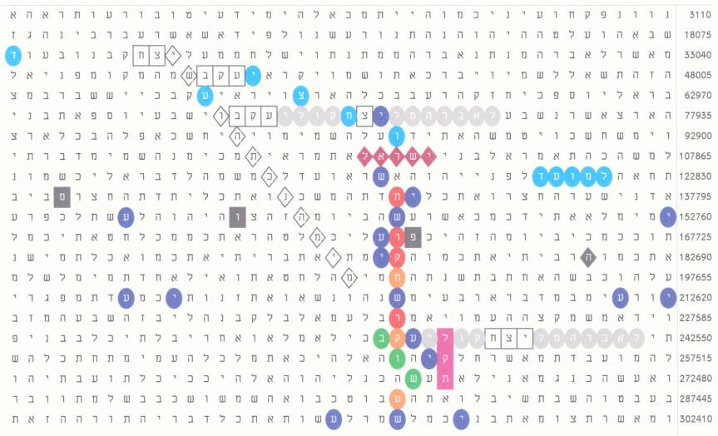
Figure 1.

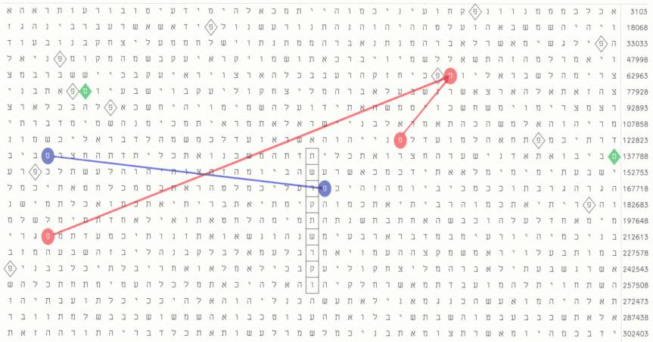
Figure 2.

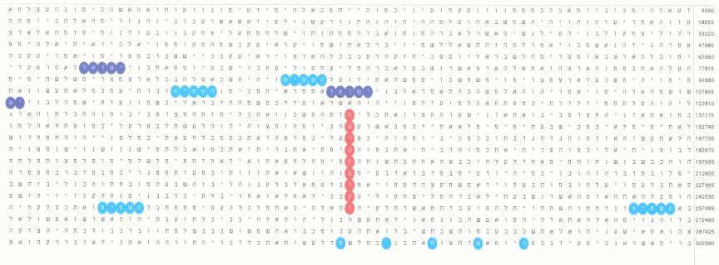
Figure 3.

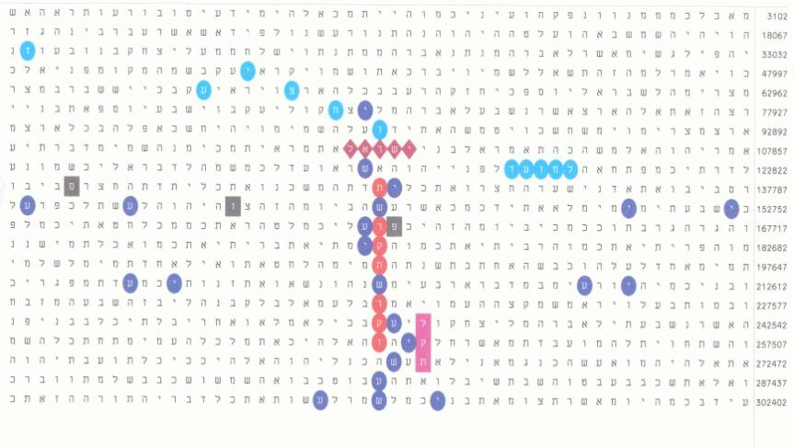
Figure 4.

There are not such pairs of numbers in Hebrew as the Roman IX (9) and XI (11) or XL (40) and LX (60), expressed by the same numerals arrayed in reversed order.
For a comparison, “in AD 1006” (בדתשסו) occurs 44 times in the Torah and only 4 times in Genesis. With gimmel (ג) indicating the fourth millennium, the occurrences for “in AD 6” are even lower: only 13 times in the Torah and none in Genesis.
The opinion of the author is that any encoded information for future events is ambiguous and we cannot get definite knowledge in advance, but can only estimate it on probabilistic basis. See the ambiguity of the word בוש discussed later.
For instance, we cannot avoid this procedure when weighing a mass of 4 or 9 grams if we possess a measuring set of 1, 2, 5 and 10 grams, although we can weigh any (whole number of grams) weight from 1 through 10 g. In such cases, we should put the weight of 1 g on the pan with the mass to be weighed and weigh against 5 or 10 g, respectively.
Even in the matrix with Michael Drosnin’s famous code about the assassination of the Israeli Prime Minister, Yitzhak Rabin, there is salvation (ישע) at skip -3, starting immediately below the last letter of the “manslayer… that slayeth”, chet (ח), or from position 263891 and going to the right. It intersects the name of Mr. Rabin. Mr. Drosnin also claims that events are determined by human actions and are not predetermined. We possess free will and are responsible for all our actions.
התשעב (5772 = 2012), although not with the same significance, also occurs starting 13 columns to the right from the stem at skip -14970 and going upwards to the right.

