Copyright © Lyuben Piperov December 2006
From Genesis to Genetics and Back
Part 2: Words, Flesh and History of the World
Lyuben Piperov
Abstract: More evidence for the analogy between the Word of God and the fundamental structure of all living has been found. The research has been extended to comprise RNA and the proteins. A significant proof has been found that the exact number of the letters in the Torah, 304 805, is unique if expressed in binary digits. A hypothesis has been developed that the Hebrew letters possess dual properties based on their position in the text and their numerical values, analogous to the quantum particle/wave dualism. Plausible evidence has been found that the letters of the Torah act as a quantum computer mapping through codes the real course of history. This has been verified in the link between the names of Aaron and Bulgaria and her long-term historical role for the current situation in the Middle East. Based on experimental data, a new level in the Bible code study is suggested, which is not deterministic but possesses emergent character. Finally, it is shown that the free will of every human is not only allowed but is required for the fulfillment of the Lord’s Plan. An example is given in the Appendix showing through an elementary computational problem the essential difference between classical and quantum computers.
Introduction
Part 1 of this study [1] started with the observation that the number of the letters in the Hebrew alphabet, 22, matches the number of the types of the human non-sex chromosomes. The overall number of chromosomes in a human sex, also called haploid, cell is 23, which matches the constant number characteristic for every alphabet – in our case the Hebrew – when it is used in an encoding method called atbash. Moreover, a surprising similarity was observed between the most famous atbash code in the Bible, that of Babylon-Sheshach in the book of Jeremiah, and the fundamental principle of encoding of DNA in its double helical structure. These facts inclined me to the thought that another well-known encoding principle - that of Gematria - may have been combined by the Creator with atbash for hiding even deeper secrets in His Word. To my surprise, it happened to be so and it appeared that the infamous number of the beast of Revelation, 666, was found to be encoded entirely in the Torah as a specific pattern applying occurrences at skip ±1 and numerical values of the complementary/reciprocal Babel-Sheshach (ששך-בבל) couple. This pattern corresponds exactly, even to such detail as the anti-parallelism of the strands in the double helix, to the pattern of the construction of DNA. Other details such as the links with number six led to the conclusion that what the code of 666 means is that the human flesh is sinful and always rebellious against God. Babylon is the archetype of all human kingdoms, which are to give way to the Kingdom of God, as prophesied in Daniel 2.
It is the right place here to elucidate an issue I rather hinted at in Part 1. I have received many questions and comments on whether finding out the number of the Beast should mean, or be equivalent to, identifying the man of sin, or Antichrist, or whoever human being representing the system inimical to God. Indeed, for centuries researchers have looked for a human being hidden behind this mysterious number. However, they have overlooked the unambiguous statement in Rev. 13:18:
... Let him that hath understanding count the number...
The challenge is to count, or calculate, a number, not to unmask a specific man! But what a challenge this one could be? The number is declared to be 666! How could we count a number already counted? ...
In my opinion, most researchers have been led astray because the ultimate value of the number is already given. For that reason, we cannot apply to this case the process of calculation as we do in our familiar mathematical processing, where we start with initial data and handle them to obtain the result. Here, we are given the result. Therefore, what other could ‘calculation’ mean but finding out a specific pattern for fitting numbers in a manner similar to arranging a jigsaw puzzle? The peculiarity of the 666-puzzle is that we have a framed picture and must pick up unknown number of pieces, out of enormously great number of scattered pieces, matching both each other and the picture in the frame.
We managed to find out ‘pieces’ that match perfectly each other. But isn’t there even deeper significance hidden in the picture and its frame. Isn’t the picture the whole history since the Creation and the frame ... time? It seems a reasonable assumption since the figures we found totalling 666 point to sin and rebelliousness characteristic of the human flesh. It is intertwined with the entire human history, at least since Nimrod. This interdependence could hardly be illustrated better than the huge human statue of the Nebuchadnezzar’s dream. Moreover, it could not require more mysterious revelation than in the basics of life: the double helix of DNA. This is not only indication that we, humans, have obtained the means for solving this problem but also that the Time of the End has come. Indeed, the words (םירבדה) had to be closed up and sealed until the Time of the End (Dan. 12:4, 9).
Having come across the strange but evident link between the structure and composition of DNA on one hand and the pattern of encoding of number 666 in the Torah on the other, I started contemplating on the reason of all this. DNA does not exist for itself. What DNA can make is copying itself within seconds and practically nothing else. The Lord God had designed everything for special purpose expressed in the next stage of His Creation. What are the ‘products’ of DNA in the reality? Proteins. DNA has no purpose without proteins. Proteins are ubiquitous. DNA is invisible in a certain sense. The invisibility is due to the fact that DNA is just a source of information. It is a molecule and the correctness of the information it contains can be determined on molecular level only. Proteins, or rather their functions, are visible on macro scale. Slight differences in proteins can lead to dramatic alterations in an organism, sometimes determining the margin between life and death. Proteins are responsible for carrying out all crucial functions in the organism. In fact, illnesses and ageing are due to changed, deficient, emerging or absent proteins. This is why at first scientists believed that life is a form of existence of proteins alone.
Within about a dozen years after the discovery of the genetic code, scientists established how DNA produces proteins. It is through molecules similar to DNA in composition. The only difference is that instead of thymine, they contain uracil and the sugar is ribose instead of deoxyribose [2].These molecules, which copy the blueprints in DNA and take part in the building up of proteins, are called ribonucleic acids (RNA). In fact, there are about 100 naturally modified nitrogenous bases in RNA, which determine its spatial characteristics. However, we will concentrate our attention on the role of RNA in the coding processes only. This process is so fundamental that it was labelled Central Dogma of Molecular Biology and is striking with its simplicity:
DNA → RNA → Protein
Why they have stamped this scheme with such a typical religious hallmark? No other law of nature has been called “dogma”, though there are many unshakable principles such as the gravitation law. I believe it is because the process of the transformation of the information in DNA into corporeal entities is very similar to issuing of decrees and fulfillment of prophecies. Here we have again words coming into effect through executors. The words in this case are written with a 4-letter alphabet in DNA, and then are ‘translated’ into another alphabet consisting of 4 letters too. This is the alphabet of the executors – the various types of RNA molecules. Three of the letters of the first alphabet are present in the RNA alphabet. The only difference is the fourth letter. This change results in significant dissimilarity of shape and functions between DNA and RNA.
Unlike DNA, whose double helical shape is similar in every living cell, different types of RNA are distinguished physically by shape according to the functions they have to execute. I will not discuss in details the chemistry of these substances. The reader can find them in many sources. However, before going further, let us reflect for a while on the alphabets of DNA and RNA.
Numbers, Letters and Words
The first fact, which impressed me, was that the overall number of the letters in both alphabets is five. This immediately reminded me of the finals in the Hebrew alphabet, whose number is also five. Keeping in mind that such coincidences are not due to the blind chance, I checked for deeper meaning hidden in this number.
The word for ‘man’ in the Bible, ish (שיא), has preserved its spelling in Modern Hebrew. On the other hand, a change in the spelling of ‘woman’ has occurred and today, the spelling in Modern Hebrew, השיא, differs from the spelling in the book of Genesis, השא.
The original spelling of both these words in Genesis provokes interesting conclusions. First, the total number of letters in these words is six. We have already discussed the significance of this number in Part 1. What is more interesting in respect to this study is that the overall number of letters from the Hebrew alphabet used for writing of man and woman is four: aleph (א), hey (ה), yod (י) and shin (ש). This number matches exactly the number of the letters in DNA and RNA alphabets. Interestingly, the two letters that are common for man and woman are aleph and shin. They form the word flame, שא. Flame is a mark of the divine. The Lord God placed flaming sword to keep the way to the tree of life from the man and the woman (Gen. 3:24). The letters that are found once in each name, yod (י) in man and hey (ה) in woman, form the concise Name of the Lord, הי. The Name of the Lord, mostly used in the Bible, YHVH, is a four-letter word, הוהי. However, it needs only one new letter, vav (ו) to be written out. Therefore, (1) the number of the final letters in the Hebrew alphabet, (2) the overall number of the nitrogenous bases - these are the ‘letters’ - in DNA and RNA as well as (3) the number of the types of letters in the three words: YHVH, man and woman, is the same in all three cases: five! Moreover, we have to add five to the numerical value of woman (1 + 300 + 5 = 306) to obtain the numerical value of man (1 + 10 + 300 = 311). This fact seems to be a good additional hint at the significance of Gematria in these studies.
Then I studied the names of the first human couple: Adam (םדא) and Eve (הוח). At first glance, it is apparent that number six is here again: the overall number of the letters in both names as well as the types of the letters is six. The next step was to check the numerical values. The numerical value of Adam is 1 + 4 + 40 = 45. The value of Eve is 8 + 6 + 5 = 19. I was greatly surprised when obtained these figures because the difference between the numerical values is
45 – 19 = 26
26 is the numerical value of הוהי, the Holy Name of the Lord! How much this fact matches the reality! Indeed, the Lord God made the woman from the man. She did not possess a name by the time of her creation. Adam called her Eve = Living after the original sin, when man is become as one of us, to know good and evil… (Gen. 3:22). That is, when human flesh became mortal… Subtraction, the mathematical operation above, is in tune with the Biblical narration. The first woman had been made of a part taken out of the Adam’s body! The formula could not hint in more marvelous way at Him Who had performed this wonderful act! So, there are again three Names: YHVH, Adam and Eve, linked by their numerical values! The next question coming up to my mind was about the sum of the numerical values of Adam and Eve, 45 + 19 = 64. Is there something hidden in it? As we will see soon, there is a significance in this number too – significance pointing to biology…
From Blueprint to Construction
Proteins consist of a limited number of building blocks called alpha amino acids or simply amino acids. Each amino acid has a moiety, which is the same in all of them. This moiety allows them to be combined by strong chemical (so-called covalent) bonds in a manner similar to stringing beads of a necklace. The remaining part of each amino acid differs so that the presence of a particular amino acid in the “necklace” defines the form and the function of the whole string. Although proteins are linear strings of amino acids, once built, they start folding until obtain a specific shape determining their function. In most cases, proteins are complicated - sometimes composed of two or more separate strings - three-dimensional bodies.
The basic mechanism of building up of proteins starting with the information contained in DNA is much sophisticated. Here again, we will ignore specific details and will focus our attention entirely on the steps involved in the processes of encoding/decoding. The first stage is transferring the information contained in DNA to an RNA molecule called messenger RNA (mRNA). mRNA is the image of a specific protein! It copies and at the same time translates the information in DNA into a new four-letter ‘script’. The method of copying is based on the same atbash encoding principle discussed in Part 1. In this process, thymine (T) from DNA converts to adenine (A) in RNA, but A converts to uracil (U) instead of T. Guanine (G) converts to cytosine (C) and vice versa, exactly as in the reproduction of DNA. This process is actually unsealing of information sealed in DNA.
Unlike DNA, RNA is single-stranded. This is because it is not intended to reproduce but to take part in the construction of proteins. In addition, RNA is not as stable as DNA. It easily degrades in the cell environment. This characteristic is important for the control of the synthesis of proteins. Just imagine what would happen if RNA is indestructible to the extent DNA is: Proteins are synthesized in accordance with the needs of the cell. Suppose the latter has produced enough quantity of certain protein and needs to switch over to production of another one. The resources – the amino acids – are spread as solutes around the sites of production, which utilize the compounds available. Even if the cell had built “plants” for each specific protein, which would be unprofitable because the number of the proteins is extremely large, each “plant” would compete for the resources of amino acids. The mRNA would continue producing, like a tiny idiot, protein that is needed no more. Therefore, the only way to stop it from doing this is … destruction. I gave this example to show how destruction can be useful for the control of the events that are part of a greater plan, whose significance cannot be estimated on lower levels. There is even deeper meaning in it. What happens in fact is turning mRNA into a protein! The mortal ‘image’ mRNA of the immortal DNA dies producing living structure. The seed dies yielding crop…
Like DNA and RNA, this real object is a linear string of amino acids. There are no side chains. The information encoded by the four-letter DNA alphabet transforms into the other four-letter RNA alphabet and then materializes in the string of amino acids unique for each particular protein. The mRNA is the blueprint, while another type of RNA called transfer RNA (tRNA), picks up a specific amino acid and “transfers” it to the site of protein building. There are as many types of tRNA as many are the amino acids. While mRNA specifies the sequence of the amino acids in the protein, tRNA provides the particular amino acid required for the precise location. We will outline the process stressing on its encoding facet.
After intense experimental work and applying great ideas, scientists established that each amino acid is encoded with three nitrogenous bases (nucleotides) in DNA. This code turns into another 3-nucleotide, that is three-letter code, in mRNA called codon. This codon binds with its counterpart in the tRNA, anticodon, in a way identical to the binding between the complementary bases from each strand of the double helix of DNA.
The codon specifies the letter of the new alphabet, that of the proteins. The sequence of the codons in mRNA is the spelling of the protein. The anticodon fixes the respective amino acid in the following way. The tRNA has two specific sites: the anticodon and the end that attaches the particular amino acid. In short, tRNA is e vehicle: it brings the right letter to the right place.
Figure 1 presents an example of a tRNA. It is one of the two tRNAs for phenylalanine. In this particular example, the codon in the mRNA is UUC (green, in the bottom). Note that the order of these letters is reversed in the picture! This is because the direction of the reading, as with DNA (see Part 1), is from the 5'- to the 3'-end. In the figure, the 5'-end of both mRNA and tRNA is in the right. The dots represent the nucleotides (base + sugar ribose + phosphate) forming tRNA. Black dots signify the non-specific part of the molecule. It is similar in the tRNAs for all amino acids. Note the peculiar, typical clover-like shape. The red dots near the 5'-end specify which particular amino acid will be attached to this end.
The codon (UUC) and the anticodon (AAG) are complementary, as discussed earlier and fix by the same hydrogen bonds as the bases in DNA. These bonds are among the weakest known intermolecular attraction forces and are very practical for the specific purpose of ensuring close proximity of the amino acid to the site of addition and then giving way to the next carrier as soon as possible.
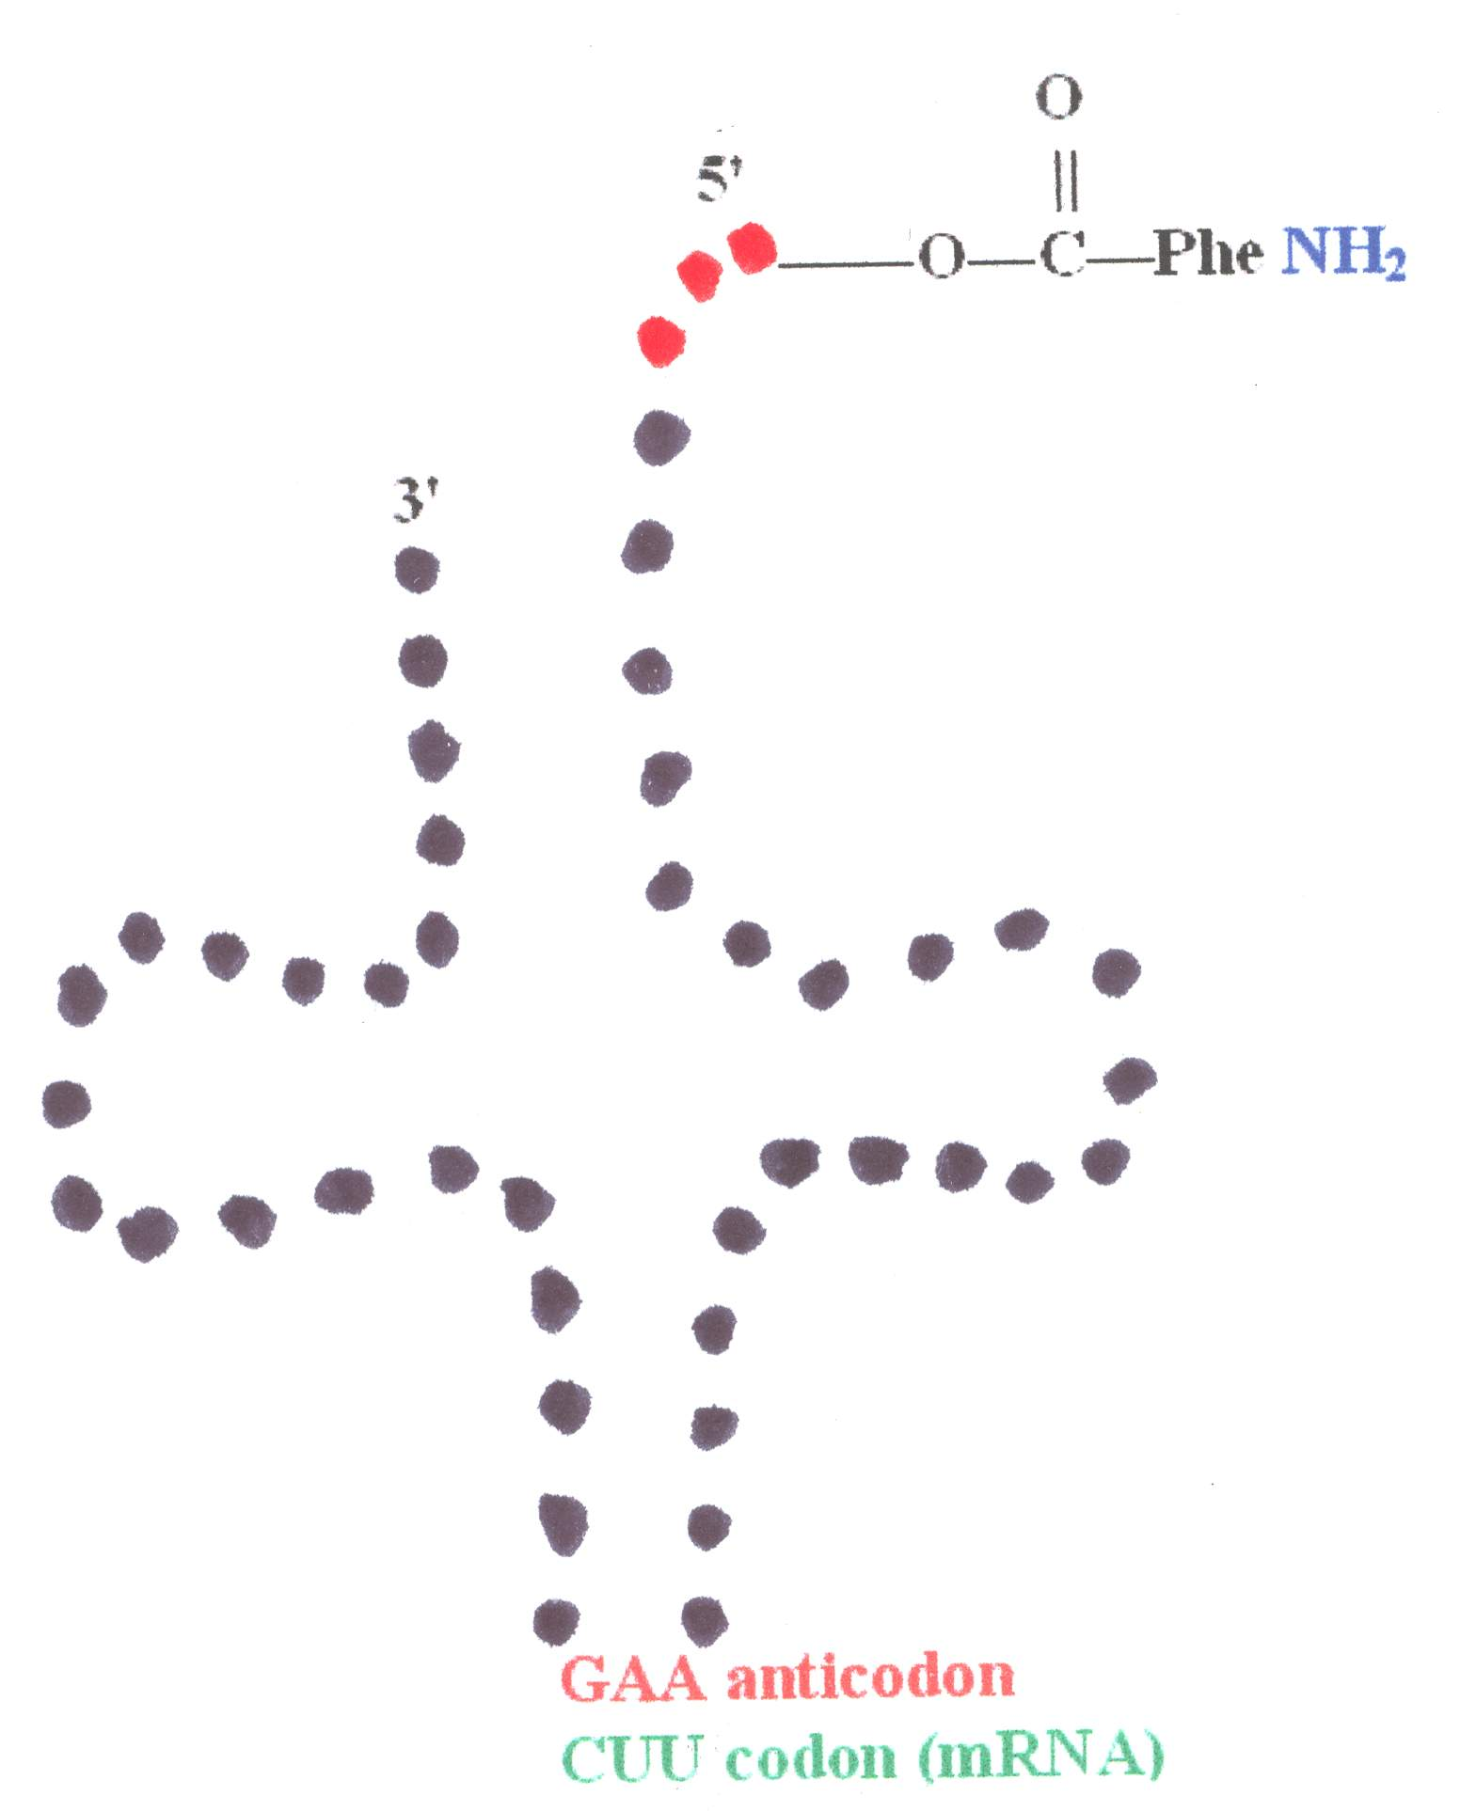
Figure 1. The typical structure of transfer RNA (tRNA).
This universal three-letter code reminded me of a specific feature of the written Hebrew as well as the majority of the Semitic languages: the law of the triliteral stem. It states that all words are or derive from a three-letter root [3]. Could this law ensure the richness of Hebrew language? Yes, because the number of possible three-letter words increases dramatically with the number of the letters in the alphabet. For instance, a two-letter alphabet consisting of, say, A and B, generates eight three-letter words:
AAA | BBB
AAB | BBA
ABA | BAB
ABB | BAA
The reader can easily find that a three-letter alphabet, say, A B C, generates 27 three-letter words. The general formula for the maximum number of three-letter words, N, generated in any alphabet of L letters is
N = L³
Therefore, the maximum number of three-letter words generated by the four-letter alphabets of DNA and RNA is 4³ = 64. Now let us recall that 64 is the sum of the numerical values of Adam and Eve! This link between names and flesh made me check the effectiveness of the Hebrew alphabet. The maximum possible number of three-letter roots written in the 22-letter Hebrew alphabet is
22³ = 10 648
In the Strong’s Concordance, which contains all Hebrew roots used in the Old Testament, there are 8 674 words [3]. Not all of them are three-letter words, of course, but about two thirds of them (~ 5 500 to 6 000) are. Therefore, an alphabet of 18 letters (18³ = 5 832) may be insufficient to generate them, but 19 letters (19³ = 6 859) most probably will be enough. This fact bespeaks of the high effectiveness of the Hebrew alphabet – it consists of few letters more than the minimum required to ensure that each root of Hebrew language has its own three-letter code!
I have reviewed practically all phonetic alphabets. It is believed that all they derive from the 22-letter Phoenician alphabet, which in its turn derives from the Egyptian hieroglyphs [4-8].The alphabets derived from the Hebrew such as Greek, many Latin and Cyrillic alphabets as well as Coptic, Gothic, Armenian and Georgian scripts had been designed to match the phonetic requirements of the respective languages. I noticed that each “newborn” alphabet had more letters than the “mother” one.
An interesting example is the Cyrillic alphabets in use today. The original Cyrillic alphabet was designed in the 9th century AD based on the specific Bulgarian speech. Contemporary Bulgarian alphabet has 30 letters. These are more than the letters in Greek and Hebrew alphabets, from which it was derived, as well as in basic Latin. However, being designed especially for Bulgarian language, I expected that Bulgarian alphabet would contain the lowest number of letters compared with all other languages using Cyrillic alphabet. I checked the number of letters in all alphabets given in [6] plus Mongolian. None of them has less than 30 letters. Among the seven Slavic languages, Bulgarian and Serbian only use 30 letters (~30%). Among the non-Slavic languages, two out of twelve alphabets use 30 letters (~17%). The highest number of letters in a Slavic Cyrillic alphabet turned out to be 37 (Russian and Ukrainian alphabets use 33 letters each), while with the non-Slavic ones it is 58. In my opinion, this is a good confirmation that the general scheme for derivation of different alphabets:
Hebrew (22) → Greek (24) → Bulgarian Cyrillic (30)
↓
Basic Latin (26)
reflects also the route of derivation within the development and “branching” of the same alphabet when borrowed by languages for which it had not been intended originally. The general rule is that every new alphabet always adds and almost never discards letters from the parent alphabet. In rare cases, a letter is modified or replaced with another one.
However, the foundation of the Egyptian hieroglyphic script consisted of 24 uniliterals. (A uniliteral is a symbol that stays for a single consonant). The earliest known Phoenician alphabet, which is considered as the progenitor of Hebrew alphabet, consists of 22 letters. Such reduction of a new alphabet derived from earlier script has not been observed with any other alphabet. How, and what is more important, why, these 24 base signs were reduced to the 22 primary signs of the Hebrew script is an enigma whose solution, in my opinion, should be tried beyond pure linguistic analysis. It seems that number 22 had become a sacred number for letters in a script at the time of the origin of phonetic alphabets.
Once Hebrew alphabet has 22 letters, the immediate reasonable question would be: Is the protein chain similar to a text written in certain script? Then, is the protein alphabet similar to a phonetic alphabet in respect of number of letters? If “yes”, to which of the considered alphabets it is closest?
How Many Alpha Amino Acids are There in the Protein Alphabet?
As early as my first acquaintance with the Hebrew alphabet – about a decade ago - I noticed that the number of the alpha amino acids building up proteins cited in the books, 20, is close to the number of the letters in the Hebrew alphabet: 22. The latter number appeared to be the closest to 20 when compared with any other phonetic alphabet I knew. As we saw, all the other alphabets have more than 22 letters.
Between 1838, when the Swedish chemist Jöns Berzelius described the proteins chemically, and 1935, twenty amino acids had been discovered altogether to build the proteins of every living creature on the planet Earth. This number was believed to be settled once for all for two or three generations of biochemists. By the time the genetic code was clarified, in the 1960’s, there were still 20 amino acids known to be encoded. The establishment of the way the code works is among the highest achievements of the human intellect. What amazed the scientists was that the code is universal! Every amino acid is encoded in the same way from viruses and bacteria through plants and animals to humans. No exception of this rule has been observed! The table shown below was thought to be conclusive for about 20 years…
 | U |  | C |  | A |  | G
U | UUU | Phe | UCU | Ser | UAU | Tyr | UGU | Cys
U | UUC | Phe | UCC | Ser | UAC | Tyr | UGC | Cys
U | UUA | Leu | UCA | Ser | UAA | Ochre | UGA | Umber
U | UUG | Leu | UCG | Ser | UAG | Amber | UGG | Trp
C | CUU | Leu | CCU | Pro | CAU | His | CGU | Arg
C | CUC | Leu | CCC | Pro | CAC | His | CGC | Arg
C | CUA | Leu | CCA | Pro | CAA | Gln | CGA | Arg
C | CUG | Leu | CCG | Pro | CAG | Gln | CGG | Arg
A | AUU | Ile | ACU | Thr | AAU | Asn | AGU | Ser
A | AUC | Ile | ACC | Thr | AAC | Asn | AGC | Ser
A | AUA | Ile | ACA | Thr | AAA | Lys | AGA | Arg
A | AUG | Met | ACG | Thr | AAG | Lys | AGG | Arg
G | GUU | Val | GCU | Ala | GAU | Asp | GGU | Gly
G | GUC | Val | GCC | Ala | GAC | Asp | GGC | Gly
G | GUA | Val | GCA | Ala | GAA | Glu | GGA | Gly
G | GUG | Val | GCG | Ala | GAG | Glu | GGG | Gly
This is the genetic vocabulary. The three-letter codes written in capital characters are all 64 codons. The bold characters in the left indicate the first letter/nucleotide in all codons in the respective row, while the same characters above the table indicate the second letter in the respective column. Each α-amino acid has also a three-letter code such as Phe for phenylalanine, Ser for serine etc. The encoded α-amino acid is to the right of each codon. Notice that the third letter, printed in bold character, is of less significance for the encoding of an amino acid compared to the first two letters. It is variable for many α-amino acids.
The three 3-nucleotide sets printed in bold coloured characters and having the exotic names have the function of ending the amino acid chain formation. (Sometimes they are called “nonsense” codons.)
The maximum theoretical number of encoded amino acids is 63. (We have to leave at least one three-letter code for the stop-codon.) There are only two amino acids encoded by a single codon: methionine (Met) encoded by AUG and tryptophan (Trp) encoded by UGG. All other amino acids are coded for by more than one codon: most of them by two codons and two amino acids are coded for by six codons.
Why there are 61 codons for only 20 amino acids? It is clear from the table above, that most of the codes allow for errors; in many cases, the third nucleotide is of no importance for the encoding of a particular amino acid. For instance, GUX, where X is any of the four letters, encodes valine; CCX encodes proline, etc. Therefore, a random error in the code would not cause fatal changes in the protein.
It was in the early 1980-s when, surprisingly, a new, rare amino acid was identified, which contains the microelement selenium. The new, 21st member of the genetically encoded α-amino acids’ collection was called selenocysteine. It is encoded for by the codon UGA (coloured in red, for umber, in the table above) [9]. Then, in May 2002, another α-amino acid was reported to have been discovered. It was found in an enzyme called methanogen methyltransferase and is generated by the methane-producing microbe called Methanosarcina barkeri. The α-amino acid is called pyrrolysine and is genetically encoded by the codon UAG (coloured in amber in the table above) [10].
Is this number, 22, the ultimate number of genetically encoded alpha amino acids? The three coloured codons in the table are normally stop codons. The last two amino acids found to be genetically encoded by two of these codons are rare and, in addition, they require some specific modifications of mRNA so that certain codons may switch from their normal function to the expression of the respective amino acid. [11] These discoveries reveal that a codon can function either as a specific code for an alpha amino acid or as a stop codon. However, no instance has been observed so far of a codon encoding two or more amino acids. If this principle is preserved, there could be only one more genetically encoded amino acid – still not observed and encoded by the last coloured stop-codon, ochre. Therefore, the maximum possible number of genetically encoded amino acids is 23. A 24th amino acid found to be encoded by a codon which encodes another one, would destroy the universality of the code. There is of course, a way to escape from this catch. As we saw, the expression of the last two amino acids requires some modification of mRNA. Could another modification make these same coloured codons express other amino acids? Nobody knows. Some scientists believe that this could happen and there may be more amino acids in the genetic alphabet…
Nevertheless, the 22nd amino acid was discovered recently. It is this fact that made me start this study. Were the number of the genetically encoded alpha amino acids different from 22, I would never put pen to paper…
Clusters of Letters, Clusters of Molecules
The core principle of the Bible code so far has been clustering of letters that are far from each other in the plain text in a close area. These letters must form a word or even a longer expression. The more and the longer are the items and the smaller is the area of the matrix the more significant is the code. There is a single rule that must be observed: the letters forming each item should be at equal distances in the plain text. This is the ELS (equidistant letter sequence) or skip. It is embedded in the computer programs searching items specified by the researcher.
As a pharmacist, I am well acquainted with the structures and the functions of the most important bio-molecules. I have noticed that the Bible code matrices are very similar to the picture of the distribution of active sites of some large polymeric molecules. This is especially valid for one of the two main types of proteins – globular proteins. [12] Globular proteins are soluble in water. Their proper function is vital for the organism. Globular proteins are all enzymes, many hormones and transporters. Globular protein is the well-known oxygen-carrier hemoglobin whose importance does not need emphasis. [13]
The basic rule, which is valid for a Bible code, is valid for the function of the globular proteins too: change, drop out or add a letter and the code/function is ruined. For example, sickle-cell anemia is caused by the replacing of one of the “letters”, glutamate, with another one, valine, in the 146-letter long text of the β-chain of hemoglobin…
A hazy idea of similarity and even analogism between the Tanakh, especially the Torah, and a globular protein started taking shape in my mind. The number of the letters in the Hebrew alphabet matches the number of genetically encoded alpha amino acids. In addition, the three-letter code is typical for both languages. Is there a distinctive feature of the proteins, which matches a similar characteristic of Hebrew texts?
The α-amino acids in the protein chain tend to form helices called alpha-helices [14]."Alpha" means that if we look down the length of the spring, the coiling is happening in a clockwise direction as it goes away from us. Under favourable conditions, these helices may be many residues long, which looked at from outside resemble tubes. These tubes bend in the space and form the so-called secondary structure of the protein. The α-helices are well-determined structures. Each complete turn of the helix has about 3.6 amino acids. But the characteristic frequency of three-letter words in the Hebrew language should mean that the average number of letters per word is relatively close to 3.6.
I checked the number of letters per word for the whole Tanakh. It appeared to be slightly below 4: 3.9; for the Torah alone, it is even lower: 3.81. Then I tried the Tanakh book by book, combining some of them in groups such as 1Samuel – 2 Kings, 1and 2Chronicles and the 12 “minor” prophets. The book with the lowest number of letters per word in the Torah is Leviticus: 3.74. However, the book in the Tanakh giving the lowest number appeared to be Ecclesiastes: 3.67! It practically matches the number of amino acid residues in a full turn of a protein α-helix! I wonder if there could be found a reasonably long text of Modern Hebrew (unless deliberately modified or created), which matches this number.
The finding that the number of letters per word in a whole book of the Tanakh matches a specific parameter of proteins conclusively assured me that there is a deeper relation between Word (information) and flesh (physical world; the Universe). Therefore, I started looking for suitable protein(s), which can be good model(s) for searching of analogies.
Most appropriate would be proteins with residues defined for specific function. Hemoglobin is not suitable for this purpose because the error causing sickle cell disease is due to a slight change in the overall behaviour of the molecule. It is not specific and could be likened to a mistake in a text, which changes the meaning of a word such as with protein and protean…
For the purpose of code breaking, more interesting appear to be enzymes. As with every other protein, the exact amino acid in each position in the chain is of invaluable importance. However, enzymes have something in addition. Their function is catching one or more molecules and fixing them in the space for a certain time, which must be enough for a chemical reaction to be carried out. Then they loose the product(s) and catch the next one(s). They do this either by means of a prosthetic group (it is not a part of the protein proper but a moiety which is fixed constantly to it to ensure its function [15]) or by a so-called active site. It is a specific spatial arrangement of the protein chain, which ensures specific amino acid residues in specific locations. These residues act as “hooks” and “pistons”.
Vital for facilitating of the three-dimensional stability of the protein are the so-called disulphide bridges [16]. Only one amino acid can form such bond. It is cysteine, which forms a disulphide bridge with another cysteine residue along the chain. It is a covalent bond and the protein chain, or tube, is like fastened with a dowel in the places where such bond is built up. Usually, there are about 4 to 6 such bridges in a typically long protein chain (~120 – 250 residues). [17]
It would be too naïve to expect that the residues forming an active site are distributed evenly (i.e., at equal intervals or skips). However, they may serve as a good analogue to the other main characteristic of the Bible code: clustering.
I had to choose a suitable protein for this purpose. It had to have well-established α-amino acid sequence and the residues forming the active site. I choose the enzyme lysozyme as a good model for verification of our ideas. It is an enzyme killing bacteria and is found in tears, saliva and even chicken egg white [18]. It consists of 129 amino acid residues and has four disulphide bridges shown in four different colours in Figure 2.

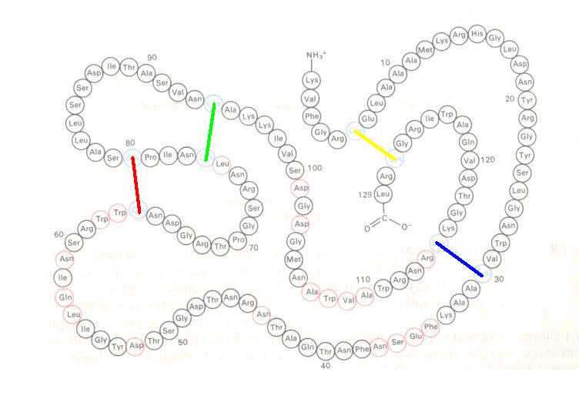
Figure 2. Lysozyme from white of hen egg [18]. The coloured lines show the location of disulphide bridges. The active site determining residues - circles coloured in red - are 19, located irregularly between the 34th and the 114th place.
Looking at the picture, I contemplated on what to do next. The simplest reasonable idea was to mark the active site defining residues and to arrange the whole protein formula in the manner a text is arranged for searching for codes. The question was: what will be the skip? The most apparent choice seemed to be the lowest number of residues between the two ends of a disulphide bridge – that coloured in red – 16. The picture I obtained is shown in Figure 3.

1 | 2 | 3 | 4 | 5 | Y | 7 | 8 | 9 | 10 | 11 | 12 | 13 | 14 | 15 | 16
17 | 18 | 19 | 20 | 21 | 22 | 23 | 24 | 25 | 26 | 27 | 28 | 29 | B | 31 | 32
33 |  |  |  |  | 38 | 39 | 40 | 41 | 42 | 43 |  | 45 | 46 | 47 | 48
49 | 50 | 51 |  | 53 | 54 | 55 |  |  | 58 |  | 60 | 61 |  |  | R
65 | 66 | 67 | 68 | 69 | 70 | 71 | 72 | 73 | 74 |  | G | 77 | 78 | 79 | R
81 | 82 | 83 | 84 | 85 | 86 | 87 | 88 | 89 | 90 | 91 | 92 | 93 | G | 95 | 96
97 | 98 | 99 | 100 |  | 102 |  | 104 | 105 | 106 |  |  |  |  | 111 | 112
113 |  | B | 116 | 117 | 118 | 119 | 120 | 121 | 122 | 123 | 124 | 125 | 126 | Y | 128
Figure 3. Lysozyme residues arranged at skip 16. The coloured capital letters are the respective ends of the disulphide bridges. Shadowed cells are the active-centre-defining amino acid residues.
I was surprised! Clustering is evident and it revealed itself at first attempt! Nine out of nineteen “active” residues – almost the half - are concentrated in less than 20% of the total area, in a 5×5 square bordered with thicker line. It also includes both ends of the G-G disulphide bridge. In addition, four out of the six remaining bridge residues are adjacent to the border of the area. Only a B and a Y residue are “scattered” away from the area. There is also the only occurrence of a column (11th) containing “active letters” from three different rows.
The next step was to check if a better picture would occur with another skip. The next reasonable skip is that of the G-G bridge, 18. The result is shown in Figure 4.
1 | 2 | 3 | 4 | 5 | Y | 7 | 8 | 9 | 10 | 11 | 12 | 13 | 14 | 15 | 16 | 17 | 18
19 | 20 | 21 | 22 | 23 | 24 | 25 | 26 | 27 | 28 | 29 | B | 31 | 32 | 33
 | 38 | 39 | 40 | 41 | 42 | 43 |  | 45 | 46 | 47 | 48 | 49 | 50 | 51 |  | 53 | 54
55 |  |  | 58 |  | 60 | 61 |  |  | R | 65 | 66 | 67 | 68 | 69 | 70 | 71 | 72
73 | 74 |  | G | 77 | 78 | 79 | R | 81 | 82 | 83 | 84 | 85 | 86 | 87 | 88 | 89 | 90
91 | 92 | 93 | G | 95 | 96 | 97 | 98 | 99 | 100 |  | 102 |  | 104 | 105 | 106
 |  | 111 | 112 | 113 |  | B | 116 | 117 | 118 | 119 | 120 | 121 | 122 | 123 | 124 | 125 | 126
Y | 128 | 129
Figure 4. Lysozyme residues arranged at skip 18.
Here, the 5×5 area is divided due to the peculiarity of the arrangement. However, it is evident that although the area is a little bit denser with active residues, ten, it does not include a disulphide bridge - the G-G bridge is adjacent to - and only one more cysteine residue, Y, “stuck” on the border. Moreover, this time the area of maximum density does not contain a column with active residues from three different rows. (A one-column extension to the left would add two active residues making them 12 altogether. Although the same operation with skip 16 would not add active residues, if performed to the right, the resulting 6×5 area would include two disulphide bridges vs. no one with skip 18.) There is also a strange similarity between the two “matrices”. In both cases, the disulphide bridge defining the skip is adjacent to the middle of the right border of the densest area.
Taking into account all parameters, I am inclined to think that the “matrix” obtained with the lower skip bears more significance. Thus, a very important requirement of the Bible code principles complies with it: higher significance obtained with a lower skip.
Trying with another “disulphide” skip is useless because the next one is… 85. Therefore, I tried with skips lower than 16. I observed nothing significant except at skip 13, where there was a column containing active residues from 5 rows. Then, at skip 12, the picture was astonishing! It is shown in Figure 5.
It is full of symmetries! Diagonals are marked with bold characters. The central vertical and horizontal lines are bold. Disulphide ends are located symmetrically both in relation to the vertical and the horizontal axes (with the exception of G-G, which are slightly off horizontal symmetry). They are symmetrical also in respect to both diagonals.
The active site defining amino acid residues also distribute symmetrically in relation to the same basic lines. Nine of them are to the left of the vertical axis and ten are to the right of it. Eleven are above the horizontal axis and eight are below it. (Notice that in both cases the lower number is in the area with less “letters”.) If we account for the halves cut by diagonals, there are 9 active residues to the upper left of the 12-122 diagonal and 10 to the down right of it. With the other diagonal, the ratio is also 9 to 10.
1 | 2 | 3 | 4 | 5 | Y | 7 | 8 | 9 | 10 | 11 | 12
13 | 14 | 15 | 16 | 17 | 18 | 19 | 20 | 21 | 22 | 23 | 24
25 | 26 | 27 | 28 | 29 | B | 31 | 32 | 33
 | 38 | 39 | 40 | 41 | 42 | 43 |  | 45 | 46 | 47 | 48
49 | 50 | 51 |  | 53 | 54 | 55 |  |  | 58 |  | 60
61 |  |  | R | 65 | 66 | 67 | 68 | 69 | 70 | 71 | 72
73 | 74 |  | G | 77 | 78 | 79 | R | 81 | 82 | 83 | 84
85 | 86 | 87 | 88 | 89 | 90 | 91 | 92 | 93 | G | 95 | 96
97 | 98 | 99 | 100 |  | 102 |  | 104 | 105 | 106
 |  | 111 | 112 | 113 |  | B | 116 | 117 | 118 | 119 | 120
121 | 122 | 123 | 124 | 125 | 126 | Y | 128 | 129
Figure 5. Symmetry found with lysozyme at skip 12.
The active residues distribute symmetrically also within the triangles defined by the half-diagonals and the sides of the matrix. There are seven of them in the left triangle and seven in the right one. There are two of them in the upper triangle and three in the bottom one. (The residues cannot distribute ideally because their number is odd.) R- R and G-G are positioned symmetrically into the left and the right triangles, while B- B and Y- Y are distributed in the same manner in the upper and bottom triangles.
What does this symmetry mean? It reminded me of x-ray diffraction patterns. They disclose the structure of the molecules. Images obtained consist of darker (usually dots) and lighter areas. This difference is due to the different contribution of each particle in scattering the incident beam to various directions. Dots indicate the positions of the tiny mirrors within a crystal as in Figure 6.
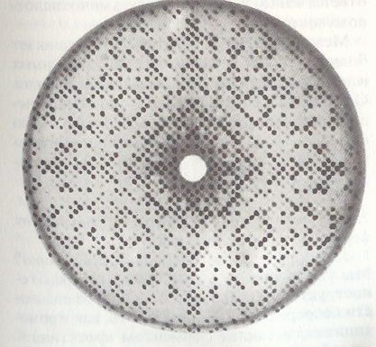
Figure 6. X-ray diagram of lysozyme crystal [19]
Notice the similarity between the two pictures above! Both contain pronounced cruciform symmetry. Often, especially close to the centre, dots on Figure 6 form squares. The letters in the matrix of Figure 5 also form a rectangle, which is close to a square. (The skip arranging the amino acids closest to a square is 11, but at this skip, the symmetry is not as clearly seen as with skip 12.) There are other techniques for taking x-ray diagrams. The cruciform may not be observable with them. However, the key aspect is that the x-ray diagram is a two-dimensional image of a three-dimensional object reflecting the spatial characteristics of the latter. Under certain conditions, the picture obtained shows specific cruciform characteristics obtained with a matrix analogous to the Bible code matrices.
There is something deeper in this. Suppose we know that at certain skip of the amino acid chain of a given protein, there is cruciform symmetry. Now if we have got the information about a part of the active centre building residues, we can predict with a probability exceeding the blind chance whether a certain residue is active forming residue or not. This is valid also for the disulphide ends and even for the non-active amino acids! For instance, if we know that the overall number of the active site forming residues is 19 and that 7 of them is in the left triangle, we will expect that more than 19/129, or about 15%, of the residues in the right triangle will be active centre forming ones. This reasoning is in the basis of the evaluation of Bible code matrices too! The only difference is that usually, symmetry there does not play such important role as distance. (I was lucky to find highly significant symmetrical occurrences of the three-letter word ישע (salvation) in the 2006 matrix [20]).
This analogy necessitates a very important consequence. Proteins are three-dimensional bodies. This suggests the notion that Bible codes are inherently three-dimensional. Both the Word and proteins are one-dimensional strings of 22 letters. Which factor raises the Bible codes and the proteins to three-dimensional level? I think this is the contribution of the non-active elements in both cases. They are not blind machines spitting out randomly active elements. These “inactive” members of the string have their own structure. With Bible codes, they are the letters of the plain, meaningful text. With proteins, these are the amino acid residues, which determine the spatial structure of the molecule. This is clear and easily understandable with proteins because they are physical bodies. We have the good example with mutations causing grave diseases such as sickle cell anemia.
On the other hand, this is not so much clear with the Bible code. Indeed, a substitution of a letter in the plain text, which is not encoded-term defining, would not change the code. So far, Bible code matrices deal with encoded terms and a single letter changed in the plain text in most cases is of no consequence. Even though the plain text in the most significant codes refers to the terms of the matrices, in many cases a letter in the plain text could be substituted with a suitable one so that the code and the general meaning of the plain text will remain unimpaired. Although there are differences in amino acid sequences in living organisms including humans, which are not fatal, the issue of the significance of particular letter for a code is unsolved.
Here is a hypothetical example to clarify my idea. Suppose we have a narration about someone and find significant encoded terms intersecting his name at certain letter. Let this man be Samuel שמואל. Let the intersection(s) occur(s) at one or both first two letters coloured in red. Now let us change his name in the plain text with Samson שמשון. We see that the length of both names is the same; therefore, the encoded terms and their intersections will remain untouched. In principle, this procedure is valid also for other words.
I must emphasize that I do not question the validity of the Bible! With this, deliberately naïve example I want to illustrate the significance of the letters, which do not take part directly in forming encoded items. In terms of ELS-obtained matrices, changes in these words or some parts of them in the plain text do not affect the particular code expressed in the matrix. Most Bible code researchers would say that certainly the importance of the plain text that is “missed out” with one matrix would be revealed with another one. I also believe that there are many ELS matrices, maybe practically infinitely many, containing significant encoded terms, which “scan” the plain text of the Word of God. Maybe there exist at least one encoded term linking every two letters in the plain text of the Torah or the whole Tanach However, I believe that we must look for another level of encoding for the following reason.
So far, we have observed a number of similarities between the clustering typical for significant Bible code matrices and the alpha amino acid residues of a protein when the sequence is arranged in the same way. We have observed the occurrence of symmetry with a protein matrix. Basically, symmetry is not considered as a requirement for a the evaluation of a Bible code matrix, although if present, it may add some significance. However, the most important conclusion of these similarities is the deterministic character common for both phenomena. We will make a short discourse in this very important subject.
Determinism and Free Will
Indeed, as with the proteins, where mutations sometimes predetermine the destiny of the individuals, the significance of a single letter in a Bible code is beyond discussion. There are diseases, which stagger with the accuracy of predicting the development of the affliction up to the time of death. Matt Ridley describes several diseases of this type in his book Genome: An Autobiography of a Species in 23 Chapters [21].
Most atheists and enemies of God use the idea of predetermined destinies as an argument against His existence or even worse, as a “proof” of His cruelty and indifference to the human race. Many believers as well reject the Bible codes on the same basis. They see in them a danger of diminishing of the importance of the personal will. Although, in my opinion, this is implicit in every prophecy – once it is prophesied that someone will betray the Messiah, a person must be born for this purpose, regardless of whether his name is or is not known – encoded names, dates and places of important events make many people feel doomed and fatalistic. “If it is certain that this will happen, what can we do then?” is the philosophy of these believers.
To avoid these philosophical difficulties, some authors such as Michael Drosnin and most of the Bible code researchers postulate the essential probabilistic nature of the codes. The core of their idea is that the Hebrew Bible contains a number of encoded events – predominantly calamities caused by men – which are going to happen with certain calculable probability. Having found such a code, we must take the measures within the frame of our capabilities to prevent them.
What confuses me with this philosophy is that our actions in such cases do not differ from divination. It is like looking in a crystal ball. We look in the Bible what will happen, then rush out to prevent it. Where is the logic? Don’t we try to “correct” God? What is His will – to happen or not happen the particular event? What do we do in our daily activities when, say, we are going to a trip driving our car? We know that statistically, there happen accidents. That is why we pay insurances. But what we, as believers must do is to maintain our cars properly, not use specific drugs or alcoholic beverages, have a good refreshing sleep before the start, observe the rules on the road and pray. Because everything is in the hands of the Lord. Therefore, in this aspect, the Bible codes are useless.
For a long time, the mass media have taught us that the cause for the troubles in the world are a handful of insane leaders such as Hitler, Stalin and a number of others and their cliques. The peoples are innocent. The man in the street is friendly and what makes him sinful is the bad influence of the corrupted politicians. Nurture has been regarded as more important than nature since Darwin. However, the current crisis in the Middle East has shattered these beliefs. It proves that history has been determined in much more complex way than we had been inclined to accept. What we see now is a result of unconscious, irrational incentives of vast masses of humans.
I think that the deterministic character of the materialistic science still exercising power in most modern sciences has determined this concept of the human mind. This notion crept out from physics into all other spheres of knowledge. From the movement of the planets around the Sun to the processes in our brains, every single step must have a specific, well-defined cause. The approach in every field of science has been entering deeper into the lower levels and finding out the mechanisms driving the particles in the specific ways. This method is called reductionism. The essence of it is that we will discover the truth about how everything in the Universe works by taking it to pieces and studying how they interact. This method has been applied practically everywhere – from physics and chemistry to social and political sciences. Thus, behind the riot of a violent mob must have been a politically and morally wrong enactment. Something wrong imposed from above must have provoked the righteous anger of the people… Well, there is the tiny problem about what makes the brains of those above work incorrectly but liberal sociologists do not bother asking such questions…
Reductionism has proved to be useful when we have to understand how our clocks, washing machines, cars, radio and TV sets, airplanes or computers work but it has proved to have many flaws and now we know that most phenomena cannot be understood through reduction to their elementary parts. To get better understanding, we must look at the phenomenon from above, as a whole. This method, opposite to reductionism is called holism. I do recommend to those readers who are interested in better understanding of reductionism and holism Douglas Hofstadter’s Gödel, Escher, Bach: An Eternal Golden Braid [22].
Reductionism is closely associated with determinism. This is because having disassembled a mechanism down to its elementary parts we see how each one of them works. The essential notion is that each part would work in the same way independently of the other parts. Without this notion in mind, we could not construct the mechanism! First, we design the parts defining their parameters and then put them together assuming that they will behave according to our preliminary calculations. This is valid for everything we do – from mousetraps through nuclear power stations and space shuttles to surgical interventions and pace makers. Moreover, due to this predictability judges and jurors are able to take reasonable decisions in trials.
The approach applied for understanding the role of a changed amino acid in a protein is primarily reductionistic. In the wrong hemoglobin causing sickle cell anemia, there is the more hydrophobic valine instead of the more hydrophilic glutamate. This affects the whole molecule and it remains twisted after coming out of the vesicles because the water molecules cannot penetrate within a part of the hemoglobin and “inflate” it properly as they do with the normal, slightly more hydrophilic molecule. This change in the behaviour is calculable. Were the change made with a less hydrophobic amino acid, the consequence would not be so grave. Thus, we can understand why some variances of proteins are harmless. The one or more differences in amino acid residues in healthy people mean that the changes have happened with amino acids of similar chemical and physical properties as of the replaced ones.
Is the approach applied to understanding Bible codes reductionistic? I think that such approach is inevitable if we believe that God had acted as we would act – constructing the codes letter by letter calculating each letter’s position in the plain text. We find these codes using our classical, deterministic computers; therefore, we conclude that the Encoder should have used the same classical, deterministic computation to set them in His Word. But is this the way He had concealed His codes? If the answer is Yes, then we will remain in the dubious position of suspecting that we are a type of robots – creatures deprived of truly free will but granted the illusion that they make decisions actually made millennia before their birth. If, however, the answer is No, then how He has done all this? Moreover, had He created us endowed with the ability to understand? I believe that we have genuine free will and the Lord God in His immeasurable love for us has created us with the ability to understand even the deepest of His secrets. We will look for the key to understanding them, which is hidden in the modus operandi of proteins.
Ordered Chaos Springing from the Quantum World
{NOTE: Full understanding of this section requires some knowledge of quantum physics and quantum computation basics as well as biology. I do recommend the reader the Jeffrey Satinover’s excellent The Quantum Brain [23] referred in the text as TQB. Those readers who are well grounded in quantum physics and protein-folding dynamics may skip over the next subtitled division.}
A Brief Lead-in for Quantum Weirdness
Thus far, we have established some strange analogies between the written Word of God in Hebrew and the proteins:
- Both are linear texts consisting of 22 letters;
- Arranged in matrices with rows of equal length, both show clustering of preliminarily specified letters as well as symmetry (which is not always present or whose significance is not always taken into account with the Bible codes)
- In some parts of the Tanach, the average length of the words is close to the number of amino acid residues needed for one full turn of the α-helix of proteins: about 3.6.
Proteins are built up for certain specific purposes. Some quicken chemical reactions millions of times; others stick to complementary proteins in the manner key fits to its lock; others build up the structure of our bodies. Enzymes, for instance, facilitate definite chemical reactions in our bodies. They catch chemical compounds from the environment, keep them for certain time while a specific reaction takes place and then release the products. Then they catch the next molecule(s) and do the same. They do this almost all their life, many billions of times. The life expectance for a protein is usually about several days.
In the past, main attention had been paid to the function of proteins. The function is indeed predetermined by the alpha amino acid sequence. Proteins are tiniest machines carrying out specific tasks in the organism. However, the protein cannot start working immediately after being “produced” in the factories called ribosomes according to the blueprint delivered by DNA to RNA. Each protein leaves the factories as a string. This string starts coiling and bending spontaneously, passing through states that are not “approved”, in its quest for the best shape, which is required for the proper functioning. The string of amino acids needs some time to fold until obtaining the acceptable shape. Only then, the protein can start functioning. When scientists paid more attention to protein folding, however, something strange about it emerged…
Even as early as the late 1930’s, some were puzzled by the short time a protein needs to obtain its final shape. Indeed, the folding time should not be so short – from a tiny part of a second for the chains of about 100 amino acids to minutes and rarely to hours for the longest chains and most complicated proteins – had the chain to attain the shape through trials and errors. This is because the number of possible intermediate states is astronomically high even for the shortest chains. Later, scientists calculated that if the protein had to reach its ultimate, functional shape by checking whether each one of the next configurations is “better” – that is, closer to the aimed state – it would need time commensurable with the age of the Universe!
This was an apparent paradox! In 1969, this phenomenon was named properly after the scientist that made the most scrupulous calculations, Levinthal’s paradox [24]. Therefore, the protein chain must have “skipped over” most configurations on its way to the perfect one. But how could the protein know in advance that these states are useless? The answer came from the quantum physics. But let us first see why the protein needs so much time for attaining the correct shape. This is due to the deterministic nature of the classical approach to the solution. Even the fastest assessment of a given configuration requires some type of computation. In the classical computers – even the most advanced in use today – the basic logical elements contain one bit of information. This means that the basic element can exist in one of two distinguishable states marked as 0 or 1. The binarity is in the core of the computing devices. Any computer can be constructed on binary principle. In the simplest abacus, it is the position of a bead on left or right (or up or down). In the electronic computers, it is the presence or absence of current; in the magnetic devices, it is the orientation of the poles etc. Whatever and however fast the computing device is, its basic elements are always definitely in one of two possible states: either 0 or 1, where they have to remain for some time before passing into another configuration. It is this characteristic, which limits the speed of the calculation in the classical computers and results in these enormous folding times obtained even with the simplest proteins.
This problem has remained dormant for some decades but its importance was realized when it was proved that some diseases such as mad cow and Alzheimer’s are probably due to errors in protein folding. When scientists tried to compute the conformations a protein goes through in its way to the ultimate, functional one – that of the lowest energy – they bumped into the problem in its full power. A team recording one of the best results in this field needed 256(!) processors working in parallel for many days to scrutinize most of the stages a relatively small protein molecule of 36 amino acids goes through within a microsecond (a millionth of a second) [25]. Is there a possibility that proteins consist of or have built-in such miniature processors running in parallel? The answer is ‘no’ because there is a fundamental limit for the size of a classical, deterministic computer. For instance, the lowest limit of the size of a semiconductor transistor in terms of operation principles is believed to be about 5 nm [26]. This is about the size of a whole protein molecule. No computer capable for carrying out the calculations required for the establishing of the intermediate conformations during the folding can go into the volume of a protein molecule.
Why we cannot miniaturize further the classical computer? When objects become very small, of the order of atoms or smaller, they cease to behave as true material objects but their movement acquires characteristics typical for the propagation of waves in our deterministic, classical world. The smaller (lighter) are the particles, the more unpredictably they behave. Their “free will” is framed by the Uncertainty Principle. Therefore, the conclusion is that such computation is impossible to be carried out within the protein molecule in the classical, deterministic way.
How do the proteins find the short way to the final goal then? The simplest answer is that they do this “spontaneously”. It is true to the point that DNA carries no information about the folding. The only information contained in the gene is the α-amino acid sequence. However, this spontaneous process cannot be explained in the terms we explain the spontaneous winding off of a spring or rolling of a stone downhill. In TQB, Jeffrey Satinover shows clearly that proteins behave while folding as computers. But they do not work as classical computers. Scientists are able to explain their performance during the process of folding in terms of quantum computation.
What distinguishes the quantum computation from the classical one is that the former is not deterministic. The classical, deterministic element of a computing device can keep the memory of – that is, being in - either state 0 or state 1. This is the smallest unit of information called bit. Due to the quantum effects, the fundamental elements mentioned above can exist in two or more states at the same time. In other words, they are neither in state 0 nor in state 1 but in both states concomitantly. This phenomenon is called superposition and has no analogue in the classical, deterministic physics. It results from the quantum effects manifested at micro-scale pieces of matter, distances, energies and times. Moreover, it can keep the memory of any, arbitrarily long string of 0’s and 1’s. In order to be capable of being in a state of superposition, the element must be tiny indeed! Its size (that is, mass) has to be of the order where quantum effects manifest themselves, which is about the mass of an atom and lower. Superposition is impossible with diodes and the logical circuits of the classical, deterministic computers. The property of the particles of existing in superposition states can explain why quantum computers are enormously faster and smaller than the classical ones.
These quantum effects are “visible” with the fundamental elements building up the Universe such as electrons, protons, neutrons, photons and many others. The term “quantum effect” means something substantially different from all we know and experience in our everyday life in this macroscopic world. We are accustomed to the cause-and-effect sequence. Quantum effects are those whose cause cannot be defined. This is because we cannot define any physical parameter with certainty. Unlike the deterministic description in which either an electron is in a specific place or not there, i.e. it shows up in either 1 or 0 state, quantum physics allows it to be wherever in the Universe, giving the probability for being in certain volume at certain time. It is as if it possesses the “free will” to be wherever it likes. The only way we can predict its behaviour is to calculate the probability with which it “decides” where to appear. This is not just allowed, but actually required by the abovementioned Uncertainty Principle.
The Uncertainty Principle is one of the basic principles of quantum physics [27]. It is widely known and, although not always properly understood, is often employed in the popular culture. It links two complementary observable physical parameters such as position/momentum and energy/time. The maximum accuracy of the determination of the value of one of these complementary parameters is connected reciprocally relatively to a certain fundamental constant with the corresponding accuracy of the knowledge, or certainty, we can have about the value of its match. For instance, the better we know where a tiny particle has passed through, the wider are the limits within which the value of its velocity could be. What we can assess from our macroscopic world are the probabilities for the values we would obtain if we measure them.
An important consequence of this principle is that in the micro world motion is not what we know and see in our daily experience. Our experience has taught us that solids move in the space along well-defined trajectories - like planets around the Sun - while waves propagate in typical patterns. Propagation of waves is passing on energy from a particle to its neighbour. It is not movement of the particle along the direction of the propagation. In the quantum world, particles move across the space like waves – according to a similar pattern. Moreover, what we regard as a wave such as a beam of light, in micro scale behaves as a set of particles!
What IS Quantum Chaos?
The most astonishing consequence of the Uncertainty Principle is that we cannot follow a particle in its motion. Moving from “here” to “there”, it goes through the all possible ways linking the two end points in the space. No “trajectory” is to be cancelled, including a “journey” to the end of the Universe and coming back within a blink of an eye! While traveling, the particle is in a superposition of all possible states. When it strikes a detector, the superposition collapses and a definite value is “observed”. A strange ability of the particle is that while traveling across the Universe, it “knows” all detectors that could destroy the superposition. The particle avoids each one of them except the one it “chooses” to strike.
This phenomenon is in the core of what is thought of as “quantum chaos”. Taken individually, each tiny particle behaves as it likes. However, when two or more particles are considered as a system, their individual behaviour depends on each other. We can illustrate this by a thought experiment in which someone tosses a coin here, on Earth. There is another one tossing a coin in the next room or wherever elsewhere - on another planet, in the other end of the Universe, if such place can be defined at all. Suppose our coin fall head up. The two coins are “twins” in a sense that they are linked in such a strange way that once our coin fall head up, her twin sister must fall tail up. Moreover, there is no way to know which coin was tossed first! We can speculate that the two coins exchange information instantly, violating the Relativity Theory, or go across the Universe in an instant – that is, travelling back in the time (!) – to “see” whether the other one has been tossed and the outcome of the tossing and then rush back with super-light speed to fall observing the reciprocity principle [28]… In TQB, another possibility is discussed: that there is a fourth spatial dimension. Two points might be far apart in the three-dimensional space but very close to each other in the forth dimension. We can see how this can be comparing the distances between the two Earth’s poles. Along the meridian (two-dimensional space of the Earth’s surface) the poles are 20 000 km apart, while the polar diameter of the three-dimensional Earth is less than 13 000 km.
Another peculiarity of the quantum world is that we cannot see the other man tossing his coin! There is no way to get in contact with him before he had his coin tossed! We can be in informational touch with him only after the events of tossing both coins have occurred or before one of them is tossed. Tossing one of the coins creates impenetrable informational barrier between the two men. Hinting meanwhile is fundamentally forbidden! The beauty of this phenomenon is in the fact that when one day these men meet, each one of them will know with absolute certainty the outcome of the coin tossing carried out by the other one! Therefore, hinting is either impossible or useless…
In the quantum physics’ terminology, our “twin-sister” coins are called entangled. This entanglement is a specific quantum parallelism. Let us mark head fall as 1 and tail fall as 0. To get the above outcome of both coins’ tossing, 10, we have to flip two coins consecutively in our classical world. This characteristic is of great importance in cryptography. As we see, entanglement generates information [29].
This hypothetical example shows the role of the observer when quantum effects are involved. Every single measurement destroys the superposition and “forces” the particle to show its bit up either as 1 or 0. Knowledge is not free. Moreover, each decoherence – what an experiment does on a system- creates a new history branch in the Universe.
On of the most important peculiarity of the quantum world is tunneling. The word itself hints at this phenomenon. It is easy to imagine an object penetrating through a spatial barrier because TV and film industry offer such examples in abundance. What is less known and much more difficult to imagine is that in the quantum world, this penetration happens in no time! Tunneling is the phenomenon that plays major role in quantum computation. It provides interactions between particles, which are far away from each other in the respective scale. Were there no tunneling, proteins would be unable to fold to their final conformation in such short time.
Unlike the classical, deterministic and sequential-operation computers, where memory is located in specific places from where stored data are retrieved and processed, there are no specific spatial areas for storage of data in the quantum computers. Memory is everywhere in the quantum computer. This allows parallel performance of operations and reduces exponentially the duration of computation. Computation itself is based not on sequential processing of 1’s and 0’s but rather on simultaneous assessment of many 1’s and 0’s. Memory is not stored as specifically oriented particles arranged close to each other and “asked” by the processor one-by-one whether they “look” up or down, but in the so-called basins of attraction described in TQB. A simple basin of attraction is a depression in a surface, in which objects are attracted by the gravitation and fall in when placed on its brim. Our memories are stored in our quantum brains in this way. As a ball oscillates some time before resting in the bottom of a bowl with rounded bottom, quantum bits of information form such “holes”, which are the memory of the quantum computer. This memory is activated when, later, a proper “object” falls in the hole because in this way it gets into the state of lowest energy. This “object” must match somehow the hole. If the object is away from the brim, it must be brought closer and closer through adequate wiggling. (In fact, quantum computers operate in the same way as our brains do. Jeffrey Satinover shows convincingly in his TQB that our brains are quantum computers.)
What is most amazing in this process is that the system works better when supplied with chaotic jiggling. What is definitely known already is that the proper arrangement of the “balls” in the “holes” of the quantum computer cannot be achieved through any chaos. The type of the chaos appeared to be of exceptional importance. Classical chaos, also called stochastic, cannot do the job. The problem is not in the perfect knowledge of the initial conditions. It is in the requirement for non-deterministic outcome on the lowest level. The type of chaos complying with this requirement is the quantum chaos! Quantum chaos is vital for the operation of the quantum computers of the second type as described in TQB. Unlike those of the first type, which should not be disturbed until they have all calculations performed, those of the second type, among which are proteins, require quantum chaos as a sine qua non for their operation.
So far, quantum computers are proved to be much better than the digital ones in two tasks: factoring and searching [30]. Searching for images…
Looking for Quantum Principles outside the Quantum World
At first glance, this may sound absurd. The popular literature and the media have created the image of quantum principles as something impenetrable and beyond understanding as well as alien to our daily life experience. Quantum world is widely known as a place similar to a tiny Alice’s Wonderland, where logic is perverted and events always happen in topsy-turvy manner. Quantum computation is a magic performance carried out in super-small spaces at super-fast speeds. These beliefs are so much widely spread because quantum effects indeed manifest themselves when weight, size and time are of unimaginably small values. On the other hand, contemporary man looks for higher speed and lower weight and quantum minimization of computers is for his benefit. Most people believe that these are devices of the future.
Electronic calculator is improved abacus. Many young people have not seen an abacus. It has beads placed on strings so that they can move up-down or left-right. In calculators, instead of beads along strings, electrons move along the wires of the circuits. The pretty Chinese girl behind the counter pushes the beads in the abacus to get the result of calculation faster than I could get it from my pocket calculator. Her fine fingers do to the beads on the strings what electric field does to the electrons in the calculator or magnetic field to the tiniest magnetized particles in the hard disc of a PC. The principle is the same in all three cases: beads, electrons and magnets exist in one of two possible states. These are marked with 1 and 0. For instance, if a bead is, say, on the upper side of the abacus, it can be ascribed 0; when pushed down to the lower side, it attains 1. This characteristic reflects the fundamental character of information and hence computation: their binarity.
Binarity is the fundament not only of computation but also of the processing of information. It is in the base of the matter and history. Indeed, history is a stem formed by series of dichotomous potentialities carried into effect. If we possess free will, these dichotomous prospects have not been predetermined. On the other hand, Bible codes revealed so far bespeak of foreknowledge of particular events millennia ahead of their actual happening. Do they disprove the existence of human free will?
To answer this question, we must be clear about what information Bible codes provide. The answer, in my opinion, is that Bible codes do not provide preliminary information as to what, where and how will happen. In the best cases, as the famous Drosnin’s code about Yitzhak Rabin’s assassination, the matrix he found could be interpreted before the terrible event as a hazy life-threat at most. We “see” the codes only when the events occur. Therefore, we cannot say how many unrevealed codes about potential but immaterialized events there are in the Bible. On the other hand, the Bible codes revealed so far are facts. The only way we can explain this accurate correspondence between the real events and those encoded in the Bible millennia ago, is to consider the string of letters of the Hebrew Bible as a map. We cannot visit every single place on Earth, but possessing an accurate map and knowledge how to read it, in theory we can tell exactly where we are when brought blindfolded there. The difference with the events in human history is that they are not objects on a flat surface or three-dimensional space, but four-dimensional space-time phenomena. Therefore, the system mapping the events in history must possess the capacity to shape reality.
Quantum computers are such maps of the reality. Moreover, quantum computers can do this mapping more effectively than the classical computers! It is possible to create a quantum computer by mapping the state of every piece of a system onto the elements of a quantum computer. Thus, these two systems – the natural structure and the quantum computer - will work in parallel. As Seth Lloyd writes, ‘[A]n observer that interacted with a quantum computer via a suitable interface would be unable to tell the difference between the quantum computer and the system itself… In fact, the universe is indistinguishable from a quantum computer.’ [31]
Therefore, once the Bible codes reflect the true history, they should be a result of a type of computation. Keeping in mind that quantum computers are much more effective than the classical computers we know better, the process more likely bears resemblance to quantum computation. On the other hand, quantum computers are widely known as super-fast atomic-scale ‘black boxes’ whose main characteristics are weirdness and unaccountability. It is believed that they have no analogue in the macro world. The letters with which we write and read are objects with no size but yet distinguishable by their shape. Therefore, what we will try now will be looking for a macro-world analogue of a quantum computer ignoring the speed of computation. We will look for a quantum abacus.
How Many Quantum Principles are hidden in A Sieve?
Winnowing chaff away from grain and assorting grains according to their size by sifting are among the oldest and thought as simplest technologies used by men. What is remarkable with these technologies is that we use purposefully chaotic movement of particles to obtain order. In addition, we define the effectiveness of the process of separation by assessing the shape of the separated groups. This estimation is on statistical basis. We would not rummage through a large heap of chaff to check whether there is a grain or two left there. Such effort would not be economical.
Winnowing is impossible in vacuum. For separation of chaff from grain, we need a medium, in which each type of particles would fly with well-distinguished velocity. The air is such a medium possessing the properties required for winnowing. In the same manner, we need mesh for sifting. This effectiveness, along with the statistical nature of assessment and the process of deriving order from chaos, made me think deeper over these, at first sight simple, processes.
I have some experience with sieving in pharmaceutical industry. For our purpose, the most interesting case is the determination of size distribution of small particles. Given a grainy material in bulk, we define the size range we are interested and select a screen with adequate mesh. We measure the weight of the mass in bulk, empty it into the sieve and start either shaking it manually or using a shaking device. We stop the process when observe that no more particles are passing through the screen and weigh the particles collected below so far. The process is so much well known and simple that does not need illustration. However, while preparing this article, I reflected on my long experience and recalled some details that are of interest in the light of quantum effects.
Many people would believe that quantum effects have nothing to do with sifting of pharmaceutical products. However, in fact they have much to do. We cannot use sieving for separation of very small particles, say, 0.1 mm or smaller. Such particles would not go through orifices a great deal larger than their size. This is due to the electrostatic forces springing up from the friction between the chaotically moving particles. Because the electromagnetic force is many orders stronger than gravity, when the grains become too small, even few electric charges in excess can influence significantly their movement. I have witnessed many experiments in which fine, dusty particles remained over the screen while larger ones have passed through it. The larger are particles, the weaker is this effect. But what is most important is that due to this effect, even larger grains’ movement is not deterministic! This is because the exchange of electric charges, that is, electrons, is a quantum phenomenon. Therefore, the trajectory of each individual particle in a process of sifting is unique. It will never repeat even if the experiment is reproduced to the tiniest details and the initial position of each particle is fully restored. Identical duration and intensity of friction will never reproduce the electrons exchange between the surfaces.
This fact urged me to look for more similarities between the process of separation of particles through sifting and quantum computation. I believe that the analogies I managed to find out are plausible. They are shown in Figure 7.
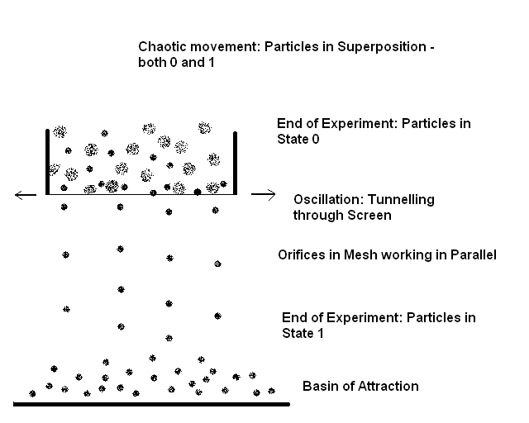
Figure 7. Separation of particles by sieving illustrates some of the basic principles of quantum weirdness.
The picture above illustrates some of the basic principles of quantum physics described earlier. When we empty the mixture of large and small grain in the sieve, we may ascribe a superposition state to the grains in the sieve because we cannot know for certain which of them will pass through the screen and when. It is plausible to consider them as one group because we have weighed them together. Although there are orifices through which many of the particles would pass freely, they would never do without shaking. Gravity is acting on the particles, but the way down is blocked. In order to materialize this potential we must shake the sieve. Shaking is in fact oscillation. This oscillation generates chaotic movement (jiggling) of the particles in the sieve similar to the temperature required for proper operation of the quantum computers of the second type. The chaotic movement in its turn allows the particles of the proper size to pass through the screen. This process is analogous to the quantum tunneling. Indeed, the oscillation introduces some analogue of the wave nature of the quantum world. This wave nature is transferred to the particles in the sieve, which, as dualistic wave-particles, cross the barrier of the screen. In the picture above, particles are deliberately shown as loose circles of two types to emphasize their wave nature along with the particularity.
This condition is entirely opposite to the low temperature required by the classical computers. There, the best performance is obtained when the elements are immovable and the temperature is as low as possible so that energy losses due to the electrical resistance decrease. In the classic, deterministic computers, the elements are fixed in a scheme. In the quantum computers, they are in ever changing configurations. Computation is performed by reaching certain conformation comprising all the elements. Such conformation(s) correspond(s) to local or global (that is referred to the computer only!) energy minimum. In our example, the more intense the shaking, the sooner the process is completed. On the other hand, this shaking should not be extremely vigorous so that the grains are thrown out of the sieve. Sifting also illustrates another aspect of quantum computation: its basic probabilistic character. Indeed, in a practical process, there always will remain “undecided” particles. Such particles, due to the irregular shape, would pass through the mesh in certain instances, while in others would not. In order to pass freely through a mesh, it may require a very long jiggling. Sometimes a particle may jam a mesh and leave in this position “forever”. Therefore, sifting is a simple illustration of a process resembling probabilistic computation. The sieve is a quantum “abacus”, with which the operator calculates the proportion of two fractions according to their size.
The orifices in the mesh of the screen manifest another characteristic of quantum computation: working in parallel. Working in parallel is the most striking advantage of the quantum computers over the classical ones. The example with the sieving is a good opportunity to reveal this dramatic difference. Suppose we have to separate ‘deterministically’ a pile consisting of two types of grains. We would equip with pincers and magnifying glass and would start checking the grains one by one if they would pass through a single hole. I believe a year would be sufficient to separate, say, the 0.5 mm from the 0.3 mm average sized grains in one kg of their mixture. A sieve would do this task within a minute. (Imagine a small grain bumping on a vibrating screen. It may have a size allowing it to pass through the mesh but it could hardly happen immediately. I have observed individual particles bouncing dozens of times on a screen I have shaken manually and then suddenly passing through it. This is characteristic especially of particles of irregular shape.)
Gravity drives the particles that have passed through the barrier to the collection area, which is analogous to the basin of attraction in the complex dynamical systems such as quantum computers. As we saw above, basins of attraction of quantum computers are the areas where memory is located. In our example, there is only one basin of attraction. However, we can imagine a system of sieves working together in such manner so that the way down of the particles is branching out in dichotomy defined by the successive sieve. Thus, a history tree can form for each group of identical particles. In theory, a very large system of sieves can provide a specific base of attraction for each individual particle as long as each one of them is unique. These basins of attraction are apt analogs to memory. Indeed, as we saw above, a jammed particle in the mesh will never reach its basin of attraction, thus preventing the activation of a specific memory of the system, i.e. the latter will be unable to ‘recall’.
Now let us discuss what is the final result of the computation. Which one we will consider as ‘final result’? Quantum systems act as ‘black boxes’ up to the time when a particle of the system ‘shows up’ or appears. This appearance is something specific. Unlike the classical physics, where the particle remains the same one regardless of the place it is in, appearance in quantum terms means information exchange. It is called decoherence and drastically changes the state of the system. Appearance means interaction between the particle – be it electron, proton or photon - and another particle or system such as a detector. This detector can be a device or the retina of our eye or a molecule of gas or liquid happening to be accidentally in a place where the particle of interest also happens to be at the same time. The collision makes the particle register. Before this event, it contains information shared with all the other particles in superposition. At registering, however, it shows up either as 0 or 1. This act of registration puts an end to the particle’s participation in the super-positioned state. Therefore, we cannot open the lid of a quantum computer to see how it works. It can never tell us how far the computation has got. If we are too inquisitive, it will spit out an intermediate result and will cease the computation. This is because a quantum computer needs all its parts undisturbed from outside and being in touch within themselves only. They do this in obscure, unobservable pattern.
The same happens with the sieving. We can ‘disturb’ the system by halting shaking. Whenever we do this, there may be still ‘eligible’ particles in the sieve, which would go down through the screen. The choice is ours: if we resume shaking, more particles may add to the pile below. Therefore, the question about when “computation” is completed is very interesting. There is no definite sign determining that every “eligible” particle has passed down. In the beginning, the accumulation of material below is fastest. Then it slows down little by little and periods come when no particle falls for seconds, then minutes, even hours, if the operator is crazy enough to go on shaking. However, just few more jerks may yield another grain… Therefore, the answer to this question is based on economical principles. Is it worth continuing wasting time and energy for shaking if the crop will increase with negligible value? What makes the operator stop sifting?
It is the shape obtained or rather its change with time. He or she may also look under the bottom of the sieve to see whether particles keep on falling down and assess the dynamics of this process. It can be made automatic by a device measuring the weight gain underneath with time. When the gain ceases or is under certain reasonable value, the device stops the shaking facility. Once a device or we decide that the computation is complete, the particles are registered. Registration means ascribing definite values: 0 to each particle remaining in the sieve and 1 to each one of that those passed through the screen respectively (or vice versa if you prefer). Once ceasing shaking and determining the ‘shape’, which could be weight measuring, we create a new branch of history. The particles remaining above, in the sieve, cannot influence the further history of those that passed through the screen.
As it turned out, we could find analogs in the ancient technique of sifting grains to almost all of the characteristics of quantum computation process. The only exception is entanglement. However, as we will see later, there is a hint even at this weirdness of weirdnesses of quantum physics…
Do the Letters of the Word Possess Wave-Particle Duality?
To many people, this question will sound absurd. First, the Word is written with the same Hebrew letters, which are used for any other text written in this language. Therefore, if the letters in the Torah possess wave-particle duality, why those with which is written, say, the translation of War and Peace do not? Second, the method so far exploited for Bible code research is writing the text of the Hebrew Bible or part of it as a continuous string of letters and looking for skips of specified words or longer expressions. In this aspect, we can imagine the letters of the Torah as beads on the strings of an abacus, but how could we see them as grains jostling in a shaking sieve? We can imagine the strings on which the letters of the Word are wired and then these strings stretched and twisted, but how could we see them as chaotically moving particles, some of them passing through imaginary barrier while others do not? We actually find with the code matrices that letters located distantly from each other in a text can become neighbours, but how could they ‘prefer’ the company of each other if once are fixed in the text? Beads in an abacus do not jump over to another string. Their movements are fixed in one dimension only. The same is valid for the electric currents and the magnet orientation of the particles in our computers.
The problem, in my opinion, arises from the new dimensions coming into being with this new approach. The Bible code matrices are two-dimensional, ‘frozen’ representations of specific configurations of some letters along the one-dimensional string. These pictures are spatial. They do not consider time because the way we or rather computers operate with the text is in certain sense ‘static’. We ask a computer if there exists a preliminary specified word so that its letters are positioned at equal distances. The answer is always ‘yes’ or ‘no’. This means that the computer checks whether there is one or more situations when all elements in a part of its system are in state 1 (1 = the letter searched for is there). In such case, the computer’s reply is ‘yes’. If one or more of the states are 0 (0 = the letter is not in the checked place), the answer is ‘no’.
This modus operandi suggested the idea that the one-dimensional string of letters in the Torah maybe is a computer program - in resemblance to the programs we write - as early as in the dawn of the Bible code research. Therefore, keeping in mind that Torah is an object of computational research, I decided to the simplest move. As shown above, binary code is the fundamental code in the whole Universe. In this system, the digits are two only: 0 and 1. The first few numbers are:
Binary Decimal
0 0
1 1
10 2
11 3
100 4
And so on. The increase of the values of binary numbers follows the same path as those in the decimal system containing 0’s and 1’s only. As in the decimal system 100 is 10 squared, 1 000 is 10 raised to the power of 3, so in the binary system 100 is 2² = 4; 1000 is 2³ = 8, and so on.
I checked the number of letters in the Torah represented in binary code. It appeared to be
1001010011010100101
Some facts immediately impressed me. First, the string is 19 digits long. Then I looked for repeating strings of 0’s and 1’s within the entire one. There should be some two- or three-digit long, anyway. Therefore, I searched for the longest. Surprisingly, it appeared to be the six-digit long 100101, with which the number starts. It repeats again in the end of the string. I converted it to decimal presentation to see what it is. What I obtained was another big surprise: the number is 37!
I have found some interesting facts about number 37. It is a prime number and is one of the two factors of the numerical value of the first verse in the Bible, Genesis 1:1, In the beginning God created the heavens and the earth, in Hebrew:
ץראה-תאו םימשה-תא םיהלא ארב תישארב
The numerical value of these 28 letters in seven words is 2 701 = 37 × 73. Another, very interesting peculiarity with number 37 is that it occurs with much higher frequency as a factor in the power set of this starting verse. That is, 37 appears to be a factor of the numerical values of all possible combinations of the 7 words in Genesis 1:1 much more often than the 3.4 times predicted on statistical basis – in fact, as many as 23 times! [32]
I pondered on the significance of the Torah starting and ending with the binary digits of 37 and my first thought was that this is a fine way to encode the exact number of the letters in a long text. Indeed, if a slight error has occurred during the long millennia when copies had been prepared by the only possible way of handwriting, a missed or added letter would destroy this correlation. However, if the added or missed letters happen to be exactly 64, the correlation would be restored. Although 1 in 64 is a not bad odd for the reliability of a proof certification, after some consideration I decided that the Lord would hardly limit His omnipotence to this extent only. Therefore, I looked back to the only other number I had in hand: 19. Suddenly I saw the link! These two numbers are geometrically connected as a centered-hexagon/star pair. But the multipliers producing the numerical value of Gen. 1:1 are also such a pair! [33]
Figure 8 illustrates the link between the numbers 19/37 and 37/73. Moreover, as it turned out, practically, number 37 is the only number, which occurs both as hexagon and as star number! The next one, 1261, is 11 binary digits long, which would make the Torah at least eight times longer! Note that in this case, 22 is much smaller than the corresponding hexagon number to 1261, 631. A 631-digit long binary number is about 10¹⁹⁰… There are no enough elementary particles in the Universe to contain so many bits.
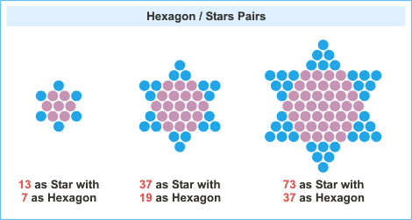
Figure 8. The first three Hexagon/Star pairs. The picture is inserted with the kind permission of Mr. Robert McGough [33].
Then I mused on the meaning of these binary expressions of 37. The length of 19 binary digits allows for 128 combinations starting with 37 and ending with 37; that is, between
1001010000000100101 = 303 141 and
1001011111111100101 = 311 269
The difference between these numbers is not very big: 8 128 letters, which is about the size of the Book of Amos. 304 805 is just one of these 128 numbers. Therefore, if there is a specific key defining the actual number of letters in the Torah, it must be looked for in the ‘middle’ – shown in red - of the binary string. For that reason, I expanded the number 304 805 as three components of a sum and checked the central one:
Binary Expression | Decimal Expression | Expression as a Power of 2
1001010000000000000 | 303 104 | 37 × 2¹³
11010000000 | 1 664 | 13 × 2⁷
100101 | 37 | 2⁵ + 2² + 2⁰
1001010011010100101 | 304 805
Then I saw that I could combine the right column in a single expression of the sum:
37 (2¹³ + 1) + 13 × 2⁷
this is the number of letters in the Torah! The first and the third members structure the first term of the expression, while the central one is in the right. What a key! The binary string is 19-digit long. The expression consists of the universal binary base, 2, in a combination with the prime numbers 7, 13 and 37. Thus, we have all - and them only(!) - four numbers of the first two centered-hexagon/star pairs taking part in the binary construction of 304 805…
A sobering thought crept into my mind and cooled my enthusiasm. I suddenly realized that besides 13, the multiplier of 2⁷ could be also 7, 19 or 37… In all these cases, each one of these four numbers would define a value that complies with the specified requirements. Therefore, I have reduced the number of possibilities from 128 to four, not to one. Is there some property, which makes 304 805 unique? To answer this question, I examined the term. And I immediately saw it! 13 × 2⁷ is also 26 × 2⁶. But 2⁶ = 64. As we saw in the Numbers, Letters and Words section above, 26 is the numerical value of the Name of the Lord, while 64 is the sum of the values of Adam and Eve! The product of the numerical values of the Name of the Lord and the Human
YHVH × (Adam + Eve) = 26 × 64 = 13 × 2⁷
displayed on binary basis includes 7 and 13 - the first centered-hexagonal/star pair. Now the number we have obtained is unique indeed!
Therefore, I could not help regarding 304 805 - the number of letters in the Torah - as a Certificate of Divinity! The Lord had computed the Torah with a precision to a single letter! I enjoyed my eyes on this beauty for hours. I could not lift them off this Universal Number of Numbers. Indeed, what would give the centered-hexagon numbers neighbouring 19? A 7-digit binary expression is equivalent to a value between 64 and 127 letters, which is few random Bible verses. The longest number, which could appear twice in such string, should be 3-digits long – that is, between 4 and 7. The next centered hexagon number, 37, produces a 37-digit binary expression, which corresponds to over 137 billions of letters – that makes more than a hundred thousands of Hebrew Bibles…
Then I started looking on the formula from another angle. Why did the Encoder choose to use hexagon/star pairs? Are not there other series of numbers and pairs of numbers such as the Fibonacci sequence and Triangular numbers? It happens that there are not so many. I couldn’t find any series of pairs of numbers such that a reasonable number could be constructed on binary basis by using all four of them. Moreover, the Lord has given us a hint at the hexagon/star pair sequence in the first verse of His Word. However, isn’t there another hint, which would convince us once and forever that human(s) had not written the Torah? There is such a hint: the numerical value of Israel! It is 541, the 10th star number. With its corresponding hexagon number, 271, it forms the pair of prime numbers in the sequence that appears to be next to 37/73. Figure 9 displays this number. Moreover, 541 is also the numerical value of HaMitzvot, תוצמה – The Commandments [34], which are… ten!
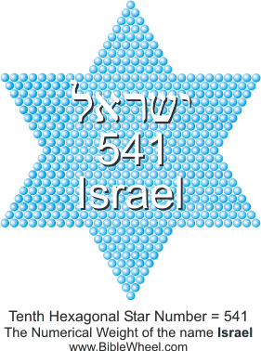
Figure 9. The numerical value of Israel happens to be also the tenth hexagonal star number. The picture is inserted with the kind permission of Mr. Robert McGough [34].
With all this evidences in hand, the next we have to do is to see how the letters of the Word differ from the letters in human writings. It is clear that we must look for a difference, if any, in a characteristic that is not common for all texts. But how such a characteristic could look like?
First, every text can be represented as a one-dimensional string of letters. Matrices could be derived from any text. Second, numerical values remain the same regardless of who has written the text. Third, it has been proved that the bigger the skip, the less differences occur between different texts. At lower skips, some peculiarities of a particular type of text affect the rate of occurrence of certain words. In his book Who Wrote the Bible Code? [35], Randy Ingermanson shows that there is no difference between the Bible and any other text, even scrambled letters, at skips above few dozen. In this aspect, the Word seems as chaotic as any other writing. Therefore, it seems that we cannot escape from the deterministic approach to the Bible codes. On top of that, we have seen that the 22 letters in their role as alpha amino acid residues are as deterministic in a string as the latter determine the properties of the proteins…
Determinism is the same everywhere, but as for chaos… there is substantial difference between the classical, deterministic chaos and quantum chaos! [36] Therefore, our task should be to reveal the difference between the chaos in the Word of God and the other chaos, which reigns in the scrambled texts, Moby Dick, War and Peace, newspapers, etc.
For this purpose, let us define the qualities of the letters in the aspect of dualism. It is easy to see letters as particles – they occupy definite places in the text. As we saw with the sieve, oscillation introduces wave characteristics to the behaviour of material particles. The only other characteristic besides the place of a letter either in the alphabet or in a text is its numerical value. Could numerical value be a type of a wave function? I believe it could because it combines letters not according to their position, but according to substance. Like interfering waves, numerical values can add up and amplify. In some positions, the wave functions of the respective letters give ‘maximums’, while in wrong places they ‘extinguish’ each other. This phenomenon combines letters in clusters of different type. These clusters can pass through a ‘sieve’, or barrier, to a basin of attraction as a whole group. In other words, the letters are no more analogous to alpha amino acids fixed in a string, but to electrons and protons in a whole protein molecule jiggling and combining according to the laws of the quantum chaos.
This idea may seem hazy at first glance and I would be surprised if it may not. I expect that the statement that there is chaos in the Word of God would shock many readers. However, I believe I have found a remarkable example confirming and clarifying it. One of the aspects that amazed me most was just the nature of this chaos. I have worked on this example for long time and many of the ideas pointed out above have been a result of what I had already found in the Torah. However, I am within limits in the exposition of my thoughts. I can think in parallel but I cannot write in parallel… And I do not believe any human being can.
Therefore, let us first see how the letters of the Hebrew alphabet look like in binary code.
Letter | Ordinal Value |  | Numerical Value
א | 1 | 00001 | 000000001 | 1
ב | 2 | 00010 | 000000010 | 2
ג | 3 | 00011 | 000000011 | 3
ד | 4 | 00100 | 000000100 | 4
ה | 5 | 00101 | 000000101 | 5
ו | 6 | 00110 | 000000110 | 6
ז | 7 | 00111 | 000000111 | 7
ח | 8 | 01000 | 000001000 | 8
ט | 9 | 01001 | 000001001 | 9
י | 10 | 01010 | 000001010 | 10
כ | 11 | 01011 | 000010100 | 20
ל | 12 | 01100 | 000011110 | 30
מ | 13 | 01101 | 000101000 | 40
נ | 14 | 01110 | 000110010 | 50
ס | 15 | 01111 | 000111100 | 60
ע | 16 | 10000 | 001000110 | 70
פ | 17 | 10001 | 001010000 | 80
צ | 18 | 10010 | 001011010 | 90
ק | 19 | 10011 | 001100100 | 100
ר | 20 | 10100 | 011001000 | 200
ש | 21 | 10101 | 100101100 | 300
ת | 22 | 10110 | 110010000 | 400
The significant digits are in bold characters. In order to reduce each value to the same format, we have to add 0’s before the first significant digit in the binary expressions, which is always 1. These non-significant 0’s are in regular characters.
Looking at the table above, I easily spotted some curious details. The format of the ordinal values is 5-digit long. Twenty-two letters 5-digit each make 110 digits altogether in the left column. 110 are the years of the life of Joseph, the first Decipherer of Secrets. Intrigued, I checked the numbers of the 1’s and 0’s. There are 48 units and 62 noughts in the left column. The latter number reminded me of the 62 weeks in the famous 70 weeks prophecy of Daniel (9:25-27), but also about the age of Darius the Mede when he took the kingdom of Babylon (Dan. 5:30), a detail whose importance making it worthy for mentioning has always puzzled me.
Then I checked the same parameters in the right column. There are 198 digits altogether, of which 54 are units and 144 are noughts. Except for 144 being 12 squared, I could not see another importance. However, I was impressed of the prevalence of the noughts over units in both columns: 206 and 102 respectively, at the ratio 2.02. Led by curiosity, I decided to see what would happen with the Greek numerals [37]. They follow the same pattern of increase as the Hebrew alphabet, but being 27 altogether, the highest value is 900. The right column will be 1 digit longer because the numbers between 512 and 1 023 are 10-digit long. I counted 264 noughts and 141 units, whose ratio is 1.87. This value differs by almost 8% from the Hebrew numerals.
Then my professional training as chemist urged me to compare the ‘concentrations’ of the units in both columns. To my surprise, the ‘concentration’ in the left, alphabetical, column related to that in the right, numerical one, turned out to be
(48:110)/(54:198) = 1.6
But 1.6 is very close to the Golden Ratio! Indeed, it is the ratio between the two consecutive numbers in the Fibonacci sequence: 8 and 5. I checked this ratio for all alphabets containing 18 to 32 letters. I have not obtained such elegant ratio again. The only value closer to the Golden Ratio I obtained with the 25-letter alphabet, but the numbers forming it, 57 and 35, are not members of the sequence.
Then I checked the ‘concentrations’ in each column. There was nothing significant with the left column. With the right column, however, I obtained two low Fibonacci numbers, though not consecutive, again. The ratio of noughts to units there is 144:54 = 8:3.
I reflected upon the findings and realized that the left column is the shortest possible text containing each letter of the alphabet. With a longer text, the left column would expand accordingly, while the right column would ‘fluctuate’ depending on what is written. Both columns, however, would go in parallel. Then the columns reminded me of the two cerebral hemispheres: the left one, performing the logical, sequential operations; the right one responsible for the heuristic ideas and images… [38]
Now, the left column indeed embodies sequential character, reasoning, ‘explanation’ of what is ‘suggested’ from the right. This is why the left column defines the skips of the items in matrices. What the right column defines? The most reasonable thought was images, or abstract thoughts, not defined in terms of skips in matrices but present there anyway. I prepared a table in the same manner including the first verse of the Bible and the last two words of the Torah. Although a tiny part of the whole Word, these examples illustrate unquestionably the idea:
The letters of Genesis 1:1 and all of Israel (כלـישראל), the last word of the Torah, with their ordinal values in the text in the left and the numerical values in the right.
Letter | Ordinal value in the Torah | Numerical Value | Word Value | Total Value
ב | 0000000000000000001 | 000000010 | 913 | 2701 = 37 × 73  The number 37 occurs exceptionally often as a factor of the combined numerical values of any combination of these 7 words
ר | 0000000000000000010 | 011001000 | 913
א | 0000000000000000011 | 000000001 | 913
ש | 0000000000000000100 | 100101100 | 913
י | 0000000000000000101 | 000001010 | 913
ת | 0000000000000000110 | 110010000 | 913
ב | 0000000000000000111 | 000000010 | 203
ר | 0000000000000001000 | 011001000 | 203
א | 0000000000000001001 | 000000001 | 203
א | 0000000000000001010 | 000000001 | 86
ל | 0000000000000001011 | 000011110 | 86
ה | 0000000000000001100 | 000000101 | 86
י | 0000000000000001101 | 000001010 | 86
ם | 0000000000000001110 | 000101000 | 86
א | 0000000000000001111 | 000000001 | 401
ת | 0000000000000010000 | 110010000 | 401
ה | 0000000000000010001 | 000000101 | 395
ש | 0000000000000010010 | 100101100 | 395
מ | 0000000000000010011 | 000101000 | 395
י | 0000000000000010100 | 000001010 | 395
ם | 0000000000000010101 | 000101000 | 395
ו | 0000000000000010110 | 000000110 | 407
א | 0000000000000010101 | 000000001 | 407
ת | 0000000000000010110 | 110010000 | 407
ה | 0000000000000010111 | 000000101 | 296
א | 0000000000000011000 | 000000001 | 296
ר | 0000000000000011001 | 011001000 | 296
ץ | 0000000000000011010 | 001011010 | 296
۰۰۰ | ۰۰۰۰۰۰۰۰۰۰۰۰۰۰۰۰۰۰ | ۰۰۰۰۰۰۰۰۰ | ۰۰۰۰۰۰ | ۰۰۰۰۰۰۰۰۰
כ | 1001010011010011111 | 000010100 | 50 | 591 = number of the occurrences of ישראל in the plain text of the Torah
ל | 1001010011010100000 | 000011110 | 50
י | 1001010011010100001 | 000001010 | 541
ש | 1001010011010100010 | 100101100 | 541
ר | 1001010011010100011 | 011001000 | 541
א | 1001010011010100100 | 000000001 | 541
ל | 1001010011010100101 | 000011110 | 541
Words on the left and images on the right… Has the Encoder dropped a hint validating our suggestion? I checked the numerical values of words, דברים and image, צלם:
דברים = 4 + 2 + 200 + 10 + 40 = 256 and
צלם = 90 + 30 + 40 = 160
The numbers of letters of each of these words are 5 and 3 respectively, which are two consecutive Fibonacci numbers. The ratio of their values, 256/160 is 1.6, which is exactly 8/5! We have again two consecutive Fibonacci numbers. Moreover, 256 = 2⁸, while 160 = 5 × 2⁵. Here is another amazing fact: These two numbers, 256 and 160 are the only numbers, whose factors include two consecutive members of Fibonacci sequence in each respective presentation reduced to powers of 2 so that the ratio of the numbers is that of the respective members! As with the presentation of 304 805, where we have the binary base, 2, and numbers of two consecutive hexagon/star pairs only, here we have the same base 2 combined with two consecutive Fibonacci numbers. To my best knowledge, eight is the only Fibonacci number known so far, which is a power of two: 8 = 2³. [39]
Then I suddenly realized that unconsciously, I have compared words (plural) with image (singular)! I had missed this discrepancy at the beginning. But now I had to find explanation. The figures obtained bespeak of something special. It is not only the uniqueness of the 256/160 pair, but also the fact that they reflect the relationship between the assumed corresponding localization of the respective mental/computation facets in the areas of the tables above. Therefore, I opened the Bible, Genesis 1:26: Then God, אלהים, (plural!) said, “Let us (plural!) make man in our (plural!) image (singular!)… This is the first occurrence of the word image, צלם, in the plain text of the Bible. In addition, king Nebuchadnezzar saw one image in his dream and later built one image (Daniel 2 and 3). Then, the image of the beast in Revelation 13 is also one image. Generally, tselem, צלם, image, occurs in the Bible mostly as ‘idea of likenesses’. For graven images, which are the idols of the pagan religions, other words are usually used.
Contemplating on the first verses of the Bible – the account of the Creation – I was impressed by the power of the Word of God. Indeed, this three-letter Hebrew word, דבר, implies both verbal commandment and matter – or the equivalence between the Word the Lord speaks and all being in reality. This reminded me again of the processes allowing a quantum computer to map certain reality so that the mapped by the computer is indistinguishable from the reality itself. I caught myself in parallel thinking. I was thinking about Words and the Golden Ratio at the same time. I was thinking about the words that Daniel had to close and seal up to the Time of the End… Suddenly, I realized that the definite article, ה, brings the ratio of the numerical values of ‘the words’ (הדברים), 261, to ‘image’ (צלם), 160, closer to the Golden Ratio! (261/160 = 1.63125 is closer to ≈1.61803 than 256/160 = 1.60000.) Is the Golden Ratio imbedded somehow in the Bible codes?
Then I became conscious about the danger of being obsessed with certain mathematical characteristic. Although the earliest researchers of this remarkable irrational number were amazed of its ubiquity in nature and called it Divine Proportion, nowadays it has lost the attraction once it had as a symbol of beauty and perfection and is used mainly in fiction books. Thinking over הדברים, the Words, I remembered that Daniel had to seal them up until the Time of the End. This word occurs very often in the plain text, so I searched for it encoded in the beginning of Genesis, among the account of the Creation. I found nothing significant there and continued searching elsewhere in the Tanakh. One of the places that attracted my attention is the book of Ecclesiastes. To my surprise, I found הדברים there, close to the end of the book, entirely in chapter 12, where there is the word end, סוף. The first letter of this word, samekh, ס, is written traditionally with larger character and helped me to find a key term in the matrix of the code about 2006 [20]. Before searching for ‘the words’, I had found a very interesting aspect of encoding with End-of-the-Matter, דבר סוף, against extremely low odds. I will discuss this finding a bit later.
What intrigued me mostly with הדברים, however, was the skip, which appeared to be -86. 86 is the numerical value of God, אלהים. ‘The words’ occurs once only in the Bible at skip ±86, with chance of about 1/30. Therefore, I supposed that there might be a reciprocal occurrence of the complementary item, i.e. God, אלהים, at skip ±261. To my amazement, one of the 11 occurrences happens to be very close to its match! See Figure 10.
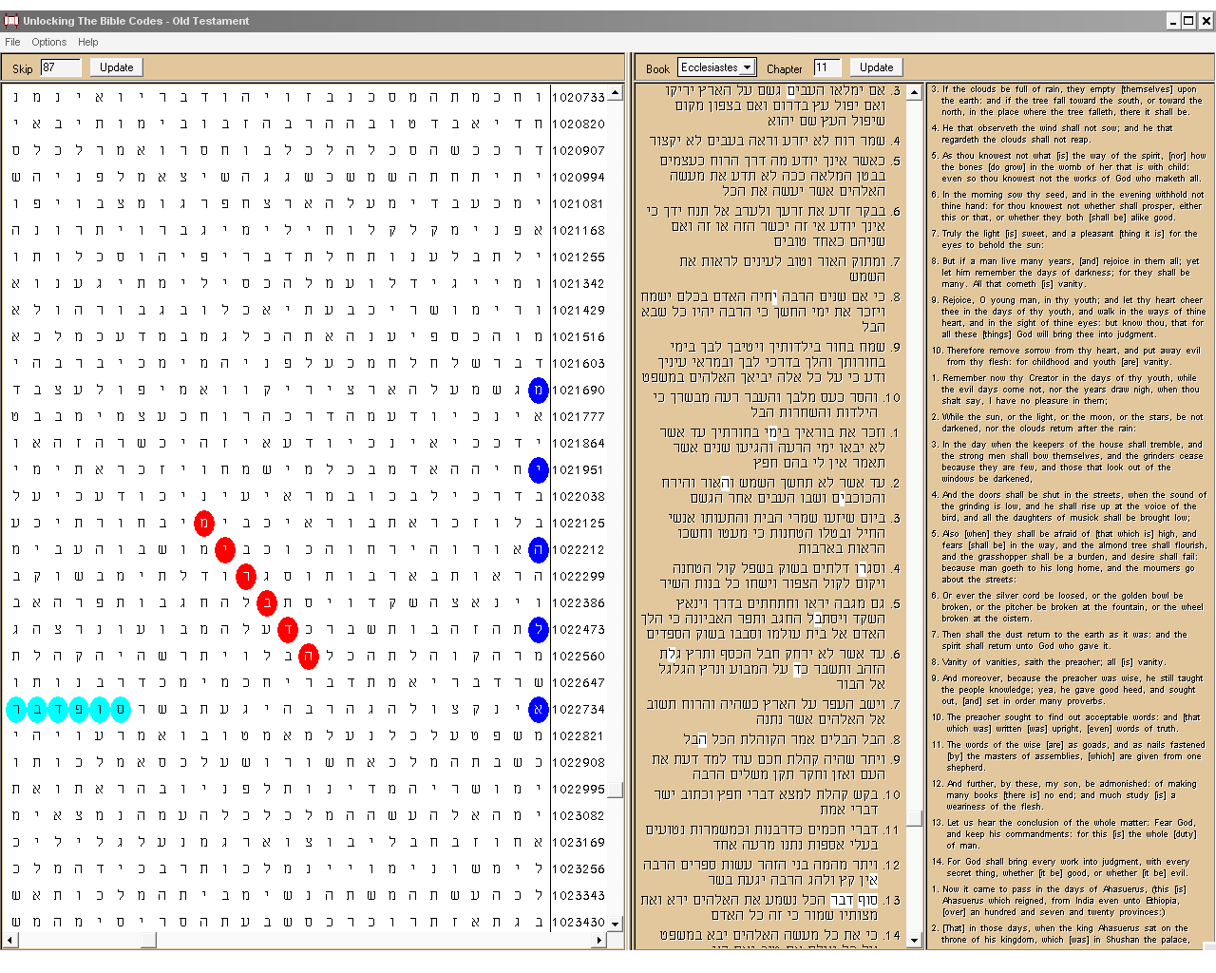
Figure 10. God (אלהים), blue ovals, at skip -261; The Words (הדברים), red ovals, at skip -86; and The End of Matter (דבר סוף) turquoise ovals, in the plain text.
Can one perform calculations of the probabilities that include the skip values? Depending on which item is the fixed one, programs give odds for such closeness between about 1 in 400 and 1 in 100. However, even when I considered the occurrence of one of the terms in the matrix as given, the odds for the occurrence of the other one in the matrix are below 1 in many quintillions. (For instance, for one occurrence of אלהים exactly at skip ±261 within Ecclesiastes 11:1 to 12:14, SD = 28.00, while for one occurrence of הדברים exactly at skip ±86 wherever in Ecclesiastes, SD = 28.03. Odds at such standard deviations are hardly calculable.) What is most important in my opinion is the fact that the closeness of these occurrences has been anticipated!
What additionally intrigued me was why this pair has occurred especially in Ecclesiastes? I checked the rate of occurrence of God, אלהים, in all the books of the Tanakh. To my amazement, it turned out that Ecclesiastes is the book where this word occurs most frequently in the plain text in relation to the size of the book! I mean this particular form of the word ‘God’. The only rival in this aspect is Jonah. However, if we take into account the forms for ‘your God’, אלהיך, ‘his God’, אלהיו or ‘my God’, אלהי, the situation may change dramatically in favour of other books. These latter forms, as well as the Name of the Lord, YHVH, do not appear in the plain text of Ecclesiastes at all.
What makes this matrix even more significant is the presence of the term in the plain text. As I mentioned above, samekh in סוף (SOF), ‘end’, is written with larger character. I was impressed by this fact when spotted it several years ago and memorized it easily because it sounds exactly as the first part of my own city, Sofia. At that time, it helped me to find a key term in the matrix. However, I haven’t believed for a minute that this peculiarity had been inserted exclusively to be of assistance to a Bulgarian in his poor Hebrew. Therefore, I examined closely the verse and found the expression ‘conclusion, or end, of the matter’, דבר סוף, somehow odd. As an expression, it occurs only once in the plain text of the Bible. דבר (DaVaR) means ‘word’ but also ‘matter’, ‘thing’ and ‘object’, thus establishing correspondence between Word and Act. This correspondence, to the point of equivalence is explicitly emphasized in Genesis 1. But Genesis 1 is the beginning of everything. Close to the end of Ecclesiastes, we read about the conclusion of everything. In the last verse, the Teacher says that God will bring everything to judgment – every hidden thing – whether good or bad…
Codes are hidden, secret things, so I decided to see if רבדפוס is encoded somehow. I tried first with the Torah. There was nothing extraordinary with the number of occurrences. However, the lowest skip appeared to be 703, entirely in Exodus. I had checked the numerical value of the item beforehand: it is 352. I realized immediately that the lowest skip in the Torah is two times the numerical value minus 1: 703 = 2×352 – 1. Intrigued, I checked in the rest of the Tanakh. And there was a hidden surprise: the lowest skip above 1 in the Tanakh is -353! The code is entirely in the Aramaic text of the book of Daniel and is positioned in the end of chapter 2 and the beginning of chapter 3. It goes right through that part of the Bible, which narrates about images! The image dreamt by king Nebuchadnezzar and the image he ordered to be made of gold. What is more, this is the fraction of the Word, where ‘image’, צלם (TseLeM), occurs most frequently in the plain text. Figure 11 speaks for itself.
What is even more striking, however, is the fact that this skip is within the numerical value ±1 range. Now we have the formula
Skip = N × Numerical value ± 1
confirmed for the natural numbers N = 1 and 2! The chances for coincidence are 1 in many billions of billions of billions. (The expected number of occurrences of סופדבר in the combined positive and negative skip intervals 351 to 353 is 0.00634. The figure for the similar intervals 703 to 705 is even slightly lower.)
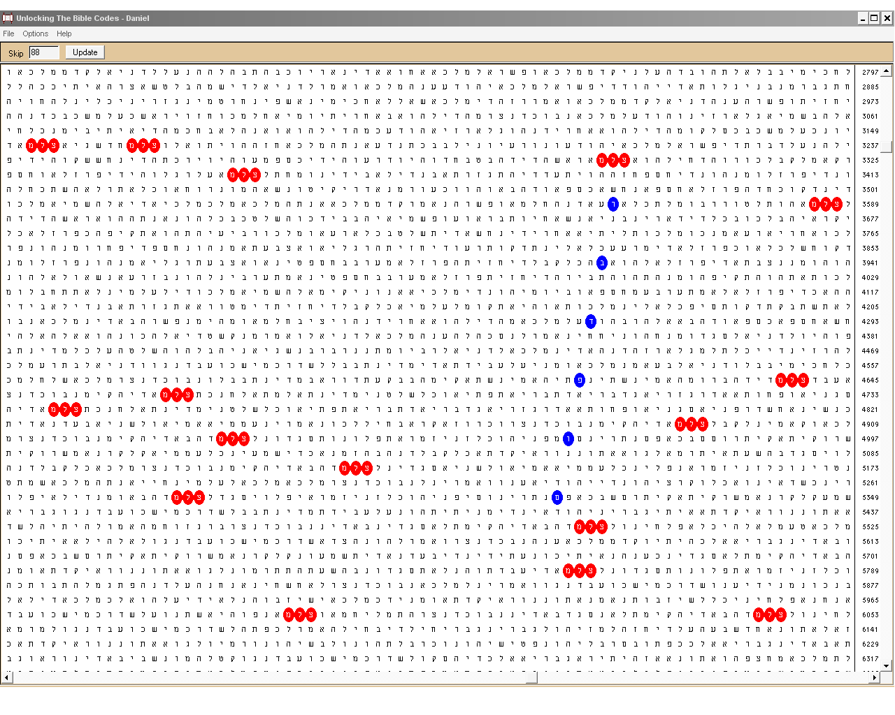
Figure 11. End of the Matter (סוףדבר), blue ovals, at skip -353; and Image (צלם), red ovals, 16 altogether, in the plain text of Daniel 2-3. Besides here, the latter word distinctively occurs 3 times in Genesis 1 and scarcely elsewhere in the Bible.
What could this code mean but a key to understanding? In the light of the discussed above, the link between numerical value, skip and image is a hint at the characteristics of quantum computation! Indeed, the numerical value is an ‘identity characteristic’ of a word. On the other hand, each entity possesses an image, which characterizes it in the reality. Finally, (Skip + 1) and (Skip – 1) values are the distances, in term of letters, between two encoded letters with and without the ‘end-points’, respectively. This distance defines the length of the ‘tunnel’ through the plain text, which a letter ‘particle’ must cross to get in touch with its match. This tunneling phenomenon is typical of quantum physics and defines the situation where a particle goes through a forbidden energy state. Such transition cannot happen in classical physics. In this aspect, our key, which associates letters and skips with tunnels and energy states, is especially adequate! It describes not only the space/time characteristic of the tunnel but also the initial and final states of the ‘end points’: as (Skip – 1) and (Skip + 1), respectively.
The major consequence of the discovery of this key, however, is that it points to another facet of the Word of God. The key points to the Word as a computer! Moreover, this computer is not of the classical, deterministic type. It is of the type scientists just recently have understood and having done the first steps in developing working models. What I mean is quantum computer!
The idea that the Hebrew Bible and the Torah in particular is a program is not new. Professor Eliyahu Rips has proposed it at the dawn of the Bible code research. However, the idea that the Torah is itself computer – a quantum computer at that - shocked me and seemed unbelievable at first thought. On the other hand, I had the reason for believing in its plausibility. The fact is that ‘the words’, הדברים, and ‘God’, אלהים, was the first pair I checked for this particular complementarity/reciprocity feature and found it against practically incalculable odds. The idea came up to my mind when I spotted הדברים close to the end of Ecclesiastes, in its only occurrence at skip ±86, the numerical value of אלהים, and suddenly the whim that אלהים should be nearby at the skip of ±261 crossed my mind. I needed few minutes to verify it! Why my mind ‘formed’ this particular pair and did not combine הדברים with another word? The answer, of course, is plain and easy. I think that everyone, who has read the Bible or who is just a regular church-goer would link ‘the words’ with ‘God’ at first thought. Word of God is a synonym of Bible. Our minds operate this way.
On the other hand, Jeffrey Satinover shows beyond doubt in TQB that our brains are quantum computers. I mused over the fact that my mind skipped over the uncountable pairs of words with their numerical values and picked up the right one at first attempt. Indeed, if I had to check the idea on trial-and-error principle, I would need ages to obtain the first reasonable result. Moreover, I would have to establish a criterion for ‘reasonable’. This is a tricky issue itself. For instance, if the chances are one of the aspects for accepting certain occurrence as encoded, what the value of the probability must be? Is there a particular value, which could be set as a criterion for decision? If we find on the millionth attempt a pair occurring against the odds of, say, one in ten millions, shall we stop searching for another pair possibly occurring against the odds of one in a billion? Moreover, which occurrence would be a more plausible code: knife and fork occurring with probability of one in ten thousand or spoon and moon occurring with one in ten millions?
What makes concepts or words match in our minds are their semantic connections. The key to such association is the matrix shown in Figure 11. It suggests, through the third term in the plain text of the matrix in Figure 10, ‘the end of matter’, that the key is in the image. Indeed, 86 is not the lowest skip above 1 at which הדברים occurs in the Tanakh. The lowest skip is 22, in Isaiah. There are about a dozen more occurrences at skips up to 100. However, it was the occurrence at -86 that caught my attention. Something made my mind skip over the other occurrences and fix on that particular one. Then, the image of the word, which I associate with 86, אלהים, emerged in my mind. I couldn’t help connecting this process with the pattern the folding protein molecule attains its final state of lowest energy. It does not check each possible state because this would be a vast waste of time. As my own brain is a setting up of many billions of such molecules, they may work as a complementary device to the Tanakh. Note that I don’t know Hebrew - at least not to the extent I would need in order to study the surface text in the original language! Thus, my own mind does not work in terms of words proper but rather in terms of numbers and images! Then it hit me that I may have found good evidence that the Word of God itself operates as a computer.
However, the matrices shown above are primarily keys. The encoded terms are words, which occur often in the plain text and therefore, a super-intelligent One could set them deliberately as codes. Strictly speaking, He would not need the principles of quantum computation to do this. In order to prove that the Hebrew Bible possesses the qualities of a quantum computer we must prove that it computes on numbers-and-images basis. Moreover, the Word of God must be a map of the real history. That is, it must compute emerging events. In the real quantum computers, this emerging is a result of the effects of the motion and interaction of many particles. Therefore, preferably, a large number of human beings must (have) cause(d) these events. In addition, on personal level, these people must be unpredictable in analogy to the quantum uncertainty of the effects of a single particle. In other words, these human beings must possess free will.
The reader should have become aware that we need a decisive example, which proves unequivocally the ideas inferred above. An example, which would show that the Word of God is more plausible to be thought of as a computer rather than just a computer program. Everybody knows that a good example is worthier than thousands of pages of theorizing. I believe I managed to find such example. I discovered the details one-by-one in the course of about year and a half. I did my first findings before having found the keys described. I wrote the whole article in a peculiar way – in a parallel pattern, sometimes having obtained the facts first, which later I had to explain. Strangely, the keys were among the codes I discovered most recently. Maybe there are more details still undiscovered. What I am certain, however, is that there are many more such examples in the Tanakh. Well, the example I stumbled across is about the strange link between the names of
Aaron and Bulgaria
What common could be there to these two names? Well, there is something common. We will consider these names in historical aspect first. Aaron is the well-known first High Priest of the Lord. He gave the name to the priesthood of the Mosaic Law. The clause of this Law stating that priests could be biological descendants of Aaron only has made him the most ancient male person, whose genetic traits could be traced with a large degree of certainty by DNA analysis of Y-chromosomes. Probably this makes him the genetically most studied person in history. As for Bulgaria, she is hardly known to a Westerner beyond the facts that she is a South-East European country to join the EU soon along with Romania, that once she was maybe the closest communist ally of the Soviet Union and that she has to solve hard problems with corruption, criminality and demography in this post-communist period. A person with more interests in history would probably know that Bulgaria is the only country in Nazi-controlled Europe, which saved all its Jewish population during the Holocaust… I can say a lot more about Bulgaria, of course. But before going on, let us muse on what history is?
Let us start up with Aaron again. We know from the Bible that he has many male descendants because the priesthood line has been kept unbroken for many generations and because the Jews keep diligently the records of their families. Today, the genetic code confirms with high probability that the Bible record is true. It is the same with the Bible codes – they confirm events that everyone knows are true. Therefore, real history is both facts and meaning. By ‘meaning’, I define the significance of certain facts as assessed by the leading individuals of the humankind or large groups of people. Very often, we have facts without significance and historical significance that is not recorded properly as a fact. While the former situation is understandable, the latter one needs clarification. As a good example, I could give the Pharaoh who raised Joseph to the highest authority in Egypt. This man had great importance for the Jewish nation as well as for history at large. However, his name is unknown. In certain sense, he is nobody. His name is probably encoded in the Bible but how could we find it?
Without names and notions in our minds, there is not history at all. Everyone who has read the books about the Bible codes knows about Yitzhak Rabin, JFK, Lady Di and Titanic codes because the public is well acquainted with the prominent politicians, celebrities and disasters. These persons and/or events have had their high significance before being searched as codes. What makes us content with the findings is the matching of the significance found as a code to the significance of the particular history in our minds. Without this correlation, any searching of codes is meaningless. The significance of the most prominent Rabbis made the Bible codes research known to the world due to the scientific article by Rips, Witztum and Rosenberg, who published their famous work in 1994. [40]
Significance, however, can change with time. A good example is the spreading of the attitude of indifference or even denial of the Holocaust in many contemporaries. However, unfortunately there is also the reciprocal example. Bulgaria saved all her Jewish citizens and was the only country under Nazi control, where the Jewish population increased during the WW2! [41] Moreover, about 35 000 Jews immigrated to Israel from Bulgaria during the first three, crucial years of the existence of the Sate of Israel. This number is greater than the overall number of the immigrants from the West. Thus, Bulgaria has one of the highest proportional contributions to the establishment and strengthening of the young state because Bulgarian Jews were highly educated and skilled. Many of them, soldiers including, behaved respectably and bravely in many critical situations, thus earning good fame to Bulgaria, where they were born and had been trained.
(Few months after the Six Days’ War in June 1967, I had to start my compulsory two-year military service in a heavy artillery unit of the Bulgarian Army. We, the soldiers, time and again commented ardently Israel’s incredible success in this war. Even our communist commanders praised highly the Israelis. In private, they admired the Israeli victory, while condemning aloud the “Zionist aggression” as a mark of servitude to the Big Soviet Brother. The shame is inevitable to draw near in such situation. It came in the next year, when the Soviet bloc invaded Czechoslovakia. Our unit was not sent there; we were the next to be dispatched in case the situation would grow tense. I was lucky. Some of my ex-schoolmates were not. Few of them died there. A chap of the next-door class I knew well was killed in a clash. We all were 19 years old.)
At those times, Israelis estimated Bulgaria and Bulgars highly. It was not exceptional event official Bulgarian groups or delegations to be met on the border on foot. (One such example told me my uncle, who was interpreter to the Bulgarian Orthodox Patriarch Cyril – the same one who, as Archbishop, played a major role for precluding the deportation of the Bulgarian Jews to the Nazi death camps in March 1943. They had to enter Israel from Egypt – it was in 1960 - and to their surprise, they were met by a large group of Israeli representatives on the frontier.) Once, a whole wall was dedicated to the salvation of the Bulgarian Jews from the Nazi death camps in the Yad VaShem memorial. Recently, a friend visited Israel and told me disappointedly that this wall has been reduced to a small corner containing few photographs. Well, it seems that people are this way. I have heard ‘logical’ opinions even from professional historians on this miraculous salvation of the entire Jewish population in a small Nazi German allied country such as “This is impossible because it cannot be”. They cannot understand that history is what it is regardless of whether we like it or not. To paraphrase the well-known saying attributed to Stalin, saving a Jewish life is heroism; saving 50 000 Jewish lives is a statistic…
Numerical Values and Basins of Attraction
The brightest readers – and I don’t doubt that all my readers are intelligent indeed – should have already guessed what Aaron and Bulgaria have in common. However, I was not aware of it for more than two years…
The Holocaust was the event that provoked my mind on searching for codes. [42] I searched the names of most of the European states and America. I was interested in the lowest skips of occurrences. I found Bulgaria, בולגריה, at her lowest skip of -456 in the Torah, in the Book of Numbers, from 19:20 to 21:22. It is the passage about one of the last revolts of Israel against the Lord in the wilderness – in the desert of Zin, in the last year of their wandering before entering the Promised Land. Miriam died and then Aaron died and the Lord was angry to Moses and deprived him of leading His people into the Promised Land because instead of talking to the rock to produce water, he hit it with his staff. Well, there was also the optimistic episode when the Lord listened to the voice of Israel (21:3) – the only occasion explicitly occurring in the whole Tanakh – as well as the Moses’ making the serpent of bronze for the salvation of everyone looking at it. However, the overall shade that left traces in me was somehow dark.
About a year later, I started correspondence with a very dear friend of mine, who commented on the Hebrew word fig (tree), תאנה. I immediately noticed that its numerical value matches the lowest skip of Bulgaria in the Torah: 456. This was my first observation of a link between a skip and a numerical value. Bulgaria played a positive role for the Jews during the Holocaust. In its turn, the Holocaust precipitated the restoration of Israel in 1948. Bulgaria also provided Israel with one of the largest numbers of immigrants from a single country during the critical period 1948-50. On the other hand, the Lord Jesus gives as one of the clearest signs of the Time of the End the seasonal growth of the fig tree:
Now learn this lesson from the fig tree: As soon as its twigs get tender and its leaves come out, you know that the summer is near. Even so, when you see all these things, you know that it is near, right at the door. I tell you the truth, this generation will certainly not pass away until all these things have happened. Heaven and earth will pass away, but my words will never pass away. (Matthew, 24:32-35; NIV)
I saw important significance in this fact at least because the Bible codes – this specific increase of knowledge - are a definite sign of the Times of the End as Daniel was told. Moreover, in its elementary form, תאנה, ‘fig’ occurs exactly seven times in the plain text of the Tanakh. Seven is the number of perfection and rest.
Several months later, the same friend posted me few Bible code programs. One of them, Keys to the Bible [44], has Gematria dictionary. I had some basic knowledge of Gematria and calculated the numeric value of Bulgaria, בולגריה: 256. One day, led by curiosity, I decided to check which words have the same value. I set the number in the browser and started the search. I had hardly looked at the list and the very first word astonished me. It was… Aaron, אהרן! I recalled at the instant where Bulgaria occurs encoded and examined the matrix closer. It turned out that Bulgaria occurs at the lowest skip of -456 in the Torah right where the name Aaron is at its densest ‘concentration’ in the plain text of the entire Tanakh. At first sight, there is nothing significant in the matrix. (See Figure 12)
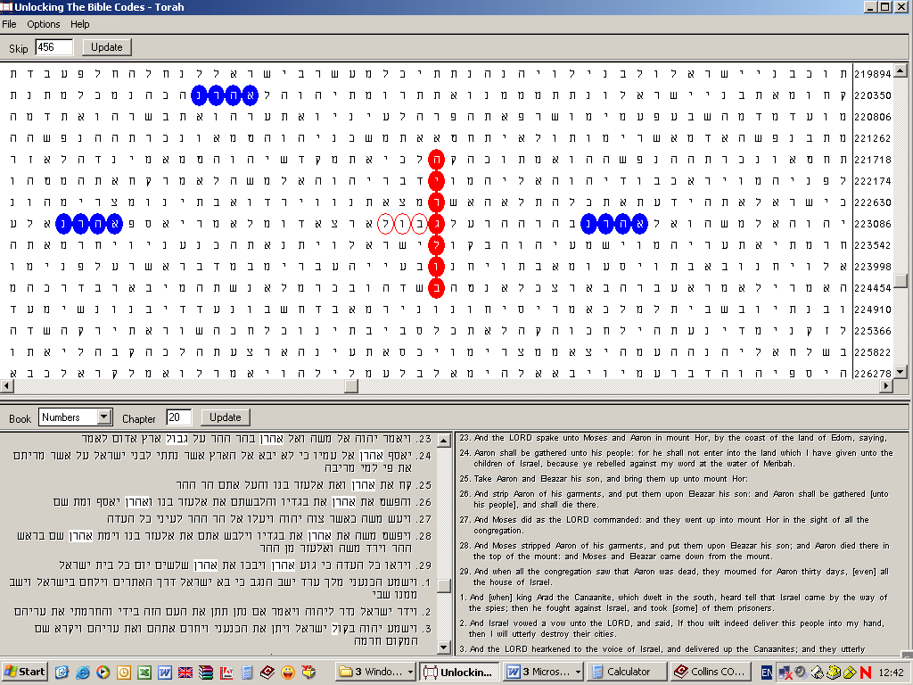
Figure 12. Bulgaria (בולגריה), red ovals, at the lowest skip in the Torah, -456; Aaron (אהרן), blue ovals, and bourn, border or frontier (גבול), red contours in the plain text. All coloured letters are highlighted in the text below the matrix. The nine occurrences of Aaron form the most compact group of this name in the Bible.
However, Aaron occurs nine times in seven verses describing his death. This passage is almost entirely between the adjoining letters lamed and gimel. I checked and found that there are only five more occurrences between the first, beyt, and the last, hey, letters of Bulgaria. Even so, the overall rate of occurrences of Aaron in the plain text is unsurpassed elsewhere in the Bible. Moreover, there are significant gaps outside of the text comprising Bulgaria encoded, where Aaron does not occur in the narration – 19 verses from the beginning of chapter 19 to 19:20 and then even a bigger gap from 21:22 right down to 25:7.
What also impressed me was the intersection of the encoded term with border, or frontier, גבול, which consists of the first four letters of בולגריה but in changed sequence. In the matrix, גבול is between the letters lamed and gimel of Bulgaria. לג is 30 + 3 = 33, which fact urged me to check the number of occurrences of the word in the Torah. As it turned out, גבול occurs exactly 33 times there! גבול has additional significance, I believe. It comes again from the positive role Bulgaria had played in the Holocaust. Historically, the Holocaust was the borderline between the eon of Jews dispersed throughout the world and the establishment of the State of Israel. In addition, the numerical value of border, גבול, is 41. Israel’s wandering in the wilderness could be assumed to have started from that regrettable rebel against the Lord after ten of the twelve men whom Moses sent to spy the land reported bad news. Then the Lord told them (Num. 14:33-34) that they will not enter the Land He gives them and then He set the time. This means that the duration of the wandering could have been full 40 years and so Israel entered the Promised Land somewhere in the 41st year, which makes 41 the upper limit, or time-border, of the dwelling in the desert. Then again, the letter lamed in the encoded Bulgaria arrested my attention. In the text, it is the last letter of קול, voice. After Aaron’s death, the entire house of Israel mourned for him thirty days (Num. 20:29). The numerical value of ל is 30 and mourning at these times should have definitely included crying aloud…
Then I noticed some interesting peculiarities with number 8. Aaron, אהרן, occurs exactly eight times between the letters gimel and lamed in Bulgaria – that is, between border (or, coast) and The Lord listened to the voice of Israel - in the plain text. The numerical value of Aaron and Bulgaria, 256, is a power of 2: 256 = 2⁸. Most of the plain text occurrences of Aaron are outside the matrix shown in Figure 12 because its true size is too wide to contain them. However, 456 is also divisible by 8 to result in the first odd number, 57. The latter number is small enough to show all the occurrences in the plain text in a reasonable area. Therefore, I resized the matrix. The new one is shown in Figure 13.
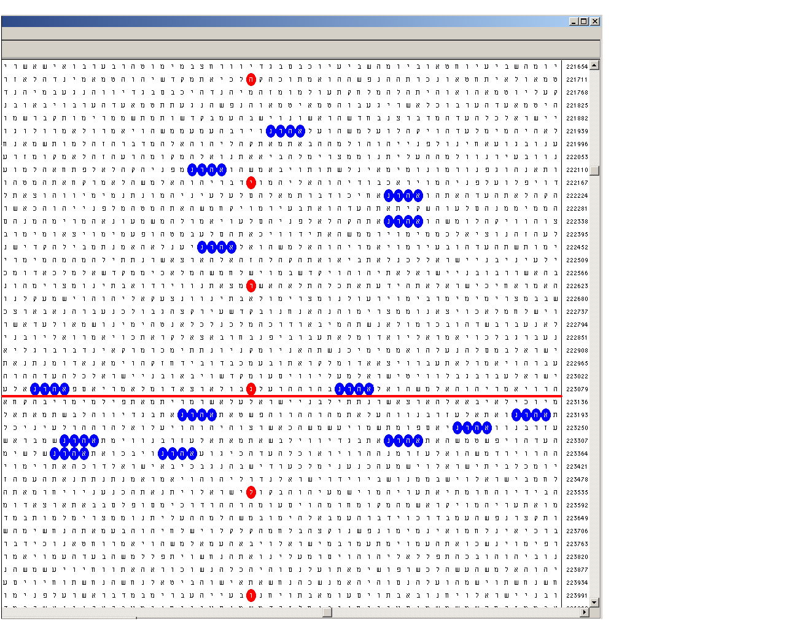
Figure 13. Bulgaria (בולגריה), red ovals, at the lowest skip in the Torah, -456; and Aaron (אהרן), in the plain text, blue ovals. The skip of the matrix is 57. For the sake of clarity, the matrix is cut above the first letter of Bulgaria, beyt. The horizontal red line is drawn immediately below the row containing the central letter of בולגריה, gimel, thus dividing the real matrix almost perfectly in two parts.
The picture above astonished me! I could not expect such symmetry. There are vertical and horizontal as well as diagonal symmetries here. The picture reminded me of the distribution of the active alpha amino acid residues in the lysozyme highlighted in Figure 5. In Figure 13, there are 14 occurrences of Aaron in the plain text comprising the encoded Bulgaria. Seven of them are to the left of the vertical column with Bulgaria and seven are to the right of it. Seven of them are above the red line and seven are below it. There are three occurrences in the upper left and lower right quadrants and four occurrences in the upper right and lower left quadrants. This picture was a clear reminiscence of the structure and function of proteins. X-ray diagrams taken with protein crystals are ‘frozen’ pictures of computing machines. Proteins are quantum computers in their vital state. Therefore, the analogy between the x-ray diagrams and Bible-code-like matrices revealing the distribution patterns of activity defining residues is a reasonable suggestion that the Hebrew Bible, especially the Torah, might be a quantum computer. What we are able to see are ‘frozen’ pictures in the form of matrices, but the Torah might be also in a ‘vital’ state and act as a computer processing data of the history of the world. Even so, the idea seemed too bold to me. However, it was exceedingly attractive and called for further investigation. In this particular case, it should include delving deep into the history of Bulgaria with special attention paying to events linked to or influencing the course of the Middle East history during the last two millennia and specifically the restoration of Israel in her Land.
I have already discussed the contribution of Bulgaria to the Jews in the 20th century and its confirmation as Bible codes. To my amazement, I found more events of great significance in the Old Bulgarian history. Their importance in the aspect we are interested in could be assessed as late as our own generation. Few decades ago, they would never be estimated in this context…
In Search for Roots of an Ancient People
Some readers may be utterly surprised to hear that Bulgars are among the oldest nations of Europe, if not the oldest one. Centuries before the rise of the British Empire, we had two Empires buried in history. The Oxford Professor of history Norman Davis believes that by the 13th century, there were only four of the contemporary European countries based on national identities: Portugal, Denmark, Serbia and Bulgaria. [45] (Isn’t it remarkable that two of the oldest nations of Europe – Bulgaria and Denmark - were most successful in saving their Jewish population during the Holocaust?) However, in accordance with the criteria of unbroken ethnic succession, Bulgar originates from the remote past and it is the oldest personal name signifying a contemporary European nation. [46] In an indirect way, it goes back to the Book of Genesis…
The name Bulgar and state organization(s) associated with it could be traced as back as several centuries BC. Bulgars disappear from Central Asia to emerge about the same time in Europe in the early 2nd century AD to the north of Black Sea and Caucasus. They were akin to other peoples, one of which was the Khazars. The latter are famous with the fact that they had the only non-Jewish state whose official religion for about 200 years (9th – 10th centuries AD) had been Judaism. [47] In their chronicles, Khazars derive their origin from one of the ten sons of Togarmah, Khazar. One of the other nine sons of Togarmah is Bulgar. [48] Interestingly, this record, if true, has not been preserved in the Bulgarian historical memory.
In the first several centuries AD, Bulgars should have been numerous because there are records of several Bulgar tribes and perhaps even organized states. Maybe many of Attila the Hun’s warriors were Bulgars because there are data that Bulgars were akin to the Huns too. Somehow or other, a Bulgarian leader managed to consolidate the scattered Bulgars in a mighty state in 630-635 AD known then as Old Great Bulgaria. [49] It survived few generations only and was broken to pieces and the royal branches scattered as far as Lombardy to the West. Some of them disappeared and some adopted Islam. Some Bulgars adopted Judaism in the Khazar Khaganate. One of them settled in the Balkans and, after a successful war against its future archenemy, Byzantium, won recognition by the Empire in about 680 AD. This branch was destined to preserve the name Bulgar through the ages. The newly born state possessed the character of an empire. It was destined to be in constant struggle for survival and geopolitically happened to be one of the major archenemies of Byzantium and its spiritual heirs.
These Bulgars kept in contact with the other branches of the dispersed once great people as well as with the kin peoples. This was especially valid for those of them, which managed to build up mighty states such as the Khazars. The Judaism of the latter influenced to a high extent Bulgars, who even in those remote times developed tolerance towards Jews and borrowed some specific traits of the Judaism. This includes giving Jewish names to Bulgars – something untypical for other European peoples at that time. For instance, we had a Tsar, whose name was Samuel and whose three brothers’ names were Moses, David and Aaron (beginning of the 11th century). We also had a Jewish Tsaritsa (Queen) in the 14th century. Bulgars everywhere were in good terms with Jews. Great Bulgaria has been a safe place for the Jewish traders on their way between China (during the Tang dynasty) and the West. [50] Bulgaria is one of the few modern countries – along with Hungary – where traces of the links between with Khazars could still be found.
The Price for Saving a Dying Empire
October 10, AD 732. Christians in Western Europe exult. The Frankish infantry led by Charles Martel checks a Muslim several thousand strong army in the woods nearby the small town of Tours in today’s Southern France. There was a good reason to be happy: for about 100 years after its rising, Islam was sweeping away every military force opposing it. In my opinion, this success was due not only to the fanaticism but also to the fact that the Arab armies were mounted and encountered resistance by usually outnumbered enemies with inferior equipment and skills. They managed to conquer the whole of Africa to the north of Sahara, then, what today are Spain and Portugal, crossed the Pyrenees and entered the territory of the Franks. They were stopped there and at this point started the well-known Reconquista, re-conquering of the Christian lands down to Gibraltar. The carrying out of this task took more than half of millennium and needed the combined efforts of the whole Western Europe. Why? Because, estimated from a military point of view, the best an infantry can do is to halt or delay a mounted army. Infantry cannot blow out a cavalry from a large invaded area.
This event crowned Charles Martel as a Saviour of Christianity and generations of historians regard the battle of Tours as one of the most important turning points in the history of Europe. It certainly deserves high estimation, but even the enthusiastic historians notice something strange in the Arab evaluation of the consequences of this battle. The contemporary Arab and Muslim historians regard the battle of Tours as a minor skirmish and are much more concerned with the aftermath of another battle, which took place 14 years earlier… [51]
Summer of AD 718, Constantinople. A 200 000 strong Arab army keeps all inhabitants of the capital of the Byzantine Empire locked behind the walls for two years. The Empire has enough naval forces to cope with the invaders at sea but desperately needs land forces to help for the breaking of the siege. She turns to her archenemy to the north, Bulgaria, which she recognized as a state less than 40 years earlier. Bulgars were wise enough to agree…
What navy was to the British Empire, cavalry was to the two Bulgarian Empires. At the time when stirrup was a novelty in the West, Bulgars could do everything a human being could do on the horseback. These skills were traditional and easily could be derived from the written on the ancient history of the Bulgars. Every single detail was considered so much important that even negligence in horse breeding was counted as treason and was punished with death. The same is valid for the specific skill and maneuvers Bulgars used in war. Needless to say, their discipline in the battles was flawless. This allowed them to match the enemy when being heavily outnumbered. And in the Battle for Constantinople they were outnumbered not less than three times. [52] (Recent discoveries suggest that the Bulgars also knew the secrets in obtaining steel of extremely high quality. This was of crucial importance for making good swords and arrow points.)
I will not describe the battle – the reference above gives many interesting details. Suffice to say that up to 30 000 elite Arab warriors were slain in the first Bulgarian attack. The contemporary historians note that the Bulgars horrified the Arabs much more than the Romans. Total loses of the Arabs in the campaign are estimated as up to 200 000. They were not just beaten by the Bulgars. The besieging army was utterly annihilated. I could not find another example of such losses sustained by any Arab army in a single campaign ever. This battle put an end to the Byzantine-Arab wars. [53]
This Bulgarian victory broke the backbone of the first powerful Islamic dynasty - the Umayyads (661-750). It could never recover from this blow and soon gave way to the next one, the Abbasids, who moved the capital from Damascus – the Caliphate capital closest to Europe – to Baghdad in 750 AD. The change of the dynasty marked also the start of the struggle for power between Sunni and Shi’a branches of Islam. [54] Non-Arabic Islamic peoples such as Kurds, Persians and later Seljuk and Ottoman Turks were involved in this struggle, which determined the main shift of interests and conquering new territories to the East. After this disastrous event outside the walls of Constantinople, Muslims abandoned their ambitions to spread Islam in Europe for about 700 years. This could be best illustrated with the map shown in Figure 14.
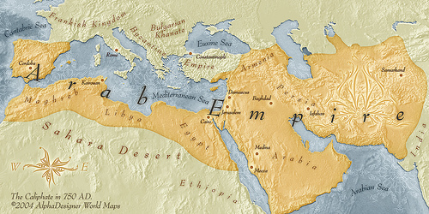
Figure 14. The Umayyad Caliphate at its highest spread ca AD 750. At that time, the main European state formations, besides the Byzantine Empire, were the Frankish Kingdom and the Bulgarian Khanate. The picture is inserted with the kind permission of Mr. Yanko Tsvetkov [55]
Although the significance of the breaking the Siege of Constantinople with the decisive help of the Bulgars has been systematically underestimated by the Western historians, the contemporary Byzantine authorities knew what deliverance they have received from the Bulgars. The Khan of the Bulgars, Tervel, was glorified as the Saviour of Europe. He was also the first foreign ruler in the Byzantine history to receive the title Caesar, which is Tsar (and, as far as I know, the only one ever). [56] This title made the rulers of Bulgaria nominally equal to the Roman Emperor.
Vows are made in storms and forgotten in calm weather. As soon as Byzantium felt safe, it resumed its violent ambition to destroy Bulgaria. The Empire tried to conquer the land using its own forces, but due to the extremely high quality of the Bulgarian warrior, it failed even though in most cases the imperial army heavily outnumbered the Bulgars. (One of the most famous example was when a 70 000 strong Bulgarian army outmaneuvered a 110 000 Byzantine cavalry leaving 70 000 of it dead on the battlefield. This happened exactly 200 years after the Siege, at the Bulgarian black Sea coast. [57]) Therefore, they had to hire money-grubbing mercenaries. In the second half of the tenth century, they succeeded in the person of Svyatoslav, the prince of the newly born Kiev Rus. He agreed to do the job for 15 000 pounds of gold. [58] An interesting coincidence is that he also managed to destroy the Judaistic Khazar Khaganate, again in alliance with Byzantium. At that time, Khazars and Bulgars, especially those of Volga Bulgaria, the remnant of the Old Great Bulgaria, were close allies against Byzantium and Rus. Although the Bulgarian and the Khazar cavalries were superior to that of the Rus in quality, Svyatoslav hired numerous experienced equestrians, which, together with his own hordes vastly outnumbered them. [59]
Svyatoslav raged North-Eastern Bulgaria and prepared her First Empire for the burial. It happened practically in 1014, after a battle, in which a 14 000 strong Bulgarian army was taken captives. [60] The Byzantine Emperor showed his despise and hatred by blinding all these prisoners of war leaving a one-eyed out of every hundred – something Bulgars have never done to a defeated enemy - and send them back to the Bulgarian Tsar. Even according to the medieval standards of war moral, this was an act with no precedent and made Basil II one of the most infamous war criminals. [61] The Tsar of the Bulgars, seeing his blinded army, fell ill and died within two days of heart attack. He was Samuel, the one I mentioned above, who had three brothers with Jewish names…

Destined not to be under the Shadow of a Roman Eagle
After having slept in the shadow of the Byzantine double-headed eagle for more than 160 years, Bulgaria came to life again in a miraculous way through a successful uprising in 1185, just 2 years before Saladin took Jerusalem from the Crusaders, thus effectively putting the end of the 88-year old Kingdom of Jerusalem. The Bulgars started to recover their past glory and especially their famous cavalry. Meanwhile, a Crusade failed to recapture Jerusalem and Pope Innocent III designed another one, the Fourth.
While Bulgaria was sleeping, some major events took place. First, there was the great Schism of 1054, which perpetuated the chasm between the East Orthodox (Byzantine) and the Catholic (the Pope) Churches. It has been forming for centuries. What is interesting with this schism is that the cause of the first major quarrel between Rome and Constantinople was the regulation of the newly established Bulgarian Church in 867. Thus, Bulgaria contributed for the division between the Christian East and West more than a millennium ago. [62]
The second most important trend in the 11th – 12th centuries was the Crusades and the establishment of the Kingdom of Jerusalem. [63] This adventure gave a good opportunity to the European West to prepare and get some experience for the colonization of the newly found lands within few centuries. The Kingdom of Jerusalem was the successful result of the First Crusade. However, due to its remoteness from the West, military forces and supplies had to be dispatched regularly. A Second Crusade was organized, along with some minor campaigns, but they were either less successful, or even downright disasters. At first, the Muslims paid little attention to the Christian activities, being occupied with internecine dynastic wars. However, some fatal errors of the Latin knights in war tactics and politics helped the Muslims realize the seriousness of the situation and try to unite against the enemy. Meanwhile, they were trying to consolidate their forces. But the circumstances of this consolidation resulted in the shift of the main Islamic region of power from the Arabic South-West (Syria – Egypt) to the non-Arabic North-East (Asia Minor and Kurdistan). For instance, Saladin, who took Jerusalem and founded the Ayyubid dynasty in Egypt, Syria, Yemen, Iraq, Mecca Hijaz and Diyar Bakr (that is, Southern Turkey), was a Kurd. [64]
More crusades have been organized but all of them exposed the difficulties in the relations between the East Orthodox (Byzantine) and the Catholic Churches. The failures of most of the crusades revealed also the tensions accompanying the formation of the West European nations. Moreover, the crusades loosened some of the most violent acts of anti-Semitism both in Europe and in the Middle East. The Fourth Crusade turned out to be remarkable with the complete redirection of the strike. Instead of recapturing Jerusalem from the Muslims, the crusaders attacked Constantinople. [65]
Byzantium was weak enough, largely due to its 20-year fruitless attempts to crush Bulgaria, to succumb. Constantinople fell in the hands of the West-European knights, who founded the Latin Empire. Bulgars were hardly unhappy seeing this and Tsar Kaloyan tried his best to be in good terms with the new neighbour. In addition, he proposed to Pope Innocent III subordination of the Bulgarian Church. The situation was unique! With a fallen Byzantine Empire and Russia still in cradle, Europe has never been so close to unity. The Second Bulgarian Empire was gaining strength and this strength could be useful for building an effective springboard for Christian domination of the East Mediterranean lands. A map showing the main political powers in the region by the time of Saladin’s seizing Jerusalem from the Kingdom could best illustrate the state of affairs.
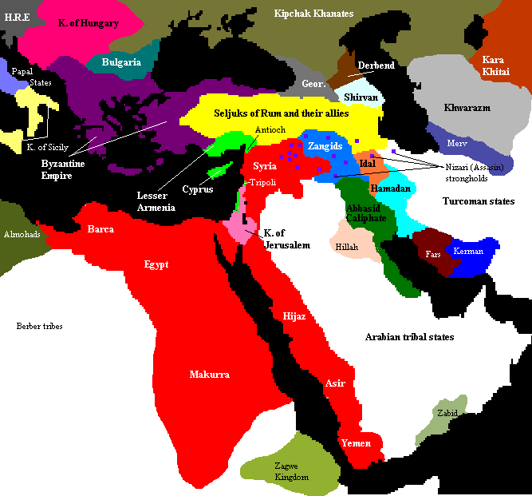
Figure 15. South-East Europe and the Middle East, c. 1190. Saladin's empire and its vassals shown in red; territory taken from the Crusader states 1187-1189 shown in pink. Light green indicates Crusader territories surviving Saladin's death. This picture is taken from the Wikipedia [66]
However, flushed with their success, the Latin knights behaved in airy manner in their relations with Tsar Kaloyan. He tried to settle the borders between the two empires. The answer was arrogant. The knights believed that having crushed the head, it would be easy thing to stamp upon the tail. The Latins declared haughtily that they do not recognize a sovereign Bulgarian state and regard the territory of Bulgaria as a legitimate part of Byzantium, which they have conquered. In a word, they said that Bulgaria is their own possession. [67] Kaloyan had no choice but to strike first… [68]
The battle took place on April 14 1205, exactly one year and one day after the fall of Constantinople. The main force of the Bulgars was the heavy cavalry. Being too young, Bulgaria had not time to create a large army and had to rely on allies’ light cavalry. Bulgaria had also her own well-trained, skilled infantry. The armies locked horns by Adrianople, nowadays’ Edirne in European Turkey, close to the point where the borders of Turkey, Greece and Bulgaria meet. On that day, Kaloyan outmaneuvered the Latins and the Bulgars crushed their heavily armed knights. Some 300 knights were killed in this battle. [69] This number may not seem impressive, but it must be kept in mind that at these times, a knight was equivalent to a modern tank and often was regarded as a symbol of invincibility. The result of the battle was devastating defeat of the Latins. Even their Emperor, Baldwin I, was taken prisoner and died in Bulgaria. [70] For the second time in their history, Bulgars decapitated a Roman Empire in the battlefield – something no other nation has ever done. (The first event happened in AD 811, when the Byzantine Emperor Nikephoros I was killed in a battle. [71])
In my opinion, the aftermath of this battle is very important although somehow neglected by the Western historians. It is true that the battle did not put immediately the end of the Latin Empire. However, the major trend as a result of this failure was turning the Western European military campaigns from the great purpose of recapturing of Jerusalem. During the several decades following the battle, instead of directing their efforts to the Holy Land, the Latins wasted their energy in clashes with the East Orthodox Greeks in attempt to keep what they had conquered in 1204-5. The Greeks succeeded in recapturing Constantinople in 1261 and, although the Latin Empire continued to exist formally for about another century, her emperors were emperors in exile. [72] Meanwhile, the Seljuk Turks were gaining strength and became the major Islamic power in the Middle East. By the end of the 13th century, the most powerful Islamic state that has ever existed, the Ottoman Empire, was born. [73] Within the next few centuries, it spread over the Middle East, Balkans and North Africa and, in 1683, the Turks even besieged Vienna.
Meanwhile, the Holy Land and Jerusalem in particular sank into oblivion. Both East Orthodox and Catholic churches taught that the Jerusalem of the New Testament is not a real geographic object but a spiritual entity. This was a suitable interpretation, which made the lives of the church leaders comfortable and easy. In the 15th century, the age of the great geographic discoveries started and the vigour of the West was directed overseas. On the other hand, the main Christian doctrines taught that the Israel of the Gospels has spiritual meaning alone, comprises the believers in the Lord Jesus only and has nothing to do with the Jews. (A significant event happened few months after the Battle of Adrianople. On July 15 in the same 1205, Pope Innocent III stated that the Jews are doomed to perpetual servitude and subjugation due to crucifixion of Jesus. One can imagine what would happen had the Bulgars failed… [74])
As for the Turks, they were disinterested in Jerusalem for two reasons, I suppose. First, the Qur’an does not mention Jerusalem explicitly even once. [75] Second, the Turks have never been in very good terms with the ethnic Arabs. [76; 77] Moreover, they provided safety for the Jews expelled from Spain. The Reformation gave new breath to the understanding of the Biblical prophecies. These new trends stirred into action the formed stalemate, which was lasting for several centuries. Many Protestants started to regard Jerusalem as a special place on the planet Earth, interpreting the Bible literally. At the same time, the Jews throughout the world turned their eyes to the Holy Land, promised to them in the Bible….
Now, looking back to this two-millennium long period, we can understand the meaning of all these events. The Lord prepared the Holy Land for His chosen people by preventing it to be possessed neither by physical Abrahamic descendants (Arabs) nor by spiritual Abrahamic descendants (Christians) for significantly long time. So, when Zionism was born in the end of the 19th century, it found a specific situation, which was a result of a two-millennium long history. The today’s state of affairs in the Middle East derives to a high extent from this extensive period. Indeed, let the reader try to imagine what would we witness in 2006 had General Allenby taken Jerusalem from an Arab instead of Ottoman Turkish commander in December 1917. [78]
A Computer or a Crystal Ball?
I knew the events described above quite well because they concern the activities of my own ancestors. However, the first time I heard of them, several decades ago, I had no idea of how much they had affected the time I live in. Now, having reassessed them, I saw their long-term significance. Indeed, the Bulgars came on the European-Middle East stage to take a significant part in the history of the last two millennia. Out of half dozen branches, only the one settled in the Balkans, survived and preserved the name Bulgar. This happened despite the enmity of the mightiest empires of the civilized world. Meaningfully, the rise of the Old Great Bulgaria coincided with the rise of Islam thousands of miles away. The battles I recounted happened shortly – within few generations – after the emerging of the Bulgars as mighty empires. Both these empires were later destroyed. Finally, Bulgaria emerged as independent state after being included for half millennium in the Ottoman Empire in the end of the nineteenth century, just in time to take part in both world wars and to show her courage in saving all her Jewish population during the Holocaust. As an overall result, Bulgaria’s role in history appeared in some mysterious way to be always beneficial for the Jews.
When I looked at these historical events forming a long-term sequential development as a hidden code in the Torah, I realized that I was seeing something new. Indeed, it is one thing to have a ‘device’ allowing views from infinite number of directions and offering a specific picture to each one of them. It is another thing to watch a ‘full-length film’ showing details in dynamics. It is one thing to have a person intentionally doing something specific at a certain moment. It is another thing to have millions of people behaving coherently in the course of at least two millennia. Note that this does not include acting in a synchronized way only. Some of the groups of these millions of humans have been separated by many generations and have been unaware of what other groups before them have done. Finally, they had no idea of how their activities would affect the overall situation in the world in the beginning of the 21st century.
This analysis seemed to make the reductionist approach inappropriate and suggested the emergent character of the Bible codes as more plausible explanation of this phenomenon. This means that instead of inserting predetermined events in the beginning, the Lord God has created the circumstances, as both initial conditions and the frame of their possible time-dependent dynamics, which exploit whole assemblies of free wills of vast masses of humans and result in what He has had in mind. The Lord Jesus in the parable of sowing seeds and the parable of the weeds best illustrates this idea (Matt. 13). Amazingly, this same approach finds recently its application even in modern physics. [79]
The emergent character of the Bible code I have witnessed convinced me finally that the Word of God, and especially the Torah, possesses characteristics of a quantum computer. It ‘works’ in the same manner the human brain works. Therefore, I continued searching for more evidence supporting this idea. Because we know that quantum computation has recorded positive results in factorizing and searching for images, I concentrated my attention in these two aspects.
I had the fig (tree). But at the moment I recalled this word while writing these lines, a sudden thought stopped my hand. I took the numerical value of the fig, 456, as granted for signifying this particular word. However, there are some 100 more words with the same numerical value! I have checked for suitability not even one of them. Should I start checking them all, one-by-one? Or should I discard it and do not mention the skip value at all? … My mind was frustrated for few seconds only. Almost immediately, I realized that there is something, which distinguishes the ‘fig’ not only from the words I could find in a dictionary, but also from any other 4-letter Hebrew word with the numerical value of 456! The key is the name Aaron, אהרן. Three of the letters of אהרן, aleph, hey and nun, are present also in the fig, תאנה. Therefore, ‘fig’, תאנה is the only 4-letter Hebrew word with numerical value of 456, which one can construct using three – the maximum number - of the letters of ‘Aaron’, אהרן! What a magnificent way to blend number and image to point to the Time of the End!
Factorizing
As I mentioned before, factorizing is finding the prime multipliers of a compound number. For instance, the prime multipliers of 15 are 3 and 5: 3×5 = 15. 256 is a power of 2, therefore it has no other prime multipliers. The number I thought as interesting for search was, therefore, 456.
Two of the letters in each one of the names Aaron, אהרן, Bulgaria, בולגריה, are common for both names. These are hey, ה, and reysh, ר. Then I noticed that the place of Aaron’s death, Mount Hor, consists entirely of these two letters: ההר הר! I checked the occurrences of Mount Hor in the Torah. It appears twelve times in the Torah, five of which are within the several verses describing the death of Aaron. This is the highest concentration of these words in the plain text of the Torah. Do we have another basin of attraction? (See Figure 16.)
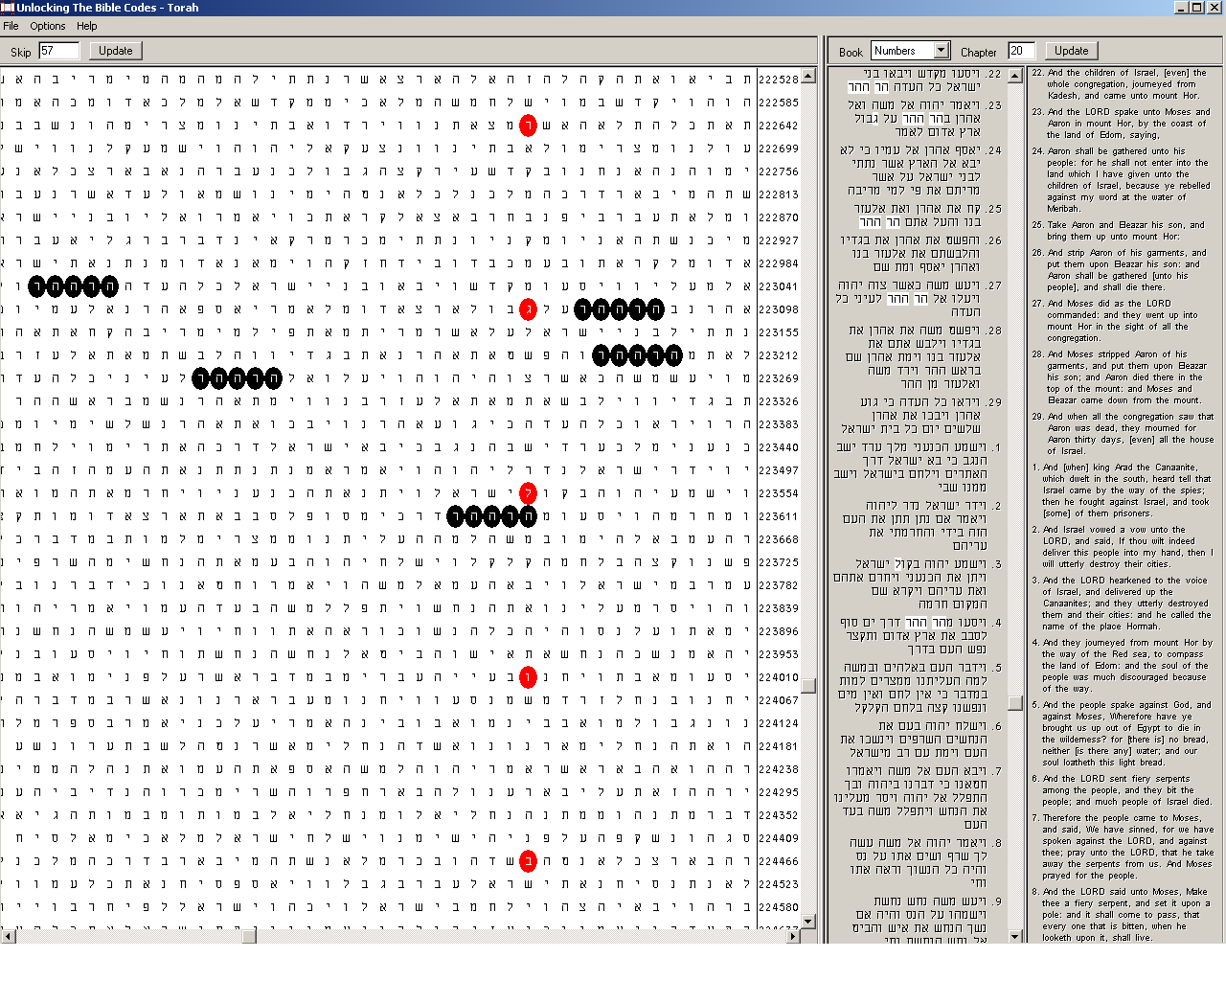
Figure 16. Bulgaria (בולגריה), red ovals, at the lowest skip in the Torah, -456; and Mount Hor (ההר הר), in the plain text, black ovals. The skip of the matrix is 57. For the sake of clarity, the matrix is cut after the fifth letter of Bulgaria.
We already have 14 occurrences of Aaron in the plain text comprised by Bulgaria at her lowest skip. Now we have 5 occurrences of Mount Hor as a string in the same passage. The sum of these numbers is 14 + 5 = 19. Nineteen is one of the prime multipliers of 456: 456 = 19×24. Moreover, if we count Mount Hor as two separated words – which they are in fact – the overall number of words in the passage; Aaron (14), Mount (5) and (of)Hor (5) will become 24. This is the complementary multiplier of 19, though not a prime, yielding 456.
Search for Images
The finding of the multipliers of 456 encouraged me in the next stage of the research: image(s). This is a good hint at the links between skip and image. The peculiarity in this aspect is that images may possibly be absent from the matrices. They may be present in subtle, mysterious way, through their numerical values. Well, we have the fig. Does it exhaust the subject? I pondered on this question and noticed that the number of the letters in all occurrences of Aaron, אהרן, in the plain text of the matrix is 14×4 = 56. But it is a unit less than the skip of the matrix, 57. This fact immediately made me recall the important key connecting the numerical value of a hidden word or expression with certain skip ±1. The question was what image we will look for.
The image, which is most characteristic of Bulgaria, is the Lion. This animal is present in the coat-of-arms of Bulgaria since times immemorial. In addition, it is always in the rampant posture! [80] All three lions in the Bulgarian coat of arms are rampant. [81] Although rampant lions are not an unusual object in coats of arms, in most cases they are accompanied by other figures such as men, eagles, unicorn, etc. Usually, they are also ornamented with various accessories. Coats of arms consisting entirely of lions with minimum additional accessories are rare indeed, especially when the lions are three. The only other coat of arms of a modern independent state containing the same characteristic, which I managed to find, is that of Kingdom of the Netherlands. [82] So deep the image of the lion is imbedded in the Bulgarian identity that the lion has given his name to the Bulgarian currency, lev.
I looked for parallels and found a striking similarity between an old coat of arms of Bulgaria and the modern coat of arms of Jerusalem. They are shown in Figure 17.
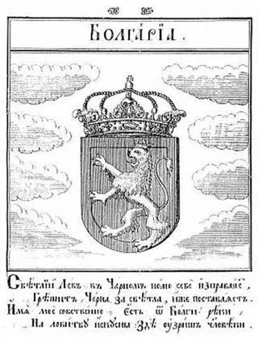 | 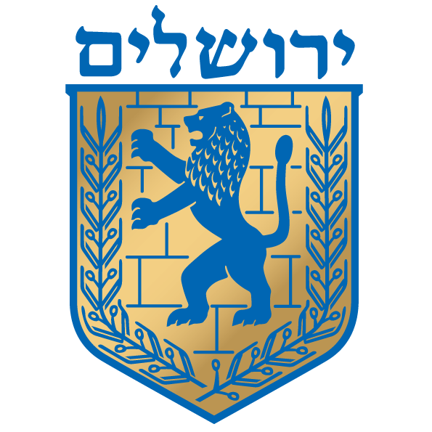
Figure 17. Two rampant lions. An old coat of arms of Bulgaria (left) and the emblem of modern Jerusalem (right). The coat of arms of Bulgaria is from a book printed in 1741 in Vienna, Austria. [83] The coat of arms of Jerusalem is taken from Wikipedia [84].
The Second Bulgarian Empire was destroyed by the Ottoman Turks in the end of the 14th century, i.e. some 350 years before the printing of the book cited above. By the middle of the 18th century, Bulgaria was an obscure province in the Ottoman Empire and the Bulgars were not even recognized as a people (Turkish, millet) by the Sultan. Therefore, this image certainly reflects the sweet memories and even sweeter dreams of a nation rather than a real situation. At that time, Jerusalem was a backwater in the same Empire. Taking into account that borrowing is unthinkable, this similarity seems to me even more mysterious.
The next step apparently was to choose the Hebrew word for lion. There are several words for lion, but the main candidates are אריה and לביא. I did not need a long time for searching. In fact, I found the answer outside the Bible, in the Wikipedia while browsing for the coat of arms of Jerusalem. The emblem of Jerusalem is actually the Lion of Judah. [85] There, I read the words that gave birth to the image. They are the words of blessing of the Patriarch Jacob addressed to his son Judah in Genesis 49:9. Jacob calls his son Judah Young Lion, Gur Aryeh Yehudah:
יהודה אריה גור
The numerical value of this phrase is 455. This is exactly the length of the ‘tunnel’ – the value of (skip – 1) - of the lowest skip of Bulgaria in the Torah, 456! It seems that אריה is obviously the Hebrew word of choice for lion in our case. It starts with the first letter of Aaron and ends with the three final letters of Bulgaria, in the proper sequence at that. Moreover, with the exception of a dalet, ד, in the name of Judah, all the other six letters constructing the 12-letter phrase above take part either in the name of Aaron or in the name of Bulgaria or in both names. In truth, only nun, נ, is missing from Aaron and beyt, ב, and lamed, ל, are missing from Bulgaria. In my opinion, this fact adds to the hypothesis that there is a link between numerical values of letters – that is, their position in the alphabet – and the tunneling effect responsible for the emerging of images in a computation performed using these letters. We can see here another type of strange basin of attraction…
(While continuing my main work, I haven’t left off thinking on the ‘emerging’ dalet in the phrase above. I have always believed that the Lord has encoded absolutely everything perfectly and even the tiniest detail is of significance. I felt that dalet must be linked somehow either to Aaron or to Bulgaria. Finally, I found something very interesting. Aaron’s sons Nadab and his brother Abihu died before the Lord (Leviticus 10:1-2). They were prominent Jewish leaders. Dr, A. Rotenberg has found significant codes about them. [86] What is interesting in our case is that the spelling of their names in Hebrew consists entirely of letters of the names of Aaron and Bulgaria, with only one exception: a dalet in the name of Nadab! Here are the spellings of these names as they appear in the plain text of the Torah:
Nadab, or Nadav = נדב ; Abihu, or Avihu = אביהוא
What is more, the numerical value of the name of Nadab is 56, which is the length of the ‘tunnel’ in our ‘smaller-skip’ matrices in Figures 13 and 16. What a hint to the phenomenon of ‘tunneling’ and its significance in the Bible code studies!)
To be honest, this finding much surprised me although I have anticipated it to some extent. However, after I had this result, I decided to look for אריה in the matrix. I checked the term using the key I had found before (see Figure 10) because this 4-letter word will surely appear many times with arbitrary skips. Therefore, I fixed the skip to ±256, the numerical value of Bulgaria. To my amazement, it occurred twice in a very close proximity to where Bulgaria is encoded at her lowest skip! I wanted to see the picture as clearly as possible, so I choose a skip of the matrix that is multiple of 256 and sufficiently close to skip of the matrices I have already found. Therefore, I picked skip 64. (See Figure 18.)
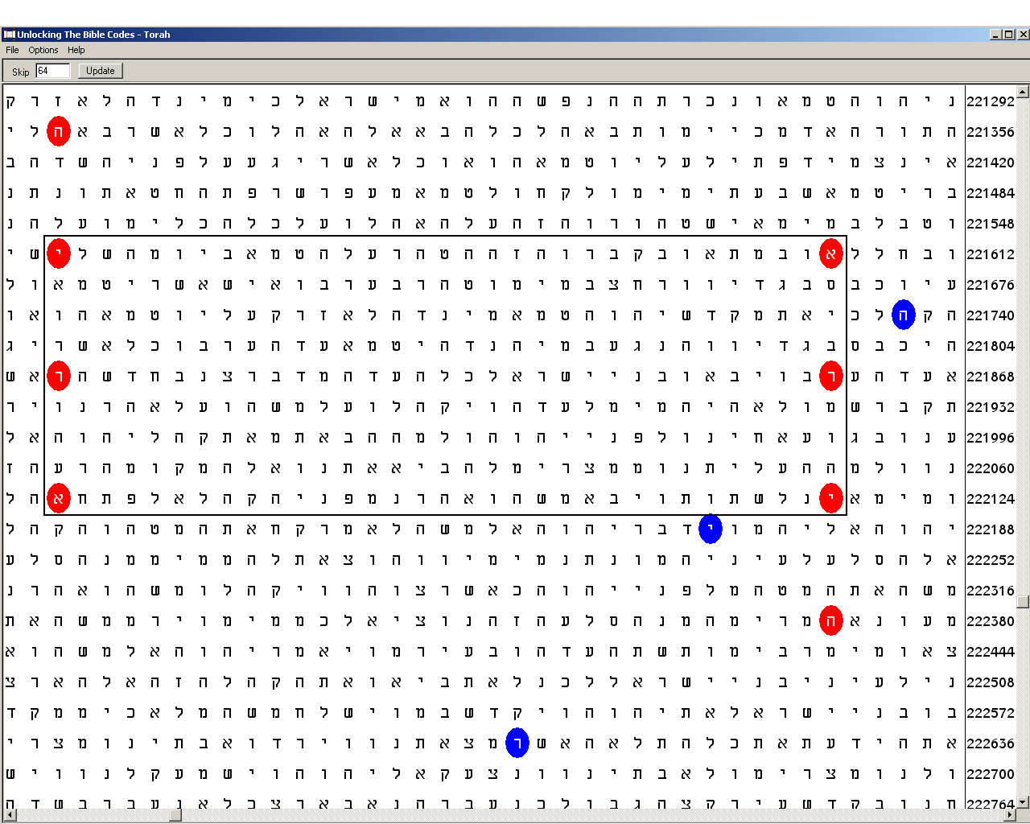
Figure 18. Bulgaria (בולגריה), blue ovals, at the lowest skip in the Torah, -456; and Lion (אריה), at skips -256 (left) and +256 (right), red ovals. The skip of the matrix is 64. The matrix includes the three final letters of Bulgaria: reysh, ר, yud, י, and hey, ה. The 3-letter words opposing each other within the box are the alternative singular form of lion, ארי.
What is remarkable with the picture we have obtained is that this is the closest consecutive pair of occurrences of אריה at skip ±256 in the Torah! The overall number of occurrences of ‘lion’ at this skip is 34. (An interesting detail: The numbers of occurrences in the Torah of Bulgaria, 21, and of Lion at skip ±256, 34, are two consecutive Fibonacci numbers.) I checked the statistics. The odds of occurrence of ‘lion’ twice at skip ±256 in the text comprising the occurrence of Bulgaria with the margins on both sides – what I had anticipated - are about 1 in 300. However, what surprised me was that the occurrences are close to just those three final letters of Bulgaria, which are also the three final letters of ‘lion’. If we confine the calculations within the text of the matrix above, the standard deviation obtained was 6.66. I ran the Keys to the Bible program, checking the SD for the two occurrences of אריה at the fixed absolute value of the skip = 256 between Numbers 19:13 and 20:17 including. If we assume normal distribution, the odds fall dramatically to below 1 in a billion. [87]
There is another interesting fact about these two occurrences of אריה. In the plain text, the first letters of each occurrence are 224 positions apart. Because the absolute value of the skip is 256, each letter of the second word is 224 positions after its respective letter of the first word and 256 – 224 = 32 positions before the following letter of the first word. But the skip of the matrix is 64. Therefore, the ‘lions’ are exactly opposite, vertically and ‘facing’ each other across the cylinder around which the plain text is coiled. This symmetry is reminiscent of the symmetry of the two supporting lions on the both sides of the throne of Solomon in the plain text of the Tanach (1 Book of Kings 10:19-20). I was greatly amazed when found similar geometrical structure of vertically parallel lions encoded in Genesis and discovered by Dr. A. Rotenberg. [88] In his book, he notes that ‘[S]uch a structure might be a source of additional information and should attract our attention’. [89]
I had an idea in my mind about what such information could mean about Bulgaria, but I was still far from definite result and therefore I could not draw a proper conclusion. I had to study what I have found first. While contemplating the matrix delightfully, I noticed that three of the letters of each of the ‘lions’ opposing each other on the same row are actually the shorter singular form of lion: ארי! The latter finding tickled my curiosity and I checked about another occasion of the same configuration exactly 32 positions apart with all 326 occurrences of ארי at skip ±256 in the Torah. There was none!
However, there was still something confusing in this picture, which dissatisfied me. Bulgaria is skewed at skip 64. Moreover, while examining the other occurrences at this skip, I found another pair of ‘lions’ closer to each other. This fact intensified my frustration. I felt that something had to make the case out. The only property coming up to my mind that was capable to restore the harmony was the symmetry. Therefore, I rearranged the matrix at skip 57. The symmetry was preserved! The symmetry of every other pair was destroyed at this skip. What is more, 57 appeared to be the only skip of the matrix, at which the symmetry is apparent (see Figure 19). It is absent in matrices of skips several numbers below and above 57.
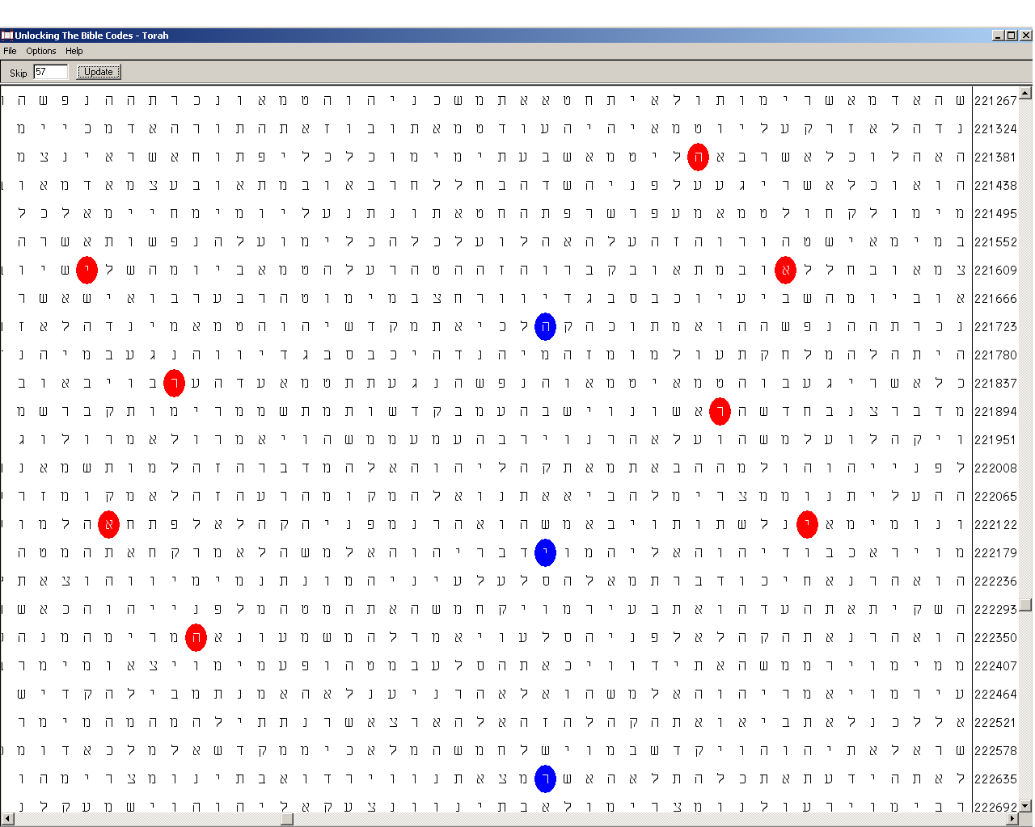
Figure 19. 57 is the only skip value of the matrix that preserves the symmetry of the red ovals in relation to the column containing (here, the final three letters of) Bulgaria. The figures to the left and the right of the column consist of 2 letters of each occurrence. Starting with skip 63, the symmetry in the matrix is lost, to reemerge at skip 57 showing this amazing pattern. It disappears again at skips below 57.
In addition to the symmetry, the red ovals are compact: they occupy small space, especially when we take into account that the column with Bulgaria is in-between. I checked the compactness in terms of extreme rows × columns product containing the red ovals at different skips. I started with skip 64 (Figure 18), where the product is 17×33 = 561, and went down to skip 52. The next smallest rectangle is that in Figure 19: 18×34 = 612. Then, at skip 51, smaller area was obtained, but the string containing Bulgaria was in the other compartment. At that point, I stopped searching. The picture above is already something resembling a greater coat of arms!
With the three blue ovals containing the final letters ריה of lion in the middle denoting smaller lion and the two larger, ‘supporting’ lions on both sides, I immediately saw clearly the idea that was dormant and hazy in my mind… I can’t help recognizing in the matrix the reminiscence of the coat of arms of Bulgaria. (See Figure 20.)
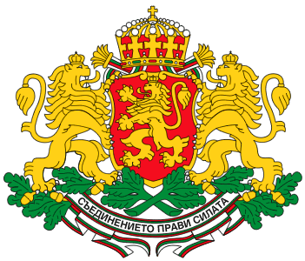
Figure 20. Three rampant lions in the coat of arms of Bulgaria. Although designed in the manner of the existing coats of arms of the older European states in the late 19th century, Bulgaria has preserved certain characteristics through the long ages. These typical peculiarities are mirrored in her coat of arms, whose purpose is to emphasize them and to distinguish her from any other state. [90]
Iron, Bronze and Essential Oil
I compared the found with the characteristics of quantum computation. Indeed, what we found includes some of the major peculiarities of quantum phenomena such as basins of attraction, superposition, tunneling and minimum principles. All these reveal themselves in beautiful symmetries. The only quantum mechanical property I couldn’t define clearly shown up in our study was entanglement, that ‘spooky action at a distance’ in Einstein’s derisive words. [91] Entanglement could be seen in the complementary binding with reciprocal numerical value/skip in the God/The words key and the occurrence of the two lions in the matrix with Bulgaria. But it can also be expressed as the opposite signs of the 256 skips of the same lions, especially these of the shorter form ארי, which stand in ideal symmetry.
Entangled things are those, which are caught together very tightly. I had this thought in mind, while trying to answer to the last question that bothered me: Why the lowest skip of Bulgaria in the Torah is negative. There is no moral implication in this question, of course. I do not believe that the positive skips define ‘good’ aspects, while the negative skips define ‘evil’ ones. I was looking at this characteristic from purely physical and mathematical angles. If there is something defining the negative skip in the basin of attraction, isn’t there an entity bound with it, existing elsewhere in the Torah, which bears the characteristic of negative skip?
Intrigued by what I read about the Khazars and their records of genealogy, which mention Bulgar, I searched for this name, בולגר, encoded in the Torah. To my greatest surprise, it appeared twice at skip -1! Although the odds for occurrence of Bulgar at skip ±1 are below 1 in many millions (SD = 6.17), a significance could hardly be derived because such occurrence reflects a specific in the plain text. However, there is no such occurrence outside the Torah…
I checked the places of occurrence. It turned out that the phenomenon arises from the fact that Bulgar is a part of the Hebrew word רגלו, his foot, which occurs eight times in the plain text of the Torah. The two occurrences of Bulgar are due to the beyt, ב in the beginning of the next word. Interestingly, this happens with the first and the last of these eight occurrences! The first one is in Genesis 41:44, when Pharaoh says to Joseph: I am Pharaoh, but without your word, no-one will lift hand or foot in all Egypt. The second one is in Deuteronomy 33:24, where Moses says about Asher: Most blessed of sons is Asher; let him bathe his foot in oil. In this verse, his foot is the last word. The first word of the next verse, which is a continuation of the blessing, is iron, ברזל, which provides the beyt.
When I saw all this, I hardly believed my eyes! Bulgaria stepped upon the stage of history right in the moment when the bronze in the image king Nebuchadnezzar dreamed turned into two iron legs. My Hebrew is not very good but as far as I could conclude from the dictionaries, it seems that in Modern Hebrew, רגל is used in this form to denote leg rather than foot. There is a subtle difference between these two words, I believe. While feet in some aspects could define individual, static character, e.g. when used as support or measure, legs usually are regarded as a pair because they are more often associated with motion than feet. For at least millennium and a half, Bulgaria have been an enemy to the Roman Empires and managed to kill or take captive two of the heads of Roman Empires. What is most interesting, they were Emperors of the East (Byzantium) and West (Latin) ‘issues’ of the ancient, original Roman Empire.
In the spiritual sphere, Bulgaria remained under the influence of the Greek East Orthodox ‘bronze’, but facilitated the schism between Rome and Constantinople. Finally, one of the products obtained in Bulgaria and famous with its best quality worldwide is the rose oil.
Therefore, Bulgar appears to be linked with the land of the Balkans where Bulgaria was established long ago and where the name Bulgar survived the vicissitudes of history. Consequently, has the skip -1 of Bulgar defined the negative skip of Bulgaria in a basin of attraction in a distant zone of the Torah (or vice versa?) to emphasize the code? And, if the answer is ‘yes’, is this phenomenon analogous to the quantum entanglement? While trying to find the answer, let us delve deeper into the harmony of the numbers and symmetries.
Variations on Sudoku Theme
Lets us start with a question: Why the numerical value of Aaron and Bulgaria is exactly 256. Is there something that makes 256 outstanding among other numbers?
Everyone shopping auxiliary memory devices for computers, cameras or other, would have noticed that the labeled memories contain numbers such as 32, 64, 128, 256, 512, 1024… The common in these numbers is that they are successive powers of two. Why the manufacturers use powers of 2 instead of the better known 10? The reasons are economical. Computers, as we mentioned above, work exploiting the binary system of 0’s and 1’s only. Therefore, every memorized number is expressed as a string of 0’s an 1’s, whose length is equal to a power of 2 in the same manner as the number of the decimal digits defines a power of 10. As the capacity of 10³ = 1000 is the 1000 numbers from 000 to 999, the capacity of 2³ is 8 numbers from 000 to 111, which in the binary system is 7. Now, if we have 718 objects, which have to be identified in the decimal system, we will have to use at least a 3-digit code. In this case, however, 282 numbers will be vacant. The capacity will be full only when we have the maximum number allowed by the 3-digit code, 1000. Manufacturers always do their best with their products, so they put forward the maximum a device can offer. This is why the size of the supplied memories is always a power of two.
Expressed in binary system, 256 is a unit followed by eight noughts:
100000000
What makes 256 special even in the binary system is that it is 2⁸ = 4⁴ = 16². Note that the base number 16 is 4 squared, which, in turn, is 2 squared. The powers themselves form a sequence of powers of 2: 2¹ = 2; 2² = 4; and 2³ = 8. This characteristic plays a major role in some algebras and other mathematical constructions and physical theories. [92] The importance of this characteristic could be seen in the calculators all computers have as accessories. Besides the normal decimal application, they offer two more applications for octal (base 8) and hexadecimal (base 16) calculations, which are more suitable in some cases. Computers widely use the hexadecimal system in expressing string representation of bytes. [93] Therefore, 256 is the next candidate for facilitating computation! 2, 4, 16, 256 – it seems that the sequence does not increase rapidly. But the next member of the progression is 2¹⁶ = 4⁸ = 16⁴ = 256² = 65536! In general, looking at this row of numbers, we can see why 256 occupies so much important place that even the number of the colours in our computer video memories that could be displayed at once are 256 – as we see, quite enough for making realistic representations of the most beautiful views and faces… [94]
The link between 16 and 256 emerges also from a widely known puzzle: Sudoku. Many readers will certainly be surprised to see that this brainteaser derives from one of the fundamental principles of computation, the NOT operation. It is carried out by an elementary device called logical gate. When a bit enters the gate, it changes its value. Because there are only two digits in the binary system, if 1 enters the gate, 0 comes out and vice versa, as shown below:
IN | 1 | 0 | OUT | and | IN | 0 | 1 | OUT
We can construct a symmetric cluster of such gates, in which the gates are interlinked so that a gate has common input with another gate and common output with a third gate. In addition, unlike the classical computers, inputs could be also outputs and vice versa depending on where a number is inserted first. Input is the square in which a bit is inserted first. The smallest cluster consists of four such gates, two rows and two columns as shown below:
1 | 0
0 | 1
We need to insert a 0 or a 1 in whichever square to define the places of the other three digits. Although seeming simple, this principle generates a very interesting phenomenon, which is deeply linked with computation. Let us take one of the elementary squares and divide it in four, thus obtaining the larger square in miniature. Instead of inserting two digits, we will fill the four squares with four different digits. Now, of course, we cannot apply the NOT operation within the square:
1 | 2
3 | 4
However, the NOT operation becomes possible in a mysterious way. The phenomenon emerges again when we combine the square above with three more similar squares and preserve the symmetry:
1 |  |  | 4
 | 2
 |  | 3
If we insert 1 in the square as shown above, the shaded squares become forbidden for another 1. The other three numbers can occupy them if the same rule is complied with in relation to each one of them. The unoccupied clear squares are not forbidden for inserting 1. This operation repeats on every next move. However, solving the problem of inserting proper numbers in each square so that this rule is complied with to the end requires considering the distribution of all four numbers in parallel. This is the second level of complication of the phenomenon. This step is so small that the problem of filling the squares is a no-brainer. The four numbers I have dispersed above define uniquely the positions of all the numbers in each square and the whole cluster. Notice that the numbers displayed above are one fourth of all 16 elementary squares. This is exactly the same proportion as in the simplest example above.
Here we can see the development of the phenomenon. Instead of an input and an output, the ‘gate’ has four openings. It goes out of the small square and stretches to the end of the cluster. The form of the ‘gate’ outside the generating square is like a pipe with orifices, whose number is the same, four, and which allow the input of numbers under the condition that they enter the gate once only.
The next step in complexity is the Sudoku itself. It consists of nine 3×3 squares containing the numbers 1 to 9. The leap is enormous. Sudoku is so much sophisticated that even World championships on solving Sudoku problems have been organized. It is a brainteaser indeed! We can see the general formula comparing Sudoku wit the simpler manifestations of the same phenomenon. If we consider the input aspects of the devices only, the smallest cluster consists of four 1×1 squares. The next cluster consists of four 2×2 squares. Sudoku consists of nine 3×3 squares with 81 elementary squares. Therefore, the next level will consist of sixteen 4×4 squares containing the numbers 1 to 16. The number of the elementary squares of this super-Sudoku is… 256.
Next, we can construct mega-Sudoku out of twenty five 5×5 squares with overall number of 625 elementary squares, then thirty six 6×6 squares with 1 296 elementary squares and so on, every next a-level-up-Sudoku square consisting of n⁴ elementary squares, where n is a natural number.
I took up this apparently side issue for a purpose. The emergent character of the phenomenon fascinates me. Indeed, we have composite squares filled with numbers according to a rule. This rule is complied with on a higher level in a space constructed of the same smaller squares. A number occurs once in a row and a column within its own square and at the same time, once in a row and a column in the large square. Thus, the phenomenon expresses itself in a larger scale. In this aspect, Sudoku offers a clear picture of how local order spreads across the whole structure. Indeed, if we are shown a large square consisting of a grid of small squares filled with numbers, we could think initially that they are randomly scattered. Only when we know the rule for the inserting of a number in each square, we will be able to evaluate whether they are filled according to the rule or not. Therefore, an apparent chaos might be in fact a hidden order. On the other hand, there could be more than one way for filling the squares in accordance with the rule.
I found a remarkable confirmation of such phenomenon in TQB. A device has been designed consisting of programmable gate arrays for distinguishing two musical tones. In the device’s ‘language, this means to discriminate time data without the use of clock or oscillator. Eventually, the system evolved an ability to discriminate perfectly between the two tones. The device consisted of one hundred gates. When the researchers traced the evolved connections , thy found that only 32 of them were connected at all. Yet if they removed any of the non-connected gates from the array, the device failed. No-one was able to give an explanation of this phenomenon. [95]
In the example above, we have 32 out of 100, i.e., 32.0% of the elements staying visibly connected. The remaining elements were connected in an unseen, ‘spooky’ manner. Now, in a good, not very easy Sudoku puzzle, the given numbers are usually between 24 and 28, i.e. 26 in average. Well, 26 are 32.1% of the total number of 81 squares…
This example provides a significant evidence of the phenomenon manifested in the system as a whole. However, there is more. Sudoku is of a good help for understanding the entanglement. There is a very simple logical operation called controlled-NOT. [96] It makes two bits to have ‘mutual information’ in the following way. Suppose we have a bit of unknown value. It could be either 0 or 1. Now suppose we have a second bit, whose value is known to be, say, 0. The logic operation is as follows. It changes the value of the second bit, that is, flips it, only if the value of the first bit is 1. Thus, we obtain one of two possible states: either 00 or 11. Notice that each of these two states requires two squares to position each bit in it. This result is obtained when the logical operation is applied in classical computational way.
A profound difference occurs, however, when this logical operation is applied on quantum bits, or qubits. Qubits contain the same quantity of information as the classical bits but they conform to the quantum mechanical laws. Because of the superposition states two particles are in, here, the analogue of the controlled-NOT logical operation results in a correlated state 00 + 11 (written considerably simplified!) [97] The plus symbol means that state is indivisible but must be considered as a whole. Therefore, we need now four squares to position each individual component of this correlated state. This is illustrated as the basic square generating Sudoku.
0011 | 0011
0011 | 0011
Each square contains all four components of the superposition. The greyness is two times lighter than that of the shaded component squares above but is spread over the whole large square instead, thus preserving the colour ‘quantity’. In addition, the numbers are typed paler to emphasize the quantum fuzziness. Although the qubits, that is, the particles, are two, they are in a superposition, which, if disturbed, or de-cohered, forces each one of its components to be in a definite state. Then, each qubit will occupy one square as in the example shown earlier. However, even when a quantum system as a whole is in a definite state, its pieces do not need to be in a definite state. When the parts of a quantum system show themselves up, they occupy a definite square with the corresponding colour.
This property of the quantum systems is called entanglement. Due to it, quantum mechanics, unlike the classical mechanics, can create information out of nothing. [98] As discussed earlier, in the Section “Ordered Chaos Springing from the Quantum World”, when the outcome of an event becomes clear, it gives information about the outcome of its entangled event. Skips in Bible code matrices are either positive or negative. They are a good analogue to any event with two possible outcomes, as the 0’s and 1’s of the examples given here. What directed my attention to this analogue was the fact that it expresses itself in the four-square core of the Sudoku game. The numerical value of Bulgaria is 256, one of the ‘Sudoku’ numbers. On the other hand, Bulgar occurs at the negative unit skip -1. These two names are obviously associated. Why the signs of their lowest skip values would not be entangled?...
The Word Becoming Flesh
Is what we have found about the similarities between the Bible code and the quantum computation strong evidence that the Torah is a quantum computer? I believe that the answer is positive. We have found practically all characteristics of quantum computation in the examples given above. In the example with Aaron and Bulgaria, we have proved that the Bible code possesses emergent character, i.e. it appears out of layers, which have been considered chaotic as far as these layers do not differ from the similar layers of the any other written text, whether in Hebrew or another language written with phonetic alphabet. These layers are the zones of skips above few dozens, where no traces of order have been found in all examined texts, the Hebrew Bible including. I have run the names of Bulgaria and some other names of states, which are similar in length and composite letters. I have used the CodeFinder program [99], which has an option for research of control texts of the Torah and the Tanakh. These texts consist of the same letters as the Word of God, but the letters are scrambled in a random way. Two parameters have been examined: the number of occurrences and the lowest skip. Standard deviations have been calculated for each case based on the expected vs. found values. SD values 3.00 or greater – meaning odds of the deviation from the expected about 1 in 370 or lower - are shaded. The results are presented in Tables 1 and 2.
Table 1. Results obtained in the Torah and the Torah control text with number of occurrences and absolute values of lowest skips for four 7-letter states.
 |  | Number of Occurrences |  |  | Lowest Skips
Torah |  | Expected | Found | SD | Expected | Found | SD
Britain | בריטניה | 13.34 | 6 | 2.01 | 4.4114 | 1 (9240) | 1.62
Bulgaria | בולגריה | 23.04 | 21 | 0.43 | 0.4119 | 1 (456) | 0.92
Hungary | הונגריה | 25.90 | 34 | 1.59 | 0.3841 | 1 (378) | 0.99
Norway | נורבגיה | 15.09 | 14 | 0.28 | 0.3426 | 1 (580) | 1.12
Torah Control Text
Britain | בריטניה | 13.34 | 16 | 0.73 | 0.0671 | 1 (128) | 3.60
Bulgaria | בולגריה | 23.04 | 22 | 0.22 | 0.4748 | 1 (526) | 0.76
Hungary | הונגריה | 25.90 | 31 | 1.00 | 0.1324 | 1 (130) | 2.38
Norway | נורבגיה | 15.09 | 16 | 0.23 | 0.6634 | 1 (1129) | 0.41
Table 2. Results obtained in the Tanakh and the Tanakh control text with number of occurrences and absolute values of lowest skips for four 7-letter states.
 |  | Number of Occurrences |  |  | Lowest Skips
Tanakh |  | Expected | Found | SD | Expected | Found | SD
Britain | בריטניה | 203.26 | 191 | 0.86 | 1.039 | 1 (512) | 0.04
Bulgaria | בולגריה | 487.91 | 489 | 0.05 | 1.030 | 1 (210) | 0.03
Hungary | הונגריה | 477.14 | 527 | 2.28 | 0.744 | 1 (156) | 0.30
Norway | נורבגיה | 304.41 | 322 | 1.00 | 0.0092 | 1 (3) | 10.35
Tanakh Control Text
Britain | בריטניה | 203.26 | 198 | 0.37 | 3.02 | 1 (1491) | 1.16
Bulgaria | בולגריה | 487.91 | 484 | 0.18 | 0.3130 | 2 (26; 64) | 3.02
Hungary | הונגריה | 477.14 | 479 | 0.09 | 0.9490 | 1 (199) | 0.05
Norway | נורבגיה | 304.41 | 285 | 1.11 | 0.0122 | 1 (4) | 8.94
All four significant deviations occur with lowest skips. The largest two of them, at odds drastically under 1 in a billion, are obtained with Norway, but the curious fact is that these deviations occur once in the Tanakh and once in the scrambled text of the Tanakh. Both other deviations at odds below 1 in 370 with Britain and Bulgaria are in control texts. The aftermath is 3:1 ratio of deviations with SD bigger than 3 in favour of the scrambled texts! In the case with Bulgaria, I found a second occurrence at abnormally low skip, which increases the SD value obtained with the occurrence at lowest skip.
There is a peculiarity in the experiment above. Besides Bulgaria, the other three names consist of the same seven letters plus nun, נ – in all three of them - and tet, ט – in Britain. Therefore, these three names seem to me appropriate for a comparative study. One of them, Norway, נורבגיה, differs from Bulgaria, בולגריה, in one letter only: Bulgaria has a lamed, while Norway has a nun instead (marked in red). In the aspect of shared letters, Norway is even closer to Aaron than Bulgaria, although its numerical value differs by 20 units: 276. I checked the matrix at Norway’s lowest skip. It occurs in a place close to the occurrence of Bulgaria: from Numbers 11:26 to 14:13. However, there is no match to the picture obtained with Bulgaria. Aaron appears eight times in the plain text defining the code, but on a three times larger area at skip 145, which is analogous to the skip 57 in the Bulgaria matrix. I can offer nothing clearer to the reader but the matrix itself in Figure 21.
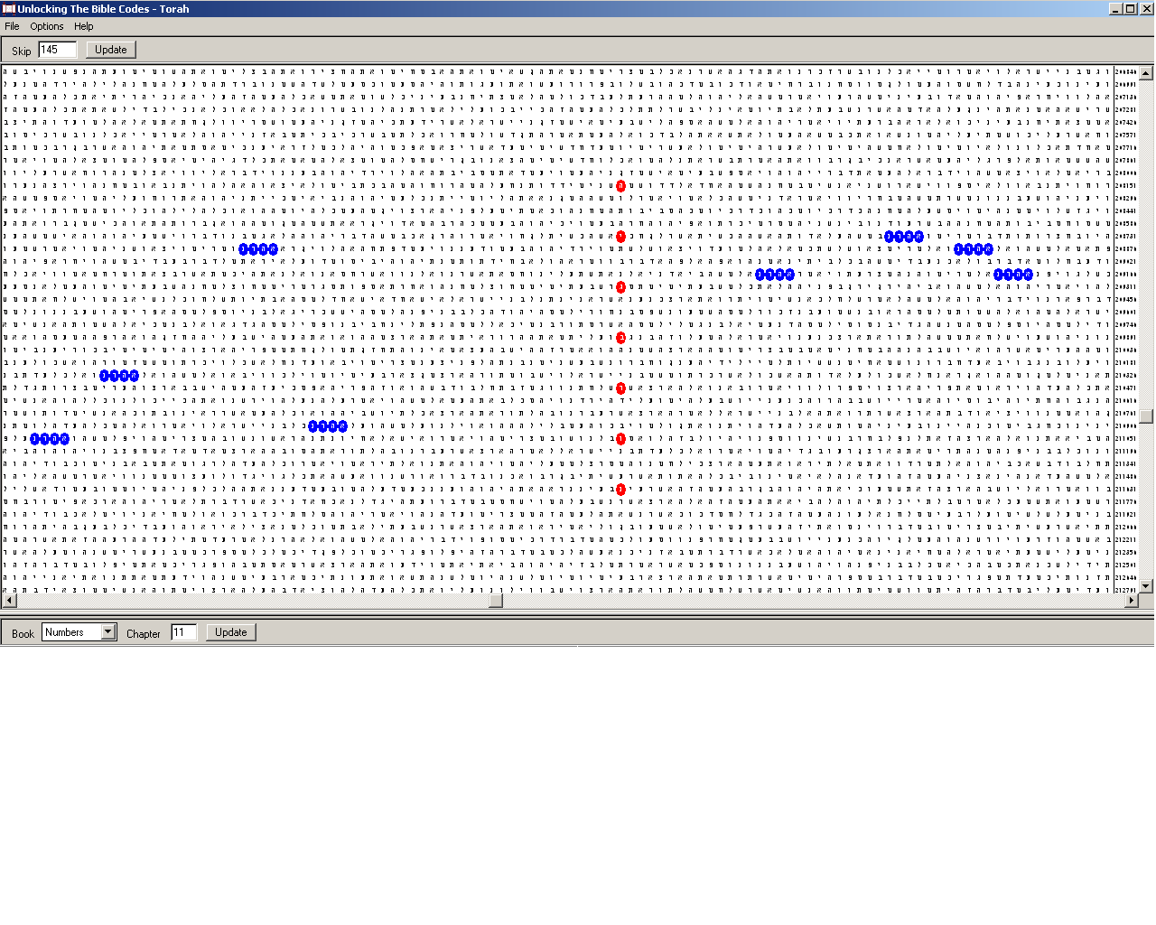
Figure 21. Norway (נורבגיה), red ovals, at the lowest skip in the Torah, 580; and Aaron (אהרן), in the plain text, blue ovals. The skip of the matrix is 145. This matrix obtained with Norway shows the closest resemblance one of the three names of states generate to a matrix with Bulgaria.
I checked also for lion, אריה, at skips equal to the respective numerical values of these three names but found nothing even distantly similar to what I found with Bulgaria.
Then I asked myself what defines the codes in the aspects wee have considered them? At first thought, the answer is simple: the numerical values of the letters. Without them, these codes would be meaningless although the figures will be still there! Let me clarify myself. Suppose that instead of alphabet, we have betalpha, that is, we exchange the places of the first two letters in the Hebrew alphabet. Thus, beyt, ב, will have numerical value 1, while aleph, א, will be 2. This move would destroy the whole structure! Indeed, if so, a link between Babylon, DNA and 666 would never be established in Part 1 of this study. Babylon, בבל, would have as atbash counterpart not ששך but תתך. There would be no key in Figure 10. Then, we will have different numerical values for God, אלהים, and Adam, אדם, and so on and so on. Finally, the numerical values of Aaron and Bulgaria would differ by 2 – they would be 257 and 255, respectively. Although differing by 2 only, these values will be a whole infinity distant from each other in our minds. Led by curiosity, I checked for ‘lion’ at skip 255 and found nothing significant.
We see that many ‘potential’ codes might exist throughout the Word of God. What activate them are our minds. Therefore, the codes are products of the interaction between His Word and our minds. This interaction depends on the number of the letters in the Hebrew alphabet, their sequence in this alphabet as well as the numerical value ascribed to each letter. There is no apparent difference between the Word of God and any other text written by a human or a scrambled quantity of letters at skips above few dozen. Therefore, these texts contain the same number of potential codes. They, however, do not correspond to the reality. They do not map the reality. Only the Word of God does. Moreover, it maps the reality only in accordance with specific rules established in the beginning.
Is the search for codes on this higher level programmable in classical computers? I don’t know. Is it programmable in quantum computers? I don’t know and I think that hardly there is someone who knows. What is more, the fact that such codes match the abilities of our brains, which definitely are quantum computers, is a remarkable proof that the Torah at least, is itself a quantum computer. What characterizes quantum computation and makes it poles apart from the classical computation is the emergent nature of the results. In my opinion, though I am not mathematician, the major difference between the two types of computation is the so-called halting problem. [100] It states whether a computer will stop computation, after taking a decision – yes or no – on if it has obtained a definite result. A good example for this is the ordinary search for equidistant letter sequences (ELS) in a text. In this case, we do not need a quantum computer. A classical computer will perform deterministic computations and will find the preliminarily specified terms. They either are there, at strictly fixed skip(s), or not. These findings do not depend on our will. This fact creates the illusion that the encoded events are predetermined. We find them post facto and believe that what had happened had been the only possible development of history. However, who could say what we would find if an alternative event had happened? Isn’t it also encoded there? There is no way to verify such hypothesis. Both computers – our mind/brain and the computer we use – have obtained the result and have halted. I offer the reader an example clarifying this idea an illustrating that codes do not predetermine the free will in the Appendix.
Now let us consider how reality goes in parallel with quantum computation/mapping of this same reality. The emergent character of the physical laws is one of the latest great achievements in science. However, this achievement makes some scientists believe that there is no design in what emerges. It is just a property of the universe. Whatever happens in the world surrounding us happens in the way we observe it because it cannot happen in any other way. This sounds deterministic and in my opinion, such reasoning restores reductionism on a higher level. Instead of considering interactions between elementary particles, we consider interactions between systems of such particles.
Well, let us see then, what is wrong with the sickle-cell hemoglobin. The particles interacting through tunneling effects are electrons and protons, or hydrogen nuclei. I checked the total number of electrons and hydrogen nuclei in both normal and abnormal hemoglobins. It is the same. In a sense, the sickle-cell hemoglobin is somehow a ‘scrambled’ text of the normal one. If we imagine the electrons and the hydrogen nuclei as letters, their number in the hemoglobin is about 10 thousand – the size of a small book in the Bible. The protein molecule twists, stretches, wriggles and folds under the influence of the environment and in accordance with its own design. The molecules of the environment such as water, salts etc, are unaware of this design. They push with the same vigour every object nearby. The jerks of these small molecules are not deterministic. In a certain sense, water and salt molecules possess ‘free will’, while the hemoglobin has none. Its form is predetermined by the lowest energy the system of particles it consists of defines, that is, by its design.
Therefore, we discern ‘normal’ from ‘abnormal’ depending on how they respond to the influence of the environment as a whole. The properties of the small water molecules as well as salts depend on several fundamental constants. Were these constants slightly different, the protein carrying oxygen would have to be redesigned. I would not wonder if there is a situation defined by concentrations of the environmental components and temperature, where the sickle-cell hemoglobin would behave better than the normal one. In this aspect, we can construct a ‘world history’ based on codes in a scrambled Torah text, War and Peace, Encyclopedia Britannica, the works of Lenin, Stalin and Mao, newspaper editions or whatever you like. The problem will be that all these events will have nothing to do with reality. They would exist in our own morbid imagination only.
Therefore, the strength of the Bible codes is not so much in the fact that an ELS or combinations of ELS-s occur with enormously low probability. (We could hardly imagine numbers as low as, say, 10⁻²⁰. On the other hand, chances as low as 10⁻¹⁰⁰ are not exceptional with Bible codes.) Such ELS-s could be found in any text. (I managed to find America, אמריקה, at skip -1 in the War and Peace text in the CodeFinder program. The SD of occurrence of America at skip ±1 in this text is 11.44, which corresponds to odds at least about 10⁻²⁰, if not even lower.) The strength of the Bible codes is rather in the fact that usually they are anticipated! This means that our minds try to find the reality reflected in the Word of God. Consequently, we measure our conviction not in terms of statistics only. We have to make the decision whether there is or there is not such correspondence. Here we come again to the halting problem, which is a problem about taking decisions. We draw our conclusions based on the similarity between what we have expected and what is forming before our eyes. It is like discerning between, say a giraffe, and a crocodile. We would never mistake them. Although all giraffes and all crocodiles possess individual traits, there is a sharp line dividing the characters of their images. When our brain analyses the category of the animal presented, it compares the seen with the images stored in the memory and at certain moment makes the conclusive decision, ignoring further details.
This is the tremendous difference between the classical, deterministic computer and the quantum computer. The deterministic computer is more stable and repeats accurately every step of the computation. It is irreplaceable for finding out tiniest details. The quantum computer is more vulnerable and skips over the insignificant details. It, however, performs incomparably faster than its deterministic cousin does.
(Three Optimistic) Conclusions
‘Civilization is doomed.’
These are the opening words of Charles Seife’s book, Decoding the Universe. [101] I agree with him. I mean, I agree that this civilization is doomed. It could not be otherwise with civilizations based on egoism, amorality, drive against pleasures and competition of be-second-to-no-one type. King Nebuchadnezzar dreamed the end of our age long ago.
However, reading the book further, I realized that by ‘civilization’, he means the physical universe and the human race. This is typical for the evolutionist’s approach. Indeed, if we are just a large pile of protons, neutrons and electrons, there is a sign of equality between these categories. Here is the point of dichotomy marking the division of believers from non-believers. I do believe that we are not a mere pile of elementary particles as long as the Torah is not a pile of 304 805 letters. The design matters!
There are three major conclusions we could draw from this work. The first one is about the number of the letters in the Torah. I am one of these naïve men who believe literally the Word of God. I have thought very often on the assertion that the Torah had been given to Moses as a continuous string of letters. Many, some of them believers, have ridiculed this idea. Their main argument is the fact that at the time of the supposed giving of the Torah, most of the events narrated in it had not happened yet. However, in the light of our finding of the uniqueness of the number of the letters in the Torah, this assertion gains credit. The odds that such a number happened to be established by chance and kept extremely cautiously through the ages with the firm belief that the Torah contains the information about everything that has and will happen in the Universe are, in my opinion, beyond calculation. But how could we explain this apparent discrepancy between writing down events that are to happen after the writing? By reversing of the time arrow?
I believe that what had happened by the time of the death of Moses confirmed that this string of letters indeed contain hidden information. When all the events narrated in the Torah had already come true, it became possible for the divinely inspired men to puzzle out the words in the Torah. Hebrew possesses enough specificity for this arrangement. It is a language almost without redundancy due to the essential absence of vowels. [102] This, in my opinion, has been the first level of decoding of the Torah. Let us call it condensation of the letters into words with the emergence of empty spaces between words. I believe that another sequence of events would result in alternative condensation with different words, although the order of the letters will be unchanged. Notice that this first decoding happened immediately before Israel entered the Promised Land. Therefore, we have the first reflection of the Word in the Creation, the first correspondence between image and reality, the first occasion of Words becoming flesh, that is, history. Later, John will use the same idea in his attempt to convince the Jews that Jesus of Nazareth is the Promised Messiah, this time referring explicitly to human flesh consisting of DNA, RNA, proteins etc. (Gospel of John 1:14; also, and very important, 1 John 4:2-3).
Then, we have the higher levels of codes formed from specific letters in consecutive words, to arrive at the well-known equidistant letter sequence, which is a return to the original form of the Torah, unbroken string of letters. The successes achieved with this approach, in my opinion, add to the weight of the argument that the Torah had been given as such a string in the beginning.
The approach used in this study defines a third level of encoding including, along with the skips, the numerical values of the searched for terms. In this study, several significant examples of coherent skips and numerical values have been found. Anticipated keys of high significance have authenticated these examples. Interestingly, the Book of Ecclesiastes has played a major role in this research. In terms of average length of words, Ecclesiastes is the closest book in the Bible to the length of a turn, in terms of amino acid residues, in alpha- helices of proteins, about 3.6. Moreover, one of the most important keys has been found in this book.
Ecclesiastes is a strange book, maybe one of the strangest and least understood books. Many scholars find it extremely pessimistic. However, in the light of what we have found, the words in this book could be interpreted in a new way. What has been will be again, what has been done will be done again; there is nothing new under the sun (1:9); …It was here already, long ago; it was here before our time (v.10); There is no remembrance of men of old…(v.11) (NIV)… Aren’t these extracts hints at the mapping of the Word of God as a quantum computer on the history of the world?
At first glance, Ecclesiastes is the book in the Bible, which is closest to a textbook of physics. There are no miracles; no hope for a bright future, man is likened to animals. On the other hand, this is the book, where the Name of God, אלהים, occurs most often… I think that this is a good hint at the correlation between quantum computation in the form of the acting Word of God and the ruthless laws ruling the physical universe, that is, the environment. The main lesson is that whatever we do, however hard we try to make events happen according to our own will, the end will be what God has specified. We are the environment interacting with His Word. However, from our point of view, everything depends on time and chance (9:11). Whatever our own will is – good or evil - we facilitate the realization of His purpose. But what is His Purpose?
The answer to this question is in the last two conclusions. Even if we accept that the Torah is a quantum computer, it does not mean that it is analogous to a protein molecule. ‘Every protein is a quantum computer.’ is not equivalent to ‘Every quantum computer is a protein’. Therefore, is there a hint in the Scriptures that the Word of God is not a no-matter-what quantum computer but specifically a type of a living protein analogue? Then, what is the meaning of this resemblance?
I think that there is a positive answer to the first question. It is implicit in the Hebrew Bible, but is clearly revealed in the New Testament. The Ultimate Purpose of the Lord God is His Kingdom! It is a Kingdom inhabited by immortal humans, without shedding blood, without pain and without injustice. Therefore, the current state of the world is not His purpose, but just an inevitable transitory phase caused by the primordial sin of the first human couple. In this aspect, there is a striking analogue to this transient stage of the human history in the folding phase of the newly born protein on its way to the final state, when it starts performing the function for which it is designed. The folding phase is inevitable as the way the humankind must go to the Kingdom of God is also inevitable.
The last conclusion we can draw from this work is even more remarkable. As I wrote earlier, many atheists and agnostics blame God for the cruelty observed in the world. Some say that He has predetermined some people to be good, while other to be evil. Some say that once everything happens according to His will, He either needs or enjoys the wickedness, amorality and cruelty. Even some believers feel confused when faced with questions of this sort. The answer most people find reasonable is that either God is indifferent or His Creation was not perfect in the beginning. Why, they say, if God is omnipotent, He does not put an end to this anomaly?
In the light of the analogy between protein folding and the history of the world, however, there is a surprising interpretation of what we observe. First, the duration of the folding phase is immeasurably shorter than the lifespan of the functioning protein. A typical lifespan of a medium sized protein is about 2 to 3 days, while the folding of such molecule is completed within microseconds. This is an amazing suggestion to the eternity of the Kingdom of God.
The folding of a protein molecule is carried out in the most effective way and within the shortest possible time. Therefore, if the analogy to the world history is valid, the anomalies we observe are the least possible ones and the cruelty in the world will end within the shortest possible time after the primordial sin! Therefore, not only God should not be blamed anymore for what happens in the world but also it is evident that He is infinitely Merciful to arrange such speedy recovery for the human race! Indeed, were His Word and the codes therein deterministic, the Time of the End of the pain of the world would be not forthcoming but would be billions of years ahead. All the oceans on the Earth would be of insufficient capacity to collect the blood that have to be shed on the way of the humankind to this End. We would be as hopeless as animals.
What God means by saying that everything happens according to His will is that if men put all their wickedness to work against His will, they will fail. If we continue the analogies with the protein folding, the individual wills of people are both free and chaotic. They are similar to the jerks of the water and salt molecules bumping on the protein from all sides. Although chaotic, these thrusts are adjusting it to the state of lowest energy, which is the state corresponding to the intention of the Designer. There are situations when large masses of people coordinate their evil volitions against the Lord God. However, history has proved that such situations are unstable. Either people soon get bored of coordinated efforts or the Lord copes with them as when He mixed the languages of those trying to reach Him from Babylon (Gen. 11:1-9). He did this for our own benefit. In other occasions, such large masses of evil people clash with the free wills of people whose intentions God approves. This happened during the WW2, when a whole nation was threatened with extermination. If we press on with analogies to the end, the fulfillment of the Word of God does not only allow free human will. It requires the free wills of all the humans ever born!
So, good or evil, our free wills work for what He has appointed at the creation of the world. However, we should not try to hide ourselves behind the uncertainty of statistics and chaos pretending that through our evil actions, we have promoted the carrying out of His intentions and therefore we do not deserve punishment. What we should do is our duty: to
Fear God and keep His commandments…
For God will bring every deed into judgment,
including every hidden thing,
whether it is good or evil. (Eccl. 12:13; 14)

December 22nd, 2006
Sofia, Bulgaria
Contact Lyuben Piperov at l_piperov@yahoo.co.uk

Appendix
The Halting Problem: A Problem for Classical Computers, not for Quantum Ones
The subject described in this Appendix was an idea I developed 18 years ago. My intention was to show that natural numbers provide enough means for the description of the infinity. The prevailing idea is, however, is that they are not adequate for this purpose and that there are sets, whose members cannot be put into 1-1 correspondence with the natural numbers; therefore, such sets are believed to possess higher degrees of infinity than the set of the natural numbers. Such a set is, as many believe, the set of all real numbers – both rational and irrational. The irrational numbers, these people say, add infinity to the already infinite set of the rational numbers, which can be put into 1-1 correspondence with the natural numbers, making the new set ‘more powerful’ and therefore impossible to be put into the said correspondence. [103]
I have read many publications on the subject and noticed that most of them exploit confusing mathematical symbolism. The core idea, however, was coined by the German mathematician Georg Cantor in the second half of the 19th century. It is very simple and is based on changing a digit of each one of numbers in a list in such a way that a new number emerges consisting of these digits, which is not a member of this list. The outline is as follows.
Consider the numbers between 0 and 1. Write the numbers in whatever order in a list. The only condition is that they must be expanded infinitely so that there is no places whence on zeros only follow. This means simply that instead of 0.50000000…, we will write 0.4999999999…:
1-0.-2-4-3-7-0-5-7
2-0.-0-0-3-9-5-7-5
3-0.-9-6-6-7-3-5-4
4-0.-1-4-7-3-8-4-4
5-0.-6-8-5-6-9-2-1
6-0.-7-4-5-3-2-7-8
7-0.-5-2-1-3-3-8-7
The list expands infinitely. Now, take the diagonal digits marked in red and change each one of them. We will obtain a so-called ‘diagonal’ number, say, 0.3174088 (I did it by adding 1 to each digit but there are many other ways to make this). It is evident hat this number is not one of the seven numbers in the list. However long we make the list, adhering to this rule will always result in a number, which will be different in at least one place of its expansion from any other number in the list. Therefore, this number is an ‘extra’ number to the infinite set of the numbers already in the list and therefore the numbers in the list plus the diagonal number form a new, ‘super-infinite’, set.
Such ‘super-infinite’ set is easy to be obtained using the decimal system. However, in the binary system, the possibilities are only two: either 0 turns into 1 or 1 turns into 0. Even so, the diagonal number will really differ from any other number in the list in its digital expression. However, there is a subtle detail. Notice that although 0.50000000… and 0.499999999…. differ in their digital expressions their values are equal! With the decimal system, many use tricks, some of them very funny, to avoid this problem. In my opinion, all such proofs are unconvincing. [104] With the binary system, however, you can’t get away with such maneuvers.
This is the idea of an algorithm I developed in the binary system. I managed to combine the expression of the numbers with the fact that it is not possible to ‘insert’ a number of the list between 0.4999999999…. and 0.50000000…….. Needless to say, every number expressible in the decimal system is also expressible in the binary code. In the binary system, 0.499999… is 0.0111111111….., while 0.5000000….. is 0.1000000000…..
The algorithm is very simple. The expression of the numbers inserted in the list is unified and is of the 0.4999999…-type instead of the 0.500000….-type, that is, there is no number inserted in the list, which has noughts only from a certain place on:
- Insert 0.49999999….₁₀ = 0.0111111111…..₂ as No 1 in the list.
- Insert 0.99999999…..₁₀ = 0.1111111111….₂ as No 2 in the list.
- Choose a random number between 0 and 1 and check the third digit after the point. If it is 1, insert it as No 3 in the list. If not, check the 4th digit and apply the same rule until finding the first 1 in its expression and insert it in the corresponding n^{th} place.
- Fill in the places in the list with the negative powers of 2 corresponding to the respective places, expressed as 0.00 00111111111111….., where the number of the noughts marked in red is equal to the absolute power of 2.
- Choose the next number and apply the same procedure.
Here is a simple example:
Step 1:
1 0.011111111111
Step 2:
1 0.011111111111
2 0.111111111111
Step 3: Let the chosen number is 0.01001011010011101000111….. The third digit after the point is 0 (underlined). The first 1 after the third place is the fifth digit (bold and underlined). Therefore, we insert the number in place 5 of the list:
1 0.01111111111111111111111
2 0.11111111111111111111111
3 ……………….………………
4 ………………….....................
5 0.01001011010011101000111
Step 4:
1 0.01111111111111111111111
2 0.11111111111111111111111
3 0.00111111111111111111111
4 0.00011111111111111111111
5 0.01001011010011101000111
Step 5: We choose the next number and look for the first 1 from the 6th place on.
Now look! If we change the digits of the number obtained by taking the digits in red, 0.011111111…, with their alternative ones, we will obtain the diagonal number:
0.100000000…..
But this is analogous to 0.50000000…, which has the same value as 0.4999999999….! No number in the list, as much as we like to expand it, will have a value that lies between the values of these two numbers! Indeed, 0.0111111… = 0.1000000… in the same way as 0.4999999… = 0.500000…..
But there is more here. Using this algorithm, we can insert a number not once only but as many times as we like! The diagonal number will remain the same! Moreover, we do not need to know in every digit of its expansion but only in the digit, which defines its place in the list. Therefore, we can situate a number in more than one place in the list; in fact, there are infinitely many places, where every number could be rested! So, we do not need to know whether the next candidate is a newcomer or is already in the list.
Now let us prepare a computer program based on this simple algorithm and ask a classical computer to execute it. Let us ask it to check, after each application of steps 1 to 4, if there is a number in the list, which is bigger than the number in the first place of the list and smaller than the diagonal number. Let the computer stops the application of the algorithm when it finds such a number…
Well, a classical computer will never stop! It will ask for more and more memory but it will never realize that such number does not exist. What our brains, these fine quantum computers realize within seconds, is unachievable for the classical computers. Indeed, quantum computers need not to compute in some occasions. It is enough just to be switched on! [105]
Yes, we can see across the infinity! Moreover, we believe that there is no such number without making any comparisons or calculations. It is enough to comprehend the algorithm in order to know what will happen next, even infinitely long time later…
We can even play a game. Let us regard the numbers as animated creatures and ask them for their free will expressed as their own choice of the value of each digit. The only requirement will be that they cannot choose zeros only from any place on. Now let our will is that the diagonal number is the one we have obtained. From the numbers’ point of view, their will is free and they may even try do destroy our plans. They might conspire to have the same sequence of digits as a manifestation of the ‘will of the people’. However, although they choose their own digits, the algorithm, which is our word, chooses each number’s place in the list. Thus, both theirs and ours wills are done…
References
[1] Lyuben Piperov, From Genesis to Genetics and Back. Part 1: From Atbash through DNA to 666 : http://exodus2006.com/lyuben/GenesistoGenetics1.htm ; as Word doc: http://exodus2006.com/lyuben/GenesistoGenetics1.doc
Also in http://www.carelinks.net/books/lp/dnaintro.htm
[2] Genetic code: http://en.wikipedia.org/wiki/Codon
RNA: http://en.wikipedia.org/wiki/RNA
tRNA: http://en.wikipedia.org/wiki/TRNA
Amino acids: http://en.wikipedia.org/wiki/Amino_acid
[3] Hebrew language: three-letter root: http://www.ancient-hebrew.org/26_gesenius.html
http://72.14.221.104/search?q=cache:r7NGvTGx4o4J:bibletools.org/index.cfm/fuseaction/Def.show/RTD/ISBE/ID/5418+three+letter+root+Hebrew+Gesenius&hl=bg&gl=bg&ct=clnk&cd=10
http://72.14.221.104/search?q=cache:S2tnOjDvcywJ:en.wikipedia.org/wiki/Strong%27s_Concordance+number+root+words+language&hl=bg&gl=bg&ct=clnk&cd=3
[4] Phoenician alphabet and Egyptian hieroglyphs: http://en.wikipedia.org/wiki/Paleo-Hebrew_alphabet
http://en.wikipedia.org/wiki/Egyptian_hieroglyph
[5] Aramaic alphabet: http://en.wikipedia.org/wiki/Aramaic_alphabet
http://en.wikipedia.org/wiki/Syriac_alphabet
[6] Cyrillic alphabet: http://en.wikipedia.org/wiki/Cyrillic_alphabet
[7] Latin alphabet: http://en.wikipedia.org/wiki/Latin_alphabet
[8] Lycian (29) and Lydian (26) letters: http://std.dkuug.dk/jtc1/sc2/wg2/docs/n3019.pdf
[9] Selenocysteine: http://en.wikipedia.org/wiki/Selenocysteine
[10] Pyrrolysine: Srinavasan, G., C. James, and J. Krzycki “Pyrrolysine Encoded by UAG in Archaea: Charging of a UAG-Decoding Specialized tRNA”, Science, 2002, 1459-1462. See also http://en.wikipedia.org/wiki/Pyrrolysine
[11] Unusual decoding in starfish: http://nar.oxfordjournals.org/cgi/content/full/27/7/1683
[12] Globular protein: http://en.wikipedia.org/wiki/Globular_protein
[13] Hemoglobin: http://en.wikipedia.org/wiki/Hemoglobin
Sickle-cell anemia: http://en.wikipedia.org/wiki/Sickle-cell_disease
[14] Alpha helix: http://www.schoolscience.co.uk/content/5/chemistry/proteins/Protch3pg3.html
http://www.chemguide.co.uk/organicprops/aminoacids/proteinstruct.html
[15] Prosthetic group: http://en.wikipedia.org/wiki/Prosthetic_group
[16] Disulphide bridge: http://en.wikipedia.org/wiki/Disulfide_bridge
[17] Protein: http://en.wikipedia.org/wiki/Protein
[18] Lysozyme: http://en.wikipedia.org/wiki/Lysozyme ; picture: Canfield R.E., Liu A.K., J. Biol. Chem., 240, 2000 (1965); Phillips D.C., Sci. Amer., (5) 215, 79 (1966)
[19] Lubert Stryer, Biochemistry, vol. 1 W.H. Freeman and Company, San Francisco (1981)
[20] A Strange Code about 2006: Part 1: http://exodus2006.com/2006piperov.htm
Part 2: http://exodus2006.com/lyuben/writing-on-the-wall.htm
[21] Matt Ridley, Genome An Autobiography of a Species in 23 Chapters, Fourth Estate Limited, London (1999)
[22] Douglas Hofstadter, Gödel, Escher, Bach: An Eternal Golden Braid
[23] Jeffrey Satinover, The Quantum Brain, John Wiley & Sons, New York (2001).
[24] Levinthal’s paradox http://en.wikipedia.org/wiki/Levinthal's_Paradox
[25] Watching a Protein Fold: http://www.psc.edu/science/kollman98.html
[26] Size limits and quantum computers: http://www.labs.nec.co.jp/Eng/innovative/E3/01.html
[27] Uncertainty Principle: http://en.wikipedia.org/wiki/Uncertainty_principle
[28] Quantum Entanglement and Information: http://plato.stanford.edu/entries/qt-entangle/
Speed of Light and entanglement: http://en.wikipedia.org/wiki/Speed_of_light
[29] Seth Lloyd, Programming the Universe, Alfred A. Knopf, New York (2006), p. 119
[30] ibid, p. 140ff
[31] ibid, pp. 51-55
[32] 37 as both hexagon and as star number: http://www.biblewheel.com/GR/GR_37.asp See also http://homepage.virgin.net/vernon.jenkins/Inner_Conviction.htm
[33] Hexagon/star pairs: http://www.biblewheel.com/GR/GR_Creation.asp
[34] The numerical value of Israel: http://www.biblewheel.com/GR/GR_541.asp
[35] Randall Ingermanson, Randall, Who Wrote the Bible Code?, WaterBrook Press (1999)
[36] Jeffrey Satinover, op. cit., chapter 16.
[37] Greek numerals: http://en.wikipedia.org/wiki/Ionian_numerals
[38] Cerebral hemispheres: http://en.wikipedia.org/wiki/Cerebral_hemispheres
[39] Fibonacci numbers: http://www.mcs.surrey.ac.uk/Personal/R.Knott/Fibonacci/fibtable.html
[40] Witztum, D., E. Rips, and Y. Rosenberg, Equidistant Letter Sequences in the Book of Genesis, Statistical Science: A Review Journal of the Institute of Mathematical Statistics, Vol. 9, No. 3 (August 1994), pp.429-438.
[41] Martin Gilbert, Letters to Auntie Fori: The 5,000 Year History of Jewish People and Their Faith, Weidenfeld & Nicholson, London, 2002, Letter 85.
[42] Lyuben Piperov. Safe States for Jews during the Holocaust in Europe1942-5 : http://exodus2006.com/lyuben/Lyuben-holocaust-code-study.doc or http://www.carelinks.net/books/lp/holoindex.htm
[43] Oxford Illustrated Encyclopedia, vol. 4, World History from 1800 to the Present Day, Oxford University Press, 1988, p. 154.
[44] Keys to the Bible program: http://ad2004.com/shopping/KeysToBible.html
[45] Norman Davis, Europe: A History, Pimlico, London, 1997, p.380.
[46] Bulgars: http://en.wikipedia.org/wiki/Bulgars
[47] For the links between Khazars and Bulgars, see http://en.wikipedia.org/wiki/Khazars and also http://www.imninalu.net/Khazars.htm
[48] Bulgar is one of the ten sons of Togarmah: http://en.wikipedia.org/wiki/Khazar_Correspondence ; see also http://en.wikipedia.org/wiki/Togarmah
[49] Old Great Bulgaria: http://en.wikipedia.org/wiki/Great_Bulgaria
[50] Martin Gilbert, The Routhledge Atlas 0f Jewish History, sixth edition, Routhledge, London and New York, 2003, p. 22.
[51] The Battle of Tours: http://en.wikipedia.org/wiki/Battle_of_Tours#_ref-40
[52] Siege of Constantinople: http://en.wikipedia.org/wiki/Second_Arab_siege_of_Constantinople
[53] Byzantine-Arab wars: http://en.wikipedia.org/wiki/Byzantine-Arab_Wars
[54] Umayyad Caliphate: http://en.wikipedia.org/wiki/Umayyad ;
Abbasid Caliphate: http://en.wikipedia.org/wiki/Abbasid
[55] Map: http://www.flickr.com/photo_zoom.gne?id=281780073&size=o
[56] Tervel of Bulgaria: http://en.wikipedia.org/wiki/Tervel
[57] The Battle at Anchialus: http://en.wikipedia.org/wiki/Battle_of_Anchialus
[58] Svyatoslav: http://en.wikipedia.org/wiki/Sviatoslav_I_of_Kiev
[59] ibid.
[60] The Battle of Kleidon: http://en.wikipedia.org/wiki/Battle_of_Kleidion
[61] ibid.
[62] Bulgaria and the Schism: http://www.ewtn.com/library/HOMELIBR/EASTWEST.TXT and http://www.stjohndc.org/russian/OrthHtrdx/e_P04.htm
[63] Kingdom of Jerusalem: http://en.wikipedia.org/wiki/Kingdom_of_Jerusalem ; see also http://i-cias.com/e.o/jerusalem_kingd.htm
[64] Saladin: http://en.wikipedia.org/wiki/Saladin
[65] Fourth Crusade: http://en.wikipedia.org/wiki/Fourth_Crusade
[66] Illustration in Fig 15: http://en.wikipedia.org/wiki/Image:Ayyubid.png
[67] Bulgarian-Latin wars: http://en.wikipedia.org/wiki/Bulgarian-Latin_Wars
[68] Bulgarian-Latin relations: http://www.bulgaria.com/history/bulgaria/restor.html
[69] Battle of Adrianople: http://en.wikipedia.org/wiki/Battle_of_Adrianople_(1205)
[70] Baldwin I, Latin Emperor: http://en.wikipedia.org/wiki/Baldwin_I_of_Constantinople
[71] Nikephoros I: http://en.wikipedia.org/wiki/Nicephorus_I ; for the account of the conflict, see http://en.wikipedia.org/wiki/Battle_of_Pliska
[72] Latin Empire 1204 – 1383: http://en.wikipedia.org/wiki/Latin_Empire
[73} Ottoman Empire: http://en.wikipedia.org/wiki/Ottoman_empire
[74] Pope Innocent III and the Jews: http://www.brainyhistory.com/events/1205/july_15_1205_31519.html
[75] Jerusalem not found in the Qur’an: http://www.quranbrowser.com/
[76] Arabs under Ottoman rule: http://en.wikipedia.org/wiki/Arab_Revolt
[77] Jerusalem under Ottoman rule: http://jeru.huji.ac.il/eh1.htm
[78] History of Jerusalem: http://en.wikipedia.org/wiki/History_of_Jerusalem
[79] A good explanation of the emergent character of the physical laws is Robert Laughlin, A Different Universe: Reinventing Physics from the Bottom Down Basic Books, New York, 2005
[80] For detailed explanation of the postures, see http://en.wikipedia.org/wiki/Lion_(heraldry) and also http://en.wikipedia.org/wiki/Royal_Coat_of_Arms_of_England
[81] Coat of arms of Bulgaria: http://en.wikipedia.org/wiki/Coat_of_arms_of_Bulgaria
[82] Coat of arms of the Netherlands: http://en.wikipedia.org/wiki/Coat_of_arms_of_the_Netherlands
[83] Hristofor Zhefarovich, Stematographia, Vienna, 1741. The image is taken from http://en.wikipedia.org/wiki/Hristofor_Zhefarovich
[84] Jerusalem: http://en.wikipedia.org/wiki/Jerusalem
[85] Lion of Judah: http://en.wikipedia.org/wiki/Lion_of_Judah
[86] Dr. Alexander Rotenberg, And All This Is Truth: Mysteries hidden in the Book of books, Distributed by Levi P.Enterprises, Ltd – Israel, Jerusalem, 2005, p.68ff.
[87] Standard deviation and probability: http://en.wikipedia.org/wiki/Standard_deviation
[88] Alexander Rotenberg, op. cit., p.62ff.
[89] ibid, p65.
[90] Image of the coat of arms of Bulgaria: http://en.wikipedia.org/wiki/Image:Bulgaria_coa.png
[91] Quantum entanglement: http://en.wikipedia.org/wiki/Quantum_entanglement
[92] See, for instance, Clifford algebra and the references in http://en.wikipedia.org/wiki/Clifford_algebra and http://en.wikipedia.org/wiki/Algebra_of_physical_space
[93] Hexadecimal system: http://en.wikipedia.org/wiki/Hexadecimal
[94] Colours and pixels: http://en.wikipedia.org/wiki/Pixel
[95] Jeffrey Satinover, op. cit., p.94f.
[96] Seth Lloyd, op. cit., p.81f.
[97] ibid., pp.113-117.
[98] ibid., pp.117-119.
[99] CodeFinder program: http://www.research-systems.com/codes/codefind.html
[100] Halting problem: http://en.wikipedia.org/wiki/Halting_problem
[101] Charles Seife, Decoding the Universe, New York, 2006, p.1.
[102] ibid., p.11ff.
[103] Georg Cantor, life and works: http://en.wikipedia.org/wiki/Georg_Cantor
[104] See for instance a typical, concise and clear example in http://planetmath.org/encyclopedia/CantorsDiagonalArgument.html
[105] Cited in Jeffrey Satinover, op. cit., p.152.

I am deeply indebted for these reflections on the names to a very dear friend of mine.
A process of destruction, this time of a whole cell, different in details but similar in purpose called apoptosis forces a cell turned to cancerous due to certain erroneous function to kill itself. This outright suicide prevents the organism from cancer.
An additional and very strong evidence that the Cyrillic alphabet had been designed especially for the Bulgarian language is the fact that all 29 common Cyrillic letters (that is, used in most national versions) given in [6] are present in the Bulgarian alphabet. Only 24 of them are used in Serbian and Uzbek alphabets and 27 in the Kyrgyz alphabet, which are the other three Cyrillic alphabets besides Bulgarian consisting of the lowest number of 30 letters.
The original Latin alphabet consisted of 21 letters [7]. They were borrowed from the Etruscan 26-letter alphabet. However, letters had been added later in the course of time - borrowed from the Greek alphabet or invented - because lower number of letters appeared to be impractical.
There are many more alpha amino acids. However, these 20 amino acids, as we will see soon, are those encoded through the three-letter DNA and RNA codes. Some of the amino acids already included in a protein might undergo additional chemical modification. Such modification, however, is not governed by the code.
In his book The Quark and the Jaguar, the great physicist and Nobel Prize winner Murray Gell-Mann, the man who developed the theory of quarks, challenges the idea of exchanging information between particles across the distance carried out with faster-than-light speed. He gives an example with two entangled polarized photons emitted simultaneously from an emitting device. The experimental conditions are such that if one of the photons is horizontally polarized, the other one is vertically polarized. These types of polarization are defined at the moment of the creation of the photons, so their future fate is predestined. Therefore, we do not need trans-universe exchange of information between them because each one of them “knows” its spin. This approach is shared with many other physicists. However, from the experimenter’s point of view, there is no way to know which photon is which before having the polarization measured. In other words, there is no way to know whether the coin in our pocket has already “determined” how to fall whenever flipped or behaves according to the blind chance. In the former case, what we have in our pocket is not a whole coin but a half of it bearing either head or tail. In my poor opinion, the philosophical difficulty in the case where the coin had “conspired” the result of the future experiment with her twin sister in advance is in the inherent deterministic character of such situation. True superposition should be non-deterministic. In other words, in a sense, what we would have in our pocket is not one but two coins at the same time! We will have one of them only after having performed the experiment. I could not find unanimous opinion among the physicists on whether the two particles are or are not in superposition when entangled.
Even if we reduce the requirement to pairs of prime numbers, the next one is 271/541. The decimal display of 2²⁷¹ is more than 10⁸¹. For a comparison, the overall number of the protons, neutrons and electrons in the planet Earth is less than 10⁵².
A quintillion is 10¹⁸. This figure is commensurable with the age of the Universe expressed in seconds.
For instance, according to the Oxford Illustrated Encyclopedia, about 80% of the Jewish population of Bulgaria (cited 40 000) has been exterminated during the Holocaust. [43]
He was evidently very proud of this act. His contemporaries praised him for this crime and ‘immortalized’ him by decorating his name with the byname Bulgaroktonos (that is, Bulgar-slayer). He has remained in the Greek national historical memory as one of the greatest Roman emperors in some measure due to this epithet. Even in the streets of modern Greece, Bulgaroktonos always went along with the name of Basil II in signboards and plates. His byname was cleared recently, in connection with the Bulgaria’s upcoming joining of the EU.
Or another permutation of the letters א, ה, נ and ת. I could not find such word in the dictionaries available.
I assume that the reader knows how to solve Sudoku. The rule in our example is as follows. Fill each 4×4 square with numbers from 1 to 4 so that they appear once only. Fill the other three squares in the same way and so that each row and each column in the larger square contains each of the numbers 1 to 4 once only.
The full expression is |00> + |11>. The brackets indicate that whatever appears within them is a wave.
Redundancy is the property of a written text to remain understandable after the elimination of part of the letters, usually vowels, from it. A g--d -x-mpl- -s th-s s-nt-nc-.
From mathematical point of view, this fact is very important. With this algorithm, we do not need to deal with infinities, which have often been insurmountable stumble blocks in many hypotheses and theories both in mathematics and in physics. (Notice that I did not write strings of dots after the last digits of the numbers in the example with steps 1 to 5. I did this deliberately, to emphasize our disinterest of what digit follows and that we regard the numbers already in the list as expressed in their ultimate form.) Usually, infinities are characteristic of the reductionistic approach to understanding and description of the phenomena. Therefore, our algorithm is a holistic approach and is a good evidence for the emergent character of the non-deterministic quantum computation.

