Copyright © Lyuben Piperov April 2007
From Genesis to Genetics and Back
Part 3: Solomon, His Throne and the Latter Days: Quantum Computation in Action?
Lyuben Piperov
Abstract: Two new matrices have been developed in the same area of clustering of Aaron in the plain text of the Book of Numbers. The first one is from the Jewish Biblical history; the second one is from the modern history of Israel. In both cases, the encoded occurrence of Bulgaria at her lowest skip in the Torah generated enlarged or new matrices with high significance. Attempt has been made to be demonstrated how the Torah codes work. More similarities between finding codes in the Word of God and quantum computation have been assumed based on the way of interaction between the human mind, the Word and the history of the world.
Not to us, O Lord, not to us,
but to Your Name give glory,
for the sake of Your steadfast love
and Your faithfulness (Ps. 115:1)
Introduction
In Part 2 of this study, Words, Flesh and History of the World [1], I managed to find two occurrences of lion, אריה, at skip ±256, which is the numerical value of Bulgaria, בולגריה. I prepared a matrix of skip 64 showing how these two lions stand absolutely symmetrically in relation to the width of the matrix – they are 32 columns away from each other. A very interesting hint at this code being connected to Bulgaria was that the symmetry is lost at all skips around 64, to reappear at skip 57, the skip that is a factor of the lowest skip of occurrence of this term, 456.
The reason for searching of occurrence(s) of lion at this specific skip was that it matches the numerical value of Bulgaria and that the lion is the age-old symbol both of this nation and of Judah and Jerusalem. The importance of the findings was that they have been anticipated and that they credit with higher significance the occurrences of short terms in matrices. Short terms are likely to occur very often randomly in matrices; therefore, significance could be assigned to an occurrence only if it is at a specific skip. In such cases, the significance can be estimated on the basis of the corresponding probability. The question is: What particular skip should be looked for? The most evident step seemed to be associating the numerical value of the main term with the skip of the occurrence of a new term linked characteristically to the former term. The fact that I found exactly what was the most reasonable expectation has proved, in my opinion, that there is another level of encoding in the Hebrew Bible, differing from the clustering of occurrences at any skips, which possesses and expresses the features of quantum computation. Indeed, an occurrence at a specified skip within a specified place means that all other occurrences at different skips, although actually ‘present’, fall out from the computation and become ‘invisible’ – exactly what happens when a quantum computer gets the answer or when we retrieve the looked for information from the memory in our brains.
The Magnificent King of Israel between His Famous Two Lions
I mentioned in Part 2 that the symmetry is reminiscent of the magnificence of King Solomon expressed in the splendour of his throne with the two lions on both sides of the throne. I wrote about this being impressed by Dr. Alexander Rotenberg’s book And All This is Truth! Mysteries Hidden in the Book of Books, which I read recently. He has dedicated a whole chapter on the throne of Solomon, which had been constructed on the analogy of the Throne of God. He has found very significant occurrences intersecting or very close to Gen. 1:2. However, although the allusion to the throne of King Solomon is clear, neither Solomon (שלמה) nor throne (כסא) has been mentioned in this study. [2]
While working on Part 2, I was deeply impressed by the practically infinitesimal odds for the occurrences of the lions I found, so I did not do any lateral steps of research. My main intention was to link the symmetrical occurrences of the lions right where are the three last letters of Bulgaria reysh (ר), yud (י) and hey (ה). These three letters are also the last letters of lion. I had the coat of arms of Bulgaria predominantly in my mind.
I was reading recently the Book of 2 Chronicles, chapter 9. Reading the passage about the throne of Solomon, I remembered the matrix and the idea to check for Solomon, שלמה, at the same skip, ±256, flashed through my mind. To my amazement, one of the 20 occurrences of שלמה at skip 256 in the Torah was there – even in the right side of the matrix! See Figure 1.
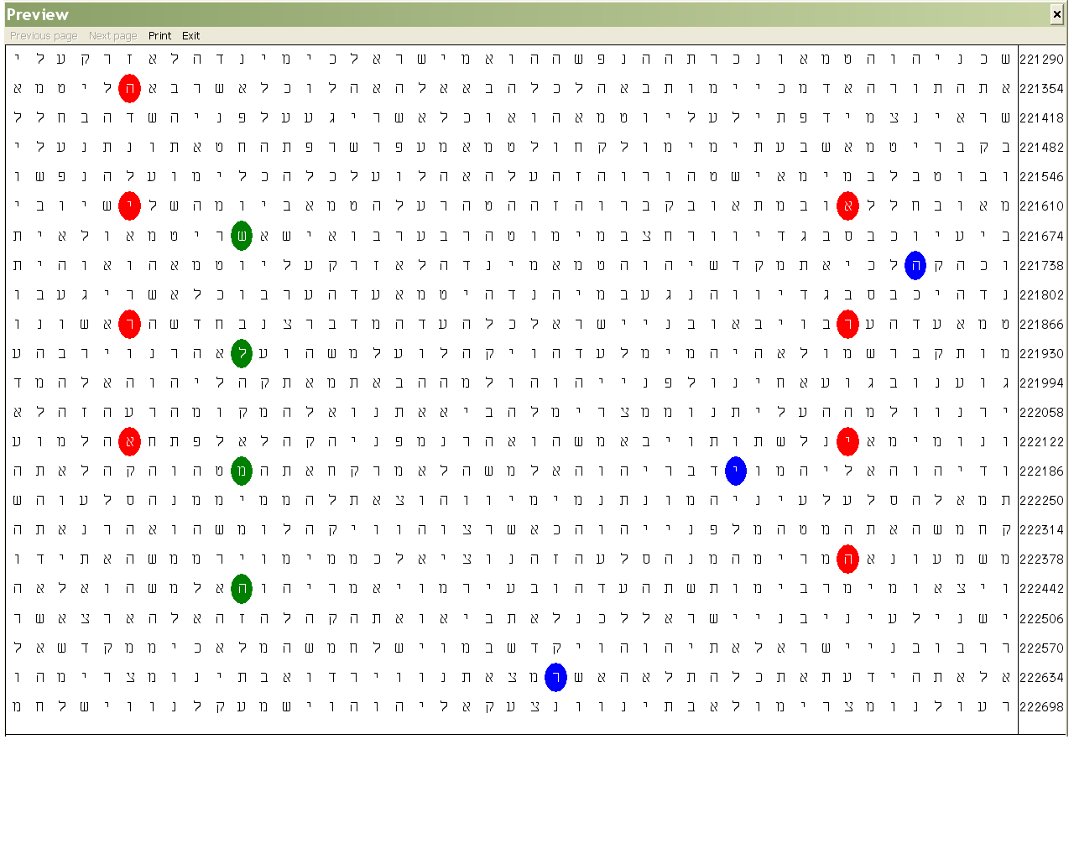
Figure 1. The final three letters of Bulgaria (בולגריה), blue ovals, at skip -456. Lion (אריה), red ovals and Solomon (שלמה), green ovals, at skips ±256. (Numbers 19:14 – 20:14.)
By the term ‘right side’ I mean the half of the cylinder that you see above. (The other half contains the remaining columns to 64.) I was looking in it because Bulgaria occurs in this area (the final three letters are shown in the matrix) but in a later examination, it appeared that this side contains more symmetry than the other half. I will comment in more details on this topic later.
Although my first thought was to check the probabilities, I knew that the common statistical models will give no significance of this occurrence at all. But I also knew that there is significance, and great significance at that. It comes from the fact that I looked for an occurrence specified not only as a sequence of letters but also as a particular skip. There are only 20 occurrences of שלמה at skips ±256 in the Torah. (The expected number is 16.8.) To anticipate one of them to occur within about 1/400th of the whole area and to see it there bears some significance, I dare say.
Why the statistical models give no significance at all? The significance of an occurrence of a term – word or expression – in any text, the Bible including, is based on three fundamental principles:
- The chances for occurrence of the term within a text. They depend on the size of the text, the length of the term and how often the letters constructing the term occur in the text. It is clear that the larger is the text and the lower is the length of the term as well as the higher are the frequencies of its letters, the greater are the chances and hence the lower is the significance.
- The semantic connection(s) between the presumably encoded term, as a whole or any part of it, and the fraction of the plain text which it intersects. It is clear that the lower the skip of the term, the higher is the significance if there is a link with the text it intersects, because the portion of the plain text comprising the term will be small.
- The clustering of one or more terms within a relatively small area defined by winding the text in the form of a string of letters around a cylinder. The Bible code matrices are two-dimensional ‘cuttings’ of the lateral surfaces of such cylinders. We must add here that, generally, the lower the skip(s), the better; also, if the skip(s) of one or more term within a matrix appear(s) to be the lowest in the text, more significance is ascribed to the finding(s).
The first two points are clear and usually they do not provoke disputes. The third point is very different in this aspect. Estimations depend on the method of statistical analysis applied. Sometimes, different researchers claim contradictory results. Therefore, let us consider how most of the researchers carry out the evaluation of the data of a matrix.
It is clear that to claim significance of an event wherever in nature it must deviate from what is ‘normally’ expected to happen. The occurring finding, or value, differs from those occurring in most of the cases. Therefore, we must have a measure of the degree of such deviation in case it occurs. If the experiment consists of measurements only, this degree can be estimated statistically, that is, it is established after a large number of measurements. When we have run a large number of measurements, we can calculate the probability of certain event. Then, when we get the value after the experiment, we can calculate the degree of deviation from the expected value. Indeed, with no expected value, no deviation can be spoken of. Usually, the expected value is the mean value of a group of values. This is the value that we can expect with highest probability in our next experiment. Thus, each one of the values is at a certain distance from the mean value. Note that the mean value is calculated; it is not a measurement!
Now all the values are distributed somehow around the mean value. The criterion for how the values distribute as a group is called Standard Deviation (SD). If most of the values are close to the mean value, and are also close to each other, SD is low. [3] In a word, SD is a measure of the degree of clustering. The denser is the cluster, the lower is the SD. If the measurements distribute symmetrically around the mean value, the distribution is called normal. [4] In Bible code studies, distributions are assumed to be normal and in most cases it is so. SD defines how much a new measurement differs from the most of the measured values. If it falls within a space where there are many other values, SD is low and the value is considered as normal and bears no significance.
The fact that the mean value is calculated makes it somehow ‘fictitious’. It represents the whole group of values, where each value has its own contribution. On the other hand, the standard deviation defines how close to each other are the values or findings. If we obtain close results of measurements in an experiment, this would mean that our methods and equipment are precise. However, precision may have nothing to do with the true value of the measured parameter! Precision is the measure of the reproducibility of the results. The difference between the measured and the true value is defined by another parameter called accuracy. The character of these two parameters is best illustrated by the well-known examples of shooting and darts throwing. [5] See Figure 2.
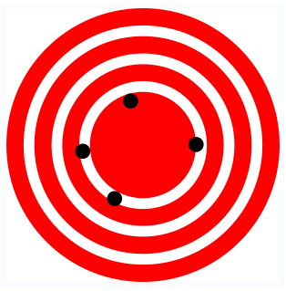 | 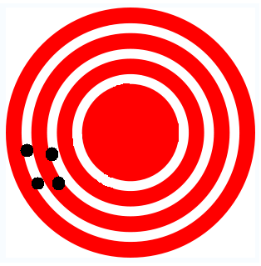
Figure 2. Accuracy and precision. In the left, we have better accuracy but low precision because the dots are scattered. The right picture shows high precision because their clustering is dense, but low accuracy. The pictures are taken from the Wikipedia [5].
Accuracy makes sense only if we have a preliminarily defined target! On the contrary, we don’t need any target in order to determine the precision. For instance, in the example given in Figure 2, we don’t need the bull’s-eye. We can fix a rifle tightly and make a series of shots against a blank wall. A dense cluster of holes on it would indicate that the rifle is reliable because it reproduces the results. More scattered clusters would hint at less reliable rifle or a poor shot.
Now let us imagine ourselves looking at a wall with traces of shots on it. See Figure 3.
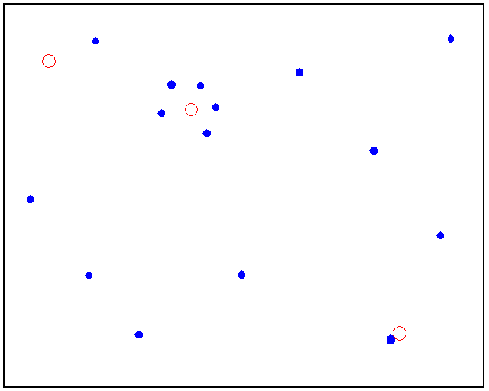
Figure 3. A wall covered with traces of shots. There are two types of rifles that have been used represented by the red circles and blue dots, respectively.
This is a picture typical of what we see also in a Bible code matrix. We see two distributions. There are fifteen blue dots and three red circles. Now let us try to draw conclusions from what we see. Taken separately, there is nothing unusual with the three red circles. The only special feature of the blue dots’ distribution is the cluster of five dots. This is anomaly itself and we could use statistical methods to estimate how significant this deviation is. Then we see that the cluster of blue dots surrounds a red circle. The first question we ask is: Why do the five ‘abnormal’ blue dots surround the red circle?
Were the wall in a shooting ground, we would say that the red circle in the middle is a target and most likely, someone had fired five times trying to hit it. As for the rest of the blue dots, they have been the holes of bullets fired by another shot or the wall has been fired at random by the same shot or anyone else. But if there were not a red circle in the middle, we would conclude that maybe someone has tried the steadiness of his or her eye and hand. With a certain calculable degree of probability, the configuration of these five dots could appear by chance. So what is the truth? Was there a target or not? What was the target: a red circle for the one firing blue shots, or a semi-circle of blue shots forming a bull’s-eye for the one firing red circles?
The Bible code programs I know do not consider such situations as aiming at a target. Therefore, they do not deal with accuracy! What they actually do is overlapping two or more distributions and calculating the probability of concomitant occurrences within a defined area. The calculations result in a standard deviation or analogous parameter, which characterizes precision and cannot be applied directly to accuracy. However, we, humans can understand a code only if it has been inserted there deliberately. Therefore, programs need a pseudo-target. We have to define one of the occurrences as a main term and calculate the odds of the other terms to occur closely to them. The result depends on which one of the items we single out as the main term. In a word, if we choose the red circle as a bull’s-eye fired at five times with good accuracy we will obtain one value of the probability, while if we accept the semi-circle of blue dots as the bull’s-eye perfectly hit by a single shot, we will find a different value.
Why it is so difficult to define accuracy in Bible code research? To see why, let us look again at the wall. There we see the bullet-holes but we know nothing about the shot and from what distance he or she has fired. A two-inch missing the bull’s-eye is a disastrous failure for a 10m air-rifle Olympic competitor, while the same deviation is an excellent shot for a sniper firing from a mile away. Here comes the difficulty with the red circle and the blue spot in the bottom right corner of our wall. Is it an excellent shot from a far distance or a random coincidence? It depends on from how afar the target, if any, had been fired at. Can a program define the distance? I think it cannot. It ‘sees’ everything in the same scale. For instance, what it sees in Figure 1 is presented in Figure 4 and clearly shows why all programs I have tried determined zero significance of the occurrence of Solomon in the matrix in Figure 1. In Figure 4, I deliberately included all occurrences of Solomon and Lion at skips ±256 available.
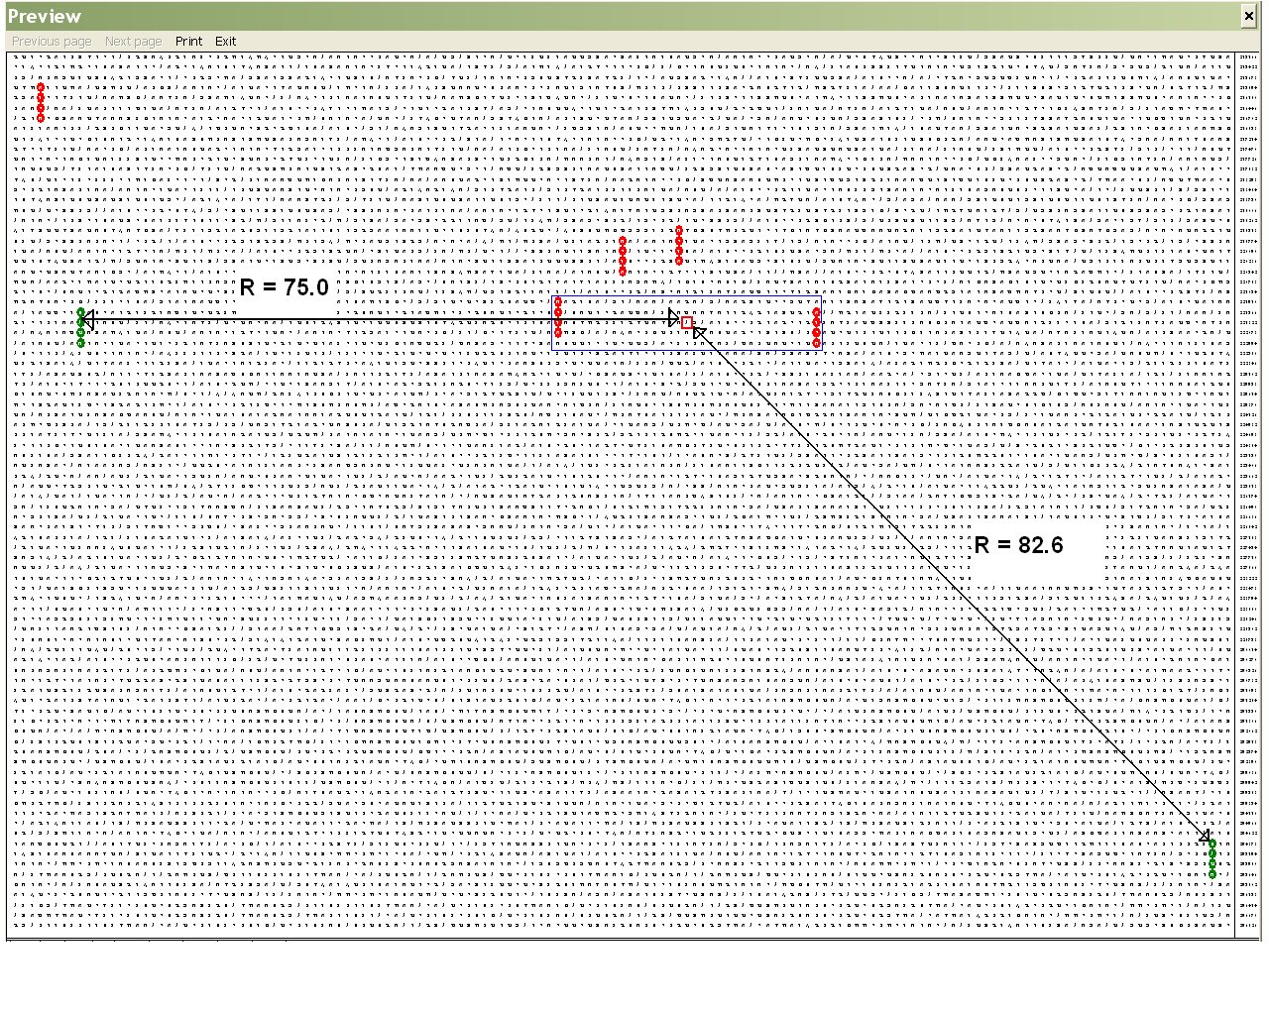
Figure 4. The terms in Figure 1 at their ‘natural’ skips of ±256: Solomon (שלמה), as green ovals and Lion (אריה), red ovals. Note the new occurrence of Solomon at the same skip in the bottom right corner as well as the three more occurrences of Lion in this large-scale matrix. The blue box includes some of the plain text between the Lions in Figure 1. The small red quadrangle is the letter lamed, ל, right in the centre of symmetry of the two occurrences of Lion.
A computer program would not distinguish between two arrangements of an occurrence of a term at certain skip. Even though I have asked it to check the probability for occurrence of שלמה between the two occurrences of אריה, what it does is taking out the green-letter term and measuring the distance shown in Figure 4. There, I have used the Pythagoras theorem to calculate the distances shown in the picture. The new occurrence of Solomon turns out to be only some 10% farther from the ‘bull’s-eye’ than the term from Figure 1. Moreover, there appears a term in the upper left corner, which is closer to the occurrence of Solomon, שלמה in our matrix. There are also a couple of occurrences of Lion, אריה just above the twins in Figure 1. These are closer to each other and symmetrical as well, although the centre of their symmetry is not a letter because the number of the columns between them is not an odd number. I have checked the distance from our term in the left to their centre and it turned out to be less than 71. However, as a sniper ignores targets that might be closer to his or her position, if there is a more important target, the Encoder has ignored some closer ‘targets’. See Figure 5.

Figure 5. The telescopic sight is the key sniper’s tool. Note that points that are distant and clearly distinguishable in the telescopic sight would be practically indistinguishable with naked eye. The picture is taken from the Wikipedia [6]
Now let us begin ‘magnifying’ the matrix in Figure 4 by changing the skip by a half to 128. See Figure 6.
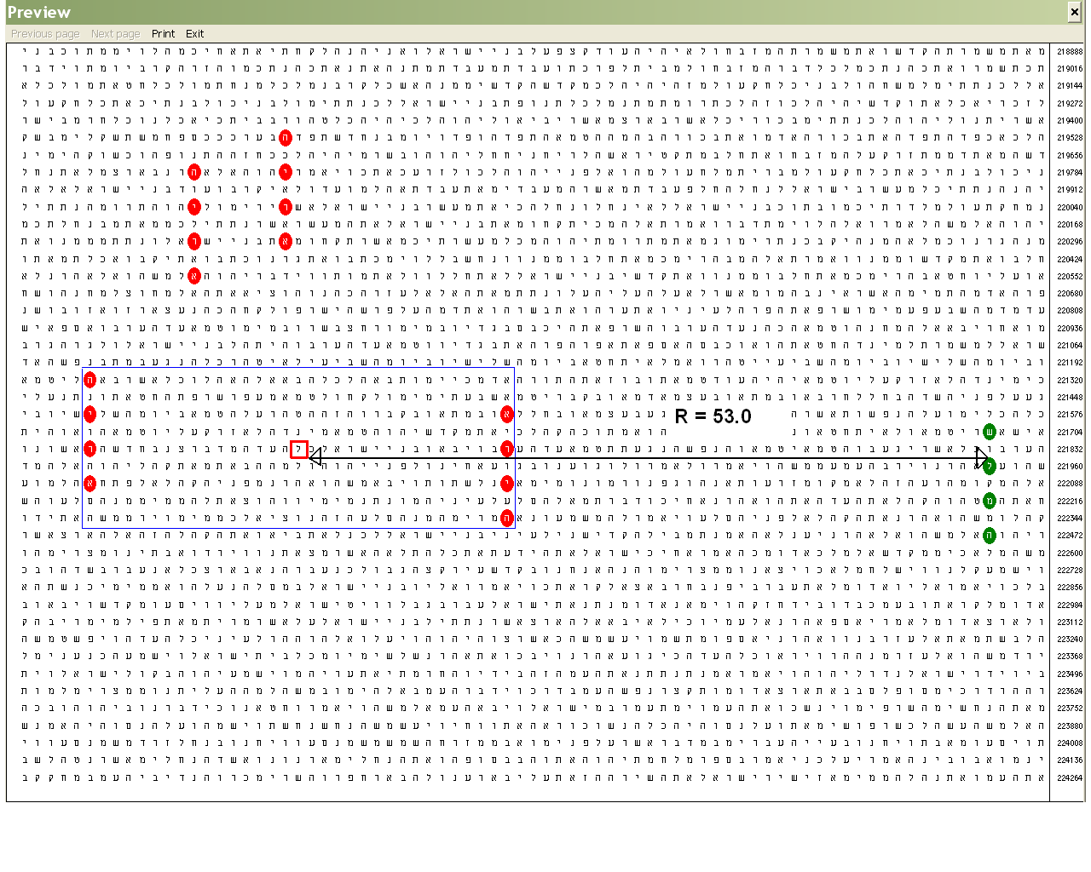
Figure 6. Here is a part of the terms in Figure 4. The matrix is rearranged at skip 128. Due to the twofold ‘magnification’, the area in the blue box, in terms of letters contained within, enlarges twice.
Two of the terms in the matrix in Figure 4 have fallen out and the term of interest is not only much closer to the bull’s eye, but it is already farther than the centre of symmetry of the other couple above. (Special note: The pair of lions in the blue box is the closest pair at ±256 in the plain text of the Torah, as I wrote in Part 2. The apparent proximity between the terms in the pair above creates the illusion that they are closer. In fact, starting from the topmost letter of the right term and going left, as Hebrew reads, one has to skip more letters to reach the topmost letter of the left term of the couple compared to the respective left and right terms of our couple. In the first case, it is 128×2 + 7 = 263; in our case, it is 128×2 – 32 = 224.)
If we magnify the blue box twofold once more, we will arrive to the matrix in Figure 1. I decided that it is worth to insert it again – see Figure 7 - to demonstrate the evolution of these magnifications.
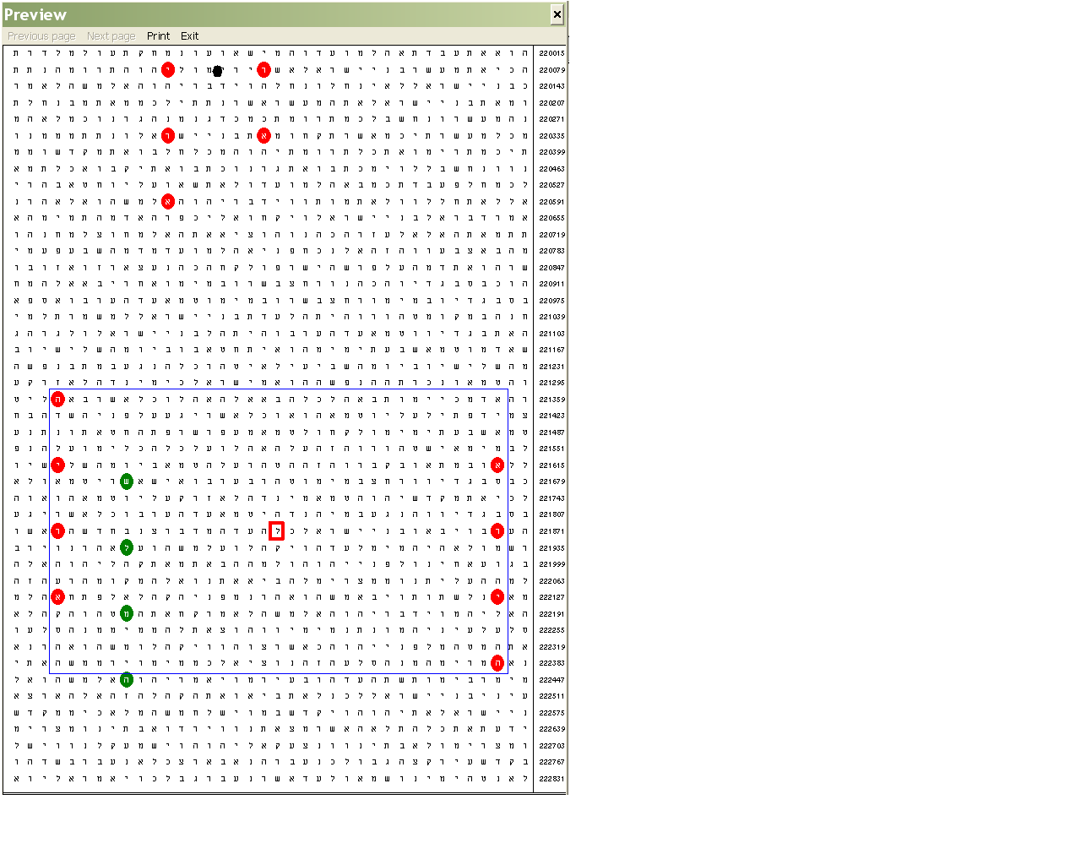
Figure 7. Note the rapid and tremendous change in the distance between the (second of the) green ovals and the ‘bull’s-eye’, R = 11.0 (not shown for the sake of clarity). Note also the change in the ratio between this distance and that to the centre of symmetry of the upper pair of terms (the black dot between the two top ovals), which in this matrix is R = 25.7. The latter distance is less than that to our ‘bull’s-eye’ in Figure 4 and their ratio was close to 1 in Fig 6. In this picture, the ‘shot’ in the blue rectangle is about 2.5 times closer to the assumed right target.
A further twofold and subsequent ‘magnifications’, however, would give no result because the blue box will degenerate into a vertical line. Therefore, as it happened, we have guessed not only the right occurrence but also the right skip of the matrix, that is, the right configuration of many other letters. But what is the meaning of all this? The Encoder is Omnipotent, so He could place Solomon right between the two lions even in the matrix in Figure 4. Therefore, He must have had a specific purpose to make us go this longer way.
The Throne That had no Equal ever made for any Other Kingdom
I was musing on whether this is the bull’s-eye we had to aim at and how to evaluate the odds. I had the idea how to calculate them but the most astonishing fact in this case, in my opinion is that this occurrence has been anticipated! That is, we have aimed at this spot from a long distance, like snipers. The two lions were fixed on both sides of Solomon’s throne…
Then I decided to see if throne, כסא, is also there. First, of course, I checked at skip ±256. It was not there at that skip. Then I checked for other skips. Being a three-letter word, it occurs quite often even in a small space like this. I looked for skips below 31, if any, so that they could be positioned on a single row in the matrix. And here was another surprise: the lowest skip of occurrence of throne that I found to comply with my requirement turned out to be -14. It also appears almost perfectly symmetrically between the columns with the lions, though few lines lower, in the matrix. See Figure 8.
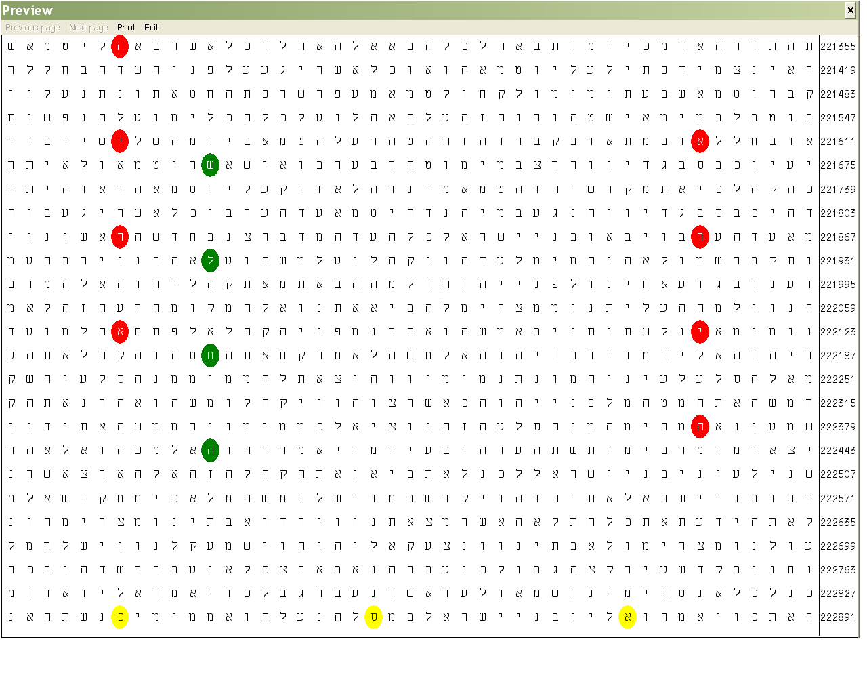
Figure 8. Solomon (שלמה), green ovals, and Lion (אריה), red ovals, as in the Figure above. Throne (כסא), golden ovals, at skip -14.
There is nothing unusual of this occurrence in terms of chances for the lowest skip of throne in the matrix to be ±14: they are 1 in 2. What is interesting, in my opinion, with this skip is that the overall number of the lions at the throne of Solomon is… fourteen. (1 Kings 10:18-20 and 2 Chronicles 9:18-19)
At first, I associated number 14 only with the number of the lions at the throne of Solomon, but then I remembered that the number of the occurrences of Aaron (אהרן) in the plain text of the cluster comprised by the occurrence of Bulgaria at her lowest skip is also 14! (See Part 2.) Therefore, I decided to expand the matrix in Fig. 8 to include this cluster. Meanwhile, I continued to watch for the other terms. Knowing that Solomon and the lions will not appear at the skip of interest, I concentrated my attention on the throne. I set as upper skip of search ±100 and I was both puzzled and surprised to see that throne, כסא, does not occur at skips below 100 any more, although the expected number of occurrences increased to about 6. I kept on expanding the matrix verse by verse to see what the next occurrence of throne will be like. To my astonishment, when it appeared next time at skip below 100, it was 14 again! See Figure 9.
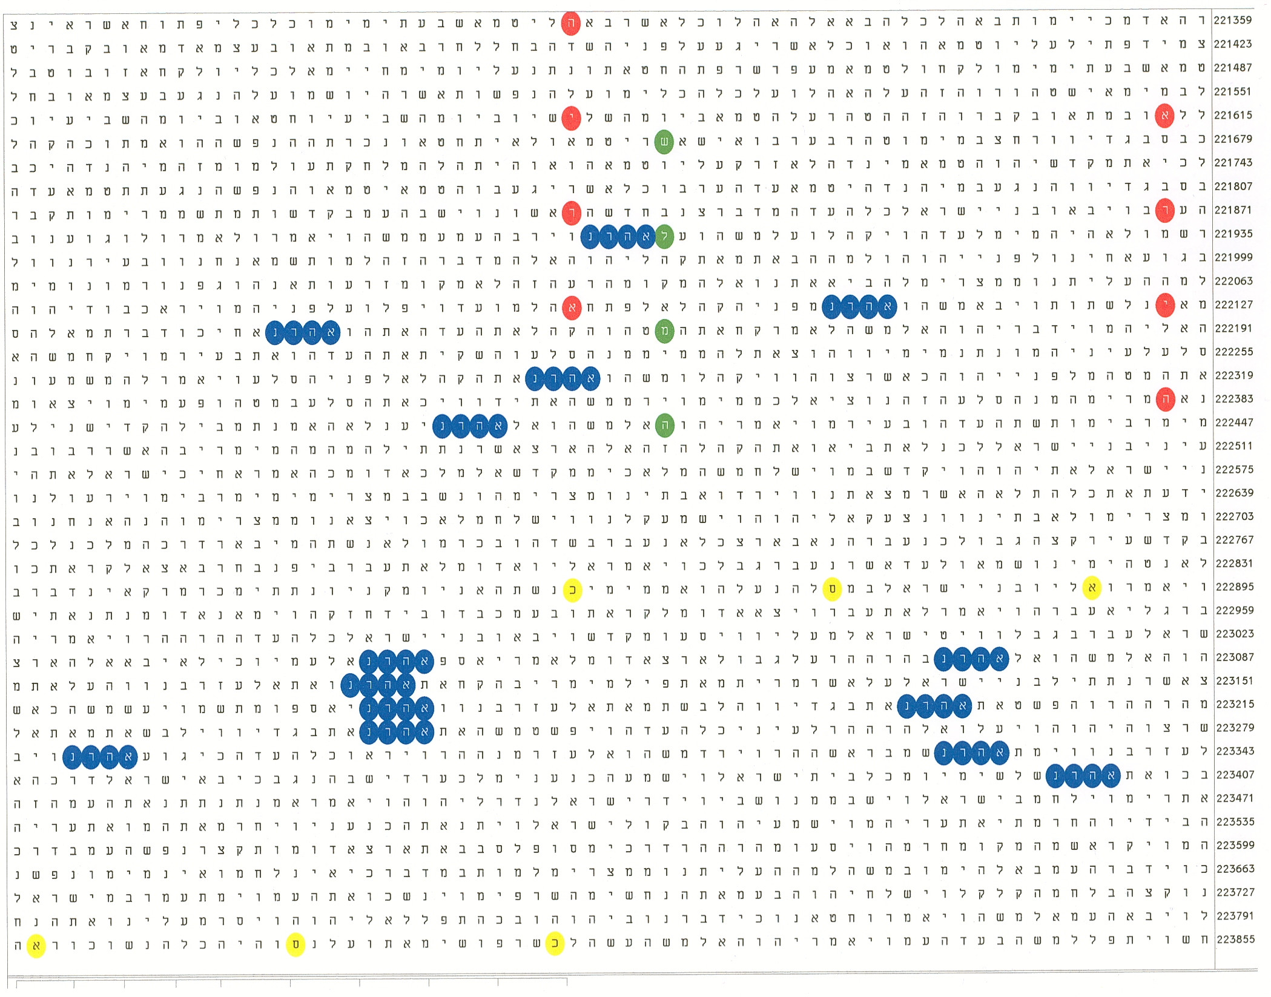
Figure 9. Solomon (שלמה), green ovals, and Lion (אריה), red ovals, at skips ±256. Throne (כסא), golden ovals, at skips ±14. Aaron (אהרן), blue ovals, occurs 14 times in the plain text. The plain text runs from Numbers 19:14 to 21:8.
The odds for two occurrences of כסא exactly at skip ±14 in the matrix are below one in forty billions! The standard deviation is 7.30. However, I find another feature of the matrix above not less amazing. Both encodings of כסא occur in such a way that they almost perfectly symmetrically ‘cover’ a row and its ‘projection’ below. This is possible only if the skip between the last letter of the first occurrence and the first letter of the second one (in our case both are kav’s, כ) is close to a multiple of 64. Here, the skip appeared to be 15×64 + 1 = 961, or 31 squared. I also find the absence of any other occurrences at skips up to 100 in the whole area puzzling and maybe, along with the other results, hinting at ±14 as a code. (The lowest skip above 100 within the matrix is 102.) Indeed, the chances for no other occurrence below 100 are about one in fifty. Few verses above and below the matrix in Figure 24, throne starts occurring again as expected and at skips below 100 and thus showing tendency towards ‘normalization’.
Being puzzled by the absence of ‘throne’ at skips up to ±100 within a text containing over 2 500 letters - large enough to be expected some 6.8 occurrences, I decided to scrutinize the experiment and checked for any other closer occurrence of כסא twins at ±14 in the Torah. Although there are only 18 occurrences in total in the Torah, it turned out that there are two other occasions, where the appearances at ±14 are closer than in our matrix (989 letters apart): Genesis 43:17-25 (475 letters apart) and Deuteronomy 14:9-13 (66 letters apart). The respective texts contain about 550 and 150 letters. (I have carried out the search within whole verses.) The text in Genesis yielded 10 occurrences at skips up to ±100 (expected 8.1) and 6 occurrences at skips up to ±50 (expected 4.5). Therefore, even if we discard the two occurrences at ±14, the number of the remaining ones will be closer to the expected value and hence to normal distribution.
Trying the Deuteronomy text, I supposed that this once there might be no third occurrence: the expected number of occurrences at skips of up to ±74, the maximum, is 1.8. But there it was: at skip -15! Although not an extraordinary phenomenon, I believe that these findings verify the hint that the Encoder had something special in mind with the outstandingly suggestive occurrences of throne, כסא, twice at the skip of the specific value of ±14, in the part of His Word containing the densest cluster of fourteen occurrences of the name Aaron in the plain text.
The number 14 intrigued me for another reason as well. In the Gospel according to Matthew, the genealogy from Abraham to the Lord Jesus is presented as three main steps consisting of 14 generations each: (i) from Abraham to David; (ii) from David to the exile in Babylon and (iii) from the exile in Babylon to the Lord Jesus. Therefore, the number 14 may bear encoding importance itself. Having found it in the matrix above in two aspects, we may need a validation of the code in respect to number 14. So far, we have found number 14 connected to throne. כסא, and Aaron, אהרן, but not yet to Solomon, שלמה. The Encoder should have hidden another hint somewhere else. For this purpose, we must look for a validation of the codes in the matrix elsewhere in the Scripture.
Searching for Hidden Signs of a Number
It is clear that the only way to find anything significant about short-letter terms in a large text is to search for pairs of terms. Both Solomon and throne occur very often, so I searched at the lowest skips in the Torah. As it turned out, although Solomon is not mentioned as a name in the Torah, שלמה appears five times in the plain text at skip 1. In Deuteronomy 25:15, this word appears twice as feminine for perfect. I decided to check for throne at very low skips nearby. To my astonishment, it was there! I have prepared two matrices of this occurrence shown in Figure 10; why, I will explain below.
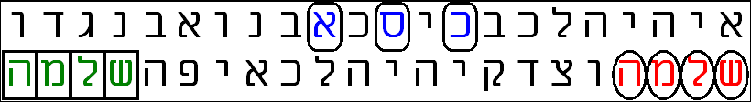
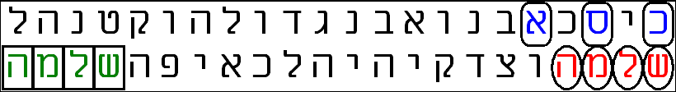
Figure 10. Perfect/Solomon (שלמה), red and green letters in the plain text, and Throne (כסא), blue letters, at skip 2 in the Torah.
First, the odds for such close occurrences appeared to be very low. As I explained above, the calculated odds depend on which term will be accepted as the main term. If we look for throne close to Solomon – that is, Solomon is the main term – the odds are 1 in about 375 000, while if the throne is set as the main term, the odds fall as low as about 1 in 2 000 000!
Then I saw that the number of the letters between the two occurrences of שלמה in the bottom row is fourteen! These two occurrences of שלמה are the closest pair in the plain text of the Torah.
Finally, I found some significance in the geometric configuration of these three terms within the matrix. The encoded throne, כסא, occurs two verses earlier, in Deut. 25:13: You shall not have in your bag two kinds of weights, a large and a small. This commandment is directly linked to verse 15: But you shall have a perfect and just weight, a perfect and just measure shall you have… The upper matrix is at skip 64. This, along with skip 65, is the closest position of כסא to the vertical line of symmetry between the two occurrences of שלמה. (Perfect position is impossible because the line of symmetry goes between two columns.) Note that 64 is the skip of our main matrix, one of whose major characteristics is symmetry!
Then I realized that changing the skip of the matrix within certain limits maintains the same odds because the area of the matrix remains the same. The lowest skip preserving this characteristic is 56 (the bottom matrix). This is so because the skip between the first letter of throne, כ, and the first letter of the first occurrence of שלמה, ש, is 56. But 56 is 4 times 14! Fifty-six is the total number of letters in the cluster and the value of (skip – 1), the ‘tunnel’ of the matrix at skip 57, where Bulgaria is in a column that is a line of symmetry in relation to the occurrences of Aaron in the cluster. At this skip also, the letters of the two lions recover their symmetrical positions (see Part 2). I was impressed very much by the significance of number 14, which I managed so far to discover. At this point, I decided to test out a fresh idea that had just downed on me…
We have found number 14 revealing itself in several more or less enigmatic ways. What about looking for it ‘directly’, that is, written as fourteen in Hebrew. It has two forms: masculine and feminine. I chose the masculine, of course, because the lions around the throne of Solomon are masculine: עשר ארבעה. It occurs 17 times in the plain text of the Torah and 15 more times in the rest of the Tanakh, 32 altogether. Interestingly, the book containing the largest number of it, 13, is Numbers, where our target is. I looked for occurrences at skips above 2 in the Torah. There appeared to be none. Then I searched in all the Tanakh. I found 12 such occurrences with the CodeFinder program and 17 occurrences with the Keys to the Bible program. Different programs often produce divergent results because unlike the Torah, there is no unanimously established text for the rest of the Tanakh. This usually happens with some large-skip occurrences. However, all programs I use, Torah4U including, agree on the lowest skip of fourteen, עשר ארבעה, in the Tanakh, 1 466. I had the idea where approximately this occurrence has to be anticipated, but I was utterly astonished when saw it with my own eyes. It was in 1Kings and it was going right through the verse with the description of the throne of Solomon! See Figure 11.
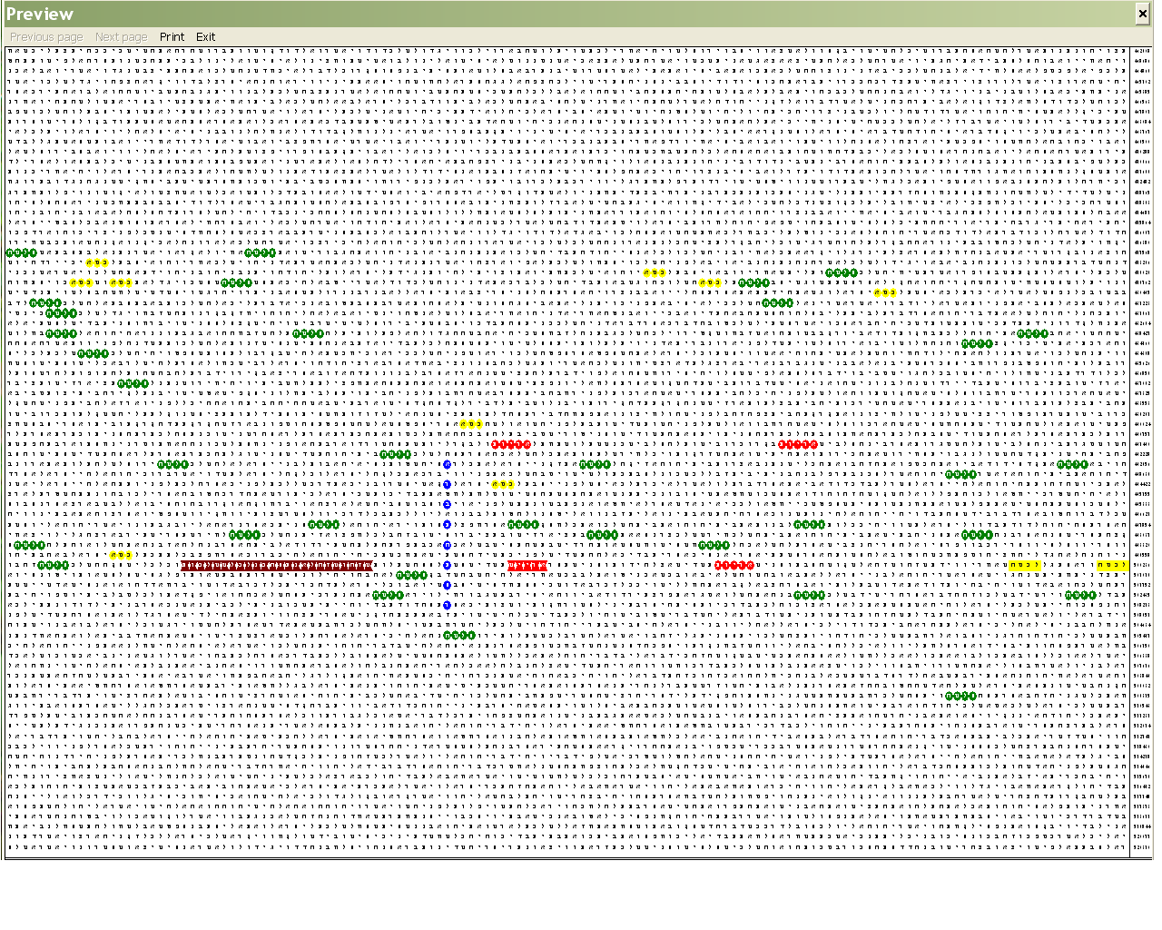
Figure 11. Fourteen (עשר ארבעה), blue ovals at skip 1466; Solomon (שלמה), green ovals; Throne (כסא), gold ovals and (כסה) gold squares; and Lions (אריות), red ovals and (אריים), red watches; and There was nothing like it made in any kingdom, violet watches, in the plain text of 1Kings. (For an adequate examination of this matrix, I recommend 500% magnification on the computer screen.)
I deliberately presented the picture above at a larger scale, at skip 733, to emphasize the fact that fourteen, עשר ארבעה, occurs at its lowest skip in the Tanakh right among the densest clustering of Solomon, throne and even lions. The bands above and below the ‘strip’ of the cluster lacking any such occurrences emphasize further the significance of the finding. Indeed, I counted 34 occurrences meaning Solomon out of all 366 occurrences of שלמה, of which 294 are Solomon in the plain text of the Tanakh in the matrix, which is about 12% of the occurrences of his name. There are also 9 out of the 138 occurrences of כסא in the Tanakh and 32 in 1Kings at skip 1. Not all occurrences of כסא at skip 1, however, mean throne. But in 1Kings, all such occurrences have this meaning. The two rightmost occurrences are of different spelling, כסה, and are marked as squares. There are also three occurrences of lions, spelled as אריות, out of the five occurrences in 1Kings (27 in the Tanakh, including the nine occurrences in Daniel 6 spelled as אריותא) and the only occurrence in the Tanakh spelled as אריים, referring to the twelve lions on both sides of the six steps. It is marked as red watches. The main term, fourteen, intersects exactly this verse at its third letter from below, ע. The phrase There was nothing like it made in any kingdom (1Kings 10:20) fits entirely within the matrix.
Having obtained two very significant results with throne, כסא, and number 14, it is time to turn our attention back to Solomon, שלמה, and to try to estimate the significance of its occurrence between the two lions and above the first throne. Although we could be accused for doing this post facto, let us keep in mind that we have started with Solomon and, due to its occurrence, we were able to do our next discoveries. This is a very different approach compared to the famous animated film, where an archer shoots an arrow at the trunk of a large tree and then draws the bull’s-eye around the hit.
Vindication of a Shot
Looking at our main matrix in Figure 9, I realized that if we include the line with throne into the blue box representing our ‘bull’s-eye’ its area will increase a little, but the occurrence of Solomon would be entirely within it! The ‘shot’ would be perfect! But is this enlargement justifiable?
In my opinion, a justification of this type requires the presence or emergence of a characteristic, which unequivocally reveals clear connections with all the other findings. Now let us draw the blue rectangle with the terms of the matrix in Figure 9. The new picture is shown in Figure 12.
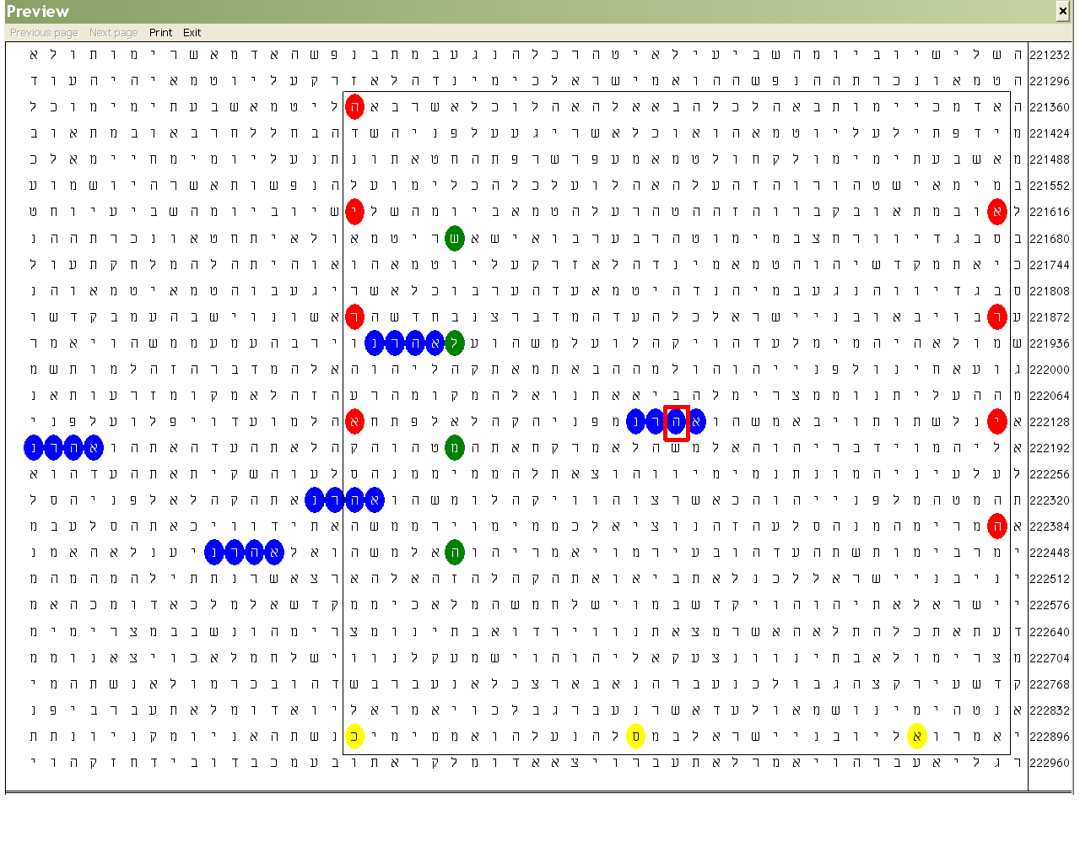
Figure 12. Solomon (שלמה), green ovals, and Lion (אריה), red ovals, at skips ±256. Throne (כסא), golden ovals, at skip -14. Aaron (אהרן), blue ovals, in the plain text. The plain text runs from Numbers 19:14 to 20:19.
In the new rectangle, the number of the rows is also odd, which defines a letter as a centre of symmetry. This is not a big surprise, of course, but is an intriguing coincidence because if either the number of the rows or that of the columns were even, this characteristic would not exist. It is surprising that this letter is one in the name of Aaron, אהרן. Therefore, we have a definite hint at the cluster of Aaron in the plain text as a basin of attraction (see Part 2 for basin of attraction) for all the other encoded terms. What astonished me, however, was the particular letter in the name of Aaron: hey, ה! As it turned out, this is the only common letter in all three names: Aaron אהרן, Solomon, שלמה and Lion, אריה! Moreover, its numerical value, five, corresponds to the number of occurrences of Aaron in the plain text of the matrix. One could hardly imagine a better choice for a target, I believe. The distance from the occurrence of Solomon (that is, the letter closest to the target, in this case mem, מ) is the same as that between the second letter, lamed, ל in שלמה and the target we aimed at earlier, which is four lines above the current target.
Now the time came to try to estimate the odds for this good hit. If we demand from a program to calculate the odds for the occurrence of Solomon, שלמה, at skips ±256 in the text from Numbers 19:14 to 20:19, it will give as expected number of occurrence 0.05349. With one occurrence, the standard deviation SD = 4.09, which corresponds to approximate odds of 1 in 50 000. Such low odds verify the adequacy of our suggestion. However, even so, this calculation does not reflect the perfection of the occurrence. The matrix in Figure 9 contains all 64 columns. The occurrence of Solomon happened to the right of the occurrence of lion in the middle top of the matrix. It could have happened to the left of it. At this skip of the matrix, 64, it is clear that there will be no throne close below the two occurrences of lion. In addition, there is no a letter in the centre of the symmetry between the two lions because the number of the rows is even, 16.
Now let us try another approach. Given the skip is ±256, any 4-letter word occurring at that skip will look like our Solomon and lion items at skip 64 – that is, their letters will be within a column, four rows apart, with overall height of 13 rows. Let us imagine the text of the Torah as a band of 64 columns. The number of the rows will be about 304 805/64 ≈ 4 762. We must subtract 13 rows from this number and multiply by 64 to find out the total number of the ‘nests’ in which there could occur a searched term. This makes approximately 304 000 such ‘nests.
Such an item can occupy a column 25 rows high within the rectangle forming the bull’s-eye 13 times. Therefore, ignoring the fact that few ‘nests’ are already occupied we have 33×13 = 429 free positions. This is a 429/304 000 = 1.411×10⁻³ part of all ‘nests’. The total number of occurrences of שלמה at skip ±256 in the Torah is 20. Therefore, the expected number of occurrences of this term within the bull’s-eye will be 1.411×10⁻³×20 = 0.02822.
We have one occurrence. Applying the formula for the standard deviation

Actual Number of Occurrences – Expected Number of Occurrences
SD = ——————————————————————————————
Square Root of Expected Number of Occurrences
we obtain SD = (1 – 0.02822)/√0.02822 = 0.97178/0.168 = 5.78.
SD-value of 5.78 corresponds to approximate chances of 1 in 100 000 000.
A Philosophical Reflection on Rarity and Anticipation
Is there any sense to try to calculate an overall probability? I think there is not. I do not believe that we will derive more meaning of an event whose happening occurs with odds of, say 1 in a billion billions, than of an event happening with odds of ‘only’ 1 in a hundred billions. Both these probabilities are hard to imagine. In my opinion, the most miraculous feature of the Torah codes is not so much in the infinitesimal odds to occur by chance but that we do anticipate them. If everything written by humans is translated into Hebrew and ordered in, say, chronological series, we could find some day somewhere something like our main matrix. In our case, as in all cases of Bible code researches, the most surprising and intriguing aspect is that we find them on practically our first attempt. Therefore, here is the right place to say that rarity of an event and its anticipation are different categories. Rarity is a pure mathematical and statistical, calculable, characteristic. We do not need profound knowledge of the driving forces of the events. The only thing we need is to measure and record data about what happens accordingly. The rest is calculation. Let me clarify the difference between rarity and anticipation with a very simple example.
Suppose you live in a multimillion city and spend your days working or living in a room high above the ground. Suppose you have the habit to choose at random a minute in the day to peer from your window down to the busy traffic in the streets. Finally, suppose that red cars are an extreme rarity in your city. One day, within the minute you are peering through the window, you spot a red car down in the street. Such an event could happen, according to your own observations, say, once in a year or even hardly ever. You will remember this day because you have witnessed an extremely rare event. This is the phenomenon of rarity of certain event. Now imagine that you have had a dream in the night or other presentiment that you will see on a particular day a red car. You peer through the window and spot it in the street, right according to your expectation…. There is a difference between these two situations, isn’t it?
The point is that the latter situation is possible only with human psychic. A suitable device could record a red car in the street. It can also calculate the statistics according to its own-recorded results. The device, however, cannot anticipate. The latter event described above suggests a very specific and subtle interaction between our minds and the reality outside us. We dream of a car moving in the street at a time still unknown to us. This time is also unknown to the driver, who may have not decided at the time of our anticipation whether will drive his or her car later or not or whether he or she will choose this or another street. What is the cause and what is the effect? Does our dream force him or her to make the choice or vice-versa? Is his/her choice free or there is a force generating both our dreams and the driver’s intentions? Could we apply the cause-and-effect sequence to every aspect of life as a general principle?
I believe that we cannot apply the cause-and-effect sequence everywhere. At the same time, I believe that we possess free wills. They reveal themselves when we make moral choices. I have discussed this issue in Part 2. On the other hand, even our actions could seem independent and chaotic, the overall result of them could be predicted in the way the behaviour of a large system of particles could be predicted in accordance with the principles of quantum mechanics. Hence, the subtlety of the way Bible codes are being discovered in the recent years made me believe that the Hebrew Bible and especially the Torah is a quantum computer because it seems that what happens in reality goes in parallel with some processes in our brains. And, because our brains are proven quantum computers, they could be matched only by another entity possessing the same characteristics. This also inclines me to think that Bible code research is not programmable as long as classical computers cannot anticipate. Bible code researches requires associations of higher order and even if it were possible to download every event that has happened since the Beginning, I could hardly imagine such a computer doing what our minds do. Because, apart from the anticipation of a code, its importance does matter too. Using the analogy with shooting again, if anticipation is seeing clearly the target through the sight, importance is choosing the right target among many other targets.
What the analogy between the sniper’s aiming at a target from a far distance and the tunneling effect in quantum computation can give is seen in our work. Indeed, looking through the telescopic sight, the sniper ‘tunnels’ the distance. The optics ‘brings’ him or her closer to the target and the shot does not differ from a shot from a closer distance. In the same manner as a quantum computer ignores a large number of intermediate states and quickly approaches the state of lowest or very close to the lowest energy, the sniper ignores the uninteresting targets and shoots at a point or a very small area surrounding it. (I am not a warmonger; I think that shooting, as a very old practice with the experience accumulated for ages, provides one of the best knowledge the humankind has collected. Shooting has been researched and modeled mathematically to tiniest details and therefore I believe that it illustrates adequately our ideas.) In short, when searching for codes in the Torah, we look in the right place and ignore all inadequate targets.
I was musing for days on the findings presented above. I was surprised in a way, because I expected that someone else would make the next discovery in this basin of attraction in the book of Numbers. Having found the code about King Solomon and his famous throne, I believed that this once everything that could be found there is taken out in daylight and was working on the conclusive part of my study. I was unaware of how wrong I was…
A Latter-Days’ Connection between an Israeli General and Bulgaria Encoded in the Beginning
We, Bulgars, are a small nation and therefore immediately become aware of prominent figures in the world connected in any way with Bulgaria. This is especially valid for Israel because Bulgars saved all their Jews during the Holocaust and can boast with one of the relatively largest contributions to the foundation of the State of Israel in the early, critical years. Therefore, when a friend told me that the father of the newly appointed Chief of the Israel Defense Forces General Staff Lieutenant General Gabi Ashkenazi, אשכנזי גבי, is a Bulgarian Jew [7], I decided to check for codes in the Torah. Initially, I checked for the full name, but it does not occur in the Torah. Therefore, I started trying with Ashkenazi, אשכנזי. It occurred, at its seventh lowest skip, -1 819, close to the lowest skip of Bulgaria, -456, in the Torah. In addition, there was also Gabi, גבי, very close to the main term, at the very low skip of -2 (see Figure 13).
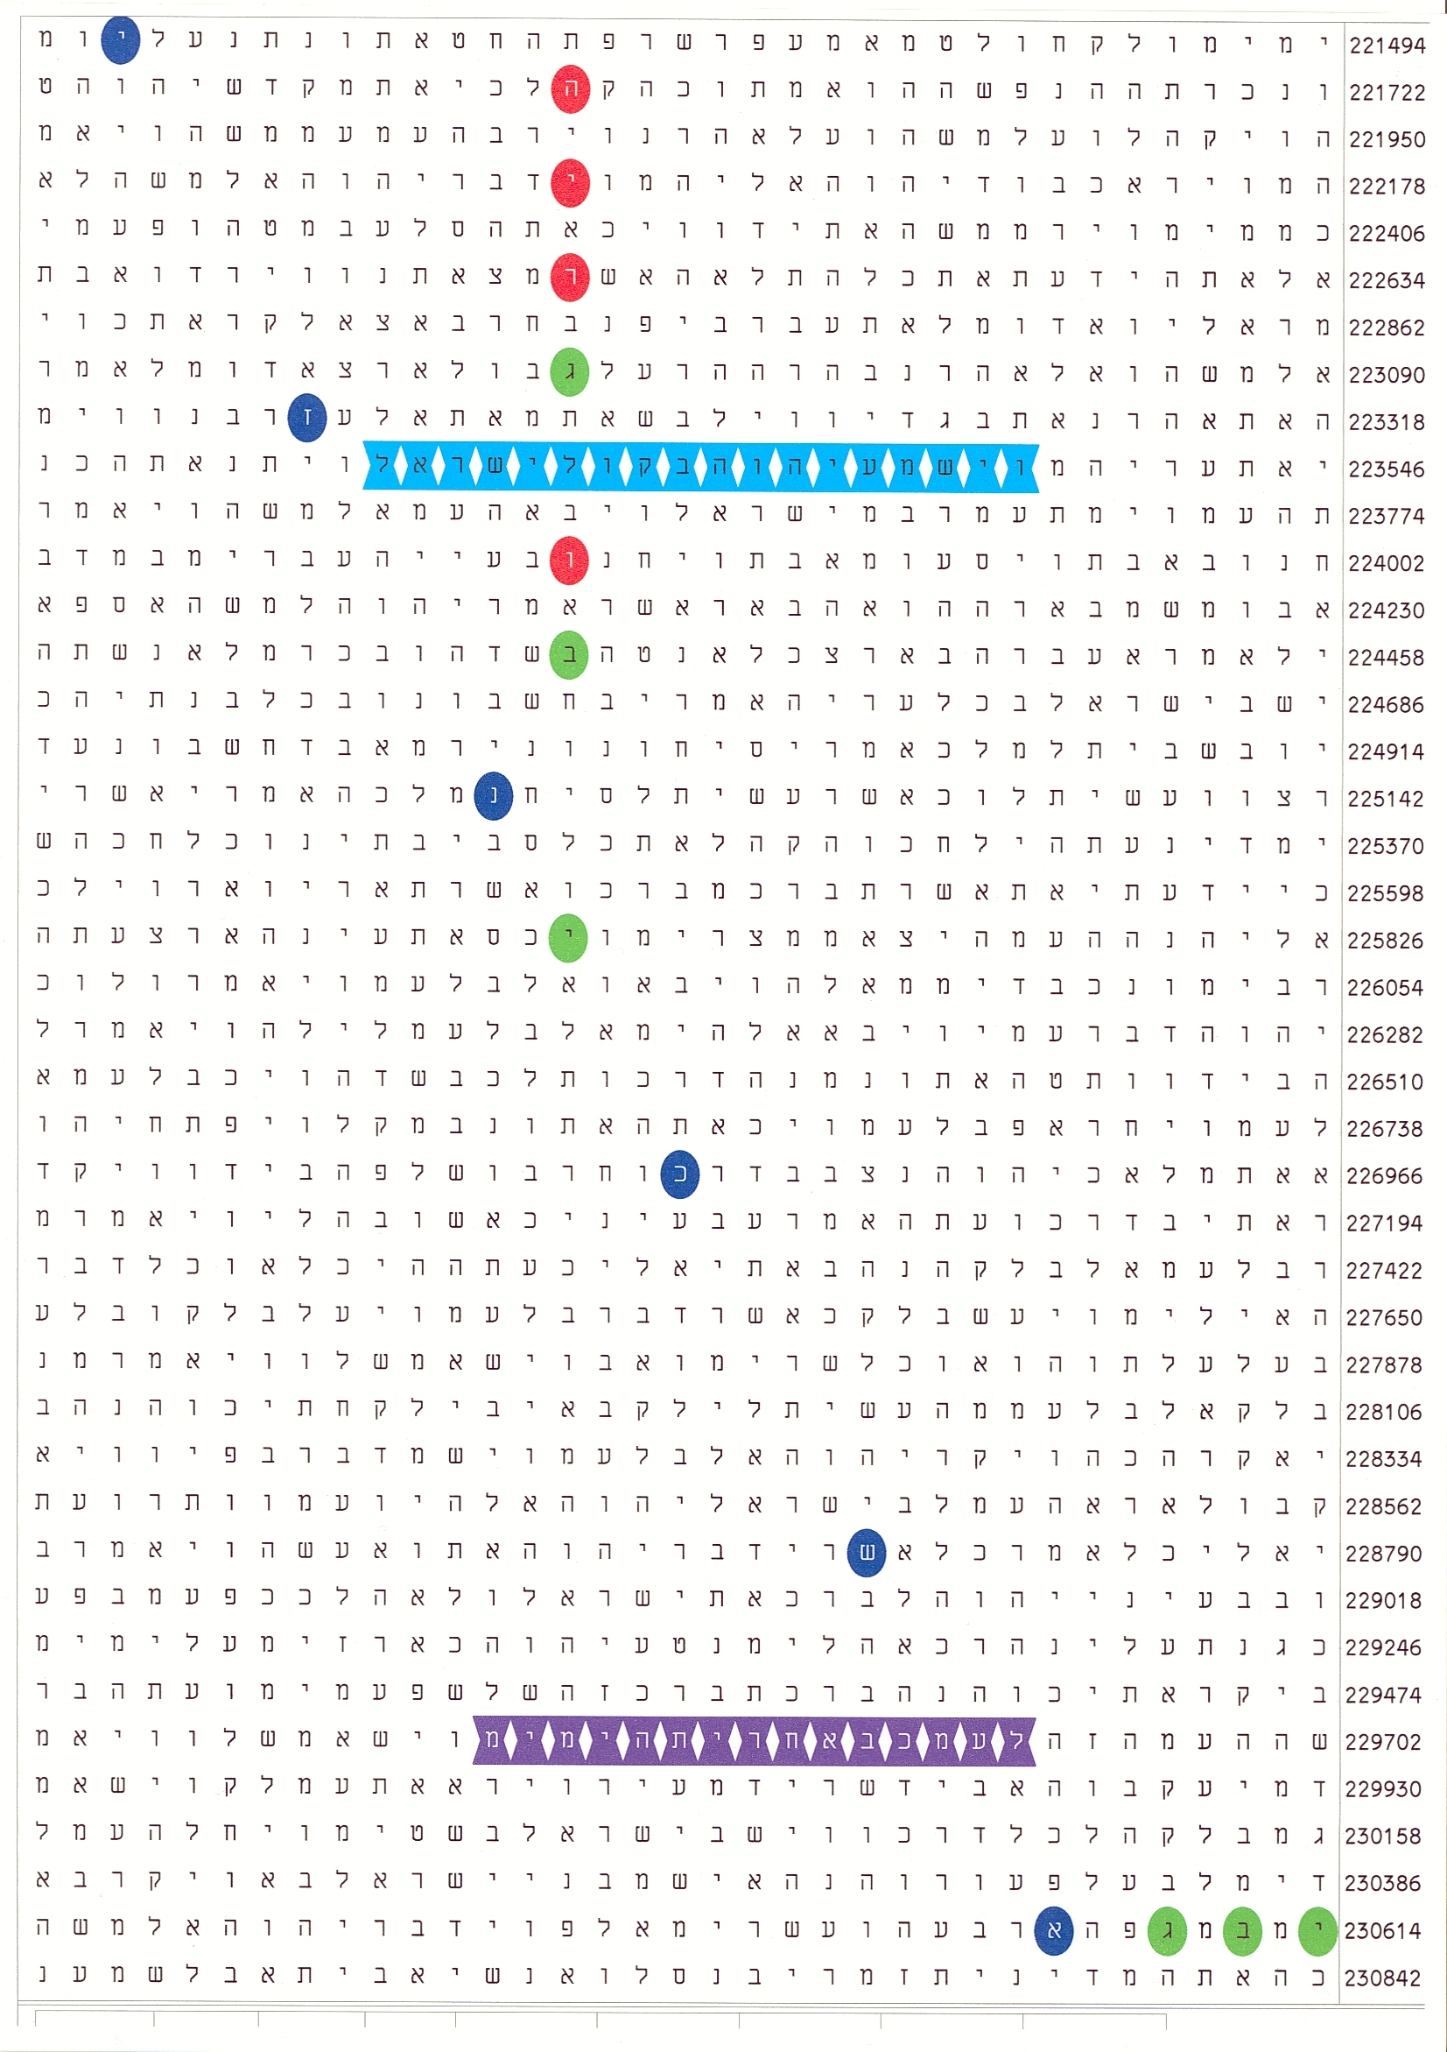
Figure 13. The encoded terms are Ashkenazi (אשכנזי), blue ovals at skip -1819; Bulgaria (בולגריה), red ovals, at skip -456; and Gabi (גבי), green ovals, at skips -2 and 1368. There are also two terms at skip 1 discussed in the text below. The skip of the matrix is 228. The plain text runs from Numbers 19:17 to 25: 9.
The programs recognize as significant terms Ashkenazi, Bulgaria and Gabi at skip -2. The other occurrence, at skip 1368, is counted as insignificant. The overall odds are 1 in 2 631. However, I insist that there is significance in the term at skip 1368 as well. My claims are based on the grounds that the first two if the three letters of גבי, are also letters of Bulgaria, בולגריה. Therefore, they are ‘fixed’. The methods used for approach to such cases apply the so-called conditional, or Bayesian, probabilities and are valid in the theory of probabilities for solving problems in many fields, especially in medicine. [8] Therefore, I believe that having two of the letters fixed in the text at a distance 1368 places away from each other, we are right to ask what is the probability that the letter positioned in the text 1368 letters further will be yud, י. (Note that the direction for searching of the yud in the text is fixed! That is, we cannot reverse the order of gimel, ג and beyt, ב in Bulgaria and look for an occurrence of Gabi at skip -1368.) This probability corresponds to the frequency of appearance of yud in the Torah, which is roughly 10%. Therefore, if the reader agrees with my reasoning, the probability for this occurrence should be taken as 1 in 10. This would diminish the odds in the terms of the matrix 10 times, down to about 1 in 25 000. However, I think that there are more interesting tasks waiting to be carried out in the matrix than hunting for lower odds.
While I was working on my first article on the Bible code devoted to the Holocaust, I noticed that Bulgaria intersects, at her lowest skip in the Torah, an expression that is found in Numbers 21:3 only and nowhere else in the Tanakh: And the Lord listened to the voice of Israel… (ישראל בקול יהוה וישמע). This happened to be the first recorded miraculous action, which the Holy Name performs after the death of Aaron. These are the words in turquoise watches in the matrix above.
The words 27 rows below them, in the violet watches, are not less indicative. They are a part of Balaam’s prophecies in Numbers 23 and 24. The words outlined in the matrix are from Numbers 24:14: … Come, I will let you know what this people will do to your people in the latter days. Here, the words are addressed to Balak, the son of the king of Moab and point to what Israel will do to Moab in the latter days. The words ‘to your people in the latter days’ (הימים באחרית לעמך) occur only once more in the Tanakh: in the Book of Daniel, 10:14. There, however, the people that are the subject of the action are Israel! These words are very interesting in the aspect that although written as plain text, they hint at hidden significance.
Daniel had mourned and fasted for three weeks, for full three weeks (10:2-3). In the end of these three weeks, an angel appears before Daniel to comfort him that his words are heard and to let him understand. Part of the angel’s words are very interesting: The prince of the kingdom of Persia withstood me twenty one days, but Michael, one of the chief princes, came to help me, for I was left there with the kings of Persia, and came to make you understand what is to happen to your people in the latter days. For the vision is for days yet to come. (10:13-14)
I have always found the punctuality in the words of the angel intriguing. Indeed, why does he say twenty-one days and not just three weeks or three full weeks, as Daniel did and probably every human would say? Is there something in the angel’s words pointing to our matrix? Well, there may be something… The number of encoded occurrences of Bulgaria, בולגריה, in the Torah is exactly twenty-one.
There is another aspect of the Bible codes I find fascinating, but which could be hardly assessed statistically. In Part 2 of this sequence, I have used the factorization of a number to explain the idea that the Torah is a quantum computer. One of the prime factors of the lowest skip of Bulgaria, 456, is 19: 456 = 24×19. The skip of the matrix in Figure 13 is also a multiple of 19: 228 = 12×19. A change of the skip even by a unit would result in a less significant matrix. In addition, the number of the rows from the last letter of Bulgaria, hey, ה, on the top to the last letter of Gabi, yud, י, is nineteen. Now Lieutenant General Ashkenazi is the nineteenth Chief of the Israel Defense Forces General Staff.
Chief of the General Staff is Ramatkal (רמטכל) in Hebrew. I looked for this word in the matrix with Bulgaria but it was not there. However, there was an occurrence close by and I started searching for intersections to see if there is another occurrence of Ashkenazi resulting in a better fit. Ramatkal is a 5-letter word and therefore occurs often in the Torah. To my surprise, the seventh lowest skip of Ashkenazi and the seventh lowest skip of Ramatkal produced a matrix with odds of 1 in 100. This is the lowest probability of intersection I managed to find between these two words. The seventh lowest skip of Ashkenazi in the Torah is our term in the matrix in Figure 13. To my astonishment, there were also two additional occurrences of Gabi at the significant skips ±2, which confirm our anticipation of who is who. See Figure 14.
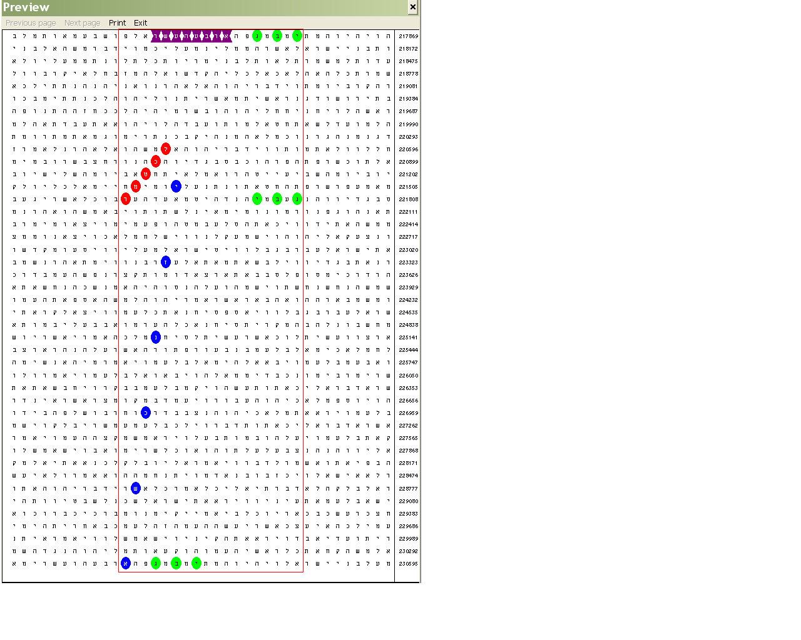
Figure 13. The encoded terms are Ashkenazi (אשכנזי), blue ovals at skip -1819; Ramatkal (רמטכל), red ovals, at skips -304; and Gabi (גבי), green ovals, at skips ±2. There is also fourteen (עשר ארבעה) violet watches in the plain text. The skip of the matrix is 303. The plain text runs from Numbers 17:14 to 25: 9.
The odds calculated for the terms in the box (save the term at skip 1 in the violet watches) is 1 in 15 836. Odds are odds, but there are also other facets hinting at encoding. In this particular case, we have two matrices. In both of them, Ashkenazi is the main term. The terms of highest significance in the matrices are Bulgaria and Ramatkal, respectively. The very interesting fact is that the skip of Ramatkal, 304, is exactly two thirds of that of Bulgaria, 456. Indeed, 456:304 = 1.5. Two and three are among the first consecutive members of the Fibonacci sequence. I find in this fact a very interesting link between the two matrices. But this also means that 19 is a factor of 304! Indeed, 304 = 16×19 = 2⁴×19. I pointed out in Part 2 that 456 is 24×19 = 2³×3×19 that is, 304 and 456 have 2 and 19 as common factors. The significance of number 19 has been discussed in Part 2 both as the length of the number of the letters of the Torah expressed in binary code and as the hexagon match number to the star number 37 (see Part 2).
There is more hidden in the latter matrix. As I mentioned above, this intersection between Ashkenazi and Ramatkal occurs with the seventh lowest skips of both items. I ran an experiment with the first six lowest skips of both items and the reply of the programs was that there is no intersection! The seventh pair arranged the closest proximity as shown in the matrix above. This proximity remained the closest one among many more trials I have made with much larger skips.
Seven times Ashkenazi and seven times Ramatkal… This makes fourteen altogether. Now we have the number fourteen on the top row within our matrix, marked with violet watches. Does number fourteen links this matrix to the previous ones with the cluster of occurrences of Aaron and the fourteen lions by the throne of Solomon? I find such links one of the most fascinating aspects of the Torah codes. As we find what we need in other parts of the Bible when trying to elucidate some difficult issue, in the same way the codes refer to each other. This is the power of the Word of God!
How could we estimate the odds in the case with Lieutenant General Gabi Ashkenazi? Shall we just multiply the probabilities found for each one of the two matrices? In such case we will obtain 1/2.6×10³×1.6×10⁴ = 1/4.16×10⁷, which is about 1 in 40 000 000. May be it is fair to take out the occurrence of Gabi גבי on the bottom row from one of the matrices because it is in both of them. This would increase the odds roughly to about 1 in ten millions. But how could we estimate the significance of that occurrence of Gabi sharing two of the letters with Bulgaria? And how could we estimate the significance of number 19 and the fact that it is a factor of the value of the skips of the important items encoded with the 19th Ramatkal Lieut. Gen. Gabi Ashkenazi? Finally, how could we estimate the significance of a matrix given the significance of another matrix containing the same items? This is another example, I believe, of conditional probabilities characteristic of reciprocally dependent events.
An Attempt for an Aftermath: Contemplations on the Connection between the Beginning and the End
I was looking back at the findings and was trying to get understanding that goes beyond the calculated odds. I felt that there is something more profound in the Torah codes, something that cannot be fixed within the frame of any established statistical model. Most of these models have been developed for comparative purposes – to enable us weigh our results against similar experiments carried out by other researchers or under different conditions. The Torah codes have proven themselves as a real phenomenon and I believe that now the time has come not to give evidence that they exist but to find out how do they work.
So far, I believe I could demonstrate that one of the most amazing facets of the Torah codes are their anticipation and their importance. They do not just appear. They appear in the right place and in the right time. This means that they are both products of the Word/Will of God and our own free wills. Our life experience is a quintessence of the history of the world. In this aspect, our minds/brains work in parallel with His Word. Finding out codes in the Hebrew Bible, we perform operations typical for quantum computation such as tunneling, skipping over meaningless states and so on. It is as if the history of the world is going to a point predestined in the Beginning by the Encoder, having passed through many intermediate states. The Torah codes demonstrate that our wills are free and that we have arrived at a point, which is a turning point in the course of time.
This raises another interesting question – about the ‘revealability’ of the Torah codes. Indeed, even if the number of the codes hidden in the Torah is infinite, how many of them will be revealed? What makes a code ‘revealable’? As far as the finding of any code is partly a product of human knowledge and efforts, what defines which code will be revealed and which one will be not revealed? Is the revelation of certain codes also a part of the Lord’s plan for the world history?
I was musing on all these questions while reviewing the articles of this sequence. As a Bulgarian, I possess specific knowledge that few non-Bulgarians are even interested to possess. On the other hand, a major part of these studies depended on the encoding of Bulgaria at skip -456 in the Torah. This code somehow ‘catalyzed’ the finding of other codes specific for the Jewish history, both Biblical and secular, where Bulgaria can be dropped out from the matrices. The following diagram can clearly illustrate this. A similar one can be drawn for the Gabi Ashkenazi code – Bulgaria is absent in Figure 13.
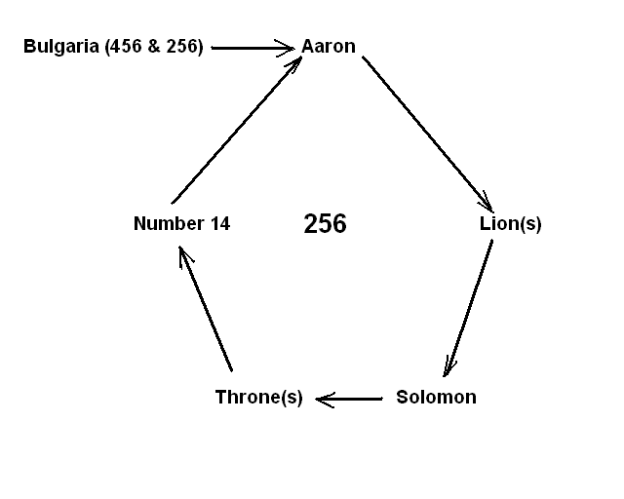
I stared at the diagram recalling many details of the course of the discovery of the codes. The arrows show the sequence of my logic, which, within the pentagon, is also the logic of the Biblical narration. In fact, this code was found because the numerical values of Bulgaria and Aaron are the same. This is why I placed 256 in the middle of the pentagon. But before that, there was number 456, the lowest skip of Bulgaria in the Torah. This is an unimpressive number, which generated so much…
How all this started? It was an interesting beginning. Few months after my first article on a Holocaust code was published in the net, a reader sent me an e-mail from overseas. She knew almost nothing about Bulgaria, while I had just done my first steps in numerology. We discussed some Bible code issues. One of her questions was about the fig (tree), תאנה, whose numerical value she cited to be 456. I immediately linked it with the lowest skip of Bulgaria in the Torah. This was how it started…
So, in the beginning was the fig, תאנה. This is indeed the first plant mentioned by its name in the Bible. The first couple made coverings sewing fig leaves together to conceal their nakedness. Then I remembered that the fig plays a significant role in the Lord Jesus’ teaching. Shortly before His crucifixion, He cursed a fig tree because He did not find fruits on it but leaves alone (Matt. 21:18-19; Mark 11:12-14). Mark adds the interesting note that the season was early for figs. Many scoffers use this fact to accuse the Lord Jesus as being unfair. However, I think He gave a sign through this event: Leaves are the symbol of hiding bad features of our characters. They facilitate hypocrisy and lie. We must look for the fruit, not for the leaves.
The significance of this event is emphasized, I think, in the sign the Lord Jesus gives about the Time of the End. He says: Now learn this lesson from the fig tree: As soon as its twigs get tender and its leaves come out, you know that the summer is near (Matt. 24:32). Interestingly, these two stories go together in Matthew and Mark, while they both are missing in Luke and John.
Leaves of a tree – the Tree of Life - are mentioned for the last time in the Bible in Revelation 22:2 And the leaves of the tree are for healing of the nations. For healing, not for concealing shameful acts any more…
I was still staring at the diagram above. In the Bible, that what is in the beginning is also in the end. In addition, Bulgaria seemed to me sticking out as a tail from the pentagon. There should be something referring back to Bulgaria… to the fig… to…
Suddenly a thought flashed through my mind. I stretched out my hand and started clicking keys on the keyboard. While billions of electrons were rushing through the integral schemes of the computer flipping logical gates, electrons, protons and whatever else were rushing within my brain. I felt that my mind does not work on ‘logical’, cause-and-effect basis. I knew the answer, which the computer was calculating. I knew what will appear on the screen… because it had to appear. But this does not mean that I was not surprised when saw the three beautiful digits: 456. The numerical value of the Throne of Solomon, שלמה כסא!
It is interesting that this expression, Throne of Solomon, שלמה כסא, does not appear in the plain text of the Tanakh. Solomon refers to his throne as the throne of his father David or as the throne of Israel. I was surprised when realized this detail. I have made the construction in accordance with the form used for the Throne of David, דוד כסא, and Throne of Israel, ישראל כסא, occurring 10 and 9 times in the plain text, respectively, which are 19 altogether. Then I checked the numerical value of the Throne of David. It turned out to be 95. Surprisingly, like 456, 95 is also a multiple of 19: 95 = 5×19! Ninety-five is formed from the numerical value of David, דוד, 14 and that of throne, כסא, 81. While the role of the first of these numbers had been illustrated in details in our study, I must remind that in Part 2 we have discussed some of the special features of the quantum computation on the example of the popular Sudoku puzzle. The number of elementary squares of the ‘normal’ Sudoku is 81. I have not found this number while working on Part 2. There, we have pointed out that number 256 is the next number in the series 4, 16, 81, 256, 625, … forming Sudoku puzzles of higher orders. Now we see these two Sudoku numbers, 81 and 256, intertwined in the matrix with Solomon, throne and lion occurring at skip ±256 and in the picture above.
Was it all? 456 is not only a numerical value but also a skip of a key item. We have found in Part 2 that the value (skip ± 1) is also an important parameter, especially (skip – 1), which defines the length of the tunnel between the letters in a term occurring at certain skip. Let us try to find something significant with Solomon and his throne…
Solomon is famous with his wisdom. The book of Proverbs is ascribed to him. It is also believed that he is the Ecclesiastes, Qoheleth. Some of the Psalms are his. However, nowhere in these books Solomon is called King. He is called King Solomon, שלמה מלך, in the historical books, once in Jeremiah, as historical reference, and twice in the Song of Songs. (There is also a very interesting occurrence of King Solomon as a string of letters, מלכשלמה, at skip 1 in Genesis 14:18: Then Melchizedek king of Salem brought out bread and wine. He was priest of God Most High. There, this string of seven letters is spread over the three words in bold characters.) What amazed me with these occurrences was that the overall number of occurrences King Solomon. שלמה מלך, with or without the definitive article or other prefixes, in the plain text of the Tanakh is 56: the number of the letters of all 14 occurrences of Aaron in the cluster we have examined! The string in Genesis is the 57th occurrence – or rather the first one - and it is the only one in the Torah! 57 is the skip of the matrix I developed in Part 2.
A throne is a royal attribute; therefore, I decided to look in the Song of Songs, one of my favourite books. Before starting the search, I recalled that although Solomon was famous with his wisdom, the only real historical event recorded showing him applying his wisdom was his verdict in the dispute between the two prostitutes (1Kings 3:16-28). There is also one of the rare occasions of sleeping women. The other two occasions I found (allusion to death excluded) are in the Song of Songs and Matthew 25 1-13 (the Parable of the Ten Virgins). In the Song, in chapter 5, the Beloved Girl is too lazy or hesitant to open the door to her Bridegroom Solomon. Keeping in mind the similarity to the Ten Virgin’s story and the words of the Lord Jesus that there is more wisdom and splendour in Him than in Solomon, I did not hesitate any more and delved into the Song.
Solomon is King in the Song of Songs but there is no throne in this book… There, Solomon is on a carriage, or litter (palanquin). King Solomon’s splendour is described in chapter 3 of the Song of Songs. Semantically, carriage is close to throne and also to litter and palanquin – so close that NIV uses the same word in 3:7 and 3:9. In older versions, there are different words to reflect the original Hebrew text. These words are chariot, or carriage, אפריון, and litter, couch or simply bed, מטה. The latter word is used first, when Solomon comes from the desert like a column of smoke:
Look! It is Solomon’s carriage,
escorted by sixty warriors of Israel,
all of them wearing the sword,
all experienced in battle,
each with his sword at his side,
prepared for the terrors of the night. (Song 3:7-8)
Here, carriage, מטה (meeta) of the young Solomon is written in a strange, poetic form. It is defined twice as belonging to Solomon: once as the form in Genitive masculine and once as directly specified as Solomon’s by the prefix of, של: (שלשלמה מטתו). Therefore, the first line could be translated approximately as Look! It is his, of Solomon, carriage… Now the Genitive form, meaning simply his bed, מטתו (pronounced meetato), and occurring many times in the Bible, has numerical value of 455. This is equal to the numerical value of Judah is a young lion (Gen. 49:9), Gur Arieh Yehudah (יהודה אריה גור) and the length of a ‘tunnel’ discussed in Part 2.
The sum of the numerical values of the fig/throne of Solomon on one hand and Young Loin of Judah/his carriage on another, also point in a strange way to the Latter Days. It is 456 + 455 = 911.
April 3rd, 2007 (Pesach, 5767)
Sofia, Bulgaria

Contact Lyuben Piperov at l_piperov@yahoo.co.uk

References
[1] Lyuben Piperov’s works in http://exodus2006.com/BibleCodes5.htm;
http://www.carelinks.net/booksandarticles.html (Part 2 as Genesis, Genetics and Bible Codes) and
http://80.189.248.54/BibleCodes/
Some of them, Part 2 including, are in http://ad2004.com/Biblecodes/articles/articles.html
[2] Dr. Alexander Rotenberg, And All This Is Truth!: Mysteries hidden in the Book of books, Distributed by Levi P.Enterprises, Ltd – Israel, Jerusalem, 2005, p.62-67.
[3] For Standard Deviation, see in http://en.wikipedia.org/wiki/Standard_deviation
[4] For Normal Distribution, see in http://en.wikipedia.org/wiki/Normal_distribution
[5] For Accuracy and Precision, see in http://en.wikipedia.org/wiki/Accuracy_and_precision
[6] For Sniper, see in http://en.wikipedia.org/wiki/Sniper
[7] Gabi Ashkenazi: http://en.wikipedia.org/wiki/Gabi_Ashkenazi
[8] For conditional probability, see http://en.wikipedia.org/wiki/Conditional_probability

Programs do not do this task in exactly that way. What they do in reality is checking for all possible occurrences of the defined term at skips from 1 to that of the actual occurrence(s) within the specified frame. They determine the significance on this basis. However, defining a parameter similar to distance is a good analogue and demonstrates clearly the way we, humans, approach some problems of decoding, I believe. This parameter allows us to ignore occurrences at any other skips and concentrate our attention to the one of interest.
Interestingly, throne, כסא, occurs at abnormally low frequency at skips between 2 and 100 throughout in the Torah. While the expected number of such occurrences is 1 265, the actual number is 1 127. The standard deviation is 3.87, which corresponds to odds of 1 in 17 000. This is not so in the rest of the Tanakh: The expected number of occurrences in the books from Joshua to 2 Chronicles including between 2 and 100 is 3 516, while the actual number is 3 480, with SD = 0.60 corresponding to odds of 1 in 2. (I have ignored skip 1 because it occurs quite often in the plain text in the books following the Torah.)
I have obtained lowest odds at skip 18. However, at this skip, the matrix loses its symmetry and beauty. There are more lines and the two occurrences of Solomon are in different rows.
Taking out an occurrence of Gabi, גבי, at skip ±2 from one of the matrices would increase the odds about ten times. However, taking out the only occurrence from the matrix with Bulgaria would decrease considerably the area of the matrix and the remaining odds would be about 1 in 700. Multiplication of ~15 000 and ~700 makes 10.5 millions.

