Copyright © Lyuben Piperov April 2008
Intricate Mathematical Relations indicating specific Importance for Year 5768 (2007/8) encoded in the Bible
Lyuben Piperov
Abstract: Highly significant codes about the president elect of Russia, Mr. Medvedev, have been discovered in the Torah and Tanakh. These codes generated other temporal codes suggesting high significance of the Jewish year 5768 and especially the Feast of Shavuot. Besides matrices, the codes include other parameters such as skip-values, expected numbers of occurrences of specific terms and the number of letters in the Tanakh. An intriguing ratio between the number of the days in a solar year and a fundamental physical constant has been uncovered hidden in the numerical values of the letters in the Hebrew alphabet. The role of feedback in the process of Bible code breaking has been emphasized, enlightening the similarity between this constructive process and quantum computation.
The infinitesimal number is smaller than the tiniest number we can imagine
A famous Bulgarian Professor of Mathematics
Introduction
What made me start this research was the meaning of the surname of the president elect of Russia, Mr. Dmitry Medvedev. It derives from medved’, which means bear in Russian, the symbolic animal of Russia. It was this symbolism that intrigued me and I decided to look for his name encoded in the Bible. I started with his full name, which I found in the Hebrew sites: מדבדב דמיטרי, but did not find any occurrence either in the Torah, or in the Tanakh. Then I tried with the term President Medvedev, מדבדב נשיא, and to my greatest surprise, it occurred in the Torah, at skip -1836, against the odds of about 1 in 10 000 000 (standard deviation SD = 5.42)! For a comparison, the occurrence of the well-known “Yitzhak Rabin” code discovered by Michael Drosnin and discussed in details in his book The Bible Code occurs against the odds of about 1 in 300 (SD = 2.86) in the Torah.
I performed the search using the “CodeFinder” computer program. This program produced two more occurrences in the Tanakh, altogether against the odds of 1 in 300 (SD = 2.87)! The term does not occur outside the Torah with “The Keys to the Bible” program. Although, as we will see later, the differences between the texts embedded in these two programs are minor, these occurrences emphasize the importance of each letter in a text for the appearance of a code, especially at large skips. This fact by no means could justify claims on which text is valid! On the contrary, my own belief is that in this way, the Encoder substantiates the revelation of His codes as a sophisticated process of interactions, in which the text is only a component.
Mr. Medvedev’s presidential star rose with lightning speed in the end of 2007. Within few months, he was elected as the president to succeed Mr. Vladimir Putin. All these events happened after the start of the Jewish year 5768 (התשסח). Keeping in mind that it started in September 2007, it seemed reasonable to me to look for year 5768 encoded together with the President Medvedev term. I managed to find two very significant matrices with President Medvedev encoded with Year 5768. The first one is in the Torah, where the Year 5768 occurs at its lowest skip, -12. The second one is outside the Torah, with “President Medvedev” at its largest absolute skip-value, -35 467. In the latter case, there were the two lowest-skip occurrences of Year 5768 in the Tanakh – at skips 5 and -6 – in the matrix with the main term! The odds in favour of significance of this matrix are about 1 in 1.7 millions, while those for the Torah are about 1 in 100 000. These matrices are practically independent and I wondered what the meaning of this abundance is.
Bearish Mood starts emerging, but is calmed in the End
Having found the year with such high significance, I started looking for specific dates. At first, I tried with the date of the election of Mr. Medvedev: 2 March 2008, which is 25 Adar I 5768. I couldn’t find significant occurrences of this date. Then I realized that the main term, “President Medvedev” implies him as incumbent President of Russia. Therefore, it should be more reasonable to look for the date of his inauguration: 7 May 2008, which is 2 Iyyar 5768. I felt somehow uneasy, because this date is still in the future and I have never used the Bible codes as means for prediction of specific events. However, this date is not a predicted or prophesied, but an appointed one, so I decided that my search is justified. To my amazement, the date occurred in both matrices! See Figures 1 and 2.
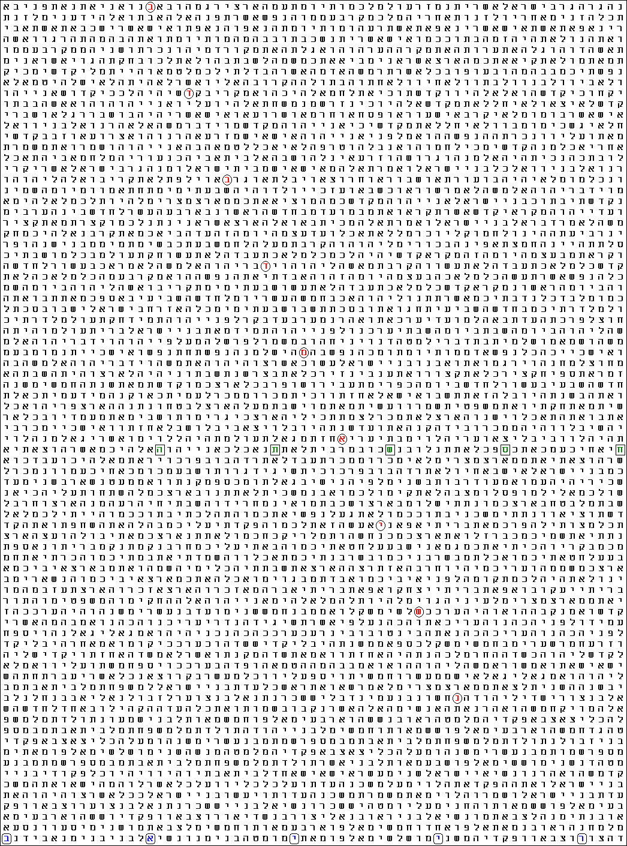
Figure 1. President Medvedev (מדבדב נשיא), red, at skip -1836; Year 5768 (התשסח), green, at skip -12 and 2 Iyyar (באייר), blue, at skip -15, in the Torah. The skip of the year is the lowest in the Torah.
Term Translation Skip R Factor (in Matrix) Start End
נשיאמדבדב President Medvedev -1836 2,523 4,302 Numbers 1:7:7 Leviticus 20:2.82
התשסח Year 5768 -12 0,541 2,319 Leviticus 25:38.7 Leviticus 25:36.31
באייר 2 Iyyar -15 -1,442 0,336 Numbers 2:22.29 Numbers 2:20.39

The ELS reference is 230 characters between rows.
There are 3 displayed terms in the matrix.
The matrix starts at Leviticus 20:2.33 and ends at Numbers 2:22.29.
The matrix spans 17775 characters of the surface text.
The matrix has 78 rows, is 65 columns wide and contains a total of 5070 characters.
There are 3 significant terms in the matrix.
The matrix odds are 1 chance in 150660,707 in favour of significance.
The cumulative ‘R’ Factor for the displayed matrix is 5,178.
Here, the odds are about 1 in 150 000. The other matrix, entirely outside the Torah, is even more astonishing. There, the day of the month occurs twice, in full harmony with the number of occurrences of the year! Moreover, I noticed that the occurrence of the Jewish year at the lowest skip in the Bible extends to IN (Year) 5768 (בהתשסח)! See Figure 2.

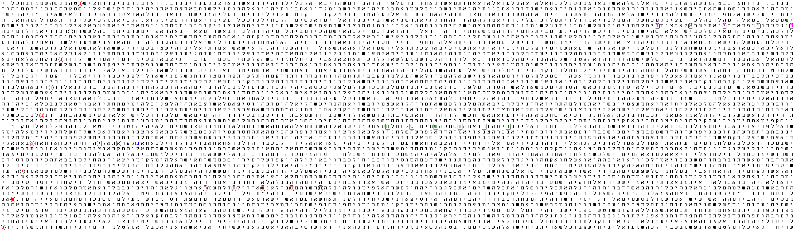
Figure 2. President Medvedev (מדבדב נשיא), red, at skip -35 467; In year 5768 (בהתשסח), green, at skip 5; Year 5768 (התשסח), brown, at skip -6 and 2 Iyyar (באייר), blue, at skip 4, and purple, at skip -7, in the Tanakh. The skips of the year are the lowest in the Tanakh.

Term Translation Skip R Factor (in Matrix) Start End
נשיאמדבדב President Medvedev -35467 0,558 2,804 Isaiah 46:5.25 Joshua 22:10.54
בהתשסח In Year 5768 5 1,678 3,924 1 Kings 8:33.69 1 Kings 8:34.20
באייר 2 Iyyar 4 -1,498 0,748 1 Kings 18:16.33 1 Kings 18:17.6
באייר 2 Iyyar -7 -1,741 0,505 Judges 12:8.23 Judges 12:7.44
התשס Year 5768 -6 0,335 2,581 2 Kings 24:14.81 2 Kings 24:14.57

The ELS reference is 7093 characters between rows.
There are 5 displayed terms in the matrix.
The matrix starts at Joshua 22:9.16 and ends at Isaiah 46:5.25.
The matrix spans 283885 characters of the surface text.
The matrix has 41 rows, is 165 columns wide and contains a total of 6765 characters.
There are 5 significant terms in the matrix.
The matrix odds are 1 chance in 206910778,422 in favour of significance.
The cumulative ‘R’ Factor for the displayed matrix is 8,316.
Although the probability for this clustering to occur by mere chance is below 1 in 200 millions, I was fully aware that it is due mainly to the occurrences of the year 5768. The overall contribution of the two 2 Iyyar terms for the significance of the matrix is the combined ‘R’ Factor 1.25 (1 in 17), which means that even without them, the odds will remain below 1 in 10 millions. I was lucky to find the days at first attempt, but there could be dates that would decrease even more the odds of the matrix. Therefore, I decided to scan for any other date in the months Nisan and Iyyar – that is, from 6 April to 3 June 2008. There were two dates that generated higher significances, both occurring once only: 20 Nisan (כניסן), or 25 April, at skip 1 – that is, in the plain text – and 8 Iyyar (חאייר), or 13 May, at skip 5.
At first, I was puzzled. The new findings surprised me. Being influenced by the widely spread Bible Code skepticism, I believed that they should not be there. My first reaction was to try to find an “explanation”. Indeed, the actual number of occurrences of 2 Iyyar at skips up to ±7 is 45. This is appreciably lower than the expected 55 occurrences (odds 1 in 5; SD = 1.35) and so the actual significance of their occurrences is somewhat higher. However, all this by no means satisfied my research principles. I believe in the Omnipotence of the Lord God, the Encoder, and I am certain that He could arrange the code in a way He would silence any critic. Having provided this particular reality, He should have a specific purpose in mind…
It was while I was musing on this strange “splitting” of the code in two independent matrices when I spotted that 20 Nisan occurs in the end of the Torah, thus making the (new) matrix in Figure 2 “overlap” some text of it. Then the thought dawned on me. The Encoder has separated the Torah code shown in Figure 1 for a type of a reference standard! In this particular case, for a touchstone for the proof of any “contaminating” terms…
I rushed to check the two new dates in the Torah matrix, but they were gone! Then I realized something that has escaped my attention so far. It is the way numbers are expressed in Hebrew. The first ten letters of the alphabet define the first ten whole numbers. Larger numbers are expressed with more than one character. For instance, number 12 is written as yod (י) denoting 10 followed by beyt (ב) signifying 2. In a similar way, kav (כ) followed by ב means 22. Therefore, if the letter at the respective skip before beyt is yod or kav, the date becomes ambiguous: it could be 2, 12 or 22 Iyyar. I checked the matrix and, though the odds are very low, about 1 in 200, the term 2 Iyyar at both skips appeared to be ambiguous! The one at skip 4 could be 22 Iyyar as well, while that at skip -7 could be 12 Iyyar. I checked the matrix in the Torah (Fig. 1). There, the respective letter 15 places to the left of beyt is dalet (ד), of numerical value 4 and without meaning in this particular case, thus confirming that the date should be 2 Iyyar. A remarkable proof of the importance of this code as a reference!

Echo from the Solomon’s Prayer reverberating in the 21st Century
Nevertheless, a new task emerged now: we have to understand the deeper meaning of the code. I do not believe that the day of inauguration of a Russian president is of such major importance that needs a specific method for encoding in the Word of God. The matrix is surely pointing to something else. Knowing that the Torah is the fundament, we should look in the other code, found outside it. And I think that we don’t need to look for it diligently. It is right before our eyes: the term in 5768 (בהתשסח).
This term is remarkable in more than one aspect. It is a relatively rare occasion when a Jewish year occurs at its lowest skip with the preposition “in” (ב) before it. The other occurrence at skip -6 is in 2Kings 24, in a text narrating about the removal of the treasures from the Temple of the Lord and taking the cream of the Jerusalem society into captivity. The first one, however, occurs against a very low probability. It is in a text containing a lot of prophetic character: King Solomon’s solemn prayer of dedication of the First Temple to the Lord. The code occurs in a very significant part of the prayer. See Figure 3.

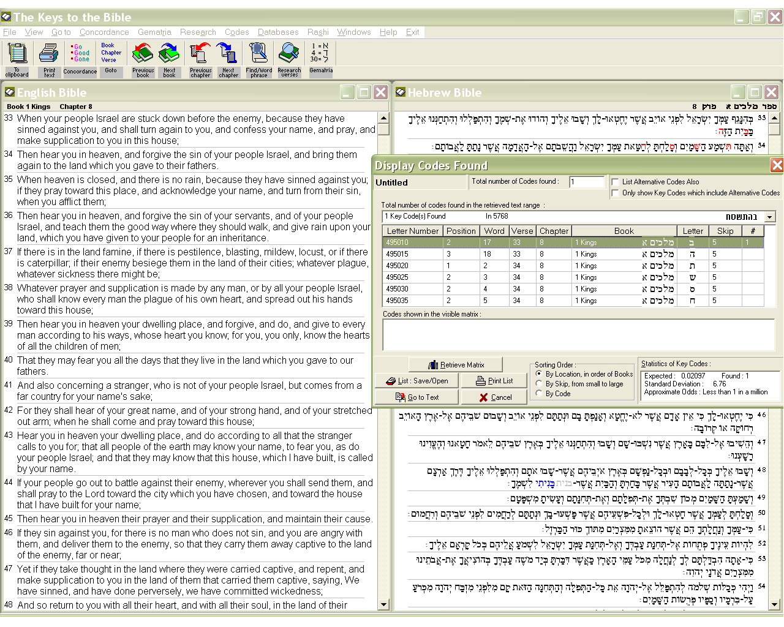
Figure 3. In (Year) 5768 (בהתשסח), marked in red characters, up in the right column, at skip 5, in 1Kings 8:33-34. The Figure contains a part of the Solomon’s prayer concerning Israel as a nation when turning to the Lord after having repented. The insertion contains statistics. The actual odds for בהתשסח to occur once at skip up to ±5 are much smaller than 1 in a million; the SD value 6.76 defines a chance far below 1 in a billion!
This text exists in every Bible version I have read. I realized that this code had to be there! It is connected to specific attitude of the people of Israel and the Temple; this is why it is in the Solomon’s prayer and therefore could not be found in the Torah. On the other hand, the process of revealing it so far unequivocally pointed back to the Torah. Although the lowest skips of the encoded occurrence of both “Year 5768” and “In Year 5768” are outside Torah, the matrix in Figure 1 invites us to look more meticulously there. We have already found the lowest skip of “Year 5768”. Therefore, the next step is to look for the lowest skip of “In Year 5768” in the Torah.
It turned out to be the apparently insignificant occurrence at skip -218. There was significance, however, hidden elsewhere. In my recent study on the Comet Holmes [1], I managed to find the lowest encoded occurrence of God (is) with us = Emanuel (עמנואל) in the Torah at skip 4 in a matrix with the main term defining the year of the outburst of the comet, 2007, against the odds of about 1 in 200 000. I knew where the occurrence of Emanuel is: in Deuteronomy 1:28-29. Therefore, when I saw in the report that “In 5768” is entirely within Deuteronomy 1, I foretasted the picture I was about to see after a while. See Figure 4.

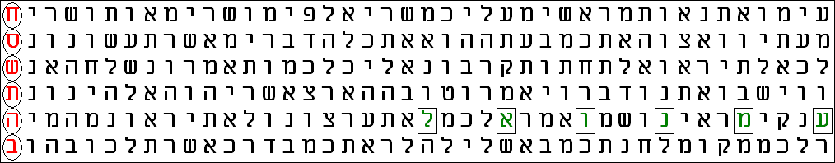
Figure 4. In (Year) 5768 (בהתשסח), red, at skip -218 - the lowest in the Torah; and God with us (עמנואל), green, at skip 4 in a 6 × 42 matrix. The odds in favour of significance of this matrix are 1 in 20 000.
Looking at the matrix, I had the feeling that I have been led to it. The whole process of Bible code breaking we have carried out so far looked like going a long way. It started at the glorious times of the United Kingdom of Israel and the building of the First Temple, or even earlier, and ends in our days. This process outlined the Jewish Year 5768 as an outstanding milestone in the course of history. God is with us in the Year 5768… What could this mean?
In Exodus 23:17, the Lord commands: “Three times in a year shall all your males appear before the Lord God.” In the verses immediately above, these three feasts, called also Pilgrim Festivals, are defined as the Feast of Unleavened Bread (Passover), the Feast of Harvest (Pentecost) and the Feast of Ingathering (Booths). This commandment implies that standing before the Lord God, we unite with Him closer than in any other everyday circumstances. Therefore, I searched for codes of these three feasts: Passover = Pesach (פסח), Pentecost = Shavuot (שבועות) and Booths = Sukkoth (סוכות). The most significant matrix I obtained was with Pentecost. Then, however, I decided to check also for New Year = Rosh Hashanah (השנה ראש) and the Day of Atonement = Yom Kippur (כפור יום). The matrices obtained with these terms appeared to be less significant than the one with Pentecost. Finally, I added to the list the other two major Jewish feasts: Chanukah (חנוכה) and Purim (פורים). No one of the matrices exceeded in significance of the matrix obtained with Pentecost – Shavuot. The one obtained with Chanukah was close in significance to that with Pentecost – having about 50 % higher matrix odds. Chanukah occurred at its lowest value in the Torah, 3, but far enough from the main term – in Deuteronomy 5:33. The matrix obtained with this term was more than three times larger than that obtained with Pentecost.
Although not at its lowest skip, Shavuot שבועות was also entirely within Deuteronomy 1. This fact made me examine the occurrence scrupulously. I noticed that the letter preceding the term is hey (ה), which is the definite article in Hebrew, thus making the term more specific: The Pentecost, HaShavuot! The odds are below 1 in 4.5 millions! See Figure 5.
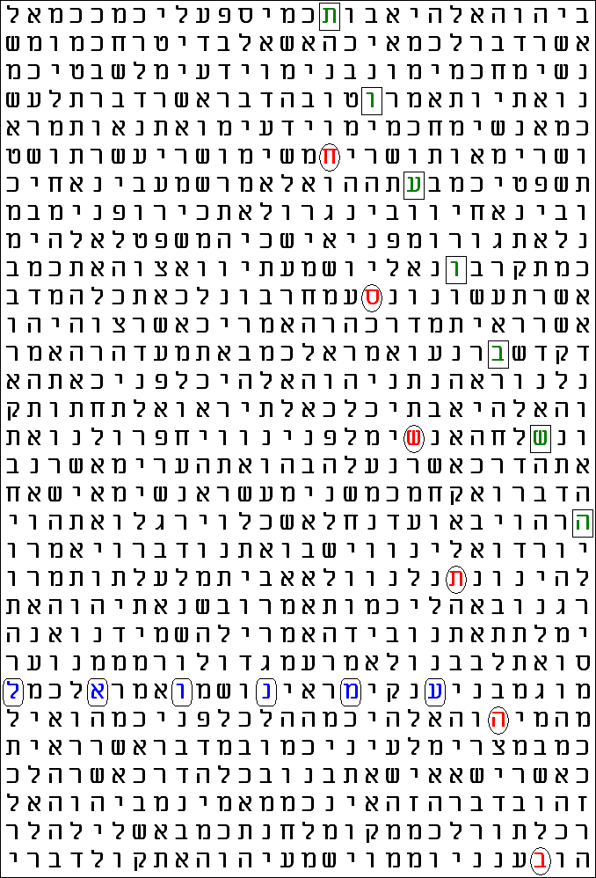
Figure 5. In (Year) 5768 (בהתשסח), red, at skip -218; The Pentecost (השבועות), green, at skip -130 and God with us (עמנואל), blue, at skip 4. The Pentecost is at its lowest skip in the Torah. See the report below.
Term Translation Skip R Factor (in Matrix) Start End
בהתשסח In Year 5768 -218 0,553 3,098 Deuteronomy 1:33.59 Deuteronomy 1:15.71
השבועות The Pentecost -130 0,361 2,906 Deuteronomy 1:24.12 Deuteronomy 1:11.12
עמנואל God is wi th us 4 0,666 3,211 Deuteronomy 1:28.71 Deuteronomy 1:29.9

The ELS reference is 44 characters between rows.
There are 3 displayed terms in the matrix.
The matrix starts at Deuteronomy 1:10.41 and ends at Deuteronomy 1:34.18.
The matrix spans 1348 characters of the surface text.
The matrix has 31 rows, is 28 columns wide and contains a total of 868 characters.
There are 3 significant terms in the matrix.
The matrix odds are 1 chance in 4683524,108 in favour of significance.
The cumulative ‘R’ Factor for the displayed matrix is 6,671.
A stunning Coincidence spotted due to earlier Findings
But why Pentecost? In the course of carrying out the research, I noticed few impressing coincidences. I have never expelled from my mind the strange code I found back in 2004 [2]. I called it ‘strange’ because I ‘invented’ it as a string of Hebrew letters forming the number 2 000 in a way matching the numerical value of the year, at the same time expressing it as a logical sequence in accordance with the rules established for denoting the years within a millennium. The core of this ‘invention’ was the number 1 000 represented as the sum of the numerical values of the lowest number of different letters: tav ת (400), shin ש (300), resh ר (200) and qof ק (100), in their descending order in accordance with both Hebrew and Roman rules. It seemed to me logical that 2 000 will be this string repeated twice. To my greatest surprise, it occurred in the Torah against the odds of about 1 in 300. To my astonishment, however, the letter following the string was vav ו, forming a 9-letter term. Therefore, I concluded that the code, occurring against infinitesimal odds in the Torah, defines the year 2006, תשרקתשרקו, which was still in the future.
My first findings showed the strong link of this term with the Time of the End as prophesied by the Spirit of God through the Prophets in the Tanakh, especially Daniel [3]. Specific interests of every devoted researcher’s approach to the Bible codes are the structure and the symmetry of the terms within a matrix. We cannot part logic and truth from harmony and beauty. The codes I managed to find were mostly of general character, usually elucidating specific aspects of prophecies or looking from a new angle at the world history. However, although these codes, as I believe and hope, might have contributed to a better understanding of the Word of God and enhance our awe at His Omnipotence, I could not find any particular major event from 2006 encoded with this term. Then, quite unexpectedly, the election of Mr. Shimon Peres as the President of Israel [4] unambiguously appeared to be connected with this term. However, this event took place in 2007, not in 2006! Then I realized the significance of the letter aleph א at the other end of the term. Its numerical value is 1, so the overall numerical value of the extended term matched exactly the numerical value of the year: 2007!
In the end of the year 2007, a magnificent event happened in the sky. It was the unexpected outburst of the Comet Holmes and the occultation of the brightest star in the constellation Perseus, Mirfak, by the comet’s tail. Again, all these appeared to be encoded with the same main term, which I, to some extent confused, named 2006/7 code. My confusion was caused by this strange confirmation of the significance of the aleph on the side of the term that is opposite to the vav, making it 10-letter long: אתשרקתשרקו. I was so much puzzled that, led by the wish to avoid ‘inflation’ of significance of matrices, continued to apply the term as its original definition, the 9-letter 2006 code.
I have run a number of times several computer programs loading this term and each time a same set of figures were displayed on the screen. These figures were imprinted in my mind. Therefore, when such figures occurred with another term, I could hardly remain unimpressed.
While carrying out the study on the President Medvedev code, I did some search in the Tanakh outside the Torah. The reason for this was to find some relations between the Torah as reference standard and the other text. I searched for the odds for in Year 5768 (בהתשסח) to occur within skip ±5 in the text from Joshua 1:1 to the end of 2Chronicles. When the programs displayed the figures, I had the feeling that I have already seen them before. See Figure 8.
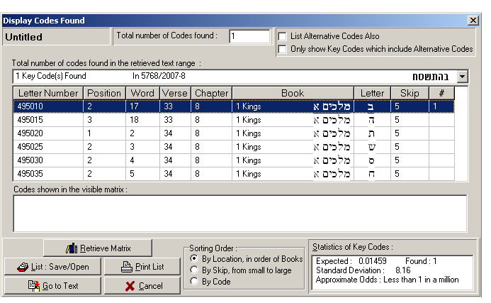
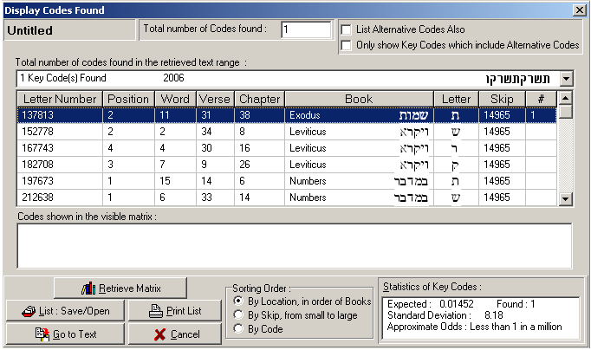

Figure 8. Statistics calculated by The Keys to the Bible computer program for the occurrence of in Year 5768 (בהתשסח) in the text outside the Torah (top) and 2006 (תשרקתשרקו) in the whole Tanakh (bottom) within the absolute values of their skips ±5 and ±14 965, respectively. The expected numbers of occurrences 0.01459 and 0.01452, respectively, differ by less than 0.5 %! The standard deviation values 8.16 and 8.18 define actual odds of the order of 1 in trillions.
This appeared to be the first one in an amazing series of coincidences. Both terms generated significant codes with “God (is) with us” (עמנואל) in the Torah at their lowest or only skip. Both terms occur at their skips against practically the same odds in the Tanakh (2006) and in the combined Prophets and Writings (in Year 5768). I evaluate these facts as justification of the structuring of the Word in three major parts and evidence of specific interaction between the codes occurring in the different parts of the Bible. But isn’t something deeper here? Don’t these coincidences hint at a role of the 2006/7 term in these new codes? A role defined by its skip value?

A rusty Key found in an old Treasury
Then I noticed another strange coincidence. The “God with us” term appeared close to the main term 2006 (תשרקתשרקו) within a highly significant matrix at the fifth row splitting of the main term. That is, the skip of the main term is divided by five and therefore, there are four rows between the letters of the main term in the matrix. (See Fig. 14 in my work on the Comet Holmes [1]). The term occurs here most significantly along with the main term in the “unprocessed” matrix in Fig. 4. However, it forms most significant matrix together with the Pentecost term at the fifth row splitting of the main term “in 5768” (בהתשסח) in Fig. 5 here again! Is this a vague hint at a connection between the Feast of Shavuot this year and the 2006/7 term?
I checked the date of the Feast of Shavuot in year 5768. It starts at sunset on 8 June. As a Gentile, I am much better accustomed to this type of dating rather than to that of the Jewish calendar and clearly remember that the Six-Day War was in its heat on this day of June back in 1967. It was the day after the Israeli army liberated the Old City of Jerusalem and the paratroopers reached the Western Wall and took the Temple Mount: 7 June!
Although I have carried out research with the 2006 code for years, it was as late as in the summer of 2007 when I noticed that 365, the number of the days of a normal solar year, is a factor of its skip 14 965:
365 × 41 = 14 965
The exact number of days in a solar year is not 365, of course, but about a quarter of the day larger. This is why an extra day is inserted in every fourth, or leap year, as in the current 2008. At the time of my writing the article on Shimon Peres code [4], I considered the factorization above exclusively from Bible code standpoint and noticed that the number of the letters in the words of the plain text intersecting the main term is exactly 41. I was satisfied with the results obtained, which seemed to me a very good example of how quantum computation works. I did not look for any temporal connotation of the number 41 at that time…
I closely examined the various calendar systems used in the East Mediterranean world and the Greco-Roman civilization and observed that all these have taken into account, more or less accurately, this approximately one extra day in four years. All, except the ancient Egyptians! Their year consisted of exactly 365 days. They appeared to be addicted to this number, although being aware of the discrepancy, most probably because they believed that the deity Thoth divinely ordained the number of the days in the year. Israel in Egypt had surely been subjected to this calendar system.
On the other hand, a skip value should be a whole number. Therefore, if the Encoder wants us to see a time period expressed as an exact number of years, I believe, He would have hardly used another method but the number of the years multiplied by 365. Remembering the Six-Day War, I realized that from the liberation of the Old City of Jerusalem and the Temple Mount to the start of this year’s Shavuot will be exactly 41 solar years – to the day!
However, although the number of the years will be exactly 41, the number of the days will exceed 14 965 by ten days, coming from the number of the leap years between 1967 and 2008 including…
One of the programs I use – The Keys to the Bible –displays the largest possible skip of the dialed term within the specified text. This is the skip at which the first and the last letters of the term touch both ends of the text – that is, the term spreads over the whole text – and is one of the crucial parameters for defining the expected number of occurrences of the term. For years, I have searched codes with the 2006 term in the Torah only, so I knew the number for this text by heart. Therefore, I was very much surprised when saw that the first four digits of the largest possible skip of the “President Medvedev” term in the Tanakh, 149 615, are the same as those in the 5-digit skip of the 2006 term in the Torah: 14 965! Then I noticed that both President Medvedev (מדבדב נשיא) and 2006 (תשרקתשרקו) are 9-letter long terms and therefore they should have the same skip limit in the Tanakh.
What a sign! The skip of 2006 is almost exactly one tenth of the largest possible value in the Tanakh! I was shocked because of my blindness all these years. Concentrating my attention on the Torah alone, I may have never looked outside it had I not performed the research with the President Medvedev code. Well, just about one tenth, but not exactly…
The maximum skip of a term is defined by the length of the text minus one letter and the number of intervals between the letters in the term. The largest skip of a term is the integer part of the ratio of the number of the letters in the text minus 1 to the number of intervals – in our case, 8. Therefore, the maximum skip will change by a unit if the number of the letters in the text increase or decrease by 8 letters. It will remain the same within intervals of 8 letters. For instance, were the Tanakh only 35×8 = 280 letters (that is, about 0.02% only!) longer, the maximum skip of any 9-letter long term would be 149 615 + 35 = 149 650, or exactly 10 times the skip of the 2006 term.
The number of the letters in the Tanakh version used with the CodeFinder program is 1 196 925, while the text with The Keys to the Bible program contains 1 196 921 letters. Both these programs define 149 615 as the maximum skip value for a 9-letter long term. An interesting detail, indeed. Both numbers are within the 8-letter interval between 1 196 921 and 1 196 928 specifying the abovementioned maximum skip.
This maximum skip value, however, divided by 10 does not yield a whole number. Therefore, if there is a meaning in the findings we have discovered so far, we must look for it in the skip value 14 965. The maximum skip divided by 10 gives 14 961.5. How much this number differs from the actual skip? The subtraction of the smaller from the bigger number gives 3.5. In the light of the number-of-days interpretation of the skip value we have applied so far, the result of the subtraction should be 3 ½ days. I looked for hours this number in amazement. Indeed, one could hardly invent a better key to the skip value enigma! 3 ½ days are exactly the half of a 7-day week! It is mentioned in the famous 70 “sevens” prophecy in Daniel 9:27. To my best knowledge, this is the only occasion in the Bible where divided day is alluded to.
Why Pentecost?
The 3 ½ days key unambiguously points to a period(s) of time measured as a set of weeks, that is, “sevens”. There is an interesting facet of the three Jewish Pilgrim Festivals. While the duration of each of the other two of them, Pesach and Sukkoth, is 7 days = one week, Shavuot is a one-day feast, but its date is to be calculated as a set of seven weeks from a certain day after Pesach. I find this type of specification by calculation very much intriguing. Indeed, all other days of celebration are given in the Law as concrete days of certain month. Thus, Pesach is always on 15 Nisan. Therefore, if there were to be counted seven weeks starting on the next day, Shavuot will always be on a certain date as long as the months Nisan and the two months following it, Iyyar and Sivan, are of fixed length. Therefore, it would be practical to fix the date of Shavuot on the respective day of Sivan, the 6th of the month, as it is in the Jewish calendar today.
The reason for the calculation could be on one hand either the movable day for starting the counting of the seven weeks – as some believe it should be the first Sunday after Pesach – or the possible changes in the length of the months. On the other hand, the commandment for counting the seven weeks could have spiritual implication: we have to be vigilant. The process of counting would prepare our minds and hearts for the coming Day. In addition, we will be aware of how much time is left before the Day comes…
The religious importance and the spiritual depth of the Pentecost/Shavuot could hardly be overestimated. Historically, this was the Day when Moses received the Torah on Mount Sinai on behalf of all Israel [5]. About thirteen centuries later, another historical event happened on the same Day: the Holy Spirit of the Lord descended on the Lord Jesus’ apostles. Therefore, it is much surprising that Pentecost/Shavuot does not find due recognition worldwide today. What is more, it seems that its significance has rapidly decreased in the last few generations. Monday after Pentecost, which once had been official holiday in most Christian countries, is becoming an ordinary day throughout. But maybe this fact should not be surprising at all. A call for spirituality will be normally cried down by worldly craves in this materialistic epoch. It is noteworthy that the East Orthodox churches regard Pentecost as the second to Easter only feast in importance. Being more mystical than the Catholic or Protestant denominations, they were seeing profounder significance in the voluntary act of dying on the cross followed by the Resurrection of the Messiah the King and the descending of the Spirit of God from heaven – a consequence of this Feat, corresponding to the giving of the Torah – than in the relatively more mundane act of His birth. In the East, Christmas gained its current aspect of a period of demonstrative spending mainly under the influence of the West on the last several generations.
I was much intrigued by this rapid change of the significance of the religious feasts both in Judaism and Christianity. The Codes state unambiguously: God IS with us on Pentecost/Shavuot… But God is with us always when we turn to Him with broken hearts. God was with Israel in the night of the first Pesach, when the Angel destroyed every firstborn in Egypt and spared the firstborn of Israel. What makes Pentecost/Shavuot unique?
On Pesach, the Lord spared Israel as people, but under the condition that each member of the people had to adhere to His commandment to sprinkle the doorposts of his house with the blood of the Paschal lamb. On Shavuot, He created the Nation of Israel by giving the Torah to Moses on the Mount Sinai. The remarkable difference here is that the Lord did this Feat through one man: Moses! Although many Israelites sinned by making the golden calf, they were not destroyed due to the interceding of Moses with the Lord for the nation of Israel.
Now I was able to understand how God allows us to come closest to Him permanently: through His Chosen Man only! His standards are so high that they are unachievable by ordinary persons. He would be pleased to have a Nation of persons. However, these human individuals would be unable to approach Him without leadership. The best the Lord could do with larger masses of people is to spare their lives. This is not His flaw. Simply higher objectives need compliance with higher standards. Generally, people are susceptible to follow their own sinful desires (Genesis 6:5). However, history has proved that the activities of large masses of humans could be concentrated on certain good purposes through a suitable leadership of individuals. So, there were Moses and the prophets as well as judges, kings and many more fine men and women in the Tanakh. Then, the Only Begotten Son of God was born, the Lord Jesus, Who is the Prophet Moses was told that the Lord will rise from among Israel, a Prophet like him (Deut. 18:15, 18-19). There were wicked leaders as well of course, just to prove the validity of this rule. These have dragged away many.
Even though Pentecost/Shavuot marked the zenith of the revelation of God to Israel in the Tanakh, it has gradually become insignificant in these final materialistic days. Liberal democrats cannot assimilate the idea of something good coming through one man. Genuine wisdom is believed now to be a phenomenon emerging out of conscious way of thinking and – to even a higher degree – to the unconscious desires of large masses of people. Skeptic Bible scholars could easier assimilate and “explain” the origin of Pesach as a memorized historical event. I have read many attempts for “scientific” interpretations of the ten plagues. I have not seen, however, a single plausible materialistic reasoning on the giving of the Torah from above within one day and as a string of letters to Moses. Even most of the religious leaders consider Torah a piece of literature written within a period of time. The only difference from materialists is that the former say that this process had been carried out under “divine inspiration”. The notion that Torah has already existed by the time of Creation is too much for a carnal mind. Therefore, it cannot digest the deeper spiritual significance of the giving of Torah. This is why, I believe, Pentecost/Shavuot is a one-day feast. It is reminiscent of the most spiritual time in history: the Day of the Lord!
All this could elucidate another interesting psychological aspect of the general attitude kept in the Biblical record. When Moses ordered what Israelites were to do with the Paschal lamb, they rushed forward to carry out strictly what they were told to do. The story in Exodus does not mention even a single case of disobedience or disbelief. Just about few months later, however, these same people were both disobedient and desperate – wanting to stone Moses – and skeptic: As for this fellow Moses who brought us out of Egypt, we don’t know what has happened to him (Ex. 32:1). Keeping in mind that both the Paschal lamb and Moses are two of the several archetypes of the Messiah, we can see that the egoistic human nature readily accepts Him in the role of sacrificial offering, but is reluctant to recognize Him as Glorious King.
The Number of Letters in the Word as a Code of a Cycle of History
I believe that the Messiah had already been the sacrificial offering – about two millennia ago – for salvation and eternal life for everyone who believes in His Name. Now, we are looking forward to seeing Him coming as the promised King to establish the Kingdom of God on Earth. Therefore, the significance of Pentecost/Shavuot matched with the significance of the year 5768 (=2007/8) corresponds to the coming of the Messiah in His aspect of Glorious King. What we have found so far in the Bible is in almost perfect harmony with the date of Shavuot according to the Jewish calendar calculated based on the skip value of the 2006/7 term starting from 7 June 1967. However, although expressed in years the account is accurate, there is a 10-day discrepancy if we apply the stricter counting in term of days due to the extra days in the leap years passing meanwhile. I checked also the dates of the Christian Pentecost, but both West (11 May) and East Orthodox (15 June) dates appeared to be even further away from the 14 965 days count since 7 June 1967 (28 May 2008)…
I was trying to understand the reason for this discrepancy when a sudden thought dawned on me. The number of letters in the Tanakh is approximately eight times 149 615. But the latter number is almost exactly ten times 14 965, which is about 41 years. Therefore, the number of letters in the Tanakh would correspond to the number of days in approximately
41 × 10 × 8 = 3 280 years!
Has something significant happened about 3 280 years ago?
I read the article on Torah in Wikipedia. This is what is written there about the date of the giving of the Torah [5]:
Rabbinic writings offer various ideas on when the entire Torah was actually revealed to the Jewish people. The revelation to Moses at Mount Sinai is considered by many to be the most important revelatory event. According to datings of the text by Orthodox rabbis this occurred in 1280 BCE. Some rabbinic sources state that the entire Torah was given all at once at this event.
1 280 years BC are about 3 287 years ago! I carried out more accurate calculation. I divided the number of letters in the Tanakh version used by the CodeFinder program, 1 196 925, by the number of the days in a Julian year, 365.25 (exactly!):
1 196 925 / 365.25 = 3 277.0020533880903490759753593429
This result is astonishing! It is almost a whole number of years – the deviation is 1/487, that is, the accuracy is better than one day! (1/487th of a year is 18 hours.) It is manifestation of a very interesting mathematical phenomenon! Starting from 1 461, which is 4 times 365.25, every 1 461st number divided by 365.25 gives a whole number. Within this interval, the result of division comes closest to a whole number three times: every 365th/366th, 730th/731st and 1 095th/1 096th number. These are the only six numbers giving such small deviations from a whole number factor within a range of 1 461 numbers. These deviations, which are less than 1/365.25 = 4/1461, or “one day”, are 1/1461, 2/1461 or 3/1461 = 1/487. As it turns out, the abovementioned number of letters in the Tanakh is the 366th number of such a cycle. Were the letters in the Tanakh just one less, the deviation would be the smallest possible: 1/1461. The next numbers giving such high accuracy are 366 less (giving as a result the whole number 3 276) or 365 and 366 more (giving 3 278 ± 2/1461) than 1 196 925.
There is something more intriguing with this number 1 461. It brings us back to… Egypt! It is the lowest whole number of Egyptian years of 365 days each corresponding to a period of time expressed as a whole number, 1460, of Julian years of average 365.25 days each. This period is called Sothic cycle, after the Hellenized name of the star Sirius [6]. Ancient Egyptians defined the start of their year as the heliacal rising of this brightest star in the sky, but defined the duration of the year as only 365 days. Therefore, the heliacal rising shifted every next year by about a quarter of a degree, making a full circle in 1461 years. This astronomical fact sometimes is of irreplaceable help to archaeologists and historians in their attempts to establish dates of events in Egyptian history.
In Search for Deeper Meaning
I tried to understand the significance of this discovery. First, I performed the calculation with the number of the letters in the Torah, but the result appeared to be well away from a whole number. I tried also with the prophetic year of 360 days as well as with lunar years consisting of 12 or 13 months of 29.53 days each. The results were similar. It appears that the particular version of the Tanakh generating the “President Medvedev” code incorporates also a specific temporal facet. It is linked to the solar year, hinting in an intriguing way at the number harmonizing the ancient Egyptian calendar with the Julian calendar, which is in the core of the modern calendar system applied globally. Therefore, it implies time linked with Gentiles.
But why it should be in the Tanakh and not in the Torah? In addition, there are versions of the Tanakh, which do not contain this property! Moreover, if we accept the rabbinic dating of the First Shavuot on the Mount of Sinai, when the Torah was given to Moses, and count a day-for-letter since then, the time that the calculation above yields should have elapsed some 10 years ago…
This could be put in accord with a very strange opinion of Judaism [5]:
It is commonly believed within Judaism that had Israel been faithful to the God of Israel, the rest of the Tanakh or Old Testament would have been unnecessary.
That’s it! Had the first human couple been obedient to the Lord God, sin and death would have not entered the world and there would be no history of the type we know it. As the first sin of eating the forbidden fruit had started a gigantic cycle of time, so in a similar way the unfaithfulness of Israel to the Lord God had caused the generation of another time cycle. Keeping in mind that the books after the Torah reflect mainly the relations between Israel and Gentiles, it is reasonable to expect that this part of the Word would contain – both in plain text and as a secret code portion – some attributes specifically concerning Gentiles. Perhaps this is why there is only one version of Torah, while there are more versions of the Tanakh. In this way, maybe, they reflect the versatility of peoples and nations.
I felt overwhelmed by these data and especially by the strange coincidences. However, there was no exact matching of two values! On the other hand, the way we have obtained these seems to me remarkable. What is the profit of all these and, above all, what is their meaning?
At first, I believed that the codes define specific date(s) or years(s). What we all are most interested in is the Day of the Lord Jesus’ Return. However, we know very well that it is impossible to know the day and hour (Matt. 24:36; Mark 13:32). We can hardly even imagine how this Day will look like! On the other hand, the codes suggest that Shavuot in the year 5768 (8/9 June 2008) is likely to be a special day. This fact elucidates to some extent the character of the Bible codes. They always contain some uncertainty. If the nature of an event is revealed more explicitly, the time of its occurrence lacks exactness. In the same manner, if a certain date occurs unambiguously revealed, what will happen then is hinted at vaguely. The latter case is even more sophisticated because we often realize the significance of what has happened at much later time. Even in the Beginning, the Lord God told Adam that on the day (ביום) he eats the fruit from the forbidden tree, he would surely die (Gen. 2:17). Yet the Bible record states that Adam lived for at least 900 years after he broke the Lord God’s commandment (Gen. 5:3-5). Much later, we come to realizing that with the Lord, a day is like a thousand years and a thousand years are like a day (2 Peter 3:8).
Is there an ultimate Meaning?
This immanent uncertainty of the codes corresponds to the character of physical law. It shows that everyone and everything in the Universe are intertwined. It convinced me for the last time that the Bible code research and the results thereof are a type of quantum computation and its product. In certain sense, it means that the Bible codes do not a priori exist. Or, put in slightly different way, there is enormous number of codes “waiting” to be found. Only those that are “needed” come up to the surface. I will explain my idea with an example that everyone knows well: petrol.
Oil fields exist for millennia. Nonetheless, they remained practically untouched up to about few centuries ago. Why? Because they had not been “necessary”. Had the internal-combustion engines not been invented and modern chemical industry not been developed, the resources would have remained intact. Humankind would still be blind for these riches. It is clear that exploitation of oil fields cannot be considered separately from the other human activities. We cannot imagine the contemporary world without oil. Neither can we imagine the invention of cars without the availability of the – once thought of being inexhaustible – oil fields. The use of any natural resource is an event occurring when specific human activities intersect with its qualities and availability.
The emerging character of the Bible codes could be illustrated also with examples from the unanimated matter. The crystal structure of ice is “encoded” in the water molecules’ characteristics even when they are in the form of steam. But a particular glacial structure forms only when the conditions, i.e. temperature, pressure, tempo of cooling and the presence of impurities, if there are any, become appropriate.
Some Bible code skeptics – especially those among them who are believers – reject the codes applying the reasoning that Lord God should not require the invention of computer to allow revealing of His codes. In my opinion, these skeptics should apply the same reasoning to the need for printing as well. Just imagine how the Word could reach everyone on the planet who wants to read it without the billions of copies printed in every language. Yet the art of printing was invented (especially for this purpose!) some fourteen centuries after the last book of the Bible was written. Protestantism would be hardly possible without printed Bibles, I dare say.
What seems to me more plausible is to regard the codes as riches – similarly as with petrol – which needed the proper technology in order to be exploited. Moreover, it is not the computer only we need to understand the Bible codes! Profoundest understanding needs also, I believe, deepest comprehension of the way the Universe had been built, that is, the character of the physical law. This had also been impossible just few generations ago. The need of such understanding goes in harmony with another basic principle of revelation of the truths in the Word of God. The time of any revelation is specified so that it would exert maximum effect on the people – both believers and skeptics. If God has a plan for the duration of the time circle, what would be the use for the generations living centuries ago to know exactly what will happen in the 21st century? Just imagine how much desperation will befall on us if we get reliable information that we will have to wait another fifty – or even fifteen – years to see the Messiah! The need for vigilance combined with some uncertainty is in the core of the Lord Jesus’ teaching about the suddenness of His return (Malachi 3:1; Matt. 24:43-44; Luke 12:39-40 and elsewhere). In this connection, Bible codes seem to be a sign of the times.
Do you know this Face?
Torah is Law; therefore, it should be associated with the fundamental laws ruling the Universe. I believe that this association is two-way.
Let us consider the physical laws mirrored in the Word of God. One of the greatest achievements in the last few decades is the understanding of how quantum computers work and even the building of the first – though inferior in performance to the classical computers so far – primitive quantum computers. The deepening of this understanding was going along with the development of the Bible code research both as methods and worldwide spreading. At the dawn of the computerized Bible code research some twenty years ago, it was believed that the codes are a type of computer programs to be executed on classical computers. In a word, they were regarded as pre-existing and therefore pre-determining the events!? Such concept raised unpleasant questions of philosophical and moralistic character. Although much effort had been put in to evade this uneasiness through emphasizing the probabilistic character of the codes, the bitter aftertaste remained lasting.
Fortunately, it gradually became clearer meanwhile that the Universe is constructed much more complex than once was thought. I will not go into details, but will suffice to consider the basic property that is in the core of the difference between the two types of computation devices. It is that the elements of the classical computer – the switches, or gates – can exist in one state at a time only, usually defined as 0 and 1. They are activated by a signal, which should be directed specifically to them and therefore the state of a switch is independent of the states of the other elements of the classical computer. This is valid also for its function. We may remove an element from a computer and place it in another one; it will execute the same function in its new place.
Unlike these, the elements of a quantum computer can exist in any state between 0 and 1. This takes place during the process of computation. However, when the quantum computer has to show the result of a computation, it displays this result in the same terms as the classical computer does – the elements should “choose” to be in either 0 or 1. The choice any element makes – and this is very interesting – depends on the choice the other elements make as a whole ensemble! Therefore, if we consider letters as elements or “switches”, an aleph is an aleph in every plain text in Hebrew. It defines the meaning of a particular word and does not interact with letter(s) in the other end of the text. As a “switch” in a Bible code matrix, however, this aleph must have a specific position and – in some more intricate studies – its numerical value is of specific importance.
Let us make use of all this. There is a very subtle difference between the character of the result a classical computer displays and the result obtained from a quantum computer. It is in the accuracy or rather the repeatability. Classical result is accurate because the end product of a classical computation is pre-determined. The program algorithm specifies which switches will be activated/deactivated and in what sequence. Repeat a calculation a million times and you will get a million times the same result. Results will be undistinguishable. Slightest change of the initial conditions will result in an answer that will differ from the pervious one in accordance with the algorithm.
The quantum computer, however, gives the most probable answer as the result! Quantum computation is rather like a hot-warm-cold game. The process is aimed to suggest the ultimate value; it is carried out through making the less likely results fall out. This is why slight changes in the initial conditions may not change the final result! We can see how it works in recognizing a human face. This is a very good example of quantum computation. We recognize the people we know when seeing them after many years, although grown up or aged, and we recognize our close ladies even when their new hair-styles have “terrifically beautified” their faces. In these cases we believe we have recognized the right person because he or she “cannot be anyone other”. This difference between the two types of computers is so much characteristic, that in order to prevent pirates using computer machines from intruding into web sites, servers may ask customers to dial several distorted and/or blurred characters shown on the screen.
I digressed for a while because I believe that the study I have carried out so far corresponds to the quantum computation model described above. Indeed, like recognizing a face, we see an entity consisting of known and unknown parts something we must identify. These parts served as means for hinting at the next step we had to do thus making our next suggestion more reasonable; that is, leading more easily and quickly to the right answer. As the reader has surely noticed, the process of Bible code research includes many ruling-out steps!
The first step of this type was the confirmation of the date of inauguration of Mr. Medvedev as President of Russia: 2 Iyyar 5768 = 7 May 2008. But the same process has carried out in my mind when I noticed that the first four digits of the skip of a term that had not been involved in this study is the same as those of the maximum possible skip value of a 9-letter term in the Tanakh. Then, it was repeated with the expected number of occurrences of “year 5768” and “2006” (Fig. 8). I had to compare the pairs of “faces”
14 965 and 149 615; 0.01459 and 0.01452,
each pair consisting of “known old” (red) and “unknown new” part. Were these two pictures of a same face? It seems they are, likely…
Then, we saw another “face” – the fractional part of the result of a division
.0020533880903490759753593429158111…
The “known” part of this decimal row is the two red zeroes showing that the result is very close to a whole number. The biggest contribution of the other characters comes from the 2 in blue. Every next one in the row has ten times lesser significance. However, without this known part, I would never come up to realize that the whole string of 34(!) digits is just 1/487. Or, is it? You cannot obtain the whole number 487 as reciprocal value of the figure above. No computer exists, which could take the whole expansion because it is infinite. The string above contains an infinitesimal part of it. However, even the value obtained with these digits differs slightly from 1/487. Every calculator rounds the result. But do we need greater exactness? Even the simplest calculator taking the first 7 digits will give a result with accuracy better than 1 in 20 000!
(This is a good opportunity to compare the data processing in classical computers with that in our brains. The reciprocal value of any number that is not divisible by 2 and/or 5 only is expressed as an endless string of decimals. This string consists, from a certain place on, of specific sequence of digits that reiterates endlessly. It is clear that no computer capacity could exist in the whole Universe, which could contain unlimited quantity of data. Therefore, the computer has to “cut” the decimal expansion somewhere. This is what it does when displaying the string shown above. However, it “knows” the source of the data it has just processed. Therefore, if you ask it to give you back the original number, which is the reciprocal number of the displayed one, the computer will write it back correctly. But if you dial the first members of this decimal expansion – those the computer is capable to take in – and ask it to perform the same operation, it will display a number that differs, even though slightly, from the original one.
For instance, dial on your computer calculator 487. Click R on the main keyboard or 1/x on the calculator keyboard. It will display the decimals we already have. Click again R or 1/x. The computer will write back 487. Click again R or 1/x. It will display again our row. Now, go to Edit in the calculator menu. Select Copy. Clear the display with C. Go again to Edit. Select Paste. The computer will take the number from a memory, which does not account for the origin of the data and will cut the last four digits of the string in the display: 0.002053388090349075975359342915. Then ask it again to give you the reciprocal value of the number by clicking R or 1/x. The number you will obtain is
487.00000000000000000000000019237
This number differs from the whole number 487 by the tiny value of about 1.9 × 10⁻²⁵.
Do you see? The classical computer cannot ignore this tiny difference, as our brains would do. It would never look for meaning or significance of a data. We sacrifice unnecessary exactness for economy. In this case, the economical pattern comes from the theoretical impossibility to obtain the accurate value by loading the decimal expansion. We can get 0.333333333… from 1/3, but we can never get 1/3 sharp from 0.33333333…. even if we continue entering 3’s up to the end of time. This is because 1/3 is a universal number. It represents something that is three times smaller than another entity. It does not depend on what system we use to express it. On the other hand, every system – decimal and binary are the most commonly used – imposes certain limitations on the expression of the fractional ingredient of a numbers.)
Had I not dealt with Julian and Egyptian years, I would probably remain forever ignorant of the fact that 1/487 is 3/1461 and that the number of letters in a version of the Tanakh is the 366th number of a specific cycle…
The most stunning fact of this part of the research is that all that is written above came from the “other side”. I know that the fraction part of the number is 1/487 = 3/1461 because every result of the division of a whole number by 365 ¼ is a whole number plus a multiple of 1/1461. Had I encountered the string above first and tried to derive number 487 from it, there would always be slight uncertainty in my conclusions. The uncertainty that makes the sound doubts of the skeptic differ from the optimism of the idiot?...
In many cases, I look at the matrices the programs yield as if they are faces. Beauty and expressiveness are not dimensions and proportions only. As I mentioned above, Hanukkah gave a matrix with “in year 5768” and “God with us” terms at odds only about 50 % higher than the odds for the matrix with Shavuot. Hanukkah is a highly respected and strictly observed festival in Judaism. It lasts for a whole week, nights being predominantly the time for activities. The space in the Hebrew article in Wikipedia devoted to Hanukkah (7 odd pages) is more than twice as much as the one devoted to Shavuot (3 pages). Therefore, I decided to compare the respective matrices. See Figure 9.
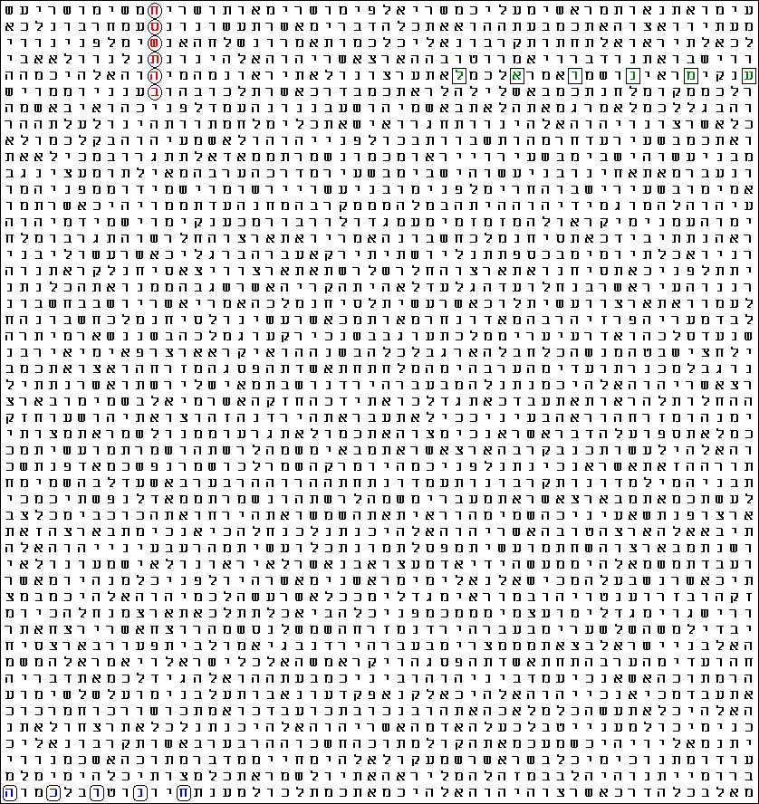 | 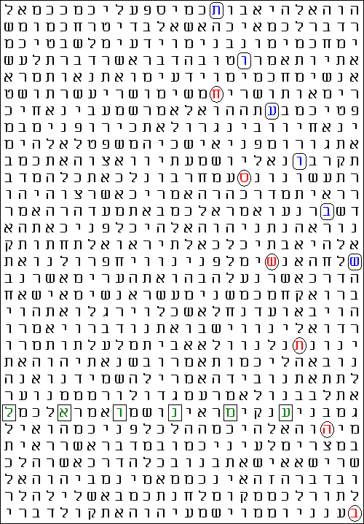
Figure 9. Which “face” is more “attractive”? The matrix in the left is with Hanukkah (חנוכה), blue, at its lowest skip in the Torah, 3. The one in the right is with Shavuot (שבועות), blue at -130 – the third lowest skip in the Torah. The odds for the matrices differ little – had the left one been some 10 rows shorter, they would be equal.
The “face” in the left is somewhat lifeless, static. The “face” in the right is full of life and dynamic. Note how the 6 letters of Shavuot are placed right over the 6 letters of “in 5768”. Looking at this “face”, I got the impression that it has prepared especially for our meeting, putting make up and even smiling…
Is everything dubbed Impossible in the Bible just Allegory?
Now, let us pay more attention to another aspect of the Bible codes manifesting itself in this study: their emergent character.
An achievement in the recent years is the understanding that what we can establish as physical laws are emergent phenomena. That is, the properties we observe in experiments are not preliminarily fixed or predetermined, but emerge as an outcome of the interaction between all the elements taking part in the phenomenon. Such understanding is correct because what we actually observe in our experiments are effects caused by zillions of tiniest particles. These effects are amplified and averaged contribution of each one of them. In a word, the physical law is manifestation of the “will” of the random basic element multiplied incredibly large number of times. Similar to the election results estimated as the free will of the average voter multiplied by the number of the electorate. Indeed, both these processes and results thereof are characterized by the same statistical data processing.
This undeniable success has been used by evolutionists to state (in my opinion, unjustifiably) that there is no design. Not only everything emerges as it is and we are all here by mere chance, they say. Perfection emerges out of imperfection. On the other hand, any evolution in the future – be it human, environment and wildlife, or universe – will be regulated by the basic forces of interaction between the respective elements. There is no place for Creation – everything kicks off from the Big Bang…
What the proponents of these ideas do not take into account is the feedback. Although this is the word used in the description of the interactions, in fact it should be “rebound”. Feedback implies making sense of the signal, i.e., thinking over it. In its turn, thinking implies suggestions and hints. In this sense, every creative process involves computation. We have seen so far that the result of a quantum computation, which is what our brains perform, is emergent. It could be predicted to some extent, but the exact outcome, up to unlimited accuracy, is unpredictable. This is particularly well manifested in the sport activities and games. Indeed, even the best player in whichever sport or game is not absolutely independent of his opponent. Every next move is “hinted at” by the rival. The best striker cannot be certain when will score, if at all, during the match, nor can the world chess champion say in advance what will be his, say, 31st move in the next game if it would keep on so far. The most we can know in advance is that the better is the player the higher is the probability that he will be the winner.
This phenomenon is subtler in scientific research. We do not have rivals and opponents, but we need the same type of hints as in the games. I hope that the reader has recognized the path of the code unveiling in this study. The way is long and lasted for years. Had I not known Russian well enough to link Mr. Medvedev’s surname with bear, I may have never started this research. Had I not found recently God with us (עמנואל) in Deuteronomy 1, I would never suggest any significance in the otherwise trivial occurrence of in year 5768 (בהתשסח) in the same chapter. Had I not worked for years with the 2006 (תשרקתשרקו) term, I would be unaware of the numerical coincidences discussed above.
These numerical coincidences uncover a new feature of the Bible codes. When a program estimates that a matrix occurs against the odds of, say one in a million in the Torah, this means that one should scan in average about one million texts of the size of the Torah in order to obtain a similar matrix. However, matrices possess the property of rapid increasing the odds for occurrence with the enlargement of the text. The increase of the odds for occurrence of any term at any skip within moderately enlarged text is drastic because not only we will search for it in more space, but also because the number of the skips in the longer texts is higher. At the dawn of the Bible code research, every so often skeptics boasted about finding terms in Hebrew texts outside the Bible. The supremacy of the Bible codes is not so much in the impossibility to be found elsewhere, but in the fact that all of them have been anticipated! For instance, the 2006 (תשרקתשרקו) term occurs in the Torah against the chances of 1 in trillions (SD = 10.53). Within the about four times longer text of the Tanakh, the estimation of the odds is billions of times higher: one in 2 000 (SD = 3.34)! Therefore, if we scan, say, Encyclopedia Britannica translated into Hebrew, it would not be a miracle if the term occurs there, even more than once…
It is another matter, however, when we look for specific skip of a term. The odds do not change so radically with the enlargement of the text. The standard deviation of the occurrence of 2006 (תשרקתשרקו) at skip ±14 965 in the Torah is… SD = 1 882.32! Within the Tanakh, the SD value turned out to be 1 043.16. Notice that I do not use the word odds, chances, or probability here! My imagination is too feeble to grasp the significance of this number! Even within the symmetric interval of one hundred skip-values ±14 915 to ±15 015, SD is above 100!
Standard deviation is a parameter linked to chances, but not linearly. About two thirds (68 %) of a set of normally distributed values are within one SD unit marked with the Greek letter σ (sigma). This means that one third of the values is normally to be found outside 1σ, or SD = 1. Only one of 20 values (5 %), however, is outside SD = 2. Then, only 1 in 370 values is outside 3σ. Scientists believe that 3σ is the limit of practicality. Further, the proportion of the set outside each next σ unit decreases drastically. For instance, there is only 1 in about 385 billions (3.85 × 10¹¹) values that is outside SD = 7! The exponent order (red) is going ahead of the SD-value (blue). Therefore, an SD about two thousand should define chances of 1 in 10 to the power of many thousands! We cannot even imagine such a number, I dare say, because the number of all particles in our Universe is believed to be of the order of 10¹⁰⁰…
This study considers the significance of the skip-values of more than one term. The 2006 term especially should be within very narrow limits in order to make sense of the findings. Therefore, let us estimate what are the chances to find it at this particular skip value, ±14 965, outside the Bible. As I mentioned above, the odds for occurrence in this case do not increase so rapidly. I found experimentally that SD values decrease by a factor of about 1.345 every doubling the length of the text. (Strictly, this is valid as long as the proportion of each letter constituting the term remains within the new text the same as in the Tanakh, but the weight of this parameter is not of decisive significance and we will ignore it.) Now, let us start with the value for the Tanakh, SD = 1 043.16, which we should bring down to a value that would not make research pointless. For this purpose, we have to enlarge the new text. How much?
Let us establish a reasonable limit for the odds not less than 1 in 100. This corresponds to SD-value about 2.5. Therefore, the SD-value of about 1 000 must decrease to 2.5, which is 400 times. I will not bother the reader with calculations. (See the Appendix for details.) The result is as follows: We need more than a million times larger text than the Tanakh in order to provide 1 in 100 chances for one occurrence of the term 2006 (תשרקתשרקו) at skip ±14 965! A text of such length should contain some 1.5 trillions of letters.
The Gospel of John ends with a very strange expression: Jesus did many other things as well. If every one of them were written down, I suppose that even the whole world would not have room for the books that would be written. (21:25). It is interesting that the word John uses for world is cosmos (κοσμοζ), which implies physical world; the word commonly used for the inhabited earth in the Gospels is oikoumenee (οικουμενη). It has been thought so far that this is just a strong eastern expression to emphasize the great number of miracles the Lord Jesus did. In the light of the just discussed, however, we could see that these words may have more literal meaning.
Another deep Connection between Word and World
The Bible states that the Creation is one, brought to existence through the Word of God. This implies closest connection between the Word of God and the physical world. Even in the very first verse of the Bible, a special significance is ascribed to the Earth. It has been believed for ages that this means that the Earth is in the geometrical centre of the Universe. This misunderstanding has been in the core of fierce disputes reflecting the naivety of the people that often mars the clarity of His Word. Bible codes give us the opportunity to penetrate into this profound character of the Truth embedded in every single word of God.
In a previous work of mine, I have discussed the numerical values of the Hebrew letters expressed in the binary code. The table below contains the numerical values expressed both in binary (center, shaded) and decimal (right) systems.
Letter | Numerical Value
א | 000000001 | 001
ב | 000000010 | 002
ג | 000000011 | 003
ד | 000000100 | 004
ה | 000000101 | 005
ו | 000000110 | 006
ז | 000000111 | 007
ח | 000001000 | 008
ט | 000001001 | 009
י | 000001010 | 010
כ | 000010100 | 020
ל | 000011110 | 030
מ | 000101000 | 040
נ | 000110010 | 050
ס | 000111100 | 060
ע | 001000110 | 070
פ | 001010000 | 080
צ | 001011010 | 090
ק | 001100100 | 100
ר | 011001000 | 200
ש | 100101100 | 300
ת | 110010000 | 400

The expressions are in the format necessary for any machine to recognize each entity. This format requires the same number of the characters for every letter. The machine takes up the entities in “chunks”, which should be of the same size. Therefore, the letters corresponding to smaller numerical values contain some zeroes filling the space to standardize the expression. The size of the binary chunks is 9 digits, while the decimal chunks consist of 3 digits. These zeroes in both systems are in regular characters. The significant digits are in bold characters.
There is a very interesting fact I managed to find with both systems. The 0’s to all the other digits ratio in the column with decimal expressions is 44/22 = 2/1 – the first two Fibonacci numbers. The ratio of the zeroes to all the digits in this column is also a Fibonacci number: 44/66 = 2/3. I realized that the former ratio will not change if we add or take out a letter, but the latter ratio is valid for an alphabet consisting of 22 letters only!
I was intrigued and concentrated my attention on the shaded binary column. In an earlier work, I saw that it contains 144 zeroes and 54 units. The 0’s to 1’s ratio is 144/54: exactly 8/3. These are two Fibonacci numbers again! I checked how this ratio changes with the variation of the number of letters in the alphabet. The phenomenon disappears immediately. I did not find such a perfect ratio going several letters up and down and adhering to the rule for assigning numerical values to the new members of the alphabet. Is this a specific hint that the alphabet used for the writing of the Word of God is to consist of 22 letters?
(The shaded column contains the formatted expressions of the real numerical values. It could be compressed from 9-digit to 5-digit long format corresponding to the serial number of the letters in the alphabet. In this case, however, there should be a need of a special machine called converter to translate the compressed expressions of the letters from kav (כ) to tav (ת) into their real values. For instance, the 5-digit binary expression for the 13th letter mem (מ), 01101 (13), should be converted into 101000 (40). The phenomenon of the ratio of two Fibonacci numbers is lost with the compressed values. It occurs with the real values only.)
Such specific coincidences with Fibonacci ratios with both systems seemed to me a specific hint. The ratio obtained with the binary code – the primary code of the Universe – is surely pointing to a fundamental 8/3 ratio. What is it?
Almost everything we experience all the time is a result of the interaction between electrically charged particles. This interaction takes place through electromagnetic communication through photons. The energy spectrum of these spreads out from the highest in gamma-rays to the lowest in radio waves. Chemical reactions and the stability of our buildings depend on the strength of this interaction, which in most cases is invisible because these interactions take place within space of infinitesimal size deep in the structure of the atoms. We ourselves, up to the processes carried out in our brains, are woven of these interactions between matter and light.
The effects of these interactions are determined by a constant that does not change. It is the same within the protein molecule folding in a cell in our body and in the telescope receiving a photon from a distant galaxy. This constant is dimensionless. It depends on the speed of light, the value of the elementary electric charge, the permittivity of the free space and the Planck’s constant. It is called fine-structure constant. The value of this constant cannot be derived or calculated. It is established experimentally and what we know for certain is that had its value differed slightly, our life would be impossible. The reciprocal value of this fundamental constant, with sufficient accuracy for our purposes, is 137.036.
We have dealt with the number of the days in a terrestrial year: 365.25. This is also a dimensionless constant! (This assertion may surprise some readers, but 365.25 is not a measure of time. It shows how many times the Earth turns around itself while doing a complete turn around the Sun.)
Now, the ratio 365.25/137.036 is very close to 8/3: 2.665358... The ratio of the number of zeroes to that of the units in the formatted binary numerical values of the Hebrew alphabet! The difference from the exact 8/3 value, 2.666666…., is less than 1 in 2 000! Were the diurnal cycle only about 45 seconds (!) shorter in average, the value would be exactly 8/3. This ratio is also dimensionless and does not depend on what units we use for measuring of any physical parameter.
Does this fact point to a specific significance of the number of the days in a year and hence to the uniqueness of the Earth? There are many studies on the specific distance of the Earth from the Sun in respect of the quantity of the energy falling on our planet. It is well known that had the diameter of the orbit been slightly smaller or larger, the conditions on earth would become extreme – too much hot or too much cold. However, the number of the days is very important because it defines the amplitude of the daily temperatures and the whole rhythm of life. Were the Earth turning too fast around itself, there would be very little difference between night and day temperatures. Alternatively, very long days would cause overheating and very long nights – freezing. In the light of the value of the fine-structure constant defining the characteristics of the matter in general and the chemical reactions in particular, it may appear that the duration of the day – given the amount of energy incessantly received by the system – is of importance for the most effective utilization of this energy, which involves processes ruled by the fine-structure constant.
When should we stop Calculation?
How long could we continue a research? What could be the criterion for obtaining the ultimate result? Who would be authorized to establish it?
We started the research with the accidental discovery of President Medvedev code in the Torah confirmed by another very significant occurrence in a version of the Tanakh. But the role of these codes turned out to be auxiliary. They led us to the uncovering of the significance of the current year 5768 of the Jewish calendar with the specific suggestion of the importance of the Feast of Shavuot. In the course of the study, we found several coincidences approximating in accuracy exact 1-to-1 correspondences or fundamental ratios. Although the classic computer we have used does not provide exact values, our mind loads the findings with significance. We believe that generally, the smaller are the deviations from the “ideal” values the higher is their significance. The exact values of the deviations are of not of great importance for our minds. What makes these results important and meaningful is the source of the data. We believe that they are set encoded in the Word of God at the Beginning! The source of the data and the generated feedback process is what distinguishes the quantum computation – the way our brains work – from the classic, deterministic path of computation.
The process of quantum computation is a process ruled by economy. It consists of ruling out the less likely answers and looking deeper into the remaining possibilities. I believe that this process is very much like sieving. Interestingly, this simple technique is used for the illustration of separation of the God’s chosen ones from the rest of the people in the Bible. In an earlier study, I prepared a picture illustrating the basic principles of the quantum computation with the example of sieving. See Figure 10.
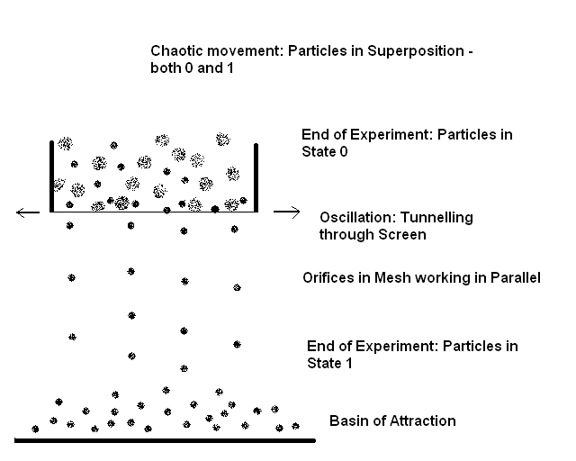
Figure 10. Separation of particles by sieving illustrates some of the basic principles of quantum weirdness.
When do we stop sieving? When the efforts we put in for shaking the sifter cease to pay back. When the number of the particles going through the strain in each oscillation is too small and the quantity we gain becomes insignificant. If we separate material that is not expensive, we do not bother about few particles. But if we want to give the chance to the last particle of size enabling it to go through the sieve because the material we separate is very expensive, we will be careful and wouldn’t mind keeping on shaking a number of times. To a strange observer, all this may seem useless and what we do is inefficient, but if we are the operators, we decide when to stop. Even so, there must be an end to the process of separation…
God Himself is the Operator of the process of separation taking place for eons. As “particles” in this process, we hope to be among His chosen. In relation to the evaluation of the process of separation, however, we are strange observers. Therefore, the best we could do is to assess how close we are to the end of this process. Based on the effectiveness so far, we can see that there are not many shakings remaining. Exactly how many are they, is His business and no-one’s else. Has He given us hints even in this aspect?
I have observed a strange recurrence of number ten in this study. The number of the days from the liberation of Old Jerusalem to this year’s Shavuot is ten more than the skip value of the term 2006, 14 965. The number of the letters in the Tanakh is equal to the number of the days in the years since the Torah was given to Moses minus ten years. The maximum skip value for any 9-letter term in the Tanakh, 149 615 is almost exactly ten times greater than the skip value of the occurrence of the 2006 term. Although at the time I found this term I believed it signifies number/year AD 2006, the actual events I managed to discover encoded in the Torah happened in AD 2007. Amazingly, the numerical value 2007 emerges from the 2006 value when the aleph on the top of the old 9-letter term, of value 1, is added, thus turning it into a ten-letter term…
When Abraham pleaded with the Lord for Sodom, the last number he mentioned of righteous people possibly dwelling there was ten (Gen. 18:32):
Then he said, “May the Lord not be angry, but let me speak just once more. What if only ten can be found there?”
He answered, “For the sake of ten, I will not destroy it.”
April 29th 2008
Sofia, Bulgaria

References
Note: All my studies can be read and downloaded from the following pages: http://exodus2006.com/BibleCodes5.htm; http://www.carelinks.net/booksandarticles.html; http://80.189.248.54/BibleCodes/ and most of them, in pdf format, from http://ad2004.com/Biblecodes/Hebrewmatrix/Hebmatrix.html and http://ad2004.com/Biblecodes/articles/articles.html
[1] The AD 2006 Torah Code: A Wonderful Tale of a Comet
[2] A Strange Code about AD 2006 Discovered in the Torah
[3] The Writing on the Wall and AD 2006: A Lateral Approach to Code-Breaking
[4] The AD 2006 Code in the Torah and the Time of the End: A Connection between a President of Israel and a Lord Jesus’ Allegory Pointing to 2007
[5] Torah: http://en.wikipedia.org/wiki/Torah
[6] Egyptian calendar: http://en.wikipedia.org/wiki/Egyptian_calendar ; and Sothic cycle: http://en.wikipedia.org/wiki/Sothic_cycle

Contact Lyuben Piperov at: l_piperov@yahoo.co.uk

Appendix
Calculation of the Size of the Text ensuring 1 in 100 odds for the occurrence of the 2006 (תשרקתשרקו) term at skip ±14 965
The calculation is logarithmic. We have to reduce the standard deviation from SD 1 043.16 down to 2.5. This means we have to cut it exactly 1 043.16/2.5 = 417.264 times. Keeping in mind that every doubling of the text length reduces the SD-value by 1.345, we write down the equation
1.345^{X} = 417.264
To solve it, we have to take the logarithm of both sides of the equation:
Xlog1.345 = log417.264
X 0.1287 = 2.620
X = 2.620/0.1287 = 20.357.
This means that we have to double the text 20.357 times. That is, we have to rise 2 to the power 20.357:
2^{20.357} = 1 343 056
We have to enlarge the text 1 343 056 times. Most versions of Tanakh consist of about 1 200 000 letters. Therefore, multiplying this number by 1 343 000 we get the approximate value of 1.6×10¹², or 1.6 trillion letters, needed to ensure 1 in 100 chances for the occurrence of the 2006 (תשרקתשרקו) term at skip exactly ±14 965.

