Copyright © Lyuben Piperov July 2007
The AD 2006 Code in the Torah and the Time of the End: A Connection between a President of Israel and a Lord Jesus’ Allegory Pointing to 2007
Lyuben Piperov
Abstract: Two independent codes manifested in more than one matrix have been found based on the term for 2006, תשרקתשרקו, and two main meanings of פרס: (1) the name of the new President of Israel, Mr. Shimon Peres, and (2) vulture. The former meaning links Mr. Peres’ presidency unequivocally to AD 2007. The latter meaning of the word generates a code correlated to the well-known allegory the Lord Jesus told to His disciples about vultures and carcasses. Both these codes are linked to an earlier code found in the Torah about the Time of the End as appearing in the plain text in the Book of Daniel.
Introduction
On June 13th 2007, Mr. Shimon Peres, a Nobel Prize winner, was elected President of Israel. His inauguration is planned for July 15th. I remember I was busy on the day he was elected, but the news impressed me in a strange way. Few days later, I started a search that surprised me with astonishing results. I will present the story as it happened chronologically, as far as possible. I believe it is a good illustration of how Bible codes work, and especially, that code breaking is an emerging phenomenon in itself, depending not only on what is encoded in the Bible, but also on who, how and when takes to the captivating task of revealing the hidden at the Beginning. Moreover, I believe that the story shows that everything in the world happens according to the Will of God. In the course of the code breaking, our brains interact both with the Word of God, which, I believe, is a quantum computer, on one hand and the reality in the world on the other. Indeed, at the beginning of this study, I even did not know the spelling of Mr. Shimon Peres’ name in Hebrew.
First, I checked the name in the Wikipedia: פרס שמעון. As everyone in my shoes would do, I tried to find the whole name in the Torah. It was not there. Then, I tried the whole Tanakh. It was not there either. I realized that I will have to look for the names separately. However, it should be clear to everyone that these names are short terms and one could hardly find something significant using them alone, or with a combination with the other characteristic terms, President (נשיא) and Israel (ישראל), and eventually with the year, 5767 (תשסז[ה]) or even a particular date. In fact, I did not search for a particular Jewish year or date until I had this work finished. And found none of significance in the obtained matrices when tried.
I carried out the searching in a way, which I can assess now as unconsciously stimulated, or even led. I was not aware of this, however, until much later, when the study had gained good progress and I wondered how I had managed to go so far. Now I have realized that the particular term I tried to associate Mr. Peres and his presidency with was a peculiar way of expression of the year 2006 I found some three years ago. Knowing that the names and the dates taken alone would hardly produce something significant, I felt that there should be a term that must “bind” these short terms into a meaningful structure.
A Seeming Discrepancy in Times that Turns out to be Not a Discrepancy
The works in questions are [1 - 4], written between June 2004 and September 2005. There, I found significant codes connected with the year 2006, which I found in the Torah expressed in a mixed Roman-Hebrew way as תשרקתשרקו, against diminishing odds (SD = 10.53). Like with the Roman, and unlike with the Hebrew method, the numerical value of the expression matches the number of the year: 2006. In [3], I found a code about the Writing on the Wall, in the Book of Daniel, chapter 5. There, I mused on the meaning of the third word in the writing, uparsin, ופרסין, which Daniel, in his interpretation, did not pronounce in the way it was written, but as peres, פרס, meaning both Persian(s) and division. The code I believe that was revealed to me, replaces ופרסין, uparsin with ויהושע, and Joshua, that is, as I interpret the occurrence of the name of Joshua in the plain text of the Torah, a code for the Lord Jesus.
2006 passed into history and the world did not witness openly something Apocalyptic. There was no atomic Holocaust or destruction of Jerusalem. On the other hand, I had never stated that this and this will happen in 2006 or at any specified time. What I found, I believe, was a cluster of terms indicating that 2006 is a crucial year in, or a mark of, the Time of the End. My own interpretation is that 2006 was a watershed in the history – that is, situation in the world is incorrigible and irreversible since the end of 2006.
However, as a man made of clay, I lost some spirit due to the psychological effect condescending smiles on critics’ faces cause upon a honest researcher. Indeed, I haven’t returned to the matrix since September 2005. What instantly made me recall this matrix was the name Peres. It was a sheer whim in the beginning, to try a search for a current event encoded with a passed period of time.
Because פרס is a 3-letter word, I did not bother even to try at skips larger than 20. I tried also with Shimon, שמעון. This is a 5-letter word and I should have set larger skips. However, misled by the high number of occurrences obtained at low skips, which I failed to notice that is due to its high frequency in the plain text, as well as because I expected to obtain a matrix of ‘normal’ shape, I set skip value maximum 20 for this term too. It did not occur in the matrices I tried in the beginning. As we will see later, this appeared to be for good…
Having failed to find Shimon, I tried with President, נשיא, at low skips too. To my greatest surprise, I obtained the matrix shown in Figure 1.

Figure 1

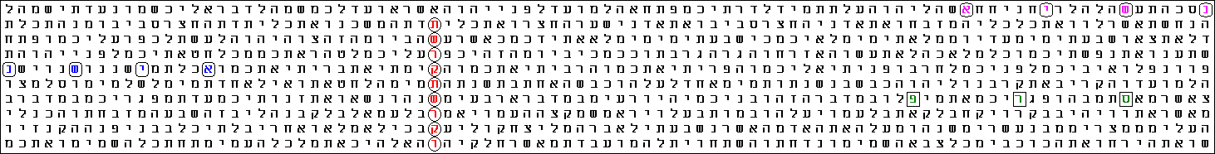

Term Translation Skip R Factor (in Matrix) Start End
תשרקתשרקו 2006 14965 2,253 4,776 Exodus Ch 38 V 31 Letter 36 Deuteronomy Ch 4 V 19 Letter 86
פרס Peres -8 -1,439 1,085 Numbers Ch 14 V 32 Letter 12 Numbers Ch 14 V 31 Letter 47
נשיא President -5 -1,822 0,702 Leviticus Ch 26 V 10 Letter 17 Leviticus Ch 26 V 10 Letter 2
נשיא President 6 -1,901 0,623 Exodus Ch 29 V 41 Letter 36 Exodus Ch 29 V 41 Letter 54

The ELS reference is 14965 characters between rows.
There are 4 displayed terms in the matrix.
The matrix starts at Exodus Ch 29 V 41 Letter 36 and ends at Deuteronomy Ch 4 V 20 Letter 5.
The matrix spans 134776 characters of the surface text.
The matrix has 10 rows, is 91 columns wide and contains a total of 910 characters.
There are 4 significant terms in the matrix.
The matrix odds are 1 chance in 45869,121 in favour of significance.
The cumulative 'R' Factor for the displayed matrix is 4,662.

In our daily life, an event occurring against the odds of 1 in about 45 000 would be considered a genuine miracle. However, during these about ten years of intense Bible code research worldwide, the public got used to odds so infinitesimal, that they could be hardly imagined. Therefore, a chance of about one in fifty thousand is accepted just as interesting. I also accepted this value as intriguing only and urging on deeper research.
What I saw as even more intriguing than the low odds, however, was the unusual shape of the matrix: narrow band consisting of 10 rows only and over 90 columns. Was there some meaning in this shape? I believe there is a very profound meaning: the letter immediately above the main term is aleph, א! The numerical value of א is 1. Therefore, the numerical value of the whole column becomes 2006 + 1 = 2007!
In order to happen this, one of the terms – in our case President, נשיא, at skip 6 - had to occur in a specific row out of 21 possibilities! The other two terms had to occur within the band already formed. Programs do not assess such peculiarities, of course, but they play a very important role in cracking codes, I think.
However, the blind chance played some role in this initial enthusiasm of mine. Indeed, if we rearrange the matrix, without the term in the top row, we would obtain a smaller matrix of 9 rows containing once Peres and once President, with significant, though about 3 times higher, odds. Then, the term defining the year would be the old 2006… So, was it 2006 or 2007?
In essence, the lower the odds, the higher the significance. On this basis, 2007 is to be preferred to 2006. But I am never satisfied with such weak arguments and had to press on searching for more. On this stage, however, something unexpected occurred…
Birds Looking for Prey in the Time of the End
One of the programs I use (The Keys to the Bible) has a dictionary giving all possible meanings of a Hebrew word in the report to a matrix. In one of the reports, something caught my eye: פרס means also vulture. I did not know this before.
This immediately made me recall the illustrious words of the Lord Jesus about the Time of the End:
Where the carcass [or, corpse, body] is, there the vultures [or, eagles] gather. (Matthew 24:28; Luke 17:37)
Even long before I got acquainted with the Bible codes, I found some encoding aspect in these words. Most Bible scholars find a prophetic aspect in them only, linking the vultures/eagles with the Romans in 70 AD and the carcass with the Jewish nation that was to be dispersed in the world. There are also endless discussions on whether the bird mentioned in Greek, αετος, should mean eagle or vulture. In our modern culture, eagles are considered to be more prestigious than vultures. Vultures have obtained the unenviable fate of scavengers anthropomorphically reflecting the meanest human qualities. In the ancient times, however, it was not so. In Egypt, the Nubian vulture was synonymous with the term applied to lovers and was considered an excellent mother. The image of a vulture stood for the hieroglyph equivalent to the letter aleph, א [5]. Who knows why, the א above the main term in the matrix, increasing the numerical value by 1 to 2007 reminded me of an Egyptian vulture perching on a column…
There was no reference to an article in Hebrew in the cited site, so I had to do some browsing before finding out that פרס corresponds to Lammergeier or Bearded Vulture, also known in the past as Ossifrage [6]. The latter term means Bone Crusher, because this bird has the habit to drop large bones or even live tortoises from high on rocks to crush them and eat marrow or fresh meat. Interestingly, the word Lammergeier is of German origin and means lamb-vulture.
At first, I was content with the bird and started looking for the flesh. I looked for carcass in the dictionaries. The first word I checked was שלד (probably SheLeD). There appeared to be only two occurrences with low significance because the word occurs very often. Then, I looked for the next word for carcass, פגר (PeGeR). And I hardly believed what I saw! A word in the plain text intersected פרס! The whole verse read:
But as for you, your bodies [or, carcasses] will fall in this desert. (Numbers 14:32)
These 3 letters are part of the single word ‘your carcasses’, פגריכם, in Hebrew. Then I saw the same word on the other side of the main term, in verse 33! I checked for פגר in the plain text of the Torah. These 3 letters in row occur 6 times. In 4 of these occasions, they are part of פגריכם. Puzzled by this intersection of vulture and carcass, I started looking for other intersections at lowest possible skips between פרס and פגר in the Torah. It appeared that this is the only intersection at skips of up to ±8. There was a mirror code, where פרס is in the plain text and פגר is encoded at skip 8, occurring twice: in Leviticus 11:5 and Deuteronomy 14:7. There, however, the word in the plain text, פרס, denoted hoof and is therefore semantically different from the match. Therefore, the code we have found is significant in its meaning. The next step was to determine the significance in terms of chances. And here was another astonishing surprise…
The CodeFinder program loaded with the terms for search produced a matrix containing three out of the four occurrences of פגריכם and the half of all occurrences of פגר in the plain text of the Torah! See Figure 2.

Figure 2
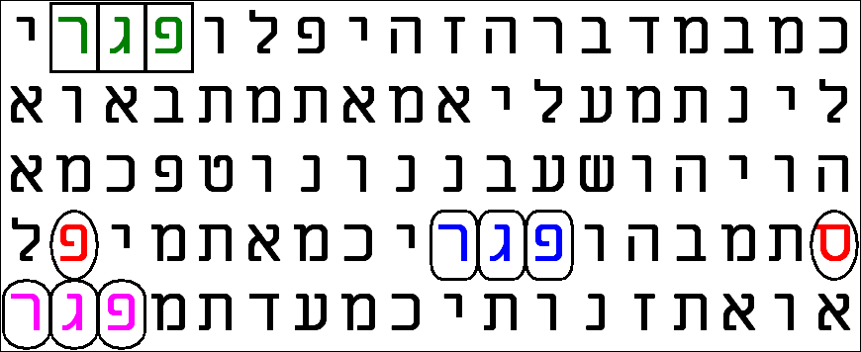
Term Translation Skip R Factor (in Matrix) Start End
פרס Vulture -8 -1,439 2,090 Numbers 14:32.12 Numbers 14:31.47
פגר Carcass 1 -0,778 2,752 Numbers 14:29.13 Numbers 14:29.15
פגר Carcass 1 -0,778 2,752 Numbers 14:32.2 Numbers 14:32.4
פגר Carcass 1 -0,778 2,752 Numbers 14:33.47 Numbers 14:33.49

The ELS reference is 58 characters between rows.
There are 4 displayed terms in the matrix.
The matrix starts at Numbers 14:28.45 and ends at Numbers 14:33.49.
The matrix spans 250 characters of the surface text.
The matrix has 5 rows, is 18 columns wide and contains a total of 90 characters.
There are 3 significant terms in the matrix.
The matrix odds are 1 chance in 179724428,037 in favour of significance.
The cumulative 'R' Factor for the displayed matrix is 8,255.

The chances are 1 in almost 180 millions! Although linked to the larger matrix in Figure 1 – all three terms in the two lowest rows are also present there – it is independent and interesting in itself. First, when we deal with words occurring in the plain text, we should evaluate the significance of the R-factor because the program calculates it based on random combination of the letters. If, however, the word (or its ‘mirrored’ counterpart at skip -1) appears frequently in the text, there would be a higher probability for a presence in a matrix. A frequently occurring word at skip ±1 devalues the R-factor. Therefore, I had to ‘validate’ the result taking into account the expected number of occurrences of פגר at skip ± 1. It happened to be 4. The actual number, as we saw above, is 6, i.e. there are only two occurrences more than the expected in the whole Torah. This means that our result practically corresponds to what we would obtain with the same number of terms in a scrambled text. In a word, we are justified to believe that the clustering shown above is significant as a code.
Anyway, to ascertain the matrix parameters, I searched for clustering of פרס at skips up to ±50 and פגר in the plain text. I saw nothing even remotely resembling the picture above.
Then I realized a very specific connection of the found so far to the original interpretation of the Writing on the Wall, which Daniel gave to the king of Babylon in the last night of the existence of the Babylonian Empire. Daniel emphasized the double meaning of the word Peres, פרס. Here, we have additional two meanings of this same word: (1) the name of Mr. Peres and (2) vulture! The bridge between these is our matrix of the Time of the End!
Therefore, the next step was to look for alternative words for vultures/eagles and carcass in the main matrix.
In the course of the research, I understood that there is no consensus among the scholars on the distinguishing between eagle and vulture. It seems also that once people did not make the difference on the basis we do it today. This is why some of the words I found in the dictionaries refer to both meanings. One of them is נשר (NeSheR) [7]. This word is used for eagle/vulture in the Matthew’s and Luke’s Gospels cited above. I found the word with some significance in the matrix. I proceeded with the word used in Modern Hebrew for eagle, but also used in the Torah, along with the former one, עיט (OYT). It was also there! Finally, I tried the word given in the dictionaries as vulture, but probably in its contemporary, figurative meaning, עושק. It also occurred in the matrix! Meanwhile, I was widening the matrix little by little in accordance with the appropriateness of the new R-factors observed.
Having found all the terms relating to eagle or vulture I have looked for, I turned to the various terms of carcass, or corpse, body, etc. It turned out that a third word denoting corpse, carcass, or carrion, נבלה (NeVeLaH), occurred at skip -1. As I mentioned before, the first word I tried for carcass, שלד, occurred twice at skip 6, but with the gradual enlargement of the matrix due to the new incomers, they lost their significance. However, it appeared suddenly again at skip 3, with some significance, though small. The only word for carcass/corpse I have met in the dictionaries, which does not appear in the matrix, is the six-letter גווייה. However, this word does not occur in the plain text of the Torah either. The Matrix is shown in Figure 3.

Figure 3
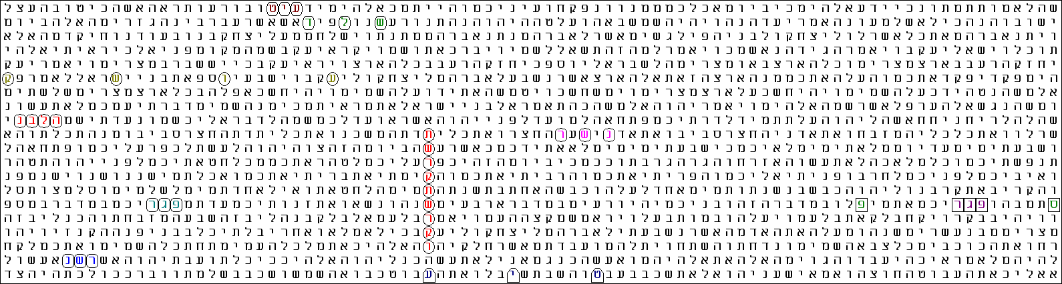

Term Translation Skip R Factor (in Matrix) Start End
תשרקתשרקו 2006 14965 2,253 4,491 Exodus 38:31.36 Deuteronomy 4:19.86
פרס Vulture -8 -1,439 0,799 Numbers 14:32.12 Numbers 14:31.47
נשר Vulture/Eagle -1 -1,934 0,304 Deuteronomy 12:31.36 Deuteronomy 12:31.34
נשר Vulture/Eagle 2 -2,235 0,003 Exodus 38:31.21 Exodus 38:31.25
עיט Eagle 1 -1,079 1,159 Genesis 3:5.52 Genesis 3:5.54
עיט Eagle -7 -1,984 0,254 Deuteronomy 24:13.13 Deuteronomy 24:12.22
עושק Vulture 9 -1,203 1,035 Genesis 50:24.85 Genesis 50:25.25
פגר Carcass 1 -0,778 1,460 Numbers 14:32.2 Numbers 14:32.4
פגר Carcass 1 -0,778 1,460 Numbers 14:33.47 Numbers 14:33.49
נבלה Carcass -1 -0,994 1,244 Exodus 29:43.12 Exodus 29:43.9
שלד Carcass 3 -2,184 0,054 Genesis 15:17.29 Genesis 15:17.35
The ELS reference is 14965 characters between rows.
There are 13 displayed terms in the matrix.
The matrix starts at Genesis 3:4.14 and ends at Deuteronomy 24:13.48.
The matrix spans 284423 characters of the surface text.
The matrix has 20 rows, is 88 columns wide and contains a total of 1760 characters.
There are 11 significant terms in the matrix.
The matrix odds are 1 chance in 10542135346,93 in favour of significance.
The cumulative 'R' Factor for the displayed matrix is 10,023.

The odds as calculated by the program for this matrix are below 1 in 10 billions! However, I carefully checked the terms occurring at ±1. The R-factors are plausible for פגר, עיט and נשר. The only significant deviation is with the occurrences of נבלה at skip -1 (37 occurrences vs. 5 expected). However, even if we remove the R-factor, 1.244, the remaining odds are still about 1 in six hundred millions.
The amazing fact with this matrix is that most of the terms are short. The individual contribution of each one of them is relatively small. Another impressive fact is, I believe, that the sum of the R-factors for the birds is 3.554; while the sum of the R-factors for the carcasses is 4.218 (or 2.974, with subtracted R-factor for נבלה). In both cases, the difference is within about 15%, which means that both categories contribute approximately the same ‘weight’ to the code. This corresponds in a subtle aspect to the words of the Lord Jesus in the Gospels.
A Search for a Name that Revealed a Gentile Time Measure

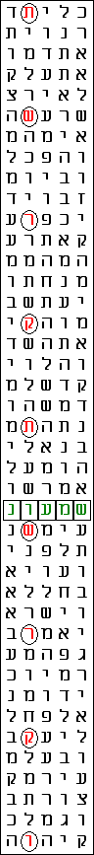
Although I managed to find three matrices of impressive significance, I was by no means satisfied. Peres is not an uncommon Jewish name, so there should be somewhere in the code an indication that the person who will be the President of Israel is called Shimon. I could not find it in the matrices above and gave up searching because I was seeing that the shapes, especially that in Figure 1 – unusually elongated rectangles – have exhausted the possibilities and שמעון is just not there. Therefore, instead of widening the matrix, after a short reflection, I decided to use the function of row splitting with the same values of the skips for Shimon. The splits 2, 3 and 4 gave nothing. Then suddenly, at the 5th splitting, Shimon, שמעון, and the main term produced a very narrow, this time vertical, matrix with Shimon at skip 1! See Figure 4 in he left.
Figure 4. 2006 (תשרקתשרקו) and Shimon (שמעון) in a matrix of skip 2 993.
The CodeFinder program calculated odds slightly above 1 in 7 000. However, knowing that the name שמעון occurs frequently in the Torah, I realized that the R-value for this word is in fact overvalued.
We have obtained another matrix of unusual shape. Two features of it impressed me very much. The first one was my own blindness. The second one was the beauty of the picture, which invites for more searches in width. Indeed, having got this matrix, I felt that there is more nearby. It turned out later that my guess was right. However, we will leave this second aspect for later consideration and will concentrate on the first one.
Every pupil knows that 5 divide every number ending in 5. I saw this when I started my first research on the 2006 code, of course, but who knows why (I have surely been preoccupied with something seeming more important to me at that time), I had not looked for any other factors of 14 965 – the skip of the main term.

When I saw the letters of the main term forming a straight column, I was surprised at first but within a second I saw that it should be a column, because the skip is divided by 5. Then I recalled that the number of letters of the Torah, 304 805, also divides by 5 resulting in 60 961, a prime number. I was curious about whether the quotient of the skip, 2 993, is prime too, in analogy to the number of the letters in the Torah.
One does not need to check every prime number for dividing a large number to verify if it is a prime. It is sufficient to check the numbers up to the square root of the tested number, which in our case is 54 odd. So, I started checking the prime numbers one by one, from 7 up. Numbers were failing to divide 2 993 and I was foretasting the end result: prime number, when suddenly, few numbers before the last one, the calculator displayed 73 in response to dividing by 41. Now it is clear:
14 965 = 5 × 41 × 73
Then it hit me!
5 × 73 = 365!
What a watermark! I looked at this for many minutes, praising and revering The Encoder. I was utterly surprised seeing this Egyptian number encoded in the skip of 2006. Indeed, rethinking on what was before my eyes, I realized that there could be hardly found more appropriate number characterizing Egypt. The number of the days we have in an ordinary year, 365, comes from ancient Egypt [8]. According to the Egyptian mythology, it was Thoth (known as Hermes in Greece) who added 5 days to the 360-day year used before [9]. The Hebrew year is never 365 days long. In addition, the number of the occurrences of Egypt, מצרים, in the plain text of the Torah is exactly 365. Along with the significance of the vulture, here we have another Egyptian feature in the code…
In my previous work on the Writing on the Wall [3], I linked the sexagesimal system (base 60) [10], the system typical for Babylon, which we still use for measuring of time – 60 seconds in a minute; 60 minutes in an hour – with an interpretation of the writing on the wall encoded in number characteristic for columns. There, I had to use the Golden Ratio as a key to validate the findings. Here, a number distinguishing the other great Middle East ancient civilization, Egypt, is encoded between the rows. Is here also a key for confirmation?
The skip of our main term is 41 times 365. Seems like 41 years of 365 days each… The first thought that came up to my mind was to link the remaining quotient, 41, with the time of the wandering of Israel in the wilderness, the time elapsed since the 6 Day War, etc… I sharpened my pencil and was about to start a long treatise on number 41 and its significance for numerology… But immediately I changed my mind and decided for another approach. Instead of theorizing in Aristotelian manner, I made my mind up for looking.
The main term consists of 9 letters. On the other hand, these letters are parts of 9 words. I decided for counting the overall number of the letters in these 9 words. It turned out to be exactly 41! See Figure 5.

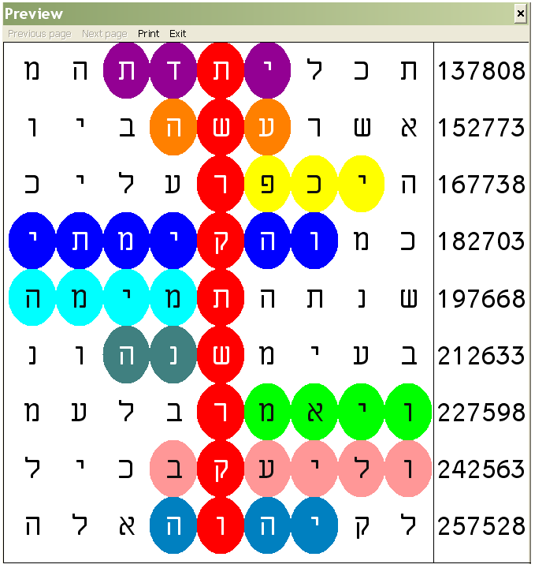
Figure 5. The 9 words, which the main term 2006 (תשרקתשרקו) intersects at skip 14 965 are shown in different colours. Note that the words most outstretched away from the column define a perfect 9×9 square. There are 41 coloured letters in the matrix.
The expected number of the letters in these 9 words based on the average number of letters per word in the Torah, 3.81, is 34.29. If normal distribution is assumed, 41 is not a so much large deviation (SD = 1.15; that is, odds are about 1 in 3). However, the distribution in this particular case is by no means normal. The shortest word is just two letters long, so the minimum number of the letters 9 words can consist of is 9×2 = 18. On the other hand, 7- or more-letter words are rare. (There is one 7-letter word in the matrix above.) Based on the lowest possible number that 9 randomly chosen words contain, 18, we could define an upper limit for the number of letters, which can be never passed practically at about 51. Thus, 41 appear to be a quite significant deviation hinting at encoding. For instance, the 9 words in the same column above our term contain 37 letters.
The number of the letters in the 9×9 matrix is 81. This number immediately reminded me of the number of the elementary cells in the Sudoku game. I believe that Sudoku is a good example of how quantum computation works. I wrote about this in another work of mine [11].
The only other feature of 41 I could remember is that written in the binary code, it is the ‘mirrored’ image of the number 37 expressed in the same way:
37₁₀ = 100101₂
41₁₀ = 101001₂
Number 37 is encoded in the Torah. I managed to find it in the binary expression of the number of the letters of the Torah, but there are many more aspects of significance [11]. (Isn’t this particular property of the numbers 37 and 41 a mark distinguishing Jews from Gentiles? 37 and 41 are two consecutive prime numbers; 37 is loaded with significance in the Torah, which is given to the Jews. Mirroring is indication of similarity.)
Having found such significant codes associated with number 2006/7 encoded in the Torah, we will have to revise the famous “Rosetta-stone” type prophetic words above the main term [3, 4]:
For a Time, Times and a Half [Daniel 7:25; 12:7; Revelation 12:14]
First, these words appear in Aramaic, then in Hebrew and finally in Greek. I managed to find them, in Hebrew, with only two letters - those defining the plural for times (yod and mem final) - missing in the original matrix [1, 4]. I found each one of these words once only and was satisfied with the result. Later, I also found Time of the End (קץ עת), as used by Daniel, within the cluster [4]. When I was doing these articles, I looked for symmetry mostly and therefore tried to obtain matrices with the main term approximately in the middle of the matrix. The matrices I have obtained so far in this work taught me that high significance with short terms could be obtained even with more elongated and asymmetrical matrices. I reviewed my old matrices and searched for more occurrences, preferably with higher significances, of the old terms.
I did not find many more: just once the term and a half (וחצי) at skip 12. This appeared to be the only occurrence with some significance according to the programs I use. After closer inspection of the found, however, what I saw exceeded my boldest expectations. See Figure 6.
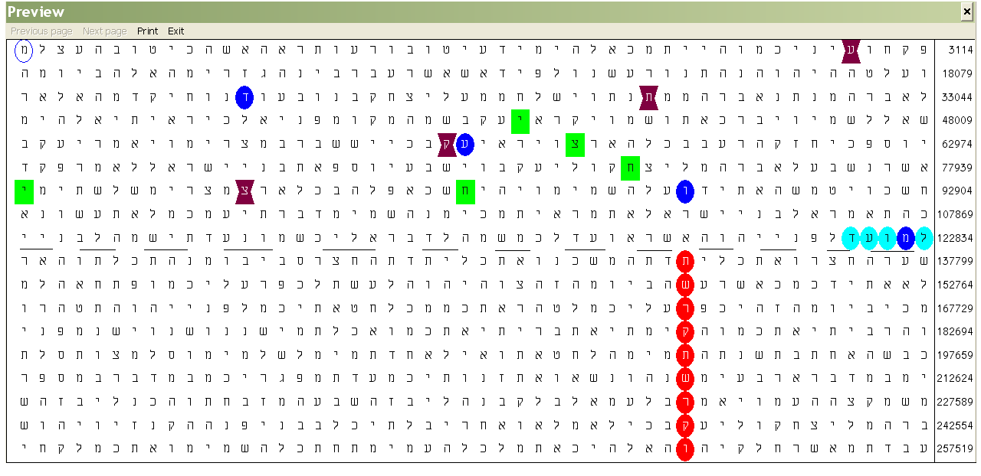
Figure 6. 2006 (תשרקתשרקו), red ovals at skip 14 965; for time (למועד) turquoise ovals, skip 1; time (מועד) blue ovals at skip -29 918; and half (וחצי) green squares at skips 12 and -14 962 and Time of the End (קץ עת), plum watches, at skip 29 941.
What you see in Figure 6, I did it manually. Programs do not assess these occurrences as significant. However, in my opinion, they are very significant. (I managed to obtain the identical matrix with the CodeFinder program, which I cannot show because of the character of the consideration. The report, however, will be presented below.)
First, all terms share a letter with another term of the cluster. למועד and מועד share a mem; מועד shares a vav with both occurrences of וחצי; finally וחצי at skip 12 shares a tsadik with קץ עת. This fact defines the items as a net rather than as a typical cluster. Every item is linked with every other one either directly or using another item(s) as a bridge(s). I find this phenomenon captivating, although we have not taught the programs how to evaluate events of this character.
Then, I noticed that all terms, regardless of the sign of their skips, go from right to left. I believe that this is a very subtle way to hint at the time arrow going always in one direction only – from the past to the future. Here, the direction coincides with that of the Hebrew script. This is especially significant, I believe, because there is a word in the plain text, for time, למועד, which defines the direction.
What impressed me next was the double occurrence of the term and half וחצי. At first glance, it seems that the occurrence at skip -14 962 is redundant. Its absence would not affect the characteristics of the cluster/net. But it must have a meaning… Half…
Then I realized that the prophetic words and the Time of the End occupy exactly the half of the matrix! The total number of the rows comprising the whole Torah at this skip and place are 21. However, the main term is 9 letters long. The prophetic words occupy a rectangle of 9 rows. (I drew a dashed line separating the two ‘compartments’.) As it turns out, the main term and the prophetic words validate each other in such amazing way. I tried for any term of the prophecy or Time of the End in the bottom compartment but there appeared to be none.
Another attribute of the matrix I found interesting is its width: exactly 50 columns. 50 is the number of the years in a jubilee cycle. Thus, we have another specific measure for time. While I was musing on the meaning of the number of the columns, I noticed that the letter in the upper left corner of the matrix is the letter following dalet, ד, in מועד at skip -29 918. It is mem, מ (marked with blue oval contour). I knew this fact from my previous studies, when I tried to find the word in plural, מועדים, but failed. Then, it was of no importance because this absence made the matrix more compact and gave me the opportunity to apply the inverted nuns [12] for balancing these two missing letters [1].
Now, however, seeing the letter mem in the corner, I decided for searching deeper. Once it is within the matrix, there should be some meaning I have failed to recognize before. I checked for the word מועדם and found it used once only in the Torah and never again in the Tanakh. It is in Lev. 23:4, in the form במועדם, denoting in their appointed times (or, seasons)! Now we have the Prophetic words in Daniel 12:7 rewritten in slightly different but most significant way:
וחצי מועדם למועד
For a time, their times and a half
Who’s times? The times of the Gentiles? And all this intertwined with the Time of the End!
As I promised above, here is the report on the matrix in Figure 6. I inserted it here because I had to load the term their times, מועדם, which we have just discussed. Even so, the only significant terms, along with the main term, 2006, are for a time, למועד, and and a half, וחצי, at skip 12:
Term Translation Skip R Factor (in Matrix) Start End
תשרקתשרקו 2006 14965 2,253 4,782 Exodus Ch 38 V 31 Letter 36 Deuteronomy Ch 4 V 19 Letter 86
למועד for a time 1 -2,155 0,374 Exodus Ch 29 V 42 Letter 20 Exodus Ch 29 V 42 Letter 24
מועדם their times -29918 -3,928 -1,399 Exodus Ch 29 V 42 Letter 21 Genesis Ch 3 V 6 Letter 18
וחצי and a half 12 -1,366 1,163 Exodus Ch 10 V 22 Letter 11 Exodus Ch 10 V 22 Letter 47
וחצי and a half -14962 -4,429 -1,900 Exodus Ch 10 V 22 Letter 11 Genesis Ch 32 V 31 Letter 6
עתקץ Time of the End 29941 -3,831 -1,302 Genesis Ch 3 V 5 Letter 32 Exodus Ch 10 V 22 Letter 35

The ELS reference is 14965 characters between rows.
There are 6 displayed terms in the matrix.
The matrix starts at Genesis Ch 3 V 5 Letter 28 and ends at Deuteronomy Ch 4 V 20 Letter 9.
The matrix spans 254455 characters of the surface text.
The matrix has 18 rows, is 50 columns wide and contains a total of 900 characters.
There are 3 significant terms in the matrix.
The matrix odds are 1 chance in 6154,38 in favour of significance
The cumulative ‘R’ factor for the displayed matrix is 3,789
Note: The colours of the terms in this box have been harmonized with those in Figure 6.
The program evaluates the odds to be slightly below 1 in six thousand. However, for a time, למועד, occurs 143 times in the plain text vs. 0 expected, which means that the R-factor should be considerably decreased. Anyway, even based on the significance of the occurrence of וחצי at skip 12 in the clustering alone, the odds of this matrix are not above 1 in 2 600.
All these findings confirm that the terms we find encoded with the main term of the matrix relate to the Time of the End. And that if we find any contemporary event encoded there, we will know where we are in the time schedule of the Word of God. Well, at least according to Daniel 12…
This whets my appetite for searching of a word still elusive so far.
In Search for a Forename
The only term still missing was Mr. Peres’ forename, Shimon. Although I found it in Figure 4, I did not assess this finding as something significant, because it is in the plain text and there is no Peres and President nearby. (One occurrence of Peres and one occurrence of President should be close by, of course, because these terms occurred in the lines with letters of the main term in Figure 1.) Therefore, I revised the settings and started a gradual widening of the search after careful selection of the parameters. Soon, the program produced a matrix, which made me staring at it in awe for hours… See Figure 7.

Figure 7

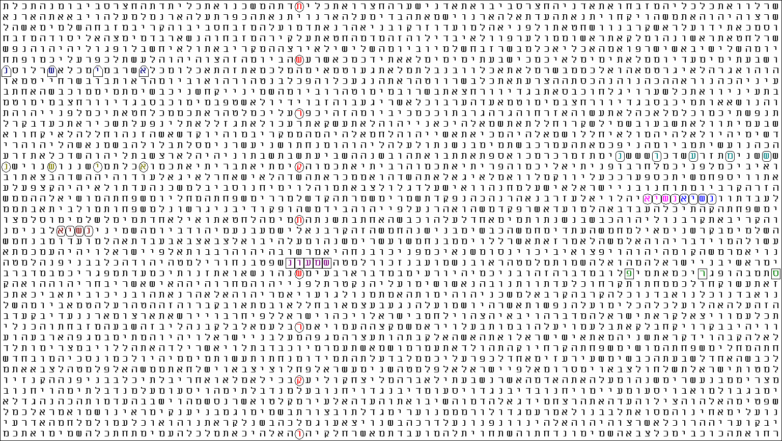

Term Translation Skip R Factor (in Matrix) Start End
תשרקתשרקו 2006 14965 2,253 4,192 Exodus 38:31.36 Deuteronomy 4:19.86
פרס Peres -8 -1,439 0,500 Numbers 14:32.12 Numbers 14:31.47
נשיא President* 1 -1,833 0,107 Numbers 3:32.2 Numbers 3:32.5
נשיא President* 1 -1,833 0,107 Numbers 3:32.6 Numbers 3:32.9
נשיא President 1 -1,833 0,107 Numbers 7:54.11 Numbers 7:54.14
נשיא President -5 -1,822 0,118 Leviticus 11:9.28 Leviticus 11:9.13
נשיא President -5 -1,822 0,118 Leviticus 26:10.17 Leviticus 26:10.2
שמעון Shimon 1 -1,591 0,348 Numbers 13:5.5 Numbers 13:5.9
שמעון Shimon 4 -0,245 1,694 Leviticus 25:3.2 Leviticus 25:3.18

The ELS reference is 2993 characters between rows.
There are 9 displayed terms in the matrix.
The matrix starts at Exodus 38:30.48 and ends at Deuteronomy 4:20.5.
The matrix spans 119805 characters of the surface text.
The matrix has 41 rows, is 85 columns wide and contains a total of 3485 characters.
There are 9 significant terms in the matrix.
The matrix odds are 1 chance in 224848,851 in favour of significance.
The cumulative 'R' Factor for the displayed matrix is 5,352.

*Terms marked with asterisk (*) form part of the unique for Torah combination of words denoting Prince of Princes נשיאי נשיא

Even if we completely remove the R-factors for both Shimon and President at skip 1, because these words occur considerably more often than expected, the remaining odds will be slightly above 1 in 80 000! As expected, the occurrences of Peres, פרס, at skip -8 and one of the occurrences President, נשיא, at skip -5 are here too. However, the newcomers, especially those in the far right, are astoundingly impressive!
First, we have Shimon, שמעון, at its next-to-the-lowest skip above 1 in the Torah, 4. Peres, פרס, is close by. President, נשיא, occurs doubled in the unique combination of Prince of the princes [RV] (or, Chief over the chiefs [AV and most modern versions]), נשיאי נשיא, the title of Eleazar the son of Aaron, in Numbers 3:32.
Even more astonishing, however, was the fact that when I tried to prepare a matrix with them only, independent of the main term, I failed! All programs refused to prepare a matrix at skip 2 993 with terms occurring at skips up to ±8. This skip, 2 993, is the only possibility to bring these three terms so close together! Therefore, our main term acts from distance. I prepared a matrix manually. See Figure 7.
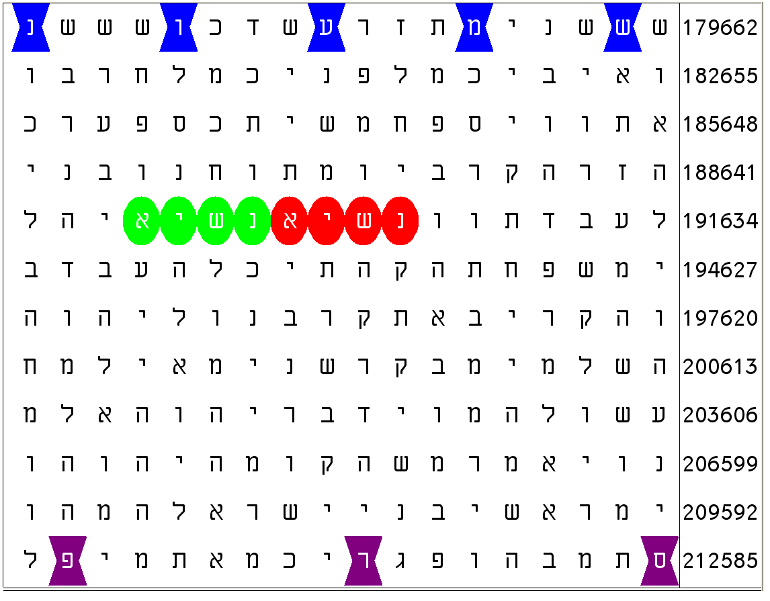
Figure 7. Shimon (שמעון), blue watches, at skip 4; Peres (פרס), plum watches, at skip -8; and the only doubled occurrence of President (נשיא) in the Torah, red and green ovals. The skip of this 12 rows by 18 columns matrix containing 216 letters, is 2 993.
Is this the smallest possible matrix with these three terms? The answer for these particular occurrences of Shimon and Peres along with the doubled occurrence of President is ‘yes’. The number of the rows between the top row and the middle one is 4, while that between the middle and the bottom one is 7. These are relatively prime numbers and there is no way to bring these three items closer. But, besides this occurrence, Shimon appears 39 times in the plain text and once at skip -3; Peres, on the other hand, occurs 50 times at skips up to ±8. Therefore, we could ask whether such a dense matrix is possible with other occurrences of these two names. I do not know the answer to this question. Just imagine the text as a very long string of beads. We press the coloured beads defining the double occurrence of President with our finger on a cylinder and start winding the string in both directions onto it. We obtained the picture above with a particular diameter of this cylinder. Another diameter could exist, which produces a similar picture with other occurrences within the ranges of skips specified above. The diversity of this phenomenon can be understood taking into account the variance of the skips of the terms in interest. Whatever the answer, because the possibilities are practically infinitely many, the picture we have obtained is a very rare event.
Apart from this, there is another most intriguing facet in the picture above. Number six, שש, is mentioned twice in the top row. The verse, part of which is there, is Lev. 25:3: For six years sow your fields, and for six years prune your vineyards and gather their crops. This is the closest occurrence of the words six years, שנים שש, in a sequence in the whole Tanakh. The skip between the first letter of the first occurrence and the first letter of the second one is 14 = 2×7, probably hinting at the seventh year of the rest, mentioned in the next verse, Lev. 25:4.
The number of the rows in the matrix is the number explicitly mentioned in the top row, six, doubled: 2×6 = 12. Finally, the total number of letters in the matrix, 216, is the cube of 6: 216 = 6×6×6.
So, we have in this matrix the closest possible double appearance of President / Prince / Chief as well as the closest possible meaningful (that is, the gap containing some information) double appearance at skip multiple of 7 of Six Years in the Tanakh! We know that the Time of the End we are living in now is the time of the end of the sixth day-for-millennium period, which will be followed by the seventh millennial day of the rest, the Kingdom of God on Earth, where the King of kings and Lord of lords will be the Lord Jesus, the Messiah (Rev. 19:16). Most of the hints we were following were pointing to temporal characteristics. We have found the name of Mr. Shimon Peres encoded with President with the main term, 2006 in the matrix in Figure 6. However, the skip of this matrix is not the skip of the term as it appears in Figure 1. Therefore, no validation about the year can be obtained from Figure 6. I felt that what I need is unequivocal confirmation of the year 2007. Figure 1 hints at this year but I found this matrix insufficient for a proof. Moreover, the forename Shimon was not in this matrix. So, I decided to enlarge the matrix at the original skip 14 965 as much as possible, looking for Shimon at larger skips. It had to be there!
The criterion I set was the value of the odds of the terms included in the matrix. Of course, sooner or later, a term would occur in the matrix, making it larger. It will add some significance, but at the same time would ‘eat up’ some significance of the terms already present there, due to the larger area they would be located in.
The maximum number of rows of the Torah at skip 14 965 is 21. I set many more columns and increased the skip for Shimon, שמעון, from 20 to 50… I cannot describe my feelings when I saw the matrix in Figure 8!
Figure 8

Term Translation Skip R Factor (in Matrix) Start End
תשרקתשרקו 2006 14965 2,253 4,513 Exodus 38:31.36 Deuteronomy 4:19.86
פרס Peres -8 -1,439 0,821 Numbers 6:16.12 Numbers 6:15.50
פרס Peres -8 -1,439 0,821 Numbers 14:32.12 Numbers 14:31.47
נשיא President -5 -1,822 0,438 Leviticus 26:10.17 Leviticus 26:10.2
נשיא President 6 -1,901 0,359 Exodus 29:41.36 Exodus 29:41.54
שמעון Shimon -23 -1,005 1,255 Numbers 23:1.23 Numbers 22:40.15

The ELS reference is 14965 characters between rows.
There are 6 displayed terms in the matrix.
The matrix starts at Exodus 29:41.20 and ends at Deuteronomy 4:21.8.
The matrix spans 134852 characters of the surface text.
The matrix has 10 rows, is 167 columns wide and contains a total of 1670 characters.
There are 6 significant terms in the matrix.
The matrix odds are 1 chance in 884490,895 in favour of significance.
The cumulative 'R' Factor for the displayed matrix is 5,947.

I have never seen such a strange matrix before as that in Figure 8. The length-to-width ratio is almost 17 to 1! Indeed, President, נשיא, appeared few times above the top row of the matrix, but at skips much larger than 6. If I included them into the matrix, they increased the odds due to the enlarged area. There was even one occurrence within the matrix, at skip 11, which turned out to have negative R-factor and I deleted it from the list.
Another remarkable fact with the latter matrix is that the second occurrence of Peres, פרס, at skip -8 in the far left occupies a place that extends the matrix to the left just enough to decrease the odds we would obtain without it! I checked the odds with a matrix with a left border as in Figure 1. (That is, just including the occurrence of President, נשיא, at skip -5, to the left of the main term.) The cumulative R-factor appeared to be 5.899 and the odds 1 in 792 501. (The respective numbers for Figure 8 are 5.947 and 884 491.) As far as I can evaluate, had the term occurred just four places further to the left, the matrix would have become large enough to increase the chances to above 1 in 792 501.
The matrix odds from Figure 1 decreased about 20 times, down to almost 1 in 900 000! And also Shimon occurred there, at skip -23! There is another occurrence of Peres too – in the far left, at the same skip -8. So now we have all three terms we started searching for in the beginning. In addition, the matrix did not gain a single row! The additional terms emerged in a very distinguishing way. They could locate in a new row – there are 8 rows above and 3 rows below the band. This could happen so that the matrix odds could be the same or even lower. Instead, both newcomers set themselves within the narrow band defined by the numerical value of the column with the main term: 2007!
Reflections on the Role of Ignorance in Discovering
Ignorance and subconscious sometimes play decisive and significant role for the revelation of information. One of the best known examples I am aware of is the D-Day crosswords panic in Britain in the summer of 1944 [13]. Shortly before the invasion of the Allies into Normandy, many of the codenames of this vital operation appeared in a British newspaper as crossword answers. Their occurrence in the newspaper day after day panicked MI5 because they thought that this is a way to pass information to the Germans. The investigation carried out revealed that the crosswords were compiled by a teacher, who asked his teenage boy pupils to insert words in crossword patterns and then created the clues. These boys spent much of their time out of school in the field, where American, British and Canadian servicemen were exchanging information while preparing for the operation, turning blind eyes to the boys hanging about and sucking in every word coming out of their mouths.
I believe that ignorance and subconscious interacted in my mind in most productive way. Indeed, I cannot assess the role of the chances in the course of this research. I am almost certain that I would hardly have started it at all had the third word in Daniel’s interpretation of the Writing on the Wall not been peres, פרס. Now, looking back, I see that had I set slightly different terms for obtaining the matrix in Figure 1, I would have got that in Figure 8 on first attempt and then, at least the matrix in Figure 7, would have remained almost certainly hidden from me. I would be satisfied with the result and would not bother looking deeper. A good example of the positive role of ignorance, isn’t it?…
How Bible codes are cracked? Even, what are they at all? How many codes are there now, how many of them will be revealed and how many will remain forever buried? Chances are characteristic not only of clustering of terms in matrices but also of the process of bringing them to light. Obviously, the processes defining thoughts in our minds depend to and interact with the tiniest and seemingly most unimportant or un-influential processes in the Universe. The word Peres, פרס, mentioned above, played the role of the overheard word inserted in a crossword. This word comes from the depth of history. However, while browsing in the Internet looking for more information about the difference between eagles and vultures, I noticed that this same Hebrew word, פרס, is linked in a deeply mysterious way with code-cracking even in our computer era. Here is the example that impressed me very much.
A group of mathematicians called RSA [14] created an algorithm for public-key cryptography in 1977. It is widely used today. It has become the algorithm of choice for encrypting Internet credit-card transactions, securing e-mail and authenticating phone calls [15]. The security of the code is in essence in the practical impossibility to factorize large numbers using classical, deterministic computers. (We factorized 14 965 to its factors 5, 41 and 73 above. But 14 965 is by no means a large number. Large numbers are considered those consisting of thousands of digits.) The only way, it is believed now, to crack such codes is through using quantum computers. There is already an algorithm called Shor’s algorithm created for this purpose in 1994 [16]. The fact that we have obtained at least one matrix (Fig. 7), which the current programs failed to display is a good evidence that some aspects of Bible code breaking are analogous to quantum computation.
The group of mathematicians mentioned above prepared a challenge ciphertext linked to the algorithm cited above and published it in Scientific American magazine in 1977. This problem proved to be a tough challenge to the world. It was cracked as late as in 1993-1994. The solution was… “The Magic Words are Squeamish Ossifrage”! [17] This started a tradition of using “squeamish ossifrage” in cryptanalytic challenges. פרס is here again, pointing as always to codes!
I was almost finishing this work when, while reviewing protocols spotted that פרס means also reward… What a proper word for the consolation in this hard Time of the End of those looking forward to the Coming Messiah and His Kingdom of God on Earth!
Conclusion: An Attempt for Estimation of the Odds
We have obtained three main matrices: (1) the matrix in Figure 8 revealing the code of Mr. Shimon Peres’ Presidency linked to 2007; (2) the matrix in Figure 7 revealing a code of the same event without specifying time and (3) the matrix in Figure 3 about the code of eagles/vultures and carcasses, which illustrates a famous Evangelical allegory about the Time of the End told by the Lord Jesus to His disciples. Besides that, we obtained two ‘auxiliary’ matrices, Figures 2 and 6, which either contain predominantly terms already found in another matrix (Fig. 2), or have not direct link to specific terms but to the characteristic of the current epoch and the main term, 2006 (Fig. 6).
One can hardly estimate the overall odds for all these findings. Even if we consider the matrices in Figures 3 and 8 alone, where we have one common term only, Peres, פרס, along with the main term, and therefore are in the right to regard them as independent, the overall chances are as low as well below 10⁻¹⁴. This is about 1 in a million billions! This is a number we can hardly imagine – it has nothing to do with what we see in our daily lives. And we have got even more amazing findings whose significance no formula can embrace…
However, it is not the diminishing odds alone that are so much amazing, but also the process of obtaining them. I tried to show the reader how all this happens. The algorithm, if any, is probably an advanced version of the abovementioned Shor’s algorithm. It is based on probabilistic approach to the solution, unlike the classical one, which first finds the solution and then estimates the probabilities. Indeed, we do not know whether there is a closer location of the terms in Figure 7. But we do not need to either. We do not calculate the answer. We see it.
This seeing is possible only when we compare our experience and expectations with what we find hidden in the Word. All this happens according to the Will of the Encoder, the Spirit of the Lord God. This is why, I believe, would never have started this research before hearing about the election of Mr. Shimon Peres President of Israel.
July 14th 2007
Sofia, Bulgaria

References
[1] A Strange Code about AD 2006 Discovered in the Torah:
http://exodus2006.com/2006piperov.htm
http://www.carelinks.net/books/lp/2006a.htm
http://www.ad2004.com/Biblecodes/Hebrewmatrix/2006a.pdf
[2] Protocol of a Statistical Evaluation of Some Items in the AD 2006 Matrix:
http://exodus2006.com/Protocol.htm
http://www.carelinks.net/books/lp/protocol2006.htm
http://www.ad2004.com/Biblecodes/Hebrewmatrix/Protocol2006.pdf
[3] The Writing on the Wall and AD 2006: A Lateral Approach to Code Breaking: http://exodus2006.com/lyuben/writing-on-the-wall.htm ; http://www.carelinks.net/books/lp/2006.htm
[4] The AD 2006 Code: The Significance of the Short Terms. Part 1: The Rising of the Lord, the Time of the End, Number Nine and the Month of Av: http://exodus2006.com/lyuben/The_LORD_will_rise.htm
http://www.carelinks.net/books/lp/risingindex.htm
[5] Vulture: http://en.wikipedia.org/wiki/Vulture
[6] Lammergeier: http://en.wikipedia.org/wiki/Lammergeier ; In Hebrew (פרס): http://he.wikipedia.org/wiki/%D7%A4%D7%A8%D7%A1_%28%D7%A2%D7%95%D7%A3%29
[7] New Testament in Hebrew: http://dvar-adonai.org/hnt/HntHe_en.htm
[8] Egyptian calendar: http://en.wikipedia.org/wiki/Egyptian_calendar
[9] Thoth: http://www.crystalinks.com/thoth.html
[10] Sexagesimal system: http://en.wikipedia.org/wiki/Sexagesimal
[11] From Genesis to Genetics and Back. Part 2: Words, Flesh and History of the World: http://ad2004.com/Biblecodes/articles/Genesisgenetics.pdf
http://exodus2006.com/lyuben/Genesis-to-Genetics2.doc
http://www.carelinks.net/books/lp/genetics.htm
[12] Inverted nun: http://www.hebrew4christians.com/Grammar/Unit_One/Aleph-Bet/Nun/nun.html
[13] Crossword Panic May 1944: http://www.telegraph.co.uk/news/main.jhtml?xml=/news/2004/05/03/nxword03.xml&sSheet=/news/2004/05/03/ixnewstop.html
http://www.historic-uk.com/HistoryUK/England-History/Crossword.htm;
http://wilsonsalmanac.blogspot.com/2004/06/216-d-day-crossword-coincidence-june-6.html
[14] RSA: http://en.wikipedia.org/wiki/RSA
[15] Sara Robinson, Still Guarding Secrets after Years of Attacks, RSA Earns Accolades for its Founders: http://www.msri.org/people/members/sara/articles/rsa.pdf
[16] Shor’s algorithm: http://en.wikipedia.org/wiki/Shor%27s_algorithm
[17] Squeamish Ossifrage: http://en.wikipedia.org/wiki/Squeamish_ossifrage
[18] Moshe Aharon Shak, Shimon Peres – Wins: http://www.biblecodedigest.com/page.php/528

Contact Lyuben Piperov at: l_piperov@yahoo.co.uk

For instance, the numerical value of the full expression of the current Hebrew year 5 767, התשסז, is 767 + 5 = 772.
I managed to find a matrix containing תשרקתשרקו (2006) and גווייה at skip -39 926, in a matrix of ELS 4 998 and chances 1 in 179, but I do not evaluate this finding as something substantially significant.
I calculated this value by subtracting 18 from the average number expected, 34.29, which gives 16.29, and adding the latter number to the average 34.29. The result is 50.58. This is not, unlike 18, a theoretical limit, of course. It is just at the same distance from the average as the lower limit is.
Six years, שנים שש, consists of 6 letters, so there are two letters remaining for something grammatically meaningful to be inserted before the next occurrence at skip 7. For the next skip multiple of 7: 14, this number is already 8, as is in the matrix.
The chance for the simultaneous occurrence of two or more independent events such as the probability of getting two six in throwing of dice is obtained by multiplication of the chances for each individual outcome. For example, the probability for getting double six with a single throwing of two dice is 1/6×1/6 = 1/36. The odds 1 in million billions are just the product of the multiplication of the individual odds obtained for each matrix in the reports attached to the respective figures.

