Copyright © Lyuben Piperov September 2005
The AD 2006 Code: The Significance of the Short Terms
Part 1: The Rising of the Lord, the Time of the End, Number Nine and the Month of Av
Lyuben Piperov
Introduction
In my earlier studies [1-3] I was naive enough to believe that I have exhausted the encoded terms in a matrix of medium size according to the standards of the Bible code researchers brotherhood. As my recently renewed research proved, I have seriously underestimated the Encoder’s omnipotent mind. This renewal was provoked by two reasons. First, I was very busy with my job-related tasks for almost a whole year and had less time to devote to my mostly beloved occupation of revealing hidden messages encoded by the Lord God millennia ago. But He is generous enough to allow me to keep on searching, so He provided loosening of certain conditions in my life and I have had more time for research. On the other hand, I haven’t ceased to keep up with the recent developments in the field, which offered some very interesting news about the significance of the current years and especially the year 5766 according to the Hebrew calendar, which means roughly AD 2006. Indeed, many Bible code researchers have found a number of thrilling codes and their number is rising steadily. Amazingly, many of them are related to the year 5766 of the Hebrew calendar [4]! Reading them I get the feeling that the time itself is speeding up...
Keeping in mind the extremely low probabilities for the occurrence of the terms in the AD 2006 matrix by mere chance, I have never forgotten even for an instant that the expression of the number 2006 is not according to the rules established by the Jewish scholars centuries ago. The term, which was found in the Torah at the odds of less than one in a million, bears to a large extent a Gentile finger print. But by no means this fact diminishes or put to question the importance of the nation of Israel. On the contrary, I believe that in my previous studies I managed to find good evidence for the importance of the Chosen People in flesh.
The Rising of the Lord
Having kept in mind that the code is about time(s) and contemplating on the future glory of Israel, I looked in the Bible for prophecies on the glory of Israel and Zion. One of the places where the magnificence of the Lord’s chosen nation is described in most exalted language is Isaiah chapter 60. In verse 1, Israel is encouraged:
…your light has come, and the glory of the Lord has risen (יזרח) upon you.
Being interested in comparative linguistics, I have noticed some surprising similarities between Bulgarian and Hebrew words with similar meanings. One of them is the Bulgarian word for dawn: zorá. It is linked not only with rising sun but also with an ancient Bulgarian verb ‘to see’. I was impressed of the similarity of this word to the Hebrew word for the verb rise used in the Bible, זרח (ZaRaKh). It is a matter of course that dawn is associated with light, which is getting stronger, that is, rising. (By the way, isn’t the English word ‘rise’ also similar to these words? After all, the consonants are the same as in the Bulgarian and very close to the Hebrew word!) Dawn is also the time when things naturally become visible or at least distinguishable. This is what is written about this word under rise in [5]:
זרח to rise or spring up; spoken of light, of the sun, of the majesty of the appearance of God (Deut 33:2); of the glory of the gospel at the coming of Christ, Isa. 60:1,2... (emphasize mine, L.P.)
I noticed that this verb is used twice in Isaiah 60:1,2. Verse 2 is especially interesting because this is the only occasion in the whole Bible (Old Testament) where the expression The Lord shall rise (יהוה יזרח) upon you (Israel, or Zion) occurs. There is no doubt that this event has been prophesied for the time of the appearance of the Messiah before the eyes of every flesh on the Earth. In Matthew 24:27, the Lord Jesus said that His own appearance will be visible as a lightning, i.e. perfectly perceptible.
So I had no better option but to check for the abovementioned words. And I was astonished! יזרח was there! A perfectly vertical occurrence very close to the main term! (Yellow ovals; see Figure 1. I chose the colour in order to match the typical sun-rise colour.) This is a tremendous hit, taking into account that there are only 3 vertical occurrences, whose skips are multiple of the skip of the matrix, 14965, in the whole Torah! Moreover, it touched the Name of the Lord as if confirming the code (turquoise ovals)!
The Lord Jesus said to the Samaritan woman that the salvation is from the Jews (John 4:22) evidently having in mind Isaiah 2:3:
For out of Zion shall go the law (Torah!)
And the word of God from
Jerusalem.
It immediately came up to my mind that the words Torah (תורה) and law (דבר) may be expected to be in close proximity to the vertical code יזרח – Isaiah 2:3 is a very important and informative verse. Both words appeared to be there. Torah at skip -29933 (black ovals) and law at skip 1 (olive green ovals). Although at skip 1, this word is essentially encoded, because in the plain text it is part of the word ‘desert’. What is very interesting with this word is that it intersects the word oracle (דביר) occurring at skip -2 (olive green diamonds). דביר occurs only 4 times at skip ± 2 in the Torah and never in the plain text or at skip -1. But it appears in the plain text from Joshua onwards. In Joshua, it stands for Debir but in 4 occasions in 1 Kings, Psalms and 1 and 2 Chronicles it denotes sanctuary. There is only one more intersection of these two encoded words but regarding to the plain text where the intersection occurs, our case is more significant because it occurs in a part of the text where the Lord is angry to Israel and assures them that your children shall wander in the wilderness for forty years (Numbers 14:33; the bold characters indicate the words containing the codes). As we see, there is an oracle in this case... I have checked also for the modern word for law, הרבד and its only occurrence – apart from an occurrence at skip +1 – is at -29936 (olive green ovals) even in a much larger matrix (91 columns wide, with the main term in the centre) than that shown on Figure 1, intersects the main term.
Then I noticed the word statute (חק and the other variation as extension of the word, חקה – in green ovals). This word is often used in the plain text of the whole Tanakh but I was impressed by its use in a verse that hints particular reference to Isaiah 2:3. It is Psalms 147:19;
He declares his word (דבריו) to Jacob, his statutes (חקיו) and rules to Israel
The closeness of these words in this meaningful verse is emphasized by the geometric proximity in the matrix.
I noticed the formation of an almost ideal rectangle. I assumed that there should be some encoded information. Due to the very small area, most probably it should be in the form of a single term. So what should we look for?
It has been believed and basically well accepted by the Bible scholars that Joseph was an archetype of the Messiah. I have exploited this idea in an earlier study of mine [6]. The eleven brothers represent Israel. They have rejected Joseph and sold him to Ishmaelites as a slave for twenty shekels of silver (Gen. 37:28). Although they had lied to their father Jacob that Joseph was torn by a beast, they should have taken for granted that he is either a slave somewhere or lives a very base life in a foreign country. They had remained absolutely unaware of his fate as the second man in the most powerful empire of the time – Egypt – even equal to Pharaoh himself (Gen. 44:18). They were unaware of to whom they were speaking when they went to Egypt many years later to buy food.
There are two major moments in the relations between the brothers and Joseph. The first one is the act of his rejection and selling him as a slave and the second one is the meeting when Joseph showed himself up. Keeping in mind that the matrix is about the time of the appearance of the Messiah before Israel, I decided that the encoded term(s) should have something to do with the latter event. Therefore, I looked for a word specific for the meeting between the eleven brothers and Joseph. A word that would characterize the meeting between Israel and the Messiah in a way similar to the meeting in Egypt.
I read the narrative several times in English and Bulgarian comparing it meanwhile with the Hebrew original. I was impressed by Joseph’s accusation of his brothers of spying. There should be something in this case because Joseph knew for certain that his brothers were not spies. Denying the accusation, the brothers told that they are honest, or true, men. The Hebrew word for honest (men) is םינכ and it is used five times in the whole Tanakh in this meaning and all the times it is in this occasion alone – the several conversations between Joseph and his brothers. I found the word entirely within the rectangle – at skip 14966 (blue ovals). It touches the main term, which is significant because this is a 4-letter word and such coincidence is not to be expected to happen with a high rate of occurrence. Even more, I noticed that the 3-letter word hint, or allusion, זמר (RaMaZ; purple ovals) precedes immediately the key word within the rectangle, forming a 7-letter string, whose occurrence in the matrix is much more significant.
This occurrence of the word hint is interesting because it confirms the validity of using of a term specific for certain event as a key to understanding another historical event(s) happening or expected to happen in different time but bearing characteristics close to the distinctiveness specific for the basic event.
I was even more amazed when noticed that hint, רמז intersects with another Hebrew word for light at skip -1: אור (ochre diamonds). This word is very interesting because from it the word Urim is derived. It occurs 57 times as individual, 3-letter word, in the plain text of the whole Tanakh. However, it is remarkable that in two occasions only it appears twice in the same verse: in Gen 1:3, when God created the light, and in Isaiah 9:2:
The people who walked in darkness
have seen a great light;
those who dwelt in a land of deep darkness,
on them has light shined.
This fact is even more interesting because this verse is referred to literally in Matthew 4:16 and less accurately in the Zechariah’s prophecy as cited in the Gospel of Luke (1:79). But what is not less remarkable is that it is mentioned twice in 60:1 as a verb (shine) and as a derivative (your light). Both words rise (חרז) and light (רוא) appear three times each within the three very important verses Isaiah 60:1 to 3.
Finally, I noticed the root of the first word in verse 1, arise (םוק) entirely within the rectangle at skip -14966 (ochre watch) and intersecting the word statute (קח or הקח). This word, in its 3-letter variety, is used in Genesis 13:17, when the Lord said to Abram:
Arise (םוק), walk through the land in its length and in its breadth; for I will give it to you.
Arise... light... the Lord has risen... These words urged me to return to Isaiah 60:1. They all are there! Is another significant word in this verse that I still haven’t looked for? Yes, I haven’t tried still to find the glory of the Lord. I checked in the glossaries for glory. There are several Hebrew words corresponding to the English word depending on the dictionary I was looking in. Therefore, I checked for the word that is used in this particular verse. It is the 4-letter כבוד. This is the very same word used in Exodus 40:34,35 and Numbers 14:10.
I believe that the encoded words forming the cluster, although short ones, represent the idea and the emotion of the first few verses in Isaiah 60. Therefore, starting the search for the 4-letter כבוד, I was almost certain that it will be found nearby. And it was there, indeed, right within the cluster. But what I found later exceeded my expectation. In fact, it occurs as the 5-letter word His glory (כבודו) as it appears in the plain text in the next verse! It goes through the rectangle at skip -14970 (pink ovals), the central letter falling within the rectangle. In this form, כבודו, it does not appear in the surface text of the Torah.
Finally, I managed to spot the single word in Hebrew upon you in the plain text adjacent to the main term: עליך, brown ovals. ‘Upon you’ (the 4-letter word is singular; it is also a part of the plural form עליכם) occurs only 57 times in the plain text of the Torah, so this occurrence in the cluster is quite significant.
Let us see how many of the words in the cluster are found in the plain text of the first few verses in Isaiah 60 in one or another form. They are written in red bold characters. The reader can make the conclusion on the basis of the facts:
Arise, shine, for your light has come,
and the glory of the Lord has risen upon you.
For behold, darkness shall cover the earth,
and thick darkness the peoples;
But the Lord will arise upon you,
and his glory will be seen upon you.
Gentiles, Times and Numbers
But the Gentiles also occupy important place(s) in the plan of the Lord regarding the Holy land and Israel. Suffice to say that a Gentile, Cyrus, is called Lord’s anointed (Isaiah 45:1), who is called by name
For the sake of my servant Jacob,
and Israel my chosen... (v.4).
Once Gentiles are mentioned explicitly, by their names, in prophetic texts, I cannot ignore the possibility of presence in the Holy Bible of terms or longer expressions bearing the characteristics of Gentile nation(s) that has/have had major importance in the history of Israel. This should be valid not only for the Tanakh but also for the Torah specifically. But because, on one hand, the Torah was given to Israel exclusively, and on the other, it scarcely contains explicitly Gentile nations or persons prophetically, we should expect to find anything linked with Gentiles in encoded form exclusively.
One of the basic ideas about Gentiles that can be followed throughout the Bible is that the Gentiles will be given certain time during which they will be allowed to rule over the Promised Land and especially the Holy city of Jerusalem. This idea was demonstrated historically before the birth of Jesus of Nazareth as well as for a period of almost 2,000 years after the crushing of the rebellion in 69/70 AD and the destruction of the Temple. But the fact that this predominance of the Gentiles will be temporary is by no means put in question. (On this subject, see especially Romans 11:25.)
As I have pointed out in my first study on the AD 2006 code, the Land, that is the space in more abstract sense, is linked with Israel, whilst the abstract, physical dimension of time, is characteristic of the Gentiles. This aspect is demonstrated most clearly in the prophetic visions of Daniel and his interpretations of the dreams of the Gentile king Nebuchadnezzar. These images outline a long period that is divided in 4 basic intervals characteristic of Gentile powers that will rule over the Land.
The quintessence of these prophecies is chapter 12 of the book of Daniel. There, the angel told Daniel that all these specific periods will end and the time when this shall take place. This time is called
The Time of the End
There are several words for end in Hebrew. One of them, סוף (SOF), has already played a major role in the research. In the current study, however, I have tried to find the word for end that is linked mostly and at the same time, understandably, prophetically with time. Our research is carried out entirely in the Torah but the most important key found in the first study was the famous expression ‘for time, times and half a time’ with only two letters denoting the plural form of ‘time’ missing. This expression was found, significantly, in its Hebrew wording. Therefore, I studied carefully the exact passage of the book of Daniel containing the prophecy. I started looking for ‘latter days’, ‘time(s) of (the) end’ and ‘end’ itself thereabout. If the code has been appointed by the Encoder for the time of the end, the term itself should be somewhere about the key, I thought.
Chapter 12 of Daniel is a short one but full of meaning. It is there where the prophecy was told in the second instance to Daniel, this time in his mother’s tongue. I have read it many times but any other time I read it I find something new to me. The scrupulous study gave fruits again. I counted in the English Bible the word ‘time’ mentioned 9 times plus ‘times’ mentioned once in these 13 verses, to say nothing about words denoting time such as ‘end’, ‘how long?’, ‘finished’, and the like. I haven’t gone through all parts of the Bible in the same way but I doubt if it is possible to find out a text of the same length that would contain this word so ‘densely’. So it is evident that the book of Daniel and especially chapter 12 is among the places of the Old Testament where are written things that concern very important times, times marking the borderline between eons.
On the other hand, it should be naive even for a man of little knowledge of Hebrew as I am to expect that in all these 10 occasions the same Hebrew word has been used. There are at least five Hebrew words that are translated as ‘time’ in English. Most of them are 3 or even 2-letter words. I could start trying to find any one of them, with good chances of success, in a close proximity to the cluster containing the key and then to look for a short word among a dozen of those translated as ‘end’ in English, which could occur nearby. But this would be adjusting the result in accordance with my wishes. A straight and serious approach would be to look for suitable expression(s) in the plain text that matches the idea of the code most closely; in the ideal case, perfectly.
I doubt that there is even one Bible scholar who does not believe that the finishing of the period or most probably the last one of the periods of time specified as ‘time, times and a half of time’ marks the end of a very long epoch of human history and starting of a new, presumably better, era. Therefore, the most appropriate expression matching this prophecy would be ‘the time of the end’. In Daniel’s original wording in Hebrew, it is the 4-letter expression קץ עת (ET KeTz). It is found twice in chapter 12, which is significant. This expression is found only 5 times in the Old Testament and in all occasions in the part of the book of Daniel written in Hebrew. (About a half of the book is written in Aramaic.) It could hardly be found a better candidate. So I tried and...
It was there!
Right among the clustered items, at skip 29941! For the sake of clarity, I prepared a matrix including the central item, the key and the last term (see Figure 2. The main term is shown in red ovals, the ‘old’ cluster is in turquoise ovals and the new term is in deep purple ovals.). Well, but this expression consists of 4 letters only, so I had to check the significance of its occurrence right there. I have checked experimentally the frequency of entire occurrence of the item קץ עת in a matrix containing 21 or 20 lines and 57 columns – about 20 columns larger than the number of columns containing the key prophecy and ‘the time of the end’. It appeared to be about 0.047. Not extremely low but low enough to provoke further investigation. What is more, its occurrence has been anticipated and the fact is that it fits almost perfectly among the clustered letters of the prophecy. I have also checked the probability of finding it within the cluster itself, in the 38 by 9 matrix of 3.5 times less area (342 letters) defined by the extreme letters of the cluster. It appeared to be about 1 in 1,500.
Having come so far, it would be worse than a misdeed to miss the possibility for trying to extract more hidden information in case there is any. As for the occurrence itself, the odds for this 4-letter word are not extremely low but the significance of the enlarged cluster is high enough to hint more. This may not be expressed as occurrences of hidden words but as interrelations of numbers.
As I did in my previous studies, I started to perceive the matrix as a whole. But what is a ‘whole’ matrix? Is there any definition of such a term? Some programs prepare matrices on the basis of the size of the main term and go up and down outside the text specified by the researcher for looking for the term. Even worse, they ‘cut off’ part of this specified text which might be of interest for looking for additional encoded terms. For instance, in order to find out the ‘time of the end’ I had to ‘enlarge’ artificially the main term in order to include the first line of the matrix shown on the figure. It is shown in a Torah4U program slide but the ‘time of the end’ was found using another program (Keys to the Bible). Sometimes one must combine the advantages of different programs in order to achieve success.
It was due to the Torah4U (the CodeFinder also produces the same matrix) that I knew for certain that if we use the text of the Torah alone, the matrix will have exactly 21 rows. I knew this fact but it hadn’t seemed to mean something important to me. However, I was contemplating the findings...
Uncharted Seas
Suddenly I saw it! With the new term קץ עת, the number of the rows containing the prophetic cluster from Daniel 12 became 9. This number matches the number of the 2006 code! Is it an additional hint that it is indeed 2006 and not 2000? That is, should the ninth term, vav (ו), be included or not? (Without its insertion, the code remains ‘valid’ but would be 2000 instead of 2006. See [1] for detailed explanation of this subject.) In its turn this should confirm the implication that the code refers to future events. Exciting!
Then I realized that the new term made the ‘cluster sub-matrix’ wider but it gets entirely within its length. Knowing that the number of the rows matches that of the main term, I asked myself if there is something hidden in the length of this sub-matrix. The length is related to the skip of the main term. If we change the skip by a unit, the main term will remain within the same matrix, but the sub-matrix will change its length and may become longer or shorter. The length at the skip 14965 is 38 columns. Therefore, I checked what will happen if we change the skip of the matrix from 14965 to 14964. The resulted matrix is shown on Figure 3. The ‘old’ cluster becomes more compact but the new term stretches outside making the overall length two columns longer: 40. At skip 14966, it becomes even longer: 44 columns (see Figure 4). It is readily seen in the figures that the skip 14965 ‘ties up’ the cluster in its most ‘packed’ or ‘densest’ form. If there could be drawn a conclusion from this fact, it is that the prophetic cluster defines the year 2006 as the true period of time among the other possible candidates that might be found within the matrix.
Pondering on the matter I recalled that the only occasion when I have come upon an encoded term where the skip does matter, was that described by Dr Jeffrey Satinover in [8]. Amazingly, it is also about times! And the Hebrew word is the very same word as one of our key roots: מועדים (MOEDYM)! In the example cited in the book, the term the appointed times, המועדים (HaMOEDYM) appears encoded in Genesis at skip 70. And 70 is the total number of the feast days within a year that the Lord has appointed in the Torah!
Time.... appointed times.... Why in both these occasions known to me the significance of the skip is linked specifically to time? Time is always associated with something moving periodically. Pendulum, hands of a dial... Then it suddenly came to my mind... I likened the cluster containing all the terms from Daniel 12 to a constellation in the night sky. A well-known astronomical fact is that the Earth’s axis ‘wobbles’ very slowly while the planet moves along its orbit. In fact, the axis describes two cones with a common vortex in the Earth’s centre, i.e. moves along a conic surface, making a full revolution for about 26 thousand years. Within that period, all constellations make full circle in relation to a defined point marking the annual movement of the sun. Usually, this is the vernal equinox, when the sun crosses the equator. The meridian on the celestial sphere that the sun crosses at this very moment is called zero-meridian. It is this meridian that turns slowly and passes through the constellations...
This movement is not circular but sinuous. For instance, those constellations of the zodiac, which are seen highest in the Northern Hemisphere sky such as Gemini and Cancer, had been at their lowest in the sky some 13,000 years ago, while Sagittarius and Capricorn had been on their highest. This is the periodic movement of the constellations.
However, the stars that we see in a constellation are not linked by strong gravitational forces within a constellation. Usually, they are far away from each other and possess their own, independent, movement. Although this movement is very slow and cannot be noticed within a generation or even a century, it could be detected by precise instruments. Also, it can be observed in ancient drawings or other documents where some well known contemporary constellations look somehow distorted. This fact proves that at any moment, the position of the stars within a constellation is unique. So, along with the periodic movement of the constellations, there is also non-periodic, linear, time arrow. It seems that although the ancients had been well aware of the periodic movement of the objects in the firmament, they remained to a high extent unaware of the uniqueness of the celestial landscape before their eyes.
This fact as well as many other data made many eminent scholars insist that the ancient Pagans were unaware of the linearity and hence historicity of time. They measured time in annual or longer periods and believed that once someone has passed certain period, his or her sins are not counted for anymore and they are ‘clean’ again. The idea of a final judgement had been alien to them. Therefore, towards the end of every year, they usually had a period for indulging in drinking, promiscuity and any other activity they had been afraid to do because there had been too much time before the start of the ‘new season’. The Roman feast Saturnalia, starting on December 17th and lasting 5 to 7 days, i.e. ending just about the winter solstice – the starting of the Roman New Year - is a good example of these habits. Some erudite scientists even believe that the idea of linear time has come through the Bible. (On this subject, see especially the works of James George Frazer, Robert Graves and Carl Gustav Jung.)
Therefore, the idea that the linearity of the time could be derived by a code in the Torah seemed to me remarkable and exciting! Once I had the ‘constellation’, I needed the time ‘measuring’ device. And I saw it at once: the 9-letter 2006 term looked like either a pendulum or a hand of a clock! Indeed, just look quickly through figures in the sequence 3-2-4 forwards and backwards and you will see it! This analogy should lead to two conclusions: (1) the number 2006 denotes time and (2) this time is linked with the prophecies in Daniel 12.
Having reached so far, has something remained undiscovered? Yes, there is still something in the number of the letters in the cluster! In [1], I have pointed out that the expression ‘for a time, times and a half (of time)’ consist of 15 letters. Due to the intersection and the two missing letters for the plural form of ‘time’, the number of the letters in the old cluster was 11. Now, with the 4 new letters of the ‘time of the end’, the original number of letters in the prophecy is restored: 15!
In this aspect, the size of the matrix, the number of the letters in one or more terms as well as the skip of the main or another specific term can be proved to play a role in the code and to contain specific significance. May be there are not only ELS’s, digrams and trigrams that matter as some researchers are intended to believe. In a study on the Holocaust, I have used such approach for calculation of a function analogous to entropy [9]. In the current study, as we will see soon, the total text volume also plays a peculiar role in decoding. However, such investigation aspects are waters remaining yet uncharted in the vast ocean of the Bible code research...
Having noticed that the number of the rows in the cluster match those of 2006: 9, I started thinking on the significance of this fact. The overall number of the rows of the ‘constellation’ and the ‘clock’ is 18. The total number of the row in the matrix is 21. There are 3 rows that remain. I have wondered why the number of the rows is exactly 21 since I have started studying the matrix more than a year ago. Now I felt that I should be close to solving the riddle. 3, 9, 18, 21... ‘Time, times and a half’... 18 is two times 9... 3 is the remainder... And then the idea came up to my mind!
When do a Thing, Things and a Half (of a Thing) Make Seven(s)?
What if 3 is the half?
I have read many studies on the ‘for a time, times and a half (of a time)’ prophecy. There are different interpretations on the meaning of ‘times’. It is a plural form, so it may have any value, presumably a whole number, from 2 on. I recall that I was impressed by a study, unfortunately I can’t remember where I read it – it was long ago – where the author claimed that ‘times’ in this particular prophecy might be in the dual form of the plural, i.e. meaning ‘two times’. But even without deep grammar studies, the authors of the first three references that the Google showed when I asked for “time + times + half + Daniel” interpret the duration of the whole period as 3 and a half years [10]. Anyway, once the number of the times is not specified, the lowest possible number remains 2. In this way, the expression “time, times and a half (of a time)” could be rearranged as “1 time, 2 times and ½ of a time”. Thus the whole prophetic period should be long
1 time + 2 times + ½ of a time= 3 ½ times
3 ½ is the half of 7. If we have to obtain a whole number on the right side of the equation, the ‘measure’ of the time should be an even number. Indeed,
2 + 2×2 + ½×2 = 2 + 4 + 1 = 7
4 + 2×4 + ½×4 = 4 + 8 + 2 = 14
It is easily proved using a method known to mathematicians as “induction” that with even numbers we will always have a multiple of 7 on the right. It is so easy that the reader can prove it him- or herself. (See the proof in the Appendix.) If the measure of the time in Daniel chapter 12 is 6, then the result is very interesting:
6 + 12 + 3 = 21
What we have in the right sides of all equations are multiples of seven! Now seven is the most important number in the whole Torah! It denotes the period of seven days of the completion of the whole Creation.
It is the third even number, 6, that yields the number of the rows in the matrix according to the formula. What is the specificity of the number 6 from Scriptural point of view? In my opinion, while number 7 is associated with the Lord, number 6 is associated with man. Man was created on the 6th day of the Creation and the number of the beast in the book of revelation is three 6s. Goliath had six fingers and six toes on his hands and feet. The famous ivory throne of Solomon had six steps (1 Kings 10:18-19). In this aspect, the fact that it is just 6 that produces the number 21 through the formula x + 2x + ½x is indication that these ‘time, times and a half’ point out a period of man’s rule and to a large extent a governance that is inimical to God. Therefore, the end of this period should be the end of the man’s rule on Earth and the time of establishment of the Kingdom of God. This should mean that we live in the time of the feet that are part of iron and part of clay (Dan. 2:33).
However, the fact that the throne of Solomon had six steps and the fact that David’s star has six vertices (strictly speaking, they are 12 but I mean the convex ones) relate the number 6 to man generally. Is there a number, which could be associated specifically with Gentiles?
Surprisingly, it appeared that there is such a number and it has direct association with our matrix. This number is
Nine
Nine is the number of most frequent use in the Indo-European, Uralic and Altaic mythologies [11]. There it prevails over number 7 or at least these two numbers are interchangeable in the latter mythology as the most important cosmological numbers [11]. Number 9 is also incredibly important in the Chinese thought [12]. In Bulgarian fairy tales, a place that is very far away from here is said to be ‘across nine lands in the tenth’. Also, when, figuratively, a cause is to be defended perfectly or something is to be cleaned perfectly, it is said that ‘water should be brought from nine wells’, etc. Nine brothers and especially nine sisters is the number that is most likely to be found in the mythologies. (Brothers could be seven but sisters are always nine [11].) It seems that the importance of number nine could be traced as far back as before the introduction of the rational notion of the linear time. That is, in the very depth of the human history. Many researchers believe that it was the time of the matriarchate, which specifies that era forgotten a long time ago. Therefore, number nine could be associated with the feminine [11]. It is also associated with the magic obtaining of knowledge. Because nine is three times three, it is associated also with the ‘tripleness’ of the ancient feminine deities. In the picture taken from a Greek vase shown of Figure 5, there are 3 feminine deities, 3 spirals evidently related to them and 3 flying cranes also related to the feminine figures because two of them are pointing to the birds. The scene is taken from [13] and illustrates the event from the Greek mythology when the triple goddess gives to a man what is necessary to him in order to pass through an ordeal.
If number seven is the most typical number associated with the Bible and especially with the Torah, then there must be a specific indication that number nine, unlike its role in the mythologies, is not a number playing significant role in the Word of God. This idea encouraged me to find a method to compare these two numbers in the Old Testament. The most obvious way was to compare the rate of occurrences of the numbers that are used mostly in our life. So I checked the frequency of occurrence of the numbers 3 to 15 in the Torah and the books from Joshua to the end of the Tanakh. I have counted the cardinal and the ordinal numbers. I have discarded numbers one and two because their rate of occurrence is expected naturally to be much higher than that of the other numbers and cannot be of use for the evaluation. Although three is also expected to appear much more often than any other number remaining, I have left it as a basis of comparison.
For the sake of purity of the experiment, I ‘sifted’ all occasions when the respective number is a part of another number. For instance, ‘seven’ was not counted if it appeared in expressions such as ‘seven thousand’ or ‘twenty seven’. This is valid, of course, for the ordinal numbers too.
The results are presented in the following Table 1. For a better illustration, they are shown also on Figures 6 and 7. Amazingly, number nine occurs most scarcely among the numbers up to 15 in the Torah! Its number of occurrences, 3, matches that of number 13. No other number among the examined items appears with lower frequency. The ratio of the rate of occurrences of 7 and 9 is almost 50! Such a ratio cannot be seen in any mythological narrative. I believe that this could be an encoded indication that the number nine is (one of) the number(s) of the Gentiles.
Table 1. Rate of occurrences of cardinal and ordinal numbers 3 to 15 in the Torah and the rest of the Old Testament.
Cardinal | Torah | Rest of Tanakh | Total | Ordinal | Torah | Rest of Tanakh | Total
1 | 2 | 3 | 4 | 5 | 6 | 7 | 8
3 | 82 | 205 | 287 | 3 | 37 | 63 | 100
4 | 45 | 107 | 152 | 4 | 21 | 61 | 82
5 | 77 | 73 | 150 | 5 | 18 | 34 | 52
6 | 37 | 54 | 91 | 6 | 9 | 22 | 31
7 | 149 | 135 | 284 | 7 | 58 | 50 | 108
8 | 7 | 20 | 27 | 8 | 14 | 17 | 31
9 | 3 | 9 | 12 | 9 | 3 | 20 | 23
10 | 46 | 97 | 143 | 10 | 48 | 29 | 77
11 | 8 | 7 | 15 | 11 | 2 | 15 | 17
12 | 30 | 65 | 95 | 12 | 1 | 21 | 22
13 | 3 | 10 | 13 | 13 | 1 | 10 | 11
14 | 10 | 7 | 17 | 14 | 8 | 15 | 23
15 | 6 | 6 | 12 | 15 | 7 | 10 | 17
It is seen on Figure 6 (columns 2 and 3 of Table 1) that there is a distinctive pattern of peaks of the odd numbers up to seven and the even numbers from 10 to 14, although the last peak is not pronounced so well, of the cardinal numbers in the Torah. The dramatic change of the peaks from odd to even numbers happens right at number nine! This tendency is not marked so well for the odd numbers less than seven in the rest of the Tanakh. There, a peak at number five is missing. What is also characteristic of this Figure is that the cardinal number seven occurs more often in the Torah than in the rest of the Tanakh, although the text of the latter is three times larger! In fact, almost all numbers occur relatively more frequently in the Torah than in the rest of the Tanakh! Only for numbers 8, 9 and 13 the ratio Rest of Tanakh/Torah is 3:1 or close to that value.
With ordinal numbers (Figure 7; columns 6 and 7 of Table 1), there are only two distinctive peaks at 7 and 10 in the Torah, whilst in the rest of the Tanakh, the tendency for peak forming is kept for the even numbers 10 to 14. It is seen also in Figure 7 that the ordinal number nine behaves more ‘normally’ outside the Torah. In the Torah, however, its rate of occurrence remains abnormally low.
The latter fact inclined me to combine the cardinal and the ordinal numbers in the each one of the parts of the Old Testament and to compare the result. It turned out to be amazing (see Table 2 and Figure 8)!
Table 2. Rate of occurrences of the sum of cardinal and ordinal numbers 3 to 15 in the Torah and the rest of the Old Testament.
Card. + Ord. Numbers | Torah | Rest of Tanakh
3 | 119 | 268
4 | 66 | 168
5 | 95 | 107
6 | 46 | 76
7 | 207 | 185
8 | 21 | 37
9 | 6 | 29
10 | 94 | 126
11 | 10 | 22
12 | 31 | 86
13 | 4 | 20
14 | 18 | 22
15 | 15 | 16
Table 2 and Figure 8 cry out the truth: number seven is the number of the Bible and especially the Number of the Torah! It is the number that occurs most frequently among all numbers from 3 to 15. It outnumbers the second of the numbers occurring in the plain text of the Torah, 3, by a ratio of almost 2:1! The pattern is preserved in the Torah: peaks at the odd numbers up to seven and at the even numbers from 10 to 14.
In this aspect, the rest of the Tanakh pales before the Torah. Although it is also Word of God, apart from numbers 7, 10 and 12, it does not differ significantly from a common narrative concerning the rest of the numbers: they show a tendency of regular decrease of the rate of occurrence of the numbers with the increase of their value. I plotted the logarithmic values of the numbers in the third column of Table 2 obtained with the Prophets and the Writings (rest of the Tanakh). The plot is shown in Figure 9. It clearly demonstrates that apart from numbers seven, ten and twelve, the text of the Prophets and the Writings does not differ from any non-sacred text regarding the pattern of decrease of the occurrence frequency with increase of the value of the whole numbers used in the narrative. Indeed, numbers 3, 4, 5, 6 and 8 form a straight semi-logarithmic line, which is pointing to exponential decrease of the frequency of use of these numbers. This should be expected with a normal narrative. Indeed, we have something to do with three objects more often than with four ones at the same time; we manipulate simultaneously four objects more often than five ones, etc. So when we describe our activities, we will use the words ‘three’ and ‘third’ more often than ‘four’ and ‘fourth’ and so on.
The logarithmic values obtained with the results for numbers 9, 11, 13 and 15 also form a straight line, which is indicative of the same pattern. In this case, however, the slope is less steep. It is evident that the change of the steepness takes place at number nine. This is interesting because it shows the psychological edge when the number of the objects become ‘many’. It seems natural that the decimal system is the most suitable system used for our life.
Another conclusion that can be drawn from the data obtained is that the occurrence frequency for almost all numbers is higher in the Torah compared on the text volume basis. Indeed, on this basis, the rate of occurrence should be about three times higher in the Prophets + Writings compared to the Torah. In fact, the nearest value to this ratio is obtained with 12. Then comes 4. However, all numbers 3 to 15 save 9 and 13 yield a rest-of-Tanakh/Torah number of occurrence ratio lower than 3:1! The ratios for 9 and 13 are 4.83 and 5.00, respectively. In other words, based on the rate of occurrence in the rest of the Tanakh as a measure unit, these two numbers occur with abnormally low frequency in the Torah!
Number Nine and the Jewish History
A notorious expression including the number nine in Hebrew for its remembrance of calamity is the ninth day of the fifth month Av. It is so widely known that instead of translated it is transliterated in many languages including English: באב תשעה or Tisha b’Av. This is the date, it is believed, when the destruction of the first and the second Temples of the Lord had taken place. While the second destruction came to pass in AD 70, the first one happened in Biblical times. It is well documented both in the Prophets (2 Kings and the book of Jeremiah) and again, schematically, in the Writings (the last chapter of 2 Chronicles). Interestingly, this date is not mentioned in the Tanakh. A ninth day associated with a tragedy is indeed mentioned in 2 Kings 25:3,4 but it is in the fourth month, not in the fifth. The famine prevailed after a long siege and a breach was made in the city. It was about a month later but on the seventh day of the fifth month when Nebuzaradan, king Nebuchadnezzar’s representative, came to Jerusalem. Finally, in Jeremiah 52:12, it is written that the same person came to Jerusalem on the tenth day of the fifth month. In the latter case, however, his coming is directly and immediately associated with the destruction of Jerusalem (v. 13).
As it is seen, it can be concluded that the most dramatic events concerning the destruction itself indeed happened between the seventh and the tenth day. Perhaps the whole process of destruction took several days and it might be that the culmination of the event came to be on the ninth day of Av. The apparent discrepancy between the dates cited in 2 Kings and Jeremiah could be explained easily taking into account that for the ancients, personal appearance is equivalent to the presence of authorized representative. So, men appointed by Nebuzaradan may have come on the seventh day whilst he came personally on the tenth.
Be that as it may, the ninth day of the fifth month has remained in the Jewish historical memory as the darkest day of the year, when disasters have happened to the nation. And these disasters have been caused by Gentiles. The last significant event happening on this was the signing of the “Final solution” by the Nazis in July 1942. The date happened to be Tisha b’Av 5701.
While contemplating on the significance of the number nine for Jews, I noticed it right in the column of the central term. It is there in its feminine, 3-letter form. I was intrigued. The occurrence of תשע in the column containing already at least two tavs and two shins is not an extraordinary event. Even so, there are only two possibilities for it and one of them is materialized. The probability for such occurrence is about 7 %. I tried with all possible occurrences in the matrix and, as it should be expected, quite a number of coloured squares appeared. Therefore, I decided to look for a pattern. In order to eliminate the redundant occurrences, I concentrated on those occurrences, which would form a geometrically regular shape. So I tried to find all the horizontal, vertical and diagonal (without step) occurrences within a zoomed out matrix 90 columns wide that the Keys to the Bible program yields. The maximum skip I set for the search has been 11. It is by a unit larger than the maximum vertical skip for a 3-letter word in the matrix. The result is shown on Figure 10.
I was surprised to see a cluster distributed relatively evenly around the central column. Moreover, the number of the codes appeared to be … nine! I checked the maximum skip and it appeared to be 8. The next skip at which a new term – horizontal - appears in the matrix is 13 and it goes right through the central column again, sharing its shin and ayin with an old term! I checked for the overall number of horizontal, vertical and diagonal without steps occurrences of תשע at skip of up to 8 in the retrieved text (That is, the whole Torah). It appeared to be 1613. The number of the columns of the cluster is 37, while the overall number of the columns of the retrieved text is, of course, 14965. So it turns out that 9/1613 = 0.558 % of all occurrences appear within the 37/14965 = 0.247 % of the whole area. Said otherwise, instead of the average rate of 4 occurrences, we have got 9 ones. I browsed through a collection of about 10 selected matrices and it happened only once when I numbered 9 occurrences within 37 columns or less. I expanded the matrix to the largest possible area that the size of the screen of my computer allows (114 columns) but there was only one more occurrence in the far left upper corner given that the column with 2006 is right in the centre. The picture didn’t change when I increased the skip to 13.
At this point I was also impressed of the symmetric absence of occurrences to the left and right of the cluster. While such empty areas were to be seen every now and then with skip up to 8, they are much more unusual with skip up to 13. These findings convinced me that number nine is hinted at in the matrix in more than one way and urged me to see if there is more encoded information associated with it.
I noticed that the horizontal term at skip -6 and the diagonal term at distance 1 (the true skip is 14966) to the right of the central column form a pair in a very small area: 3×15 = 45 letters. So I focused my attention on this area. And then I saw one more תשע entirely within the rectangle at skip 14962. I magnified the scale and what I saw held my eyes staring at the letters. I saw three occurrences of באב (BAV) again entirely in the rectangle. These findings are shown on Figure 11 (black and blue ovals, respectively). I enlarged the area of search and looked outside the rectangle for more terms associated with time. The time(s) should be linked to crucial events, most likely in the Jewish history, and to the time of the end.
I noticed two of the 20th century years written in full in Hebrew: התשה = 5705 = 1944/5 at skip -3; turquoise ovals, and התשח = 5708 = 1947/8 at skip 4; green ovals. They are well known years associated with positive developments for the Jewish nation. The former year is the year of the ending of WWII and hence the end of the Holocaust and the latter is the year of the establishment of the State of Israel. Being intrigued, I tried for more years but surprisingly, I couldn’t find any more of the last century intersecting or close to the main term. I saw a year that is ahead, התשע = 5770 = 2009/10 or even התשעא = 5771 = 2010/11 at skip 14966; oval contours of the endmost letters, that goes through the rectangle and is close to the main term.
I checked the statistical evaluation for the occurrences of the horizontal terms only just in order to demonstrate the order of the odds (see Figures 12 and 12a). The order is about one in a million. I checked for the occurrences of all possible skips in the visible matrix of תשע (purple letters in squares) and באב (green letters in ovals) on Figure 13. As it could be expected, the matrix is full of coloured letters. However, I couldn’t find an area of the same value that contains so many encoded items. Only two letters among the 17 within the red rectangle are not letters of encoded word contained in it. I couldn’t find an area that contains even the same absolute density of letters.
The right spelling of Tisha b’Av is, of course, באב תשעה. So a heh will be missing if we combine עשת and באב. I tried with העשת but there were only two occurrences at diagonal skip with step in the 90 columns matrix with the main term in the centre. One of them, however, intersects the main term in Figure 11. And this occurrence widens the very dense group with only 6 columns. Also, it shares its tav with that of a תאה in the dense cluster. It is also very near to the horizontal occurrences of באב in the same cluster. I checked the horizontal, vertical and diagonal occurrences of באב in the matrix. It turned out that the two lowest horizontal occurrences and the lowest diagonal occurrence are those in the cluster. No vertical occurrence is nearby the main term.
The ninth of Ab requires the masculine form of the numeral, i.e. that with the heh in the end. This is according to the rules. However, I was surprised to learn about a peculiarity in Hebrew. It is not only characteristic of Hebrew but also of a number of Semitic languages including Arab. The fact is that, according to the rules, the numerals from three to ten possess inverse morphological form in respect to the noun [14]. There are only two genders in Hebrew – masculine and feminine. Even so, this rule has led to confusion in many people, especially those that are of lower education and who haven’t happened to know a foreign language. So untypical is the combination of ‘masculine’ numeral with a feminine noun and vice versa, that often some people try to ‘correct’ it. This sometimes leads to funny stories [15]. There is a tendency in the contemporary Israeli Hebrew towards gender neutralization [14]. It is possible that this tendency is due to a large extent to the ubiquitous usage of English – a Gentile language characterized by its neutral gender. This impression can be supported by the fact that this tendency is spread mostly among the young people [14]. Anyway, the fact of particular interest is that it is the feminine form of the numerals that occupies the ‘neutral’ place [14].
What relation could have this fact with our code? If we take for granted that תשע prevails over תשעה in the matrix, as long as we keep in mind that the number relates to a day (masculine noun) of a month, we can suggest several conclusions. Firstly, the fact that the more significant occurrences of the number nine are in the feminine form may hint to the Latter Days because it reflects modern tendencies. The role of the Gentiles may have also been hinted at here. Secondly, it might be a pun. תשע means 9 but because its Gematria value is 770, it is used also for the concise expression of years of the Hebrew calendar. In our case, it may hint at the year 5770, that is September 2009 to September 2010. Thirdly, it may mean that there will be no more tragic days for the Jews or at least no more of what have already happened to them on Tisha b’Av.
On the other hand, we cannot ignore the significance of the occurrence of תשעה intersecting the main term 2006 and the cluster occurrences of באב in close proximity. In this case, the code may point out to the day Tisha b’Av in AD 2006 or 5770 or 5771. But it may define not a single date but a period of time. This period may start somewhere (on the ninth of Av?) in 2006 and end somewhere (on the ninth of Av?) in 2009/10 or 2010/11. This is more evidence that the Bible codes cannot be used as crystal glasses.
Conclusion
Under normal circumstances, a conclusion should generalize the results obtained in the research. I believe, however, that a Bible code research is far away from any other study although the scientific methods applied hold their ground in terms of rationale, suitability and accuracy. We have dealt with three different facets of the Word of God and the Gentile and Jewish history. Another difficulty for a unifying conclusion is that we have used ideas and instruments from different fields of science: linguistics, astronomy, mathematics, mythology, history. Even so, reviewing the article, I was left with the impression that the recurring mental pictures are two: Daniel the prophet and the Gentiles with their number nine. While Daniel lived several centuries after the Torah was given to Moses, the secret of number nine is hidden in the dawn of the human civilization – soon after the original sin and the expelling of Adam and Eve from Eden.
Daniel lived among Gentiles. We proved experimentally that number seven is the most important number in the Bible and especially the Torah. Therefore, I decided to suggest the reader an extraordinary conclusion of this study.
Look at Figure 14. Apart from the main term, which is in the column that is almost in the ideal centre, there are three identical 3-letter terms at skip 1 (blue ovals) and a diagonal, 4-letter term, at skip 14964 (turquoise ovals). The 3-letter term is שבע. These three items are the closest ones in the plain text to the main term. שבע means seven in its feminine form but the 3-letter root is always part of the masculine form. The same root is part of the verb swear and the noun oath. The number of the occurrences of number seven and its derivatives containing the unchanged root in the Torah such as week is about 180. The number of the occurrences of ‘swear’ in its all grammar forms and ‘oath’ is about 85. Therefore, the probability that any word containing שבע will be (part of) seven or its derivatives is about twice bigger than the probability that it will be a part of a word that has something to do with swearing.
The fact is that all three occurrences of שבע in the plain text closest to the main term are parts of the verb swear! The combined probability for finding 3 out of 85 occurrences of ‘swear-oath’ within 36 columns out of 14965 and the concomitant absence of ‘seven’ in the same area is about 1 in 200. But the more interesting fact, in my opinion, is that the diagonal term, שבוע is week. Its occurrence is more significant. Spelt as the 4-letter code, it occurs only twice in the Old Testament – in both cases in Daniel 9:27. Amazingly, nearby, at skip +1 (green squares) and -1 (brown squares), respectively, there are the words one (אחד) and half (חצי). I have calculated the overall probability for finding the three terms together in an area of 6 rows by 22 columns = 132 letters, taking into account the frequency of occurrence of the terms at skip ±1 in the plain text (the framed area in Figure 15), to be less than 1 in 10 000:
And he shall make a strong covenant with many for one week, and for half of the week he shall put an end to sacrifice and offering. And on the wing of abominations shall come one who makes desolate, until the decreed end is poured out on the desolator.
September 8th 2005
Sofia, Bulgaria
References
[1] Lyuben Piperov, A Strange Code about AD 2006 Discovered in the Torah. Online at:
http://exodus2006.com/2006piperov.htm
http://www.carelinks.net/books/lp/2006a.htm
http://www.ad2004.com/Biblecodes/Hebrewmatrix/2006a.pdf
[2] Lyuben Piperov, Protocol of a Statistical Evaluation of Some Items in the AD 2006 Matrix. Online at:
http://exodus2006.com/Protocol.htm
http://www.carelinks.net/books/lp/protocol2006.htm
http://www.ad2004.com/Biblecodes/Hebrewmatrix/Protocol2006.pdf
[3] Lyuben Piperov, The Writing on the Wall and AD 2006: A Lateral Approach to Code Breaking. Online at: http://exodus2006.com/lyuben/writing-on-the-wall.htm ; http://www.carelinks.net/books/lp/2006.htm
[4] I am particularly impressed by ep’s The Coming of Elijah Matrix with overall odds below than 10⁻¹⁰⁰! Online at http://ad2004.com/Biblecodes/Hebrewmatrix/ComingofElijah.pdf and, under the title Come near Elijah! - 2006 - the world is the place of burning and God created the mourning at http://exodus2006.com/elijah.htm
[5] William Wilson, Wilson’s Old Testament Word Studies, Hendrickson Publishers, Peabody, Massachusetts, No date.
[6] Lyuben Piperov, A Fresh Look at the Seventy Weeks Prophecy, The Testimony, September 2002, p.347. Also can be downloaded free from http://www.testimony-magazine.org/back/sep2002/piperov.pdf
[7] Randall Ingermanson, Who Wrote the Bible Code, Water Brook Press, 1999.
[8] Dr. Jeffrey Satinover, The Truth behind the Bible Code, Sidgwick & Jackson, London, 1998, pp. 123-125
[9] Lyuben Piperov, Safe States for Jews during the Holocaust in Europe 1941-5 Encoded in the Torah. Online at http://exodus2006.com/lyuben/Lyuben-holocaust-code-study.doc
[10] http://www.sentex.net/~tcc/Daniels_Time.html
http://www.aloha.net/~mikesch/times.htm
http://www.1260-1290-days-bible-prophecy.org/w-bible-prophecy-bible-numbers-ch-2h.htm
[11] Alby Stone, The Nine Sisters and the Axis Mundi, http://www.indigogroup.co.uk/edge/9sisters.htm
[12] Krissy Garland and Jen Watson, http://physics.gac.edu/~chuck/astro/archeo.html
[13] Robert Graves, The White Goddess, Faber and Faber, London, 1961. The theme of the picture is explained on p. 230.
[14] Uri Horesh, The Morphology of Gender in Hebrew and Arabic Numerals, 2003, http://www.ling.upenn.edu/~urih/numerals.pdf
[15] Philologos, Feminine Fasting? http://www.forward.com/issues/2003/03.08.08/philologos.html

Contact Lyuben Piperov at: l_piperov@yahoo.co.uk

APPENDIX
Even Numbers and Multiples of 7
Simply put, the method called induction is characteristic of starting with a statement which is known to be true and demonstrating that it remains true when the variable is increased by 1. In our case, we have seen that the statement
t + 2t + ½t = m7
is true for t = 2, 4 and 6. The idea is simple: Once it is proven to be true for t = 6, on this basis we will prove that it is valid for t = 8. If it is valid for t = 8, then it is valid also for t = 10 and so on. Therefore, we can start with any one of these numbers and will prove that this statement is valid for the next even number. In order to prevent confusion with odd numbers, it is a custom in mathematics to denote the even numbers as 2n where n is a whole number. Therefore, the above expression can be rearranged substituting 2n for t:
2n + 4n + n = m7
where n and m are positive whole numbers. Indeed, if this equation is true for certain even number 2n, the next even number should be defined as 2(n + 1). Therefore, everywhere there is n, we will substitute with n + 1 and the expression for the new even number will be
2(n + 1) + 4(n + 1) + n + 1 = 2n + 2 + 4n + 4 + n + 1 = 2n + 4n + n + 7
But 2n + 4n + n is the value for the starting even number, which is equal to m7. So we see that the increase of n by 1 leads to the increase of the whole-number value by 7:
2n + 4n + n + 7 = m7 + 7 = (m + 1)7
QED.
FIGURES
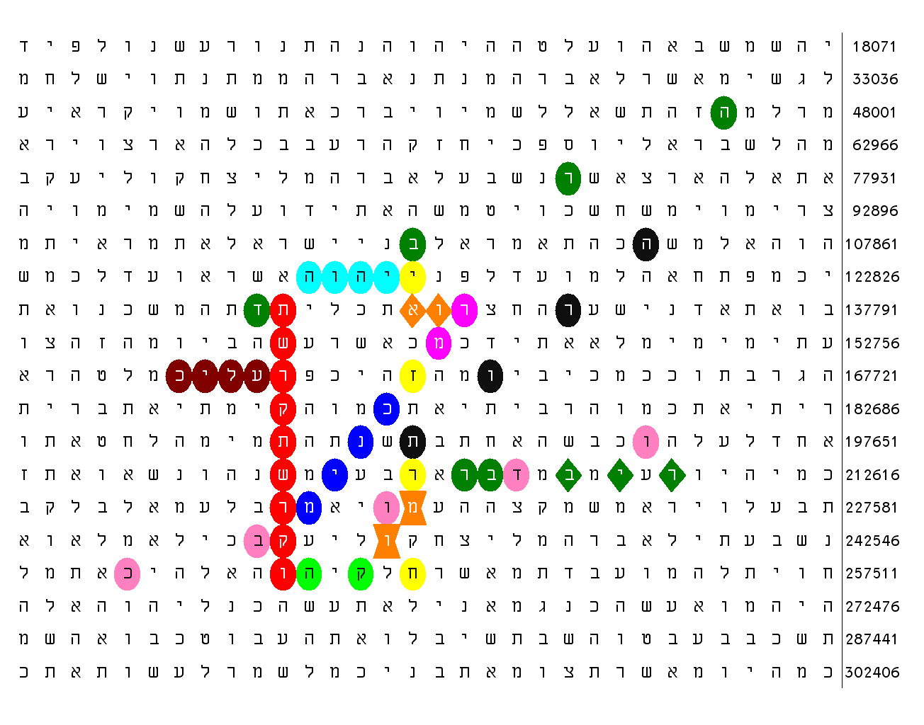
Figure 1
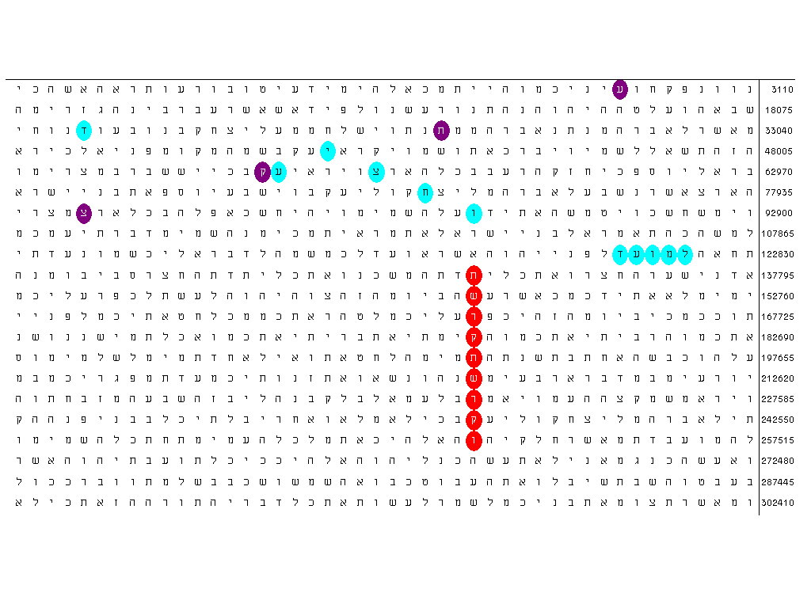
Figure 2
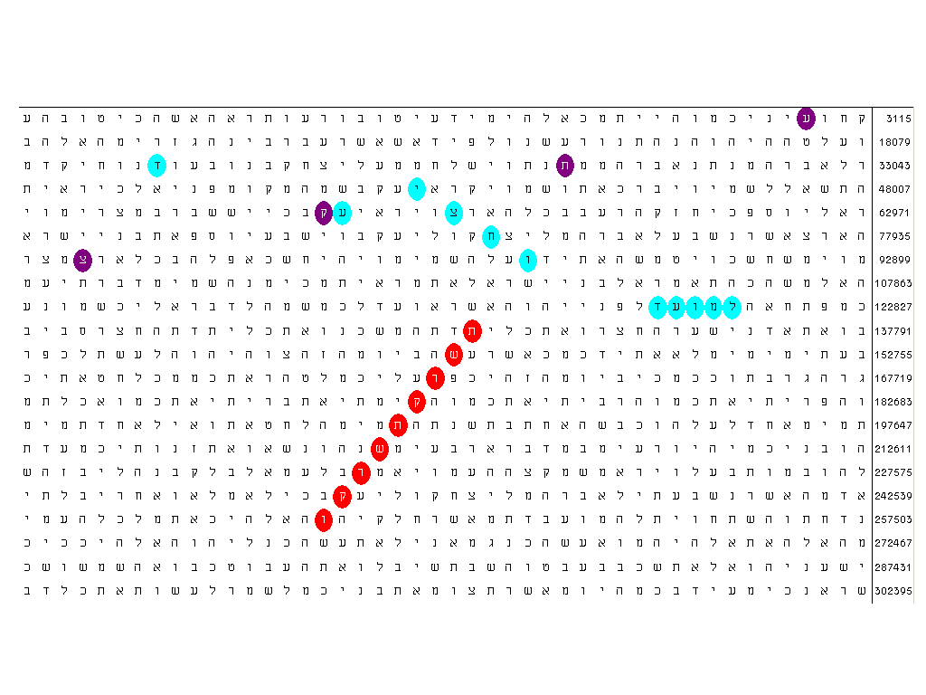
Figure 3
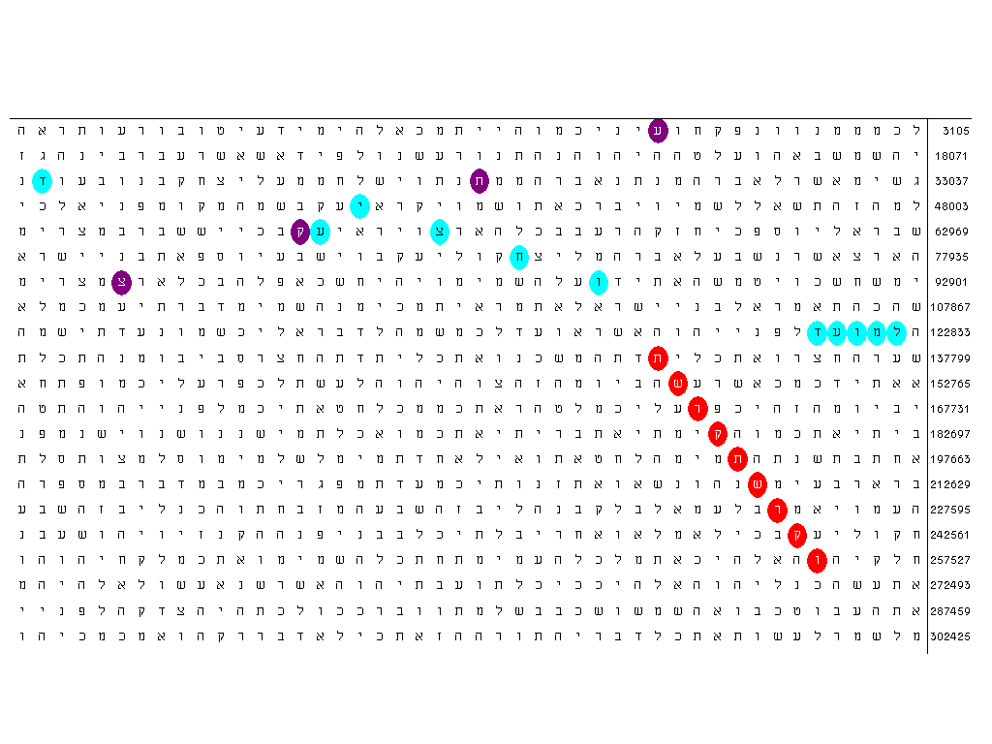
Figure 4

Figure 5. A fragment from a Greek vase. I wait for a permission from Faber and Faber to reproduce the picture. It can be seen in http://www.artefects.net/whitegoddess.html

Figure 6. Number of occurrences of the cardinal numbers 3 to 15.

Figure 7. Number of occurrences of the ordinal numbers 3 to 15.
Figure 8. Number of occurrences of cardinal + ordinal numbers 3 to 15 in the Torah and the rest of the Tanakh.

Figure 9. Logarithm of the sum of the occurrences of cardinal + ordinal numbers 3 to 15 outside the Torah in the Old Testament (the rest of the Tanakh).
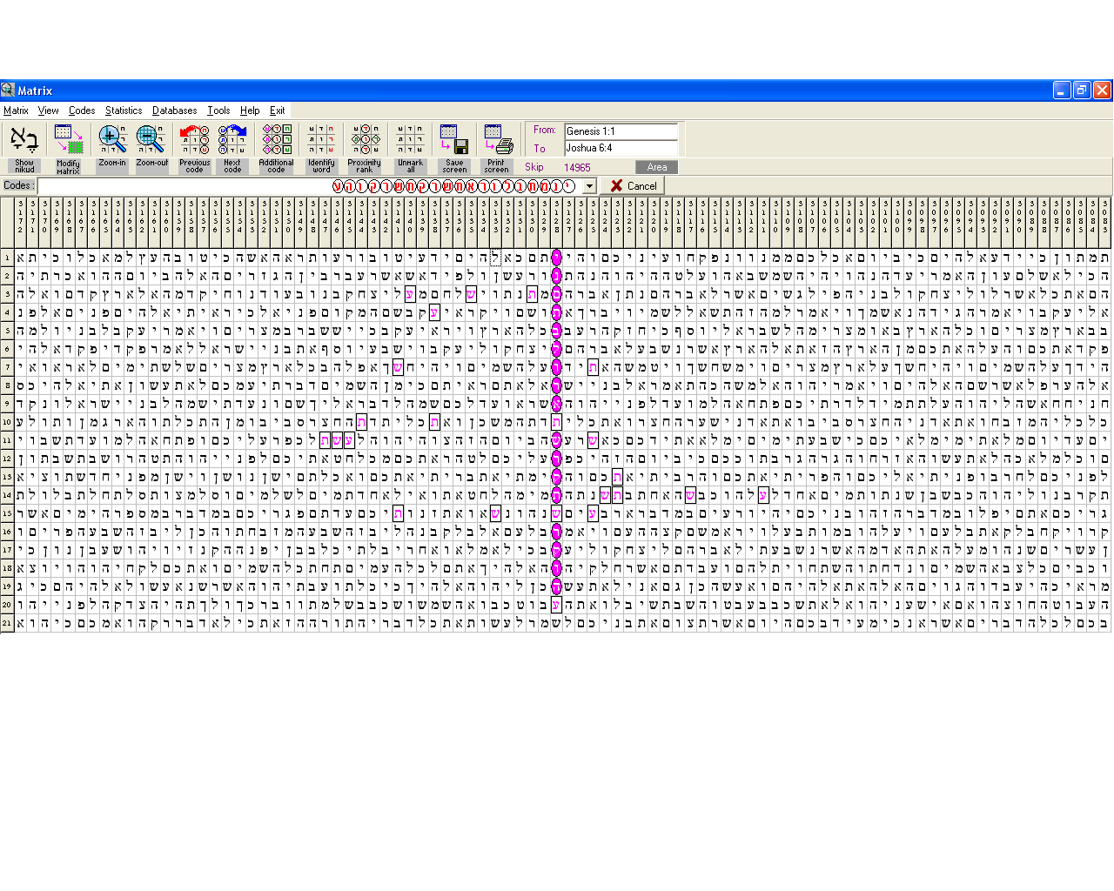
Figure 10
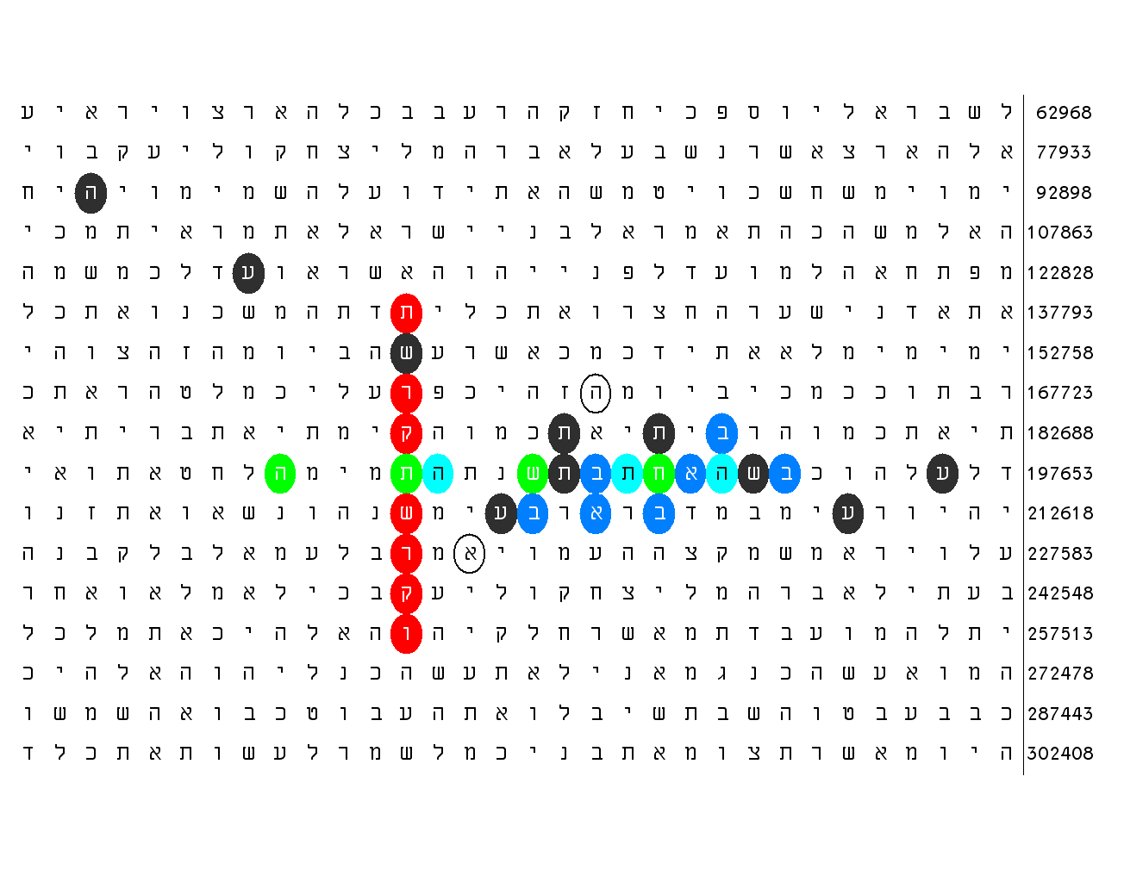
Figure 11
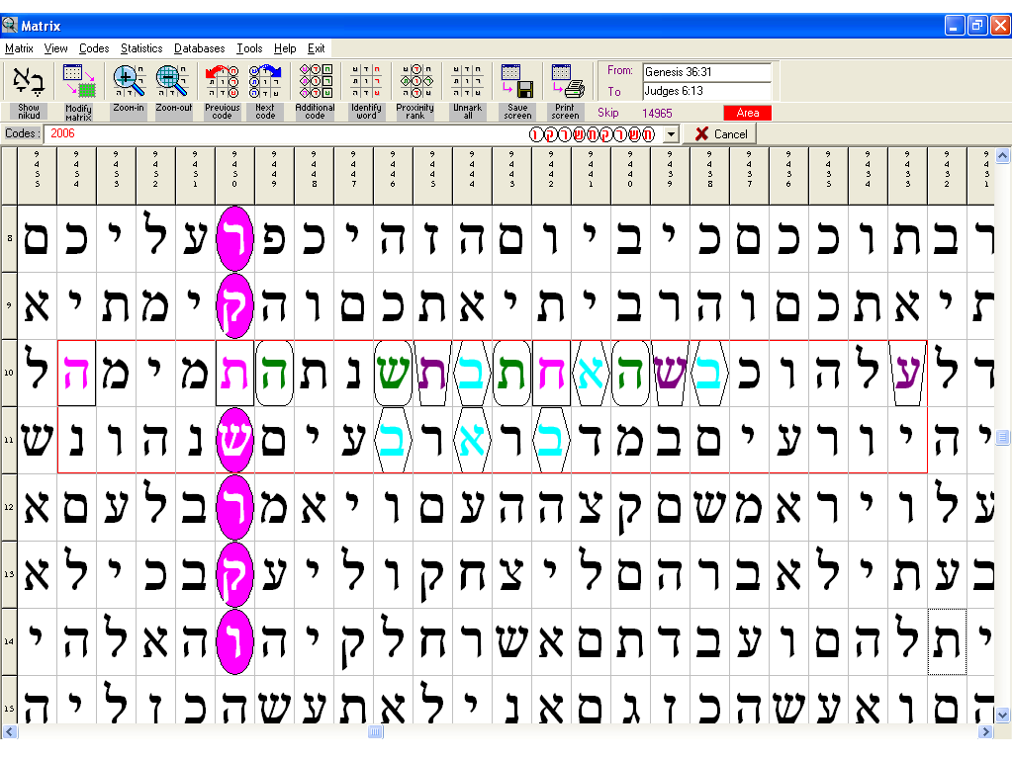
Figure 12
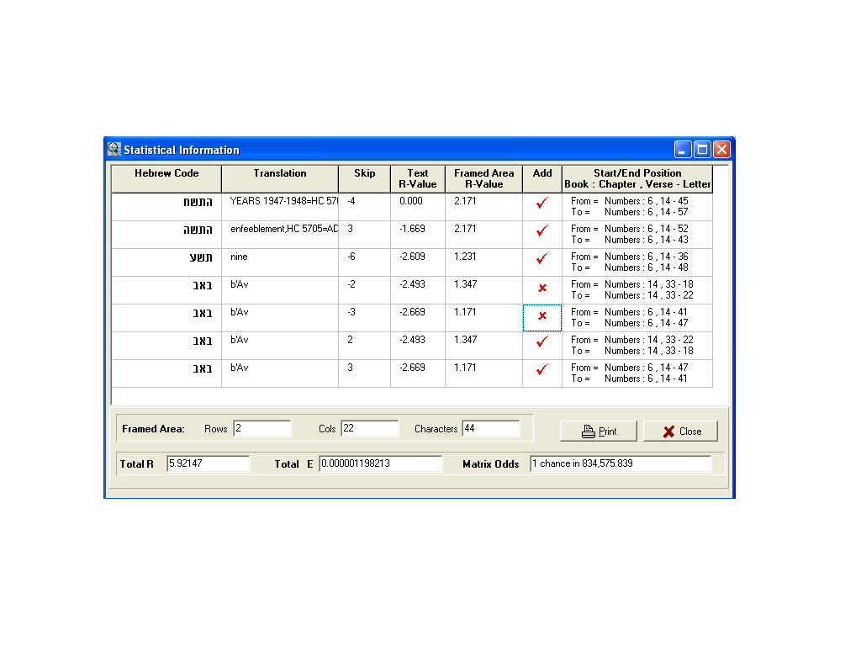
Figure 12a
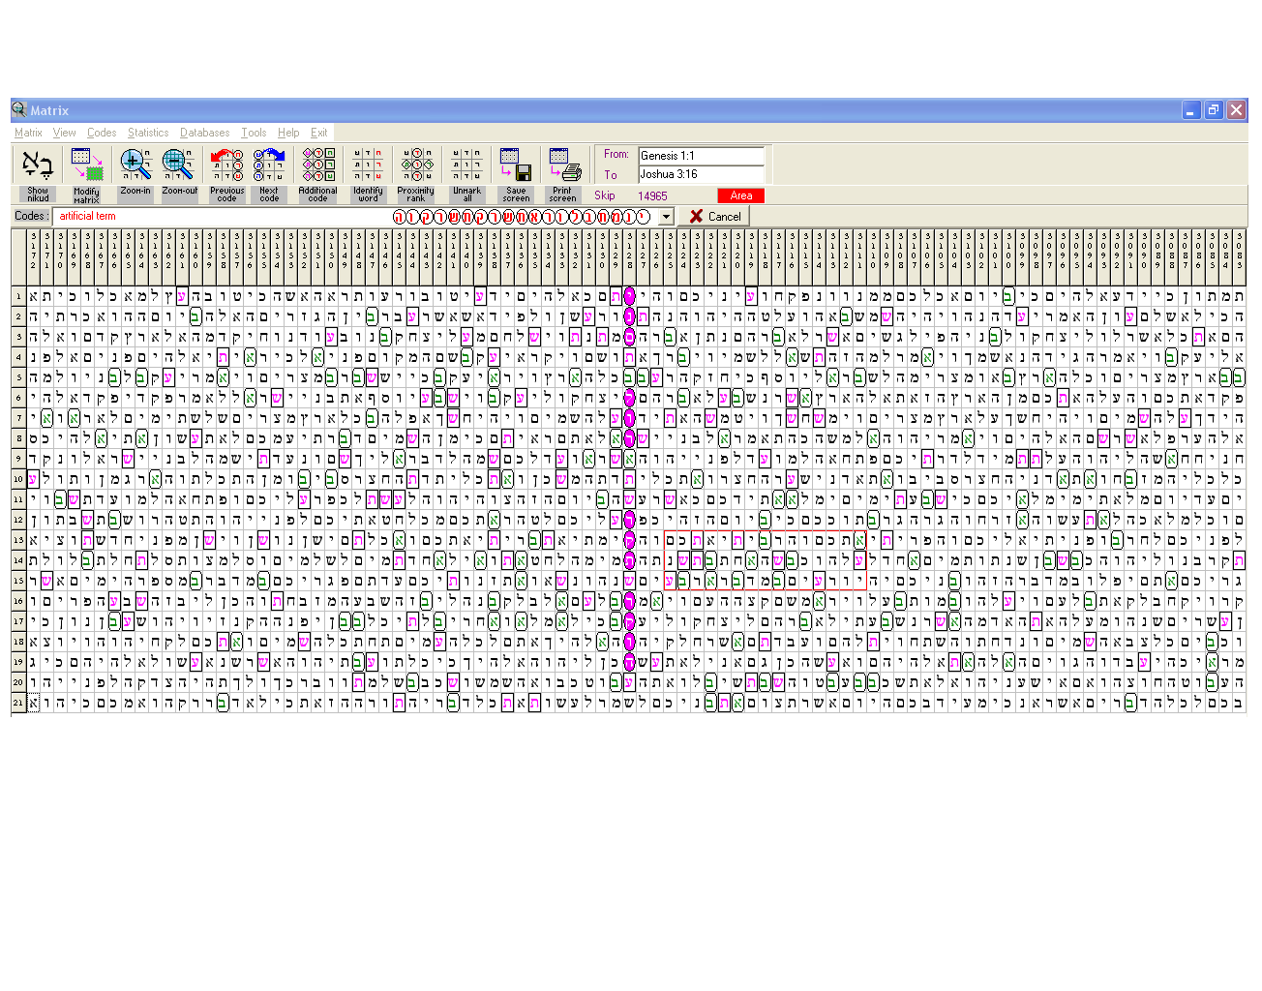
Figure 13
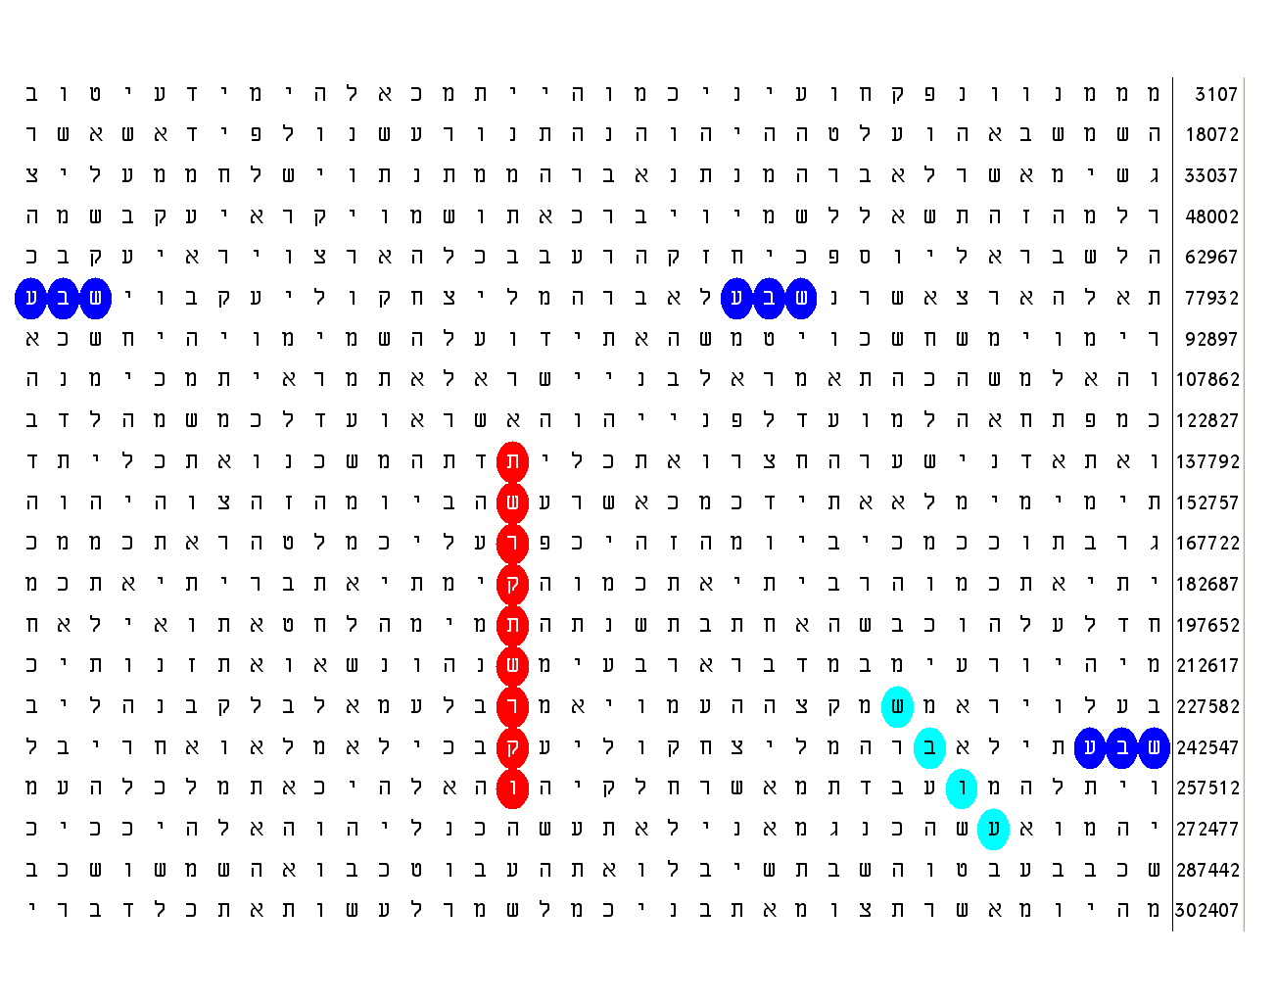
Figure 14
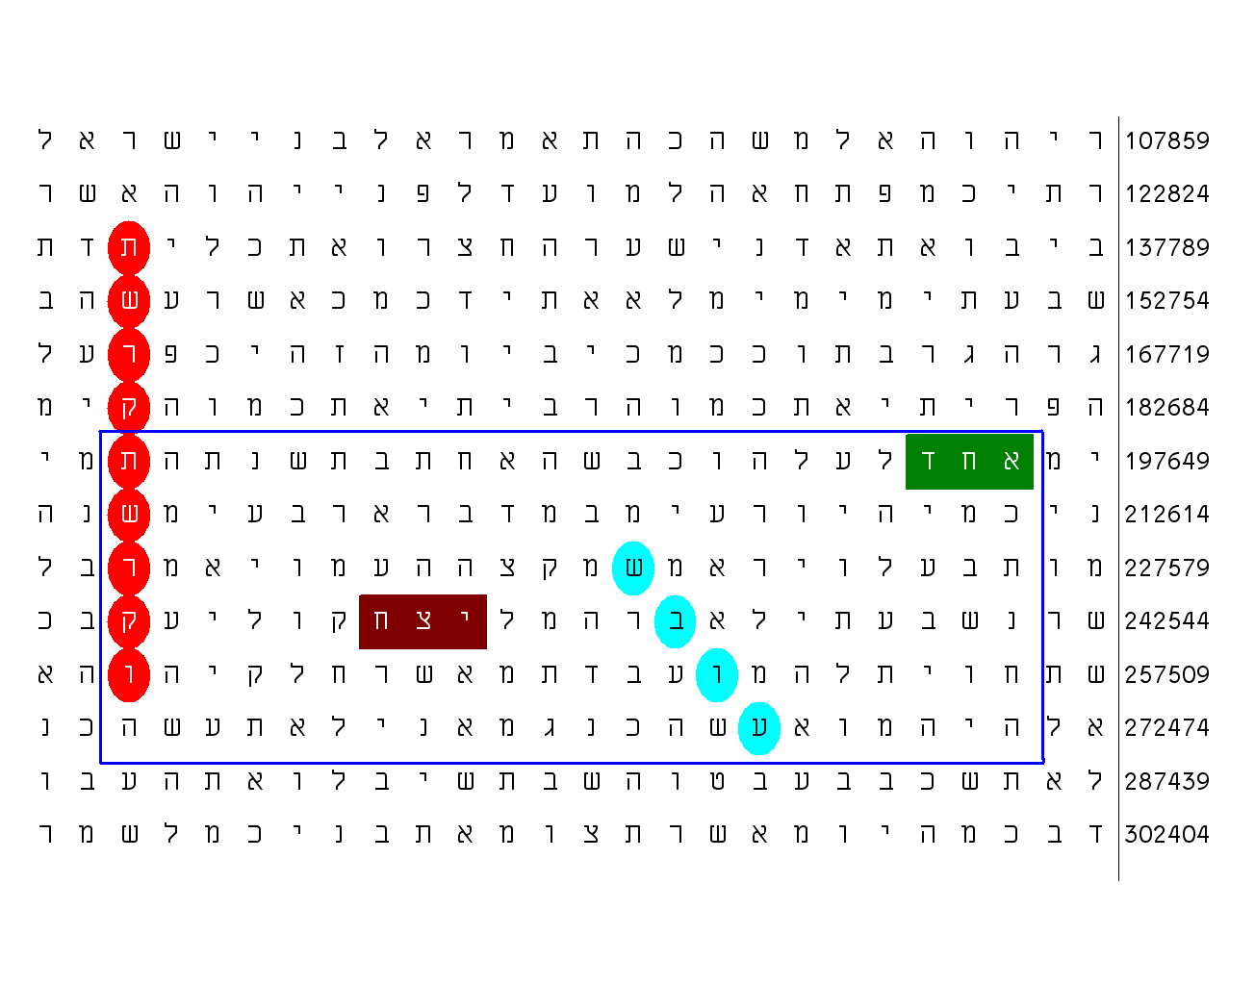
Figure 15

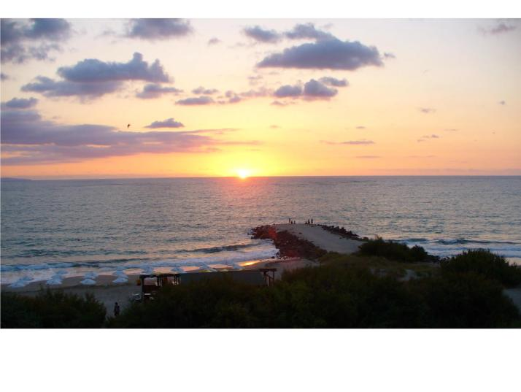
Sunrise over Black Sea viewed from the Bulgarian coast (about 42 35N 27 40E). At this time of the year (August 23rd), the moment of the event is very close (within 10 to 15 minutes) to the moment of sunrise in Jerusalem and the Mount of Sinai.

English Standard Version. In the NIV it is The Lord rises...
Such sequence of words at the same skip is very interesting from another point of view. Some authors [7] believe that it is impossible to be encoded a large amount of information in the Bible because of the randomness of the characteristic combinations of two (digram) and three (trigram) letters specific for Hebrew as well as for any other language. This is due to the so-called redundancy of our speech. It has been experimentally proved that in a scrambled bible text, the occurrence of any digram and trigram should be expected with equal frequency from skip of absolute value about 50 and above [7]. In this aspect, the Bible does not differ from any other text. In the ‘normal’ speech and texts, the occurrence of the digrams and trigrams is not random. Some of them appear more often – for instance, in English, the digram th appears much more often than, say, zf. This is because the former digram is a part of many frequently used short words such as the determinative particle the, also this, that, etc. On the other hand, however, just because these short words are frequently used, their presence could be implied. For instance, if the particle ‘the’ is dropped out from an English text and is just hinted at, the frequency of the occurrence of th in this text will decrease very much, making that text significantly different from a normal one regarding the rate of occurrence of the digram th. This fact makes me believe that the abundance of redundant particles that could be hinted at in the normal speech cannot be an argument for the principal impossibility of ‘compressing’ information as codes in a massif of letters, where the overall frequency of occurrence of digrams and trigrams does not differ from any scrambled text. The latter peculiarity is already imbedded in Hebrew. There, vowels are practically not used. In the beginning, they were to be ‘hinted at’. A system of signs (called Nikud) for indication of the vowels had been developed many years after the Torah was delivered to Israel. The fact is that a text in English requires generally about twice as many characters as the same text written in Hebrew.
There is an exception, however. It is believed that the spies sent by Moses to survey the Land returned and reported the bad news on this very day.
What is called ‘skip’ in this case is actually ‘distance’ in its geometrical meaning. It is a true skip only in the case of horizontal occurrence.

