Copyright © Lyuben Piperov January 2005
The Writing on the Wall and AD 2006: A Lateral Approach to Code-Breaking
Lyuben Piperov
Introduction
In the end of June, I sent to several Internet page operators dealing with the subject, for commentary and discussion, a study on a strange code [1, 2]. I called it ‘strange’ because I have used an approach that differs from the standard usage of Hebrew letters for denomination of years. I looked for AD 2000 using a way of writing out of the number 2000 that combined the Hebrew (in terms of numeric values) and the Roman (absence of the letter denoting current millennium) standards. Thus expressed, 2000 is an 8-letter string. It appears only once in the Torah, with a positive skip. Much to my surprise, however, the letter following the string denoted, as a 9-letter sequence already, the number 2006. I managed to find some items with a very high overall significance. The crucial three items, which formed a true key to the code, were the words “for a time, times and a half” (Dan. 12:7; turquoise ovals in Fig. 1), except for the two letters yod (י) and mem (מ) that denote the plural for times. All these were present, distinctive, in the matrix. (In order to facilitate the reference, I have slightly rearranged and reproduced the matrix in this study as Figure 1.) But there is an additional item in Figure 1 here: the name Jesus in its contemporary Hebrew 4-letter spelling, ישוע, at skip 2 (purple ovals). It is off the left border of the original matrix. I have missed it in my previous study.
Although by no means it diminished the significance of the Jewish nation (Israel is present in a central place in the matrix), the code as a whole proved to be basically oriented to the Gentiles. Therefore, I haven’t ceased since to contemplate on it, recurring to the matrices every now and then. I do not like to play the prophet, so pointed out that a 3-letter word equivalent to Bush in Hebrew spelling has a dual meaning and could denote something else, which was in tune with the other items. But the US presidential elections are over and Mr. George W. Bush was re-elected for a second mandate. This is not a decisive corroboration of the presence of his name in the matrix, but makes it more plausible. At first, I was not absolutely certain that the code includes AD 2006 and assumed that it may end, say, in AD 2000. The US election results, however, inspired me to proceed with looking for more evidence that the code relates to timing.
As I wrote previously, the Book of Daniel is one of my favourite Old Testament books because it corresponds most closely to the Book of Revelation in the New Testament. And we know that the Revelation is related generally to the End Times. One specific characteristic of the end times that is present in both books is the termination of the kingdom of Man and its replacement with the Kingdom of God. And there is a typical example of destruction of an empire that is a historic truth documented in Daniel chapter 5. This historic event was the fall of Babylon. Therefore, if AD 2006 is to be a crucial period of human history, it should correspond somehow to the termination of the Babylonian empire. Chapter 5 is an account of this, probably most significant in its fatality, night in the history. There are few more accounts of this event in the works of Greek historians Xenophon and Herodotus. None of them mentions a prophetic sign in a written form, given immediately before the event. It is found in Daniel alone: the writing on the wall.
The Shortest-Term Major Prophecy in the Bible
The writing on the wall is extraordinary both as execution (invisibility of the person: just fingers of a man’s hand were seen while writing on a wall of a candles’ or torches’ lit great hall in a king’s palace) and mysteriousness of its meaning. And it couldn’t be otherwise. This writing was so flabbergasting to all the wise men of Babylon that they could not read the writing, nor make known to the king the interpretation thereof (v. 8). It was so impressive feat that has been immortalized in numerous pictures drawn or painted by artists ever since.
The episode with the description of the situation in the king’s palace in the last night of the Babylonian empire is in the portion of the Book of Daniel that was written in Aramaic. It consists of three words but the first one is repeated twice: The words are also Aramaic, being close in spelling to corresponding Hebrew words. Daniel himself had to spell out the strange words. He gave a separate explanation of each word. We will discuss his interpretations in the course of our study.
So, having found another widely discussed and interpreted verse, I was absolutely convinced that the writing on the wall must be there, in the matrix. All the more that it has already proved to be of great importance in the real history as an “end-date” portent.
The writing on the wall, Mene Mene Tekel Upharsin, is a well-known text. In the Hebrew Bible (but written in Aramaic!) it runs as follows:
ופרסין תקל מנא מנא
Daniel the prophet was the first one both to read and interpret it. Since then, many scholars tried to interpret these fifteen letters. Nowadays, one can find scores of meanings suggested by enthusiastic authors. Most of the readings proposed are eccentric and it is usually difficult to follow the authors’ sophisticated reasoning.
Although most of the prophecies in the Bible have dual meanings, sometimes being even ambiguous, there is always a key implication, which is clear from the historical background at the times of release and fulfillment and from the object of implementation. Therefore, the interpretation of Daniel should be the authentic primary acceptation. And what Daniel told to Belshazzar the king implied that these words denote measures of weights and division.
Double meaning can be discerned in all three words. Mene (מנא) means to measure. In the writing on the wall, it is given in its Aramaic spelling. The Hebrew spelling differs in the third letter: it has he (ה) instead of aleph (א). This interpretation is reasonable because Daniel himself refers to mene as numbered (v. 26). Some authors reasonably believe that mene is also the Babylonian coin mina. It contained probably 50 tekels (that is, shekels in Hebrew), though some authors mention 60 tekels. Tekel (תקל) is a smaller coin in value, probably equivalent in weight to the shekel (שקל). Here, again, there is one letter that makes the Aramaic spelling differ from the Hebrew. Tekel also means weighed. The meaning of the third word, upharsin, will be discussed later.
We have established in [1] that, in a way, the letters of the prophecy about the time, times and a half, could be handled as weights equalizing a balance. Moreover, the Hebrew word standing for ‘time’, moed (מועד), has been used mostly to denote ‘congregation’. The remarkable fact is that in the handwriting on the wall, units of weight have been used once more to represent ‘time’ (the days of a kingdom numbered). This detail convinced me that the writing on the wall should be present somehow in the matrix with AD 2006.
Mene, Mene, Tekel...
I started looking for all the words in the handwriting in the ordinary way – searching for any ELS of all 15 letters. As is to be expected, they do not appear at all in the Torah. So I had the options to include the book(s) following the Torah in the research or to reduce the number of letters. I whole-heartedly rely on the Power of God and firmly believe that His Wisdom is hidden in the Torah so I chose the second alternative. The first reasonable step was to cut out the 6-letter upharsin. This step seemed reasonable to me because the writing consists of three clearly distinguishable parts. This is confirmed by Daniels’s own interpretation. Even if it was written as a continuous string or any other ciphered manner, the prophet considered it in three steps.
But even so, the 9-letter string mene, mene, tekel does not occur in the Torah. On the other hand, the 6-letter mene mene (מנאמנא) appeared as many as 2,208 times. The lowest skip appared to be negative: -10. The lowest positive skip is 20. I tried with these skips and all skips up to 100 (8 skips altogether) as well as with skips that are close to any number multiple to the matrix ELS: 14,965 but failed to obtain a siginificant, satisfying result.
So the only way to obtain something sensible was to look for a specific pattern of appearance – figure(s) shaped in special manner(s) within the matrix. But tekel is a 3-letter word, for which there is a normal prospect to occur quite a number of times even in a relatively small matrix. I checked for upharsin alone, which occurs 57 times but there was no occasion that fits even the loosest matrix requirements. I had to give up.
I had either to reject the ‘hypothesis’ or to blame my own self for not searching properly. I decided that it is I who is wrong. I felt that the handwriting must be there but I hadn’t followed the right path. The example with Jesus was a good lesson to me how easily an item could be overlooked even at a very low skip. I was debating in my mind where is my fault when, suddenly, an idea dawned on me. I imagined the letters of the first term as the mortise and tenon used by carpenters when dovetailing furniture or the left and right hand’s fingers in clasped hands. Indeed, because the short word is repeated twice, instead of writing the words in a sequence, they could be written in alternate order of each corresponding letter. Thus, the central dogma of the Bible code, ELS (Equidistant Letter Sequence), will be adhered to! In other words, instead of searching for
מנאמנא
we will look for
ממננאא
Due to the new symmetry, the words will ‘go together’ to the same extent as when written in a sequence: the skip between any two blue letters is equal to the skip between the red letters and all 6 letters will be like the cogged ends of the adjoining boards of a drawer. The only difference is that the skip between the letters within a word will be twice as large as the skip in the ‘normal’ arrangement but the interdependence between the letters will be kept.
I believed that my speculation was reasonable. I managed to find AD 2006 encoded in the Torah through an appropriate modification of its expression in Hebrew but by no means violation of the established rules. And there, in a less than 40×21 matrix, was ‘waiting’ one of the most mysterious long-term prophecies in the Old Testament. It was logical to expect that the other prophecy consisting of few letters, famous and not less mysterious but even more discussed throughout the ages, is present in a certain form thereabout. It is more concrete in the details of its fulfillment and is typically connected to Babylon. And we know that in the Book of Revelation, the Latter Days’ world is likened to the falling Babylon...
The overall number of occurrences of the rearranged string of letters appeared to be practically the same: 2,238. To my astonishment, the lowest ELS, 7, proved to be very close to the date 2,006 (תשרקתשרקו), to the right of it, and forming a reasonable matrix. Having such a find in hand I had nothing else to do but to start looking for tekel (תקל) accordingly. By ‘accordingly’ I mean searching the same line of the text for tekel further to the left but as close by as possible, at a positive skip of approximately same value. For this purpose, I checked the first tav (ת) to the left after the last aleph. Curiously, it appeared exactly 7 places away. Then I looked for the first qof (ק) to the left of this tav and checked whether it forms tekel with a lamed (ל). And it did – at skip 12! See Figure 2. The whole text already intersects the stem.
So I had no doubt that the writing on the wall is encoded pointing to AD 2006 as a crucial period of time. Next I had to discover the third term of the handwriting: upharsin. At this point, I must let the reader know that the reasoning henceforth is based on my personal belief that Jesus of Nazareth is THE Messiah. However, due to my insufficient knowledge of Hebrew I may have missed a better solution. Also, I may have aroused suspicions of being biased. Therefore, I would highly appreciate any other opinion on the third part of the handwriting.
A Hunt for a Term
At this stage, the only absolutely clear thing to me was the fact that the third term cannot appear practically in its original form, upharsin (ופרסין). The lowest skip of upharsin in the Torah is -215. So, even if it covered the line with the first two terms, the whole matrix would extend to over 1,000 columns. Then I decided to try with the word used by Daniel in the interpretation: peres (פרס). I checked it for skips up to ±20. The number of occurrences was 95. I examined the distribution. The item was spread approximately uniformly along the text. Curiously enough, one of the relatively big leaps – over 10,000 places - was over a part of the text where, near its middle, was the line in our matrix! Then I tried at skips up to ±30. Out of 131 occurrences, the nearest peres, at skip 29, was some 2,000 places away from the items in our matrix. Looking for peres in another line or as a vertical occurrence seemed to me useless. It hardly could be obtained a significant intersection with such a vast number of occurrences. I felt as if the experiment was telling me: ‘No, the answer is not here. Try something else!’
I had to pause and weigh up the found. Everything in the matrix was interlinked. Hence, the directions for the search for the third term should be hidden in the items already revealed. As a rule, we always start from the simplest and move towards the more complicated. The first and evident fact is that the number of letters in mene mene tekel (blue and green ovals) matches that of 2006 (red ovals): 9. Was this a validation that one of the critical years of the kingdom of men is encoded with 9 Hebrew letters? Both mene and tekel refer to measuring and numbering. May be the key has something to do with numbers?
I reflected on the Book of Revelation. There, John refers to the Latter Days’ world as Babylon the Great. So what is the link between the ancient and the modern Babylon in terms of numbers? The sexagesimal number system! This is a number system of base 60. Its origins are in ancient Mesopotamia and it survived up to our own times. Although we use the decimal system almost everywhere (computers use their own, binary, system of 0’s and 1’s), we still have 60 seconds in a minute, 60 minutes in an hour and 360 degrees – 6 times 60 - in a circle. Probably the latter number is defined as the number that is closest to the number of the days in a year (the exact number is about 365.28 days) and is practicable for calculations. This practicality is due to the fact that 60, and hence 360, is a number that is divisible by many integers: 2, 3, 4, 5, 6, 10, 12, 15, 20, and 30. 360 is divisible also by 40, 45, 60, 90, 120, and 180. We should keep in mind that a prophetic year both in the Old and the New Testament interpretations is agreed by most scholars to consist of 360 days.
I counted the number of columns starting with the first mem and ending with the qof in the stem. It turned out to be 60. The only other calculation coming up to my mind was the multiplication of 60 by 9 – the number discussed above. 60×9 = 540. I didn’t notice then anything significant in the latter number. Not yet.
I was surprised by the fact that the tav ‘continued’ the double mene at the same skip: 7. I checked the newly formed string ממננאאת. It appears exactly 100 times in the Torah. Is it just another hint that numbers will play a crucial role in the code-breaking? And is it also a hint that the number of occurrences will matter? There was an even more surprising fact. There are only 3 occurrences of this letter sequence in the Torah at skips up to ±1,000. The next-to-the-lowest skip was found to be negative: -104. None of them forms the combination shown in Figure 2 at practical ELS-s in the respective direction – I have checked the skips up to over 100. So we may conclude that there is a very low probability that this commensurable tekel ‘extension’ of the double mene ELS appears by chance. Most probably they go together as a code. Also, there is a תקל encoded with a skip multiple of the ‘basic’ matrix ELS 14,965 (44,895) that intersects at the qof with the tekel just found and forming a symmetrical design unnoticed during my earlier research (blue squares, see Figure 3). This fact reinforces, in my opinion, the impression that we are on the right way.
But if it is a code, then the third term should be somewhere nearby. In order to keeping the proportion, it should be at a rather low skip. Also, the terms disclosed so far require a positive ELS. But what criterion of search is to be established? In the writing itself, it had a dual meaning referring both to the Persians and to division. But we know that in the Latter Days the kingdom of men will be destroyed and the Kingdom of God will be established instead. So, definitely, the kingdom will not be given to Persians! Therefore, it is useless even to try to find the third word as it was written on the wall. What is more, it must not be there! And it is not. On the other hand, historically, the division did not appear to be the typical event befalling Babylonian empire. It has been its destruction. Babylon just disappeared as a political power in this fatal night. If there has been a division, it would be rather the division between its vanished political might and the spiritual influence that we still feel nowadays.
There is something peculiar with this third term. While the first two terms were repeated literally by Daniel in his explanation, the last one was not repeated. It was not repeated at all in the form written on the wall. This term would have been found so strange by the translators of the NIV that they do not mention it in its primary form, upharsin, but as parsin even in the famous verse. The original word is given in a footnote and it is explained that the term is Aramaic (but the other two terms are also Aramaic!) and stands for and parsin. Even more, it is stated in the same footnote that peres can mean, apart from ‘Persia’ or ‘divided’, ‘half mina’ or ‘half shekel’. A comparison with “for a time, times and a half” (underlined by me) predisposes one’s mind to the idea that these two prophecies are linked.
So I decided that the word upharsin, as such, cannot be used as means for the code-breaking but probably there is a key in the primary writing that could be a sign of a hidden word. I tried to find a significant term starting with letters few places after the lamed in tekel. After having made several attempts, without a result, suddenly my attention was attracted by the conjunction ‘and’. Indeed, both in Hebrew and Aramaic, this conjunction is a single letter, vav, attached to the first letter of the corresponding word. It is never used alone. My intention was to start from a vav used as a conjunction and check for significant term(s) at low positive skips. I expected that the first vav used as a conjunction will be attached to an insignificant word. I checked for the first vav in the plain text following the lamed. There was one, just 2 places to the left but it was not used as a conjunction. The second vav, however, appeared to be a conjunction... Together with the word immediately following the vav, it read
... and Joshua
The son of Nun. In the Hebrew text, ‘and Joshua’ is written as a single word (ויהושע). I stared at it completely surprised, not believing my eyes! I hadn’t expected it. Was the hunted for word ‘hidden’ in the plain text? Then I realized that it would be matching to the full extent the power of God. Indeed, some words of dubious significance may be constructed at low skips, especially short words consisting of frequently appearing letters. Then the matrix would probably extend further to the left. Such findings will be disputed because of their ambiguity, uncertainty and vagueness. But it requires God’s own skills to fix a name in this way in a code! Joshua is the Old Testament name for Jesus. And we know from the New Testament that the Kingdom will be given to Jesus. Notice that Darius the Mede received (‘took over’ in NIV) the kingdom as per Daniel 5:31. There is also an interesting link between ‘and Joshua’ (עשוהיו) and ‘upharsin’ (ןיסרפו). Both words consist of the same number of letters: six!
Thus everything fits in its right place (see Figure 4). But such interpretation may raise suspicions of the ‘too good to be true’ or ‘too easy to be an achievement’ type. Frankly, to a certain extent, I would agree with such critics. At first glance, the latter term may seem fabricated. In my opinion, the fact that it is in the plain text rather points to the opposite. However, I felt some weakness in such ready-made assertion. Therefore, we must examine the authenticity applying unambiguous criteria. Having exhausted all linguistic arguments, let us turn to history and mathematics.
The basic education of the Western people includes knowledge in mathematics that has developed since the 6th century BC. This knowledge has been enriched during this period of 26 centuries. It is widely accepted that the ancient Greeks are those who have laid the foundations of geometry. This belief is long-established due to the works of Euclid – one of the best mathematicians ever born. He lived in the 3rd century BC and left a masterpiece that hasn’t lost its importance even in our modern times. He established the basic rules for reasoning and criteria of proof that bear his name: Euclidian geometry. But even though Euclid had his own achievements and a significant contribution, he had based his work primarily on earlier models.
Almost all researchers in the field of the history of mathematics agree that the roots of our concepts sprang from the ancient Babylon. Although it was the Greeks that created what is Western mathematics today, they borrowed fundamental notions from Babylon. And it was one man that did most of the job: Pythagoras.
Pythagoras lived about 250 years before Euclid, in the 6th century BC. He is famous with the founding of a school where the disciples believed that everything in the universe is expressed through numbers. The later Greek mathematics was linked closer to geometry. Geometry was not unfamiliar to Pythagoras, however. A well-known theorem in geometry bears his name. But it is not the Pythagoras’ theorem that has great importance for our study. Interestingly, there is evidence that the Babylonians knew and used it. But what is even more interesting is that there is a sound grounds to assume that Pythagoras himself has learned it from them!
Babylon: the Cradle of Mathematics
Professional historians are rarely believers. And Bible scholars rarely show interest in mathematics. The historians claim that the Bible is a compilation of fables and therefore cannot be a reliable source. The Bible scholars restrict themselves to basic calculations in their research because they regard higher mathematics as a pagan instrument and all devices created by man, including the computer, as satanic inventions. This funny ‘complementarity’ helped for the significance of a scarcely known detail of Pythagoras’ life to remain underestimated. It is even unknown to the lay public: Pythagoras has been taken captive to Babylon! This happened in 525 BC, when Cambyses, the king of Persia, conquered Egypt and most probably Pythagoras was taken to Babylon together with the Egyptian priesthood. Probably he had been treated as what is equivalent to a ‘brain’ of our modern times. Before that, Pythagoras had been for up to 22 years in Egypt, where he obtained a religious order and had the opportunity to study the Egyptian accomplishments in mathematics. Now he was able to compare the achievements of another school in the same field.
But what impressed me most in this account was the date. Both religious and secular historians agree that Babylon fell to the Mede-Persians in October 539 BC. The fatal night can be said with a good reliability to be 11th or 12th October. Cyrus, the king whose name God told Isaiah 200 years before (referred to also as ‘Anointed One’ in Isa. 45:1-5), entered the city on 30th October. We will return later to a special feature of the invasion that may have some relation to our times.
Daniel the prophet was there, in the palace that night. The Bible account continues with events from his life that happened years after that night. It is not stated in the Bible how many years Daniel has lived after the fatal event. Most scholars believe that he died shortly after the fall of Babylon. Their beliefs are based on the fact that he was very old and therefore shouldn’t have lived for more than another few years. Be that as it may, Pythagoras appeared in Babylon 15 years after these events at the most. He must have met live witnesses of the vain attempts of interpretation of the writing and the interpretation of Daniel. Surely he has been given full account of this important event. Antipho, mentioned by Diogenes Laertis, says that Pythagoras ‘has associated with Chaldeans and Magi’ [3].
The possibility that Pythagoras has met witnesses of where and when the writing on the wall appeared and maybe even the aged Daniel personally provoked my mind. Although very old, Daniel, if live, would have been in his nineties in 525 BC. The idea that Pythagoras has met Daniel face-to-face excited me to the highest degree. What did Daniel tell Pythagoras? Did he tell him about the writing on the wall? Did he tell him what method had been used and how he managed to solve the problem? Was it a mathematical method that had been used for the solution; if so, was this method an innovation and, finally, what impact eventually has this method exerted on the development of Western mathematics up to our own times.
To answer this question, we must examine what Pythagoras has brought from Babylon that had been unknown to the Egyptians.
The “Divine” Number
Egyptian mathematics was restricted basically to solutions of practical, geometric problems [4]. On the other hand, the cuneiform tablets discovered and read in the last 200 years provide the evidence that Babylonian mathematics dealt with much deeper notions concerning numbers. We can reliably assume that Pythagoras may have been taught in geometry by the Egyptian priests. Among that what he has borrowed from Babylon, however, if any, was definitely the best knowledge available about numbers.
Pythagoras was regarded as a semi-divine, mystical person by his Greek contemporaries and followers. A strange statement of his is that ‘there is nothing in the world that is genuinely new: everything repeats itself in regular intervals‘ (emphasis is mine) (quoted from Porphyrius, Vita Pythagorae 18 in [5]). I cannot help relating this idea to the ELS of the Bible code. Talking about codes, we must mention the fact that he invented a system of communication so that ‘mathematicians’ – from the Greek ‘mathema’: knowledge - could talk together without being understood by those that are not in the secret.
But what is most important, Pythagoras introduced the notion that numbers exist as objects and that everything in the universe, both material and spiritual, could be described with numbers. He has demonstrated this idea first in music, with the ratios of the lengths of vibrating strings producing different tones. This idea appeared to be so profound that its echo could be perceived in modern physics. Pythagoreans believed that even the tiniest particles in the whole cosmos are interlinked through the laws of harmony represented by numbers. Generally, they would assert in modern terms, we can say about the physical objects that individual lengths of vibrating entities yield octaves. Undoubtedly, more yield derivations emerge as ratios… Mathematics expresses laws of deep yet achievable by the human mind natures. Melody, the individual characteristic and thus the quintessence of music, is not only an expression of the harmony describable by numbers. It can cure body and soul [5].
On the basis of this, we can assume that Pythagoras brought to the Aegean world a new understanding of the nature of the numbers. And this notion was so novel and at the same time so well defined that it must have been borrowed from a civilization that has had the potential as time and space to develop it. Egypt having been ruled out, the only civilization that matches the requirement is Babylon. At this point we may ask the next question: Is there a particular number that is characteristic for the whole civilization? And, if yes, what it is likely to be?
Babylonians were successors to even more ancient civilizations. The origin can be traced back to the Sumerians, whose civilization flourished about 3,000 BC, that is, immediately after the Flood. Interestingly, the sexagesimal number system can also be traced back to the Sumerians. And there is something else that has its roots in their civilization that reached our times through the Babylonians: astrology.
Although sun and moon as well as the other planets visible by naked eye are well documented as objects of worship, one of them is prominent as specifically Chaldean: Venus. This planet was an object of very deep religious respect. The English word ‘veneration’ (from Latin venerare adore, revere; compare also to Venereus = of Venus) is a distant echo of this heritage and reflects the influence of the Babylonian civilization on the Western culture. And what is most characteristic for Venus from astronomical point of view is its appearance at regular intervals in certain points in the celestial sphere. There are five such points that Venus visit every eight years with an accuracy of a fraction of a day! If we connect these points the result will be a pentagram. The pentagram is a figure inscribed in a regular pentagon (Figure 5). Both pentagram and pentagon were widely used symbols as signs of protection, the latter being the shape of choice for the design of fortresses.
Pythagoras definitely has brought these geometric figures, which became signs of his secret society, the Pythagoreans. But Pythagoras or his disciples were the first to understand the nature of the irrational numbers. And there is historical evidence that this understanding came through a specific relation between the sides and diagonals of a regular pentagon. This relation is expressed as a number, which value is 1.6180339887….. This number is called the Golden Ratio and can be illustrated on a line cut in such way that the ratio of the length of the longer segment to that of the shorter one is the same as the length of the line to the length of the longer segment:

A C B
The Golden Ratio is
BC/AC = AB/BC = 1.6180339887…..
The story of the Golden Ratio is described vividly by Prof. Mario Livio in his recent book [6], which I recommend to those readers who would like to consider the subject on a higher level. Therefore we will not discuss it here. The Golden Ratio amazed every mathematician that explored it. It appeared as a result in various problems famous for their beauty both in geometry and algebra. The Golden Ratio is so much peculiar in many aspects, so elusive for understanding and so deep in meaning that, engrossed by its fascinating properties, the mathematician Clifford A. Pickover suggested that in a specific rectangle a point that is defined by the Golden Ratio to be referred to as “The Eye of God”.
Golden Ratio Everywhere
We have made this discourse just to arrive to the number that is the most suitable to be checked as a key to the code-breaking. If the key is just a number, it hardly could be found a better candidate.
I prepared a matrix containing all three items. What I recognized at first glance was the striking similarity of the line containing them to the drawing shown above. Indeed, if we place the column containing the date to cut the line, the lengths of the segments to the right and to the left of it contain 60 and 37 columns (that is, unit lengths) respectively! See Figure 6.
Calculations yield 60/37 = 1.621621... and
97/60 = 1.616666....
The latter value differs with less than 0.1 % from the Golden Ratio. Moreover, 37, 60 and 97 form a series that fits the best a series of numbers containing 60, where the ratio of the last member to the next-to the last one approaches the Golden Ratio. This series is formed in the following way: choose any two numbers and add them. The sum is the third number of the series. Proceed in the same way taking the second and the third number to get the fourth member of the series, and so on. The series in which the first two numbers are two units is called Fibonacci numbers after a medieval Italian mathematician (see the Appendix).
Then I suddenly realized the link with the pentagon. The number that was the result of the multiplication of 60 with the number of the letters mene mene tekel, which is also the number of the letters of the number 2006, i.e. 9, is 60×9 = 540. But 540 is the sum of the interior angles, in degrees, of a regular pentagon.
Then I noticed that the number of the letters in 2006, 9, the number of the letters in the writing of the wall, 15, and their sum, 24, can be reduced to members of the Fibonacci sequence (red)
15/9 = 5/3 = 1.66666...
and
24/15 = 8/5 = 1.6
3, 5 and 8 are successive Fibonacci numbers and therefore their ratio is close to the Golden Ratio. The latter ratio differs with about 1.1 % but the fact that these numbers belong to this sequence could be suggestive for further exploration.
Meanwhile, I noticed that the number of columns of the left section, 37, which ends with the name of Joshua, multiplied by the sum found above, 24, yields 888. 888 is the number of Jesus Christ according to the Greek numerology. We just mention this fact. The subject itself is outside the scope of our study.
Having come so far, we should look for more places where the Golden Ratio is hidden. It surely is to be found somewhere else. The most disputable term at this point certainly is Joshua. So let us check whether the Golden Ratio has something to do with this name. Evidently, no other parameters or values are to be monitored except number(s) of appearance. The decisive characteristic that we required beforehand was that the term should be used with the conjunction ‘and’. And we examine the name in the plain text only. So let us check how many times the name Joshua appears in the Torah and how many of these occurrences are in the form and Joshua.
While doing this I ran across an interesting fact. Joshua occurs 26 times as עשוהי but also once as עושוהי. Interestingly, this single case when the spelling differs is in Deut. 3:21, in the only occasion when Moses uses it in direct speech to Israel, when speaking from himself. In the narration, even in direct speech but when the information comes from the Lord and is only conveyed by Moses, the spelling is uniform! So let us check how many of these 26 occurrences are in the form ‘and Joshua’ (עשוהיו). The number turned out to be 10. Therefore, the number of occurrences when the name Joshua is used without the conjunction ‘and’ is 16. Now, all three numbers 10, 16 and 26 may be divided by 2 and produce the sequence
5, 8, 13.
So they are three of the Fibonacci numbers. And the ratio 13/8 = 1.625 is only about 0.4 % larger than the Golden Ratio.
It appears as if Moses changed the spelling by adding an extra vav (ו) especially to fit the number of the uniformly spelled name to 26. Indeed, the number of the Name of the Lord (הוהי) according to the Hebrew numerology is exactly 26: י = 10; ה = 5; ו = 6; ה = 5. Therefore, 10 + 5 + 6 + 5 = 26.
Now I felt that even the original third term of the writing on the wall, Upharsin, (ןיסרפו) must somehow support our findings. It occurs 57 times encoded in the Torah. We have already confirmed that it cannot be found even within a very large matrix containing all the other items. The experiment, therefore, will be to find the nearest intersection with the line starting with the first mem (מ) in mene and ending with the last letter of Joshua (ע). The program Torah4U.2, which I use, gave as result an intersection at 226 places to the left of the ע in Joshua. The letter of upharsin that lay in the intersection point – that is, the letter in the line extended to the left, was pe (פ). What appeared to be most interesting, however, was that the skip was -9,151. I immediately compared it with the skip of the number 2006 (וקרשתקרשת), which is 14, 965 (as absolute values). The ratio turned out to be
14,965/9,151 = 1.63534
It is just 1 % larger than the Golden Ratio. I checked for all the skips of upharsin. Among the 56 remaining occurrences, there was no other skip to fit better the Golden Ratio with the number 14,965!
But this was not all. The number of letters between ע and פ, i.e. the number of letters that were to be leaped over, is 225. And 225 is exactly 15, the number of the letters in the writing on the wall, squared: 15² = 225!
But there is even more. The period of the orbital rotation of the planet Venus around the Sun is 224.72 Earth day-and-nights. Notice that 225 is the best whole number approximation of 224.72. Now by dividing the period of rotation of the Earth, 365.28 days by the period of Venus, 224.72 days, we obtain
365.28/224.72 = 1.6255
It differs with less than 0.5 % from the Golden Ratio. Although amazing at first glance, this result reflects the properties of the regular pentagon. The apparent movement of the planet on the sky is a direct effect of the ratio between the diagonal and the side of a regular pentagon. In the perfect case, this ratio is the Golden Ratio. The actual difference is due to the slight eccentricities of both orbits.
Conclusive Reflections
Imagine we are in the palace of Belshazzar in that fatal night. Suddenly a text appears on a wall. All astrologers, sorcerers and magicians are called to solve the problem of reading and interpretation. Did they possess the means for solution and could not solve the problem just because they didn’t use it properly? I don’t know. The Biblical record says that they were unable even to read the message. Then enters Daniel and not only reads but also interprets it. Did he use mathematical or astrological means to do it? I don’t know. So much strange seems therefore the fact that we had to use a mathematical code that was known in principle to the Babylonians at the time of this event to find the writing encoded in the Torah.
There is an even more interesting question. Did Daniel interpret the writing in such way that to give a hint to the code-breakers in the Latter Days? I dare answer positively to this question. Daniel’s weird interpretation of the third item helped me very much to find the proper answer.
We have used purely mathematical method for our code-breaking. However, this method has been ‘clothed’ in astrological meanings since the dawn of the post-Flood civilizations. Is there any astrological allusion in the Bible? I believe, yes. Star is used several times in the New Testament. We find it in the beginning of Matthew where the Gentile Magi say: We saw his star in the East (2:2). But it is in the book of Revelation where we find specific references to Venus as the Morning Star: in 2:28 I will also give him the morning star and almost in the end, 22:16 I am ... the Bright Morning Star. In my opinion, Venus is the only celestial object that could be referred to as the Bright Morning Star. Is this additional evidence that it is the Lord Jesus, Yeshuah the Messiah, Who will put an end to Babylon the Great (Rev. 17:5)? The proper meaning of I am the Morning Star is dubious due to the role of the emphasis. In the light of our findings, we can realize the implication. It is not the claim of the impostors I am a Good One but the assertion of the authentic King of Kings:
I am the Bright Morning Star,
i.e. I am those who you must glorify instead of what you do now to a wrong object.
Many Christians claim that no time limit could be found either in the plain text or hidden as a code in the whole Scripture. Their opinion is based on what the Lord Jesus said to his disciples: that He will come as a thief and that no one, even He Himself knew the day and the hour...
We may object on the following grounds: 1. No particular date can be derived from what we have found. It is just a year, which nobody knows if it belongs to the ending eon or to the new one; and 2. Even if we state that AD 2006 will be the most fateful year in the human history, it is a historical fact that the start of the Christian era, though claimed to be fixed to the birth date of Jesus of Nazareth, does not correspond to the actual year of His birth. Jesus was born earlier than 1 AD. He was born at latest in 4 BC, but most probably even earlier. Therefore, He may not knew when speaking to His listeners that some 5 centuries later a monk will set a wrong year as His birth date.
There is something unusual with the fall of Babylon. It was a great city surrounded by high walls. Four chariots could pass each other on their top. When Cyrus besieged it in the summer of 539 BC, the citizens ridiculed him because they had enough provisions and water to resist for years. The water was provided by the river Euphrates, which ran right through the city. But at inlet and outlet openings in the wall, there were grids going down enough into the water to prevent penetration of enemy. So when the autumn came, Cyrus was driven to despair. Meanwhile, he ordered his soldiers to dig a ditch that was many miles long, which had to surround Babylon. This ditch remained dry. Suddenly, one of his officers suggested that it would be better to fill it with water. The only source that could provide the required quantity of water was Euphrates. Cyrus agreed and diverted the river waters to the ditch. Xenophon and Herodotus, who wrote the records, say that even at that time Cyrus did not know what to do next. The solution flashed in his mind when he saw the water receding...
By coincidence, this happened when the Babylonian New Year feast started. The guards were so assured that they were drinking wine even while guarding the walls. Cyrus or a high-ranked officer of his ordered a small but elite group of soldiers to invade Babylon through the openings and to go directly to the palace and kill the king. Because the group was small, they had to avoid clashes in their way. Due to the drunkenness of the majority of the soldiers, they reached the palace almost unnoticed. The coup was so effective that there were citizens of Babylon, who came to know that they have a new king many days later.
Now I would like to make a brief estimation of the odds. Roy Reinhold estimated the odds for the matrix in my previous study to be 1 in about 1.6 billion. But he didn’t take into account the contribution of the symmetry of the word salvation (עשי), which is about 1 in 2,700. (This means that the calculated odds must be divided by 2,700.) Yet there is also a contribution of the same word in its central occurrences, which lowers further the chance by a new factor of 300.
I haven’t attempted to estimate chances in the current study. At any rate, the odds are very low indeed. Usually, people hardly get the right idea of the meaning of the values of very low or very high figures. This is a characteristic of the human mind – we are accustomed to linear dependencies in our daily experience and lose the sense of reality when we have to extrapolate to distant scales. What is the significance of, say, the number 10 raised to the power of 18, or 10^18? Well, this number is greater than the age of the Universe expressed in seconds! And I dare say that for the overall chance for the cumulative matrix obtained in both studies, if all parameters are taken into account, there is a considerable likelihood to be below 1 divided by this number, or less than 10^-18.
Finally, we can ask what the general result of our discourse is. The book of Daniel has been considered fabricated in the post-Alexandrian era, which is after 300 BC. Even some Jewish scholars are inclined to assign it to Greek influence. Some researchers date it as late as the first century BC. I believe that our study is the irrefutable evidence of its authenticity.
December 31st 2004
Sofia, Bulgaria
References
[1] Lyuben Piperov, A Strange Code about AD 2006 Discovered in the Torah. Online at:
http://exodus2006.com/2006piperov.htm
http://www.carelinks.net/books/lp/2006a.htm
http://www.ad2004.com/Biblecodes/Hebrewmatrix/2006a.pdf
[2] Lyuben Piperov, Protocol of a Statistical Evaluation of Some Items in the AD 2006 Matrix. Online at:
http://exodus2006.com/Protocol.htm
http://www.carelinks.net/books/lp/protocol2006.htm
http://www.ad2004.com/Biblecodes/Hebrewmatrix/Protocol2006.pdf
[3] Michael Lahanas: http://www.mlahanas.de/Greeks/LaertiosPythagoras.htm
[4] Matheus da Rocha Grasselli, Aspects of Abstraction in the Mesopotamian Mathematics (1996). From http://www.math.mcmaster.ca/grasselli/babylon.pdf
See also John Harris: http://www.spirasolaris.ca/sbb1sup1.html
[5] Michael Lahanas: http://www.mlahanas.de/Greeks/PythagorasStar.htm
[6] Mario Livio, The Golden Ratio: The Story of Phi, the Extra Ordinary Number of Nature, Art and Beauty, Review, London, 2002.
Contact Lyuben Piperov at: l_piperov@yahoo.co.uk
APPENDIX
Fibonacci numbers … and more
Fibonacci numbers are the members of a series formed in the following way. We start with 1. Then add 1 and get 1 + 1 = 2. Then we add 1 to 2 and get 3. The general formula is: take the (n – 1)th member, add it to the nth member to obtain the (n + 1)st member. Therefore, the Fibonacci numbers are
1, 1, 2, 3, 5, 8, 13, 21, 34, 55, 89, …..
But we may start with any other two (positive) numbers. This is what we will obtain if we start with 1 and 3:
1, 3, 4, 7, 11, 18, 29, 47, 76, 123….
Now if we take for starting numbers 1 and 4, we obtain
1, 4, 5, 9, 14, 23, 37, 60, 97, 157, …
37, 60 and 97, which are coloured in red, are the numbers of the columns in Figure 6 discussed in the text.
Notice that in the latter sequence, the first two numbers 1 and 4 add to 5, the number of the sides in a pentagon. Remarkably, the only other two positive integers that add to 5, 2 and 3, will produce the original Fibonacci series! Indeed, 2 + 3 = 5 and hence we obtain
2, 3, 5, 8, 13, 21, ….
A strange interlink between our sequence and that of Fibonacci, I would say.
A general property of all these sequences is that the ratio of the n + 1st to the nth member approaches the Golden Ratio. The original, let us say the ‘natural’ Fibonacci series leads faster to it compared to the other, ‘artificial’, sequences.

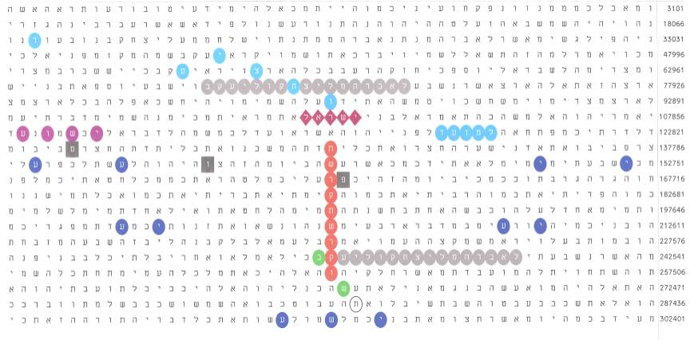

Figure 1.

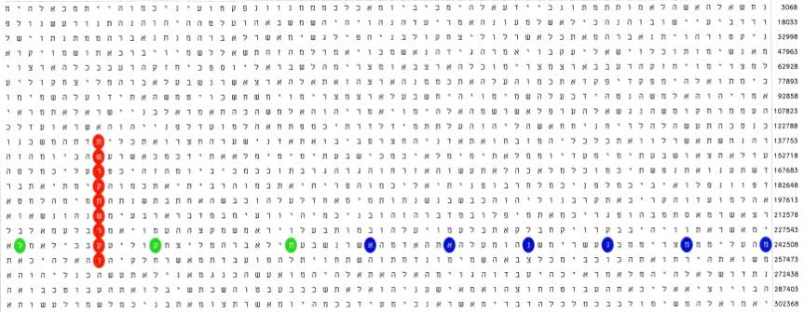

Figure 2.

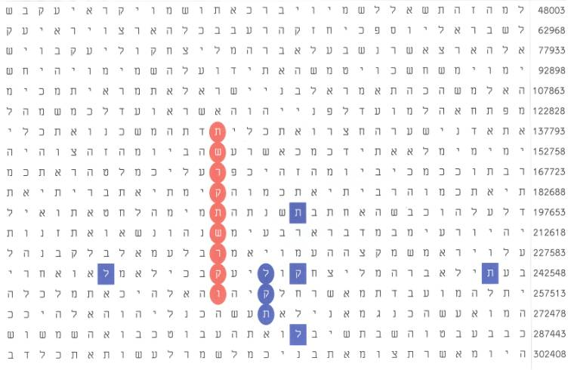

Figure 3.

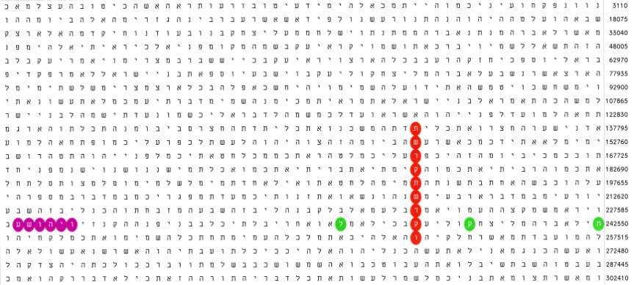

Figure 4.

Figure 5. Regular Pentagon. Regular polygons are those which vertices are equally distant from a central point and therefore lie on a circle.
The sum of the interior angles of a pentagon is 540°. Each interior angle is 108°. The sum of the interior angles of every polygon in the plain is expressed by the general formula 180(n – 2), where n is the number of sides. For a triangle, n = 3, therefore the sum is 180°. For a tetragon, it is 180×2 = 360°, etc.
This shape was thought to be protective against evil powers by the ancients. Therefore, they constructed their fortresses in the form of pentagons. The most famous contemporary building having this shape is the Pentagon in USA.
The regular pentagon is linked in a strange way with the planet Venus as well. It is an astronomical fact that Venus passes through five fixed points on the celestial sphere every 8 years with a striking accuracy of timing.
The ratio of the length of a diagonal (one of the five diagonals is shown above) to a side in a regular pentagon is exactly the Golden Ratio. These lengths are incommensurate. This means that no unit of length exists, which projects both on the diagonal and the side. The absence of such unit defines irrational numbers.

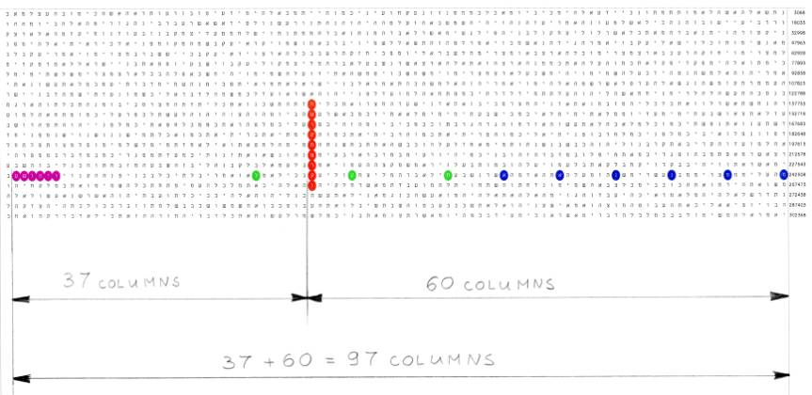

Figure 6.

I didn’t know Mr. G.W. Bush’s biography in details. It was quite recently when I came to know that he was born in July 1946. Now, if we follow the diagonal with his name in Fig. 1 (green ovals), the letter next to the last letter in Bush (בוש), shin, is tav (ת), the oval contour in Fig. 1. If we read three letters from this tav back, i.e. including the last 2 letters of Bush, at skip = -14,964, we obtain tav-shin-vav (תשו). The numerical value of these 3 letters is 400+300+6 = 706. Incidentally, July 1946 happened to be in the year 5706, according to the Jewish calendar. That year started in September 1945 and ended in September 1946.

