Potentially Interesting Dates for HC 5766

Most everyone doing or reading Bible Code research today is interested in the potentially predictive power of prophecy. The more conservative sites always constrain such predictions with terms like “might” and “maybe”, and a few discourage any prediction, usually because available dates are ambiguous or simply because the web master supports of philosophy of free will.

My own experience and beliefs are mixed. Personally, I believe that the Bible Codes were given to us for a reason, and warnings are of little value without an approximate idea of when the warning is valid.

My latest interest in trying to fix the date of a prophecy came when my Sister in Christ, Diana, had a vision of a surprise attack against the West Coast of the United States by a Chinese submarine. She had several pertinent details including the target, the potential date, that it was an older diesel sub that fired a long range cruise missile, and that it was Russian designed or built. I used the information at
http://www.strategypage.com/fyeo/howtomakewar/databases/submarine_database/submarines.asp)
to develop my primary code (see figures 1&2) which tended to support her vision, down to the date which conspicously crosses the central term “missile submarine”, with the exception that the older Russian designed, Chinese operated submarines aren’t credited with being able to launch long range cruise missiles. Additional research indicated that the long range Chinese HN-3 cruise missile is a torpedo tube launched cruise missile, like the U.S. Navy Tomahawk. In short, the HN-3 might be launched from any submarine with a “standard” torpedo tube as long as some upgrades to the submarine fire control computer are made. I think the significance of the code is something like one in ten million against chance for Figure 1-a or 1-b, Figure 2, and Figure 3 based on the positive R-values only. The code in Figure 3 was searched out to see if there was any redundancy. In summary, I think that Sister Diana’s vision is as well supported as such a vision might be by the Bible Codes I discovered.
Does that mean there is going to be a nuclear attack against Los Angeles, California, USA on 16 September 2006, perpetrated by a Chinese operated Kilo-I submarine, hull number 365, firing a torpedo tube launched HN-3 cruise missile? Well, we’ll know on
17 September 2006. There are some obvious shortcoming in the code like
(1) The year is ambiguous. ‘765 or ‘766 probably refer to 5765 and 5766 respectively, but not necessarily. The ‘765 and ‘766 codes could be there randomly or by deliberation. ‘765 is the more likely code to be valid if we have to choose.
(2) “Angels” may refer to Los Angeles or something else entrirely, and “Cali” isn’t necessarily a standard short form for California, but try finding “California” anywhere.
(3) While it is clearly possible to modify an old diesel powered submarine to fire a torpedo tube launched cruise missile, there’s no evidence in the literature that the Chinese have modified any such boat to launch the HN-3 nuclear warhead cruise missile, let alone the Kilo-I class boat with Hull Number 365.
(4) Most importantly, the geopolitical situation wouldn’t seem to support a “one-shot” attack against the United States by any major state, certainly not China.

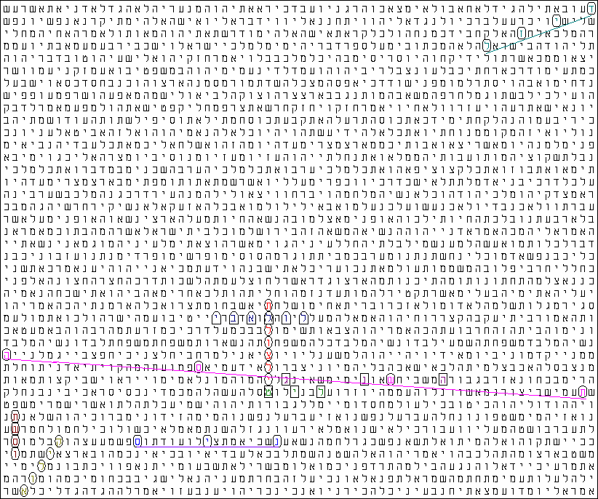
Figure 1-a (Row Split disabled)

Term Translation Skip R Factor (in Matrix) Start End
úììåöìéè missile submarine -12477 0.300 2.943 Psalms Ch 83 V 9 Letter 27 Amos Ch 1 V 10 Letter 5
ìéè missile n. -3 -2.507 0.136 Psalms Ch 83 V 9 Letter 27 Psalms Ch 83 V 9 Letter 21
ðéñ China n. -8 -2.811 -0.168 Proverbs Ch 19 V 19 Letter 27 Proverbs Ch 19 V 19 Letter 11
äñùú Year ‘765 -12455 -4.612 -1.969 Psalms Ch 83 V 8 Letter 17 Psalms Ch 18 V 21 Letter 8
åñùú Year ‘766 12477 -4.717 -2.074 Psalms Ch 124 V 6 Letter 13 Job Ch 2 V 3 Letter 51
ìåìàáé 12 Elul -2 -0.151 2.493 Micah Ch 2 V 7 Letter 42 Micah Ch 2 V 7 Letter 32
àåìé÷ Kilo-I (USSR, PRC) 12478 -4.466 -1.823 Proverbs Ch 19 V 20 Letter 8 Ruth Ch 2 V 11 Letter 25
âðä HN-3 (SLCM) 9 -2.852 -0.208 Psalms Ch 65 V 7 Letter 22 Psalms Ch 65 V 8 Letter 18
ìæéã diesel 12481 -4.711 -2.067 1 Kings Ch 18 V 12 Letter 35 2 Kings Ch 14 V 28 Letter 68

The ELS reference is 12477 characters between rows.
There are 9 displayed terms in the matrix.
The matrix starts at 1 Kings Ch 18 V 12 Letter 35 and ends at Ruth Ch 2 V 11 Letter 27.
The matrix spans 486671 characters of the surface text.
The matrix has 40 rows, is 68 columns wide and contains a total of 2720 characters.

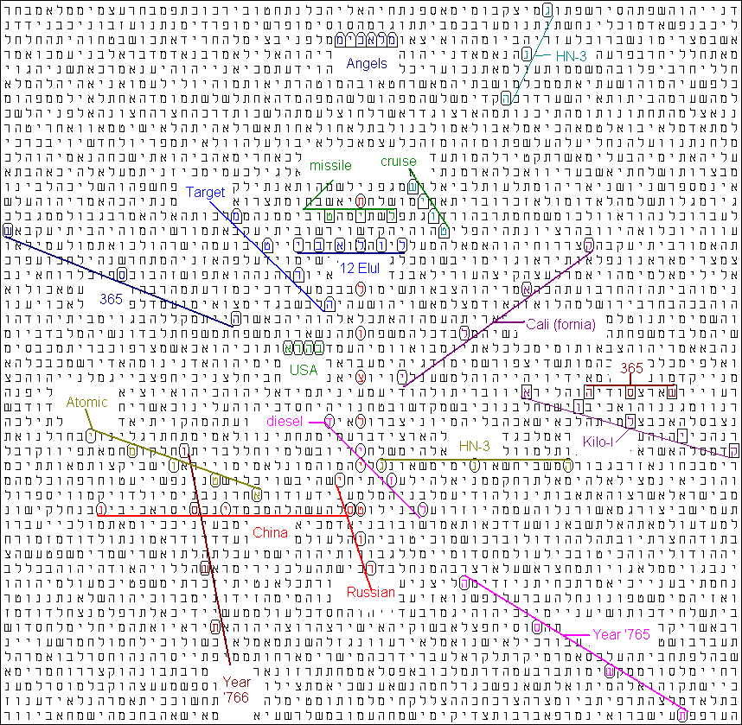

Figure 1-b (Row Split Auto … 3 selected)

Report for Figure 1-b
Term Translation Skip R Factor (in Matrix) Start End
úììåöìéè missile submarine -12477 0.300 2.836 Psalms Ch 83 V 9 Letter 27 Amos Ch 1 V 10 Letter 5
ìéè missile n. -3 -2.507 0.029 Amos Ch 6 V 2 Letter 39 Amos Ch 6 V 2 Letter 33
ìåìàáé 12 Elul -2 -0.151 2.386 Micah Ch 2 V 7 Letter 42 Micah Ch 2 V 7 Letter 32
äñùú Year 765 -12470 -4.613 -2.076 Proverbs Ch 29 V 1 Letter 18 Psalms Ch 119 V 51 Letter 5
åñùú Year 766 -16635 -4.840 -2.303 Psalms Ch 147 V 11 Letter 10 Psalms Ch 55 V 21 Letter 21
îéëàìî angels n. 1 -1.833 0.704 Ezekiel Ch 30 V 9 Letter 13 Ezekiel Ch 30 V 9 Letter 18
âðä HN-3 (SLCM) 9 -2.852 -0.315 Psalms Ch 65 V 7 Letter 22 Psalms Ch 65 V 8 Letter 18
àåìé÷ Kilo-1 -4154 -3.994 -1.458 Psalms Ch 55 V 20 Letter 16 Psalms Ch 25 V 14 Letter 11
âðä HN-3 (SLCM) -12479 -5.989 -3.453 Ezekiel Ch 40 V 10 Letter 12 Ezekiel Ch 24 V 3 Letter 51
éñåø Russian n. -8317 -4.950 -2.413 Psalms Ch 110 V 7 Letter 7 Psalms Ch 71 V 12 Letter 27
áäøà USA -1 -1.703 0.833 Malachi Ch 3 V 2 Letter 28 Malachi Ch 3 V 2 Letter 25
äøèî target n. 8315 -4.619 -2.082 Amos Ch 6 V 2 Letter 48 Zechariah Ch 3 V 3 Letter 9
ìæéã diesel n. 8315 -4.537 -2.000 Psalms Ch 39 V 7 Letter 34 Psalms Ch 83 V 9 Letter 21
äñù 365 4 -2.403 0.133 Psalms Ch 25 V 13 Letter 21 Psalms Ch 25 V 14 Letter 5
ùñä 365 -12466 -5.892 -3.356 Zechariah Ch 8 V 13 Letter 9 Obadiah Ch 1 V 18 Letter 13
éîåèà atomic adj. -4155 -3.632 -1.096 Psalms Ch 78 V 6 Letter 12 Psalms Ch 47 V 5 Letter 1
éìà÷ Cali (fornia) 12483 -5.434 -2.897 Micah Ch 2 V 7 Letter 14 Psalms Ch 18 V 19 Letter 30
èåéù cruise n. 4158 -4.500 -1.964 Joel Ch 1 V 7 Letter 1 Obadiah Ch 1 V 17 Letter 16
ðéñ China n. 12 -2.987 -0.451 Psalms Ch 83 V 9 Letter 28 Psalms Ch 83 V 10 Letter 22

The ELS reference is 4159 characters between rows.
There are 19 displayed terms in the matrix.
The matrix starts at Ezekiel Ch 24 V 3 Letter 33 and ends at Proverbs Ch 29 V 3 Letter 20.
The matrix spans 199703 characters of the surface text.
The matrix has 49 rows, is 71 columns wide and contains a total of 3479 characters.
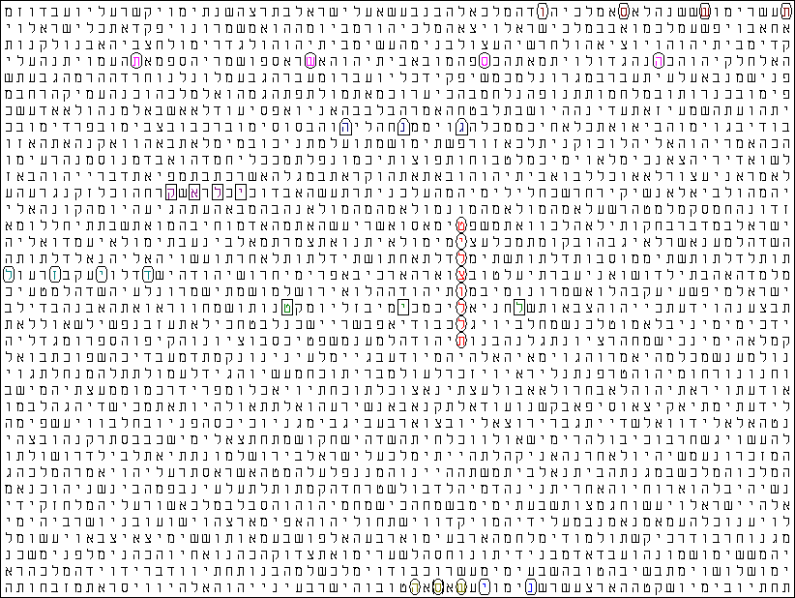
Figure 2 (Row Split Disabled)
Report for Figure 2

Term Translation Skip R Factor (in Matrix) Start End
úììåöìéè missile submarine 18511 0.136 2.825 Ezekiel Ch 20 V 13 Letter 39 Psalms Ch 48 V 12 Letter 19
ìéè missile n. -10 -3.030 -0.342 Zechariah Ch 4 V 10 Letter 12 Zechariah Ch 4 V 9 Letter 48
ðéñ China n. -4 -2.510 0.178 2 Chronicles Ch 14 V 1 Letter 6 2 Chronicles Ch 13 V 23 Letter 67
äñùú Year '765 -15 -1.700 0.989 2 Kings Ch 22 V 4 Letter 59 2 Kings Ch 22 V 4 Letter 14
åñùú Year '766 7 -1.473 1.216 1 Kings Ch 16 V 8 Letter 4 1 Kings Ch 16 V 8 Letter 25
âðä HN-3 (SLCM) -5 -2.597 0.092 Isaiah Ch 66 V 20 Letter 30 Isaiah Ch 66 V 20 Letter 20
äñù 365 2 -2.102 0.586 2 Chronicles Ch 14 V 1 Letter 4 2 Chronicles Ch 14 V 1 Letter 8
éìà÷ CALI(FORNIA?) -2 -1.646 1.043 Jeremiah Ch 48 V 37 Letter 8 Jeremiah Ch 48 V 37 Letter 2
ìæéã diesel 4 -1.223 1.465 Hosea Ch 10 V 11 Letter 66 Hosea Ch 10 V 12 Letter 5

The ELS reference is 18511 characters between rows.
There are 9 displayed terms in the matrix.
The matrix starts at 1 Kings Ch 16 V 8 Letter 4 and ends at 2 Chronicles Ch 14 V 2 Letter 13.
The matrix spans 647953 characters of the surface text.
The matrix has 36 rows, is 68 columns wide and contains a total of 2448 characters.

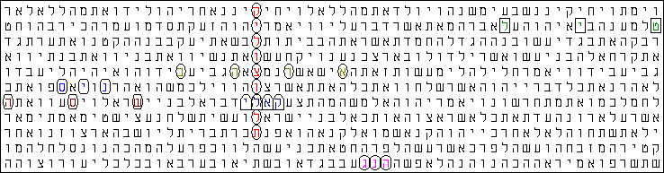
Figure 3 (Row Split Disabled)

Report for Figure 3

Term Translation Skip R Factor (in Matrix) Start End
úììåöåìé÷ Kilo submarine 15492 0.766 4.018 Genesis Ch 5 V 13 Letter 5 Exodus Ch 34 V 15 Letter 3
ìéè missile n. 7 -2.875 0.376 Genesis Ch 18 V 19 Letter 63 Genesis Ch 18 V 19 Letter 77
ðéñ China n. -2 -2.209 1.042 Exodus Ch 4 V 29 Letter 16 Exodus Ch 4 V 29 Letter 12
âðä HN-3 (SLCM) 1 -2.212 1.039 Leviticus Ch 13 V 53 Letter 21 Leviticus Ch 13 V 53 Letter 23
äñù 365 6 -2.579 0.672 Exodus Ch 14 V 15 Letter 33 Exodus Ch 14 V 16 Letter 4
éìà÷ CALI(FORNIA?) 1 -1.301 1.950 Exodus Ch 14 V 15 Letter 20 Exodus Ch 14 V 15 Letter 23
áäøà USA 5 -2.402 0.849 Genesis Ch 44 V 17 Letter 22 Genesis Ch 44 V 17 Letter 37

The ELS reference is 15492 characters between rows.
There are 7 displayed terms in the matrix.
The matrix starts at Genesis Ch 5 V 11 Letter 33 and ends at Leviticus Ch 13 V 54 Letter 5.
The matrix spans 154981 characters of the surface text.
The matrix has 11 rows, is 61 columns wide and contains a total of 671 characters.

Sometimes, however the dates are much less ambiguous, having the day, month, and year in a continuous character sequence. I used one such date in a paper found at
http://exodus2006.com/First_Seal.htm
and Fab has recently published interesting codes with a complete dates at http://exodus2006.com/fab/8Tevet.htm and http://exodus2006.com/fab/8-ab-2006.htm.

My quest was for the complete dates that might be of interest for the later part of HC 5765 and all of 5766 that might serve as the basis for interesting Bible Codes that might be prophetic with a meaningful date attached to them. I searched the entire Tanach from skip = -100,000 to skip-100,000 for each of the dates of HC 5766 plus the month of Elul in HC 5765 in each of the eight formats supported by Code Finder, Milenium Edition. The results are given in Table 1. There are nineteen days that are statistically significant (3-σ or better), and one day which has two different formats that appear to be statistically significant.

Search from skip = -100,000 to 100,000 ... no wrap
 |  |  |  |  | FORM | Number | Expectation | No. Sigma
Gregorian |  |  | Hebrew Calendar |  |  | Found |  | "Z-score"
9-Sep-05 |  | 5 | Elul | 5765 | DMY | 1 | 0.0712 | 3.5
8-Oct-05 |  | 5 | Tishri | 5766 | DMY | 1 | 0.0323 | 5.4
8-Nov-05 |  | 6 | Heshvan | 5766 | DM'Y | 3 | 0.1709 | 6.8
31-Dec-05 |  | 30 | Kislev | 5766 | DM'Y | 1 | 0.0421 | 4.7
8-Jan-05 |  | 8 | Tevet | 5766 | DMY | 1 | 0.0084 | 10.8
18-Feb-06 |  | 20 | Sh'vat | 5766 | DMY | 1 | 0.0133 | 8.5
2-Mar-06 |  | 2 | Adar | 5766 | DM'Y | 7 | 2.0108 | 3.5
3-Mar-06 |  | 3 | Adar | 5766 | DM'Y | 3 | 0.3107 | 4.8
19-May-06 |  | 21 | Iyyar | 5766 | DM'Y | 2 | 0.0506 | 8.7
23-May-06 |  | 25 | Iyyar | 5766 | DMY | 1 | 0.0043 | 15.2
23-May-06 |  | 25 | Iyyar | 5766 | On the DMY | 1 | 0.0002 | 67.9
28-May-06 |  | 1 | Sivan | 5766 | DM'Y | 1 | 0.0827 | 3.2
16-Jun-06 |  | 20 | Sivan | 5766 | DM'Y | 1 | 0.0410 | 4.7
28-Jun-06 |  | 2 | Tammuz | 5766 | DM'Y | 1 | 0.0553 | 4.0
2-Jul-06 |  | 6 | Tammuz | 5766 | D of M'Y | 1 | 0.0056 | 13.3
1-Aug-06 |  | 7 | Av | 5766 | On the DMY | 1 | 0.0434 | 4.6
12-Aug-06 |  | 18 | Av | 5766 | On the D M'Y | 1 | 0.0142 | 8.3
20-Aug-06 |  | 26 | Av | 5766 | On the D M'Y | 2 | 0.2878 | 3.2
28-Aug-06 |  | 4 | Elul | 5766 | DMY | 1 | 0.0287 | 5.7
6-Sep-06 |  | 14 | Elul | 5766 | DMY | 1 | 0.0031 | 17.9
Number of Day Formats with Significant "Hits" |  |  |  |  |  | 20
Number of Days with Significant "Hits" |  |  |  |  |  | 19
Table 1
Days with Statistically Significant Dates in the Tanach

All of the dates found whether significant or not are presented in Table 2
Search from skip = -100,000 to 100,000 ... no wrap
 |  |  |  |  | FORM | Number | Expectation | No. Sigma
Gregorian |  |  | Hebrew Calendar |  |  | Found |  | Z-score
5-Sep-05 |  | 1 | Elul | 5765 | DM'Y | 1 | 0.837 | 0.2
9-Sep-05 |  | 5 | Elul | 5765 | DMY | 1 | 0.071 | 3.5
10-Sep-05 |  | 6 | Elul | 5765 | DM'Y | 1 | 1.336 | 0.3
14-Sep-05 |  | 10 | Elul | 5765 | DM'Y | 1 | 1.259 | 0.2
8-Oct-05 |  | 5 | Tishri | 5766 | DMY | 1 | 0.032 | 5.4
8-Oct-05 |  | 5 | Tishri | 5766 | DM'Y | 2 | 0.405 | 2.5
8-Nov-05 |  | 6 | Heshvan | 5766 | DM'Y | 3 | 0.171 | 6.8
31-Dec-05 |  | 30 | Kislev | 5766 | DM'Y | 1 | 0.042 | 4.7
5-Jan-05 |  | 5 | Tevet | 5766 | DM'Y | 1 | 0.388 | 1.0
8-Jan-05 |  | 8 | Tevet | 5766 | DMY | 1 | 0.008 | 10.8
10-Jan-05 |  | 10 | Tevet | 5766 | DM'Y | 1 | 0.524 | 0.7
30-Jan-05 |  | 1 | Sh'vat | 5766 | DM'Y | 1 | 0.335 | 1.1
4-Feb-06 |  | 6 | Sh'vat | 5766 | DM'Y | 1 | 0.454 | 0.8
8-Feb-06 |  | 10 | Sh'vat | 5766 | DM'Y | 1 | 0.483 | 0.7
18-Feb-06 |  | 20 | Sh'vat | 5766 | DMY | 1 | 0.013 | 8.5
1-Mar-06 |  | 1 | Adar | 5766 | DM'Y | 2 | 2.950 | 0.6
2-Mar-06 |  | 2 | Adar | 5766 | DM'Y | 7 | 2.011 | 3.5
3-Mar-06 |  | 3 | Adar | 5766 | DM'Y | 3 | 0.311 | 4.8
4-Mar-06 |  | 4 | Adar | 5766 | DM'Y | 1 | 0.998 | 0.0
5-Mar-06 |  | 5 | Adar | 5766 | DMY | 1 | 0.252 | 1.5
5-Mar-06 |  | 5 | Adar | 5766 | DM'Y | 5 | 3.144 | 1.0
5-Mar-06 |  | 5 | Adar | 5766 | On the DM'Y | 1 | 0.161 | 2.1
6-Mar-06 |  | 6 | Adar | 5766 | DMY | 1 | 0.320 | 1.2
6-Mar-06 |  | 6 | Adar | 5766 | DM'Y | 3 | 3.996 | 0.5
10-Mar-06 |  | 10 | Adar | 5766 | DM'Y | 8 | 4.250 | 1.8
10-Mar-06 |  | 10 | Adar | 5766 | D of M'Y | 1 | 0.218 | 1.7
10-Mar-06 |  | 12 | Adar | 5766 | DM'Y | 1 | 0.218 | 1.7
20-Mar-06 |  | 20 | Adar | 5766 | DM'Y | 2 | 1.464 | 0.4
25-Mar-06 |  | 25 | Adar | 5766 | DM'Y | 1 | 0.117 | 2.6
29-Apr-06 |  | 1 | Iyyar | 5766 | DMY | 1 | 0.109 | 2.7
29-Apr-06 |  | 1 | Iyyar | 5766 | DM'Y | 2 | 1.361 | 0.5
30-Apr-06 |  | 2 | Iyyar | 5766 | DM'Y | 3 | 0.928 | 2.2
3-May-06 |  | 5 | Iyyar | 5766 | DMY | 1 | 0.116 | 2.6
3-May-06 |  | 5 | Iyyar | 5766 | DM'Y | 3 | 1.451 | 1.3
4-May-06 |  | 6 | Iyyar | 5766 | DMY | 1 | 0.147 | 2.2
4-May-06 |  | 6 | Iyyar | 5766 | DM'Y | 2 | 1.844 | 0.1
8-May-06 |  | 10 | Iyyar | 5766 | DMY | 1 | 0.157 | 2.1
8-May-06 |  | 10 | Iyyar | 5766 | DM'Y | 1 | 1.962 | 0.7
8-May-06 |  | 10 | Iyyar | 5766 | D of M'Y | 1 | 0.100 | 2.8
10-May-06 |  | 12 | Iyyar | 5766 | DM'Y | 1 | 0.100 | 2.8
19-May-06 |  | 21 | Iyyar | 5766 | DM'Y | 2 | 0.051 | 8.7
23-May-06 |  | 25 | Iyyar | 5766 | DMY | 1 | 0.004 | 15.2
23-May-06 |  | 25 | Iyyar | 5766 | On the DMY | 1 | 0.000 | 67.9
28-May-06 |  | 1 | Sivan | 5766 | DM'Y | 1 | 0.083 | 3.2
16-Jun-06 |  | 20 | Sivan | 5766 | DM'Y | 1 | 0.041 | 4.7
28-Jun-06 |  | 2 | Tammuz | 5766 | DM'Y | 1 | 0.055 | 4.0
2-Jul-06 |  | 6 | Tammuz | 5766 | D of M'Y | 1 | 0.006 | 13.3
26-Jul-06 |  | 1 | Av | 5766 | DMY | 7 | 8.904 | 0.6
26-Jul-06 |  | 1 | Av | 5766 | On the DM'Y | 3 | 5.695 | 1.1
26-Jul-06 |  | 1 | Av | 5766 | D of M'Y | 7 | 5.695 | 0.5
26-Jul-06 |  | 1 | Av | 5766 | DM'Y | 116 | 110.696 | 0.5
27-Jul-06 |  | 2 | Av | 5766 | DMY | 6 | 6.069 | 0.0
27-Jul-06 |  | 2 | Av | 5766 | D of MY | 1 | 0.311 | 1.2
27-Jul-06 |  | 2 | Av | 5766 | On the DMY | 1 | 0.311 | 1.2
27-Jul-06 |  | 2 | Av | 5766 | On the DM'Y | 7 | 3.882 | 1.6
27-Jul-06 |  | 2 | Av | 5766 | D of M'Y | 7 | 3.880 | 1.6
27-Jul-06 |  | 2 | Av | 5766 | D of M'Y | 72 | 75.451 | 0.4
28-Jul-06 |  | 3 | Av | 5766 | D of M'Y | 1 | 0.600 | 0.5
28-Jul-06 |  | 3 | Av | 5766 | DM'Y | 6 | 11.658 | 1.7
29-Jul-06 |  | 4 | Av | 5766 | DM'Y | 40 | 37.451 | 0.4
29-Jul-06 |  | 4 | Av | 5766 | D of M'Y | 1 | 1.927 | 0.7
29-Jul-06 |  | 4 | Av | 5766 | On the DM'Y | 3 | 1.927 | 0.8
29-Jul-06 |  | 4 | Av | 5766 | DMY | 1 | 3.012 | 1.2
30-Jul-06 |  | 5 | Av | 5766 | DMY | 10 | 9.489 | 0.2
30-Jul-06 |  | 5 | Av | 5766 | On the DM'Y | 5 | 6.069 | 0.4
30-Jul-06 |  | 5 | Av | 5766 | D of M'Y | 5 | 6.069 | 0.4
30-Jul-06 |  | 5 | Av | 5766 | DM'Y | 115 | 117.967 | 0.3
31-Jul-06 |  | 6 | Av | 5766 | DMY | 19 | 12.059 | 2.0
31-Jul-06 |  | 6 | Av | 5766 | On the DM'Y | 6 | 7.713 | 0.6
31-Jul-06 |  | 6 | Av | 5766 | D of M'Y | 10 | 7.713 | 0.8
31-Jul-06 |  | 6 | Av | 5766 | DM'Y | 171 | 149.930 | 1.7
1-Aug-06 |  | 7 | Av | 5766 | DMY | 1 | 0.850 | 0.2
1-Aug-06 |  | 7 | Av | 5766 | On the DMY | 1 | 0.043 | 4.6
1-Aug-06 |  | 7 | Av | 5766 | D of M'Y | 1 | 0.540 | 0.6
1-Aug-06 |  | 7 | Av | 5766 | DM'Y | 6 | 10.530 | 1.4
2-Aug-06 |  | 8 | Av | 5766 | DMY | 2 | 2.570 | 0.4
2-Aug-06 |  | 8 | Av | 5766 | On the DM'Y | 1 | 1.640 | 0.5
2-Aug-06 |  | 8 | Av | 5766 | D of M'Y | 2 | 1.640 | 0.3
2-Aug-06 |  | 8 | Av | 5766 | DM'Y | 26 | 31.930 | 1.0
3-Aug-06 |  | 9 | Av | 5766 | DMY | 1 | 0.590 | 0.5
3-Aug-06 |  | 9 | Av | 5766 | DM'Y | 8 | 7.300 | 0.3
2-Aug-06 |  | 10 | Av | 5766 | DM'Y | 156 | 159.489 | 0.3
2-Aug-06 |  | 10 | Av | 5766 | D of M'Y | 3 | 8.205 | 1.8
3-Aug-06 |  | 10 | Av | 5766 | On the D M'Y | 11 | 8.205 | 1.0
4-Aug-06 |  | 10 | Av | 5766 | D of MY | 1 | 0.658 | 0.4
4-Aug-06 |  | 10 | Av | 5766 | DMY | 17 | 12.828 | 1.2
5-Aug-06 |  | 11 | Av | 5766 | DM'Y | 14 | 12.038 | 0.6
5-Aug-06 |  | 11 | Av | 5766 | D of M'Y | 1 | 0.617 | 0.5
5-Aug-06 |  | 11 | Av | 5766 | On the D M'Y | 1 | 0.617 | 0.5
6-Aug-06 |  | 12 | Av | 5766 | DM'Y | 3 | 8.205 | 1.8
6-Aug-06 |  | 12 | Av | 5766 | DMY | 1 | 0.658 | 0.4
8-Aug-06 |  | 14 | Av | 5766 | DM'Y | 5 | 4.073 | 0.5
8-Aug-06 |  | 14 | Av | 5766 | On the D M'Y | 1 | 0.209 | 1.7
9-Aug-06 |  | 15 | Av | 5766 | DM'Y | 1 | 0.746 | 0.3
11-Aug-06 |  | 17 | Av | 5766 | DM'Y | 1 | 1.145 | 0.1
12-Aug-06 |  | 18 | Av | 5766 | DM'Y | 4 | 3.472 | 0.3
12-Aug-06 |  | 18 | Av | 5766 | On the D M'Y | 1 | 0.014 | 8.3
12-Aug-06 |  | 18 | Av | 5766 | DMY | 1 | 0.278 | 1.4
13-Aug-06 |  | 19 | Av | 5766 | DM'Y | 1 | 0.794 | 0.2
14-Aug-06 |  | 20 | Av | 5766 | DM'Y | 54 | 54.924 | 0.1
14-Aug-06 |  | 20 | Av | 5766 | D of M'Y | 1 | 2.826 | 1.1
14-Aug-06 |  | 20 | Av | 5766 | On the D M'Y | 2 | 2.826 | 0.5
14-Aug-06 |  | 20 | Av | 5766 | DMY | 4 | 4.418 | 0.2
15-Aug-06 |  | 21 | Av | 5766 | DM'Y | 10 | 4.145 | 2.9
15-Aug-06 |  | 21 | Av | 5766 | DMY | 1 | 0.332 | 1.2
16-Aug-06 |  | 22 | Av | 5766 | DM'Y | 1 | 2.826 | 1.1
18-Aug-06 |  | 24 | Av | 5766 | DM'Y | 1 | 1.402 | 0.3
19-Aug-06 |  | 25 | Av | 5766 | DM'Y | 4 | 4.418 | 0.2
20-Aug-06 |  | 26 | Av | 5766 | DM'Y | 7 | 5.615 | 0.6
20-Aug-06 |  | 26 | Av | 5766 | On the D M'Y | 2 | 0.288 | 3.2
22-Aug-06 |  | 28 | Av | 5766 | DM'Y | 1 | 1.196 | 0.2
23-Aug-06 |  | 29 | Av | 5766 | DM'Y | 1 | 0.273 | 1.4
24-Aug-06 |  | 30 | Av | 5766 | DM'Y | 107 | 102.168 | 0.5
24-Aug-06 |  | 30 | Av | 5766 | D of M'Y | 5 | 5.256 | 0.1
24-Aug-06 |  | 30 | Av | 5766 | On the DM'Y | 6 | 5.256 | 0.3
24-Aug-06 |  | 30 | Av | 5766 | On the DMY | 1 | 0.421 | 0.9
24-Aug-06 |  | 30 | Av | 5766 | DMY | 12 | 8.218 | 1.3
25-Aug-06 |  | 1 | Elul | 5766 | DM'Y | 2 | 1.064 | 0.9
28-Aug-06 |  | 4 | Elul | 5766 | DMY | 1 | 0.029 | 5.7
29-Aug-06 |  | 5 | Elul | 5766 | DM'Y | 2 | 1.134 | 0.8
30-Aug-06 |  | 6 | Elul | 5766 | DM'Y | 3 | 1.441 | 1.3
6-Sep-06 |  | 14 | Elul | 5766 | DMY | 1 | 0.003 | 17.9

Table 2
All Dates Found in Complete Form in the Tanach

Other researches may want to use the dates for Table 2 or Table 1 to perform additional searches of their own. I don’t think a date needs to be statistically significant by itself to be significant within the context of a matrix search. For instance, 9 Av is a date of historic significance to the Jews, and is likely significant within the context of a search without statistical significance. I’m sure there are other dates as well. Hopefully these tables may reduce the work load for others doing this kind of research.

Respectfully,
Al Sutton, California, USA
4 July 2005 … 27 Sivan 5765

